Linking groundwater recharge processes and nitrogen dynamics on a small Mediterranean island: A conceptual framework from Kythera Island (Greece)
Ioannis Matiatos*, Elias Dimitriou, Anastasios Papadopoulos, Ioanna Zotou, Sergios Lagogiannis, Vassiliki Markogianni, Sofia Laschou, Maria Stoumboudi
Institute of Marine Biological Resources and Inland Waters, Hellenic Centre for Marine Research, Anavissos Attikis, Greece
*corresponding author: Ioannis Matiatos, i.matiatos@hcmr.gr

Supplementary material

Table S1. Hydro-lithological formations of Kythera Island, their areal extent, and corresponding infiltration coefficients (SSW 2023)
Hydro-lithological formation | Areal extent (km²) | Percent area (%) | Infiltration coefficient (%)
Fractured formations of low to very low permeability (flysch) | 14.4 | 5.2 | 5.0
Fractured formations of low to very low permeability (phyllites–quartzites–schists) | 41.9 | 15.1 | 5.0
Predominantly alluvial deposits of variable permeability | 0.7 | 0.2 | 12.0
Non-alluvial deposits of low to very low permeability | 66.1 | 23.8 | 5.0
Carbonate formations of high to moderate permeability | 154.4 | 55.7 | 40.0
Total | 277.5 | 100.0

Table S2. Complete hydrochemical and isotopic dataset for the groundwater and surface water samples collected during the study on Kythera Island, Greece.
Station | Water Type | Water Type2 | Altitude (m a.s.l) | Date | pH | EC  (μS/cm) | Temp  (ºC) | DO  (mg/L) | NO₃-N  (mg/L) | NH₄-N  (mg/L) | δ¹⁸O-H₂O  (‰) | δ²H- H₂O  (‰) | d-excess  (‰) | δ¹⁵N-NO₃  (‰) | δ¹⁸O-NO₃  (‰)
Pigi_Mitaton | Groundwater | Spring | 220 | 5/2/2024 | 7.8 | 546 | 16.6 | 9.2 | 4.00 | <LOQ | -5.7 | -28.5 | 17.0 | 6.3 | 5.1
Amir_Ali | Surface water | River/Stream | 290 | 5/2/2024 | 8.3 | 961 | 14.2 | 9.5 | 0.02 | 0.02 | -5.7 | -26.2 | 19.2
Paleopoli | Groundwater | Borehole | 259 | 5/2/2024 | 7.5 | 600 | 15.0 | 4.6 | 0.25 | 0.01 | -5.8 | -28.2 | 18.1
Neraida_Waterfall | Surface water | Pool | 290 | 6/2/2024 | 7.2 | 846 | 13.8 | 3.4 | 0.27 | 0.03 | -5.8 | -28.8 | 17.8
Kontolianika | Groundwater | Borehole | 305 | 7/2/2024 | NA |  |  |  | 0.02 | 0.01 | -5.6 | -26.7 | 18.0
Markezaki | Groundwater | Borehole | 320 | 8/2/2024 | 6.9 | 977 | 17.7 | 5.8 | 1.16 | <LOQ | -5.9 | -29.2 | 18.2 | 6.6 | 3.9
Skoul | Groundwater | Borehole | 370 | 8/2/2024 | 7.0 | 879 | 17.9 | 7.7 | 0.65 | 0.01 | -5.9 | -29.5 | 17.8 | 4.7 | 3.5
Kalamos | Groundwater | Borehole | 131 | 8/2/2024 | 7.3 | 938 | 19.5 | 7.6 | 0.13 | <LOQ | -5.5 | -25.4 | 18.9
Livadi | Groundwater | Borehole | 250 | 8/2/2024 | 7.1 | 1823 | 16.4 | 4.3 | 2.99 | 0.03 | -5.1 | -23.7 | 16.8 | 12.5 | 6.6
Mylopotamos | Groundwater | Borehole | 290 | 8/2/2024 | 7.0 | 835 | 17.6 | 6.7 | 0.62 | 0.04 | -5.9 | -27.0 | 20.3 | 10.9 | 6.3
Kakia_Melissa | Groundwater | Borehole | 287 | 8/2/2024 | 7.4 | 750 | 18.3 | 9.0 | 0.81 | 0.01 | -5.7 | -27.6 | 18.2 | 5.0 | 3.8
Xala | Groundwater | Borehole | 170 | 8/2/2024 | 7.4 | 835 | 19.5 | 7.5 | 1.02 | <LOQ | -5.6 | -27.3 | 17.6 | 7.1 | 3.0
Petrouni | Groundwater | Borehole | 302 | 9/2/2024 | 6.5 | 469 | 17.9 | 7.2 | 0.01 | 0.01 | -6.0 | -28.9 | 19.1
Mihalakakia | Groundwater | Borehole | 370 | 9/2/2024 | 7.2 | 869 | 17.3 | 4.3 | 0.06 | 0.01 | -5.9 | -28.1 | 19.0
Psoma | Groundwater | Borehole | 298 | 9/2/2024 | 7.4 | 888 | 14.1 | 9.7 | 0.08 | <LOQ | -5.8 | -27.8 | 18.8
Potamos Gipedo | Groundwater | Borehole | 270 | 9/2/2024 | 7.3 | 917 | 17.4 | 3.7 | 0.03 | <LOQ | -5.8 | -27.6 | 18.7
Ag_Sofia_Cave | Groundwater | Borehole | 70 | 9/2/2024 | 8.4 | 704 | 17.9 | 9.0 | 2.30 | <LOQ | -4.0 | -15.3 | 16.4
Xala | Groundwater | Borehole | 170 | 12/4/2024 | 7.3 | 816 | 22.9 | 6.3 | 1.01 | 0.01 | -5.6 | -27.1 | 17.6 | 7.1 | 3.9
Amir_Ali | Surface water | River/Stream | 290 | 12/4/2024 | 8.0 | 920 | 15.2 | 8.3 | 0.01 | 0.01 | -5.6 | -26.0 | 18.8
Kalamos | Groundwater | Borehole | 131 | 12/4/2024 | 7.4 | 924 | 23.2 | 6.4 | 0.13 | 0.01 | -5.5 | -25.1 | 19.2
Potamos Gipedo | Groundwater | Borehole | 270 | 12/4/2024 | 7.1 | 949 | 19.0 | 2.5 | 0.01 | 0.01 | -5.4 | -26.5 | 16.7
Odostrotiras_Olga | Surface water | Pool | 200 | 12/4/2024 | 7.3 | 752 | 21.0 | 8.7 | 0.82 | 0.02 | -5.7 | -27.3 | 18.0 | 6.1 | 4.8
Skoul | Groundwater | Borehole | 370 | 13/04/2024 | 7.0 | 848 | 18.7 | 7.9 | 0.64 | <LOQ | -6.1 | -29.5 | 18.9 | 4.7 | 3.4
Pigi_Mitaton | Groundwater | Spring | 220 | 13/04/2024 | 8.0 | 530 | 17.6 | 9.1 | 4.00 | 0.02 | -5.5 | -28.3 | 15.8 | 4.1 | 3.8
Paleopoli | Groundwater | Borehole | 259 | 13/04/2024 | 7.9 | 536 | 18.8 | 7.6 | 0.39 | 0.01 | -5.7 | -28.6 | 17.2
Livadi | Groundwater | Borehole | 250 | 13/04/2024 | 7.2 | 1656 | 17.7 | 4.7 | 0.87 | 0.06 | -5.0 | -23.6 | 16.6 | 18.3 | 10.4
Markezaki | Groundwater | Borehole | 320 | 13/04/2024 | 7.5 | 930 | 20.0 | 8.2 | 1.95 | 0.01 | -5.9 | -28.9 | 18.6 | 9.7 | 5.4
Potamos Gipedo | Groundwater | Borehole | 270 | 13/12/2024 | 8.3 | 1253 | 11.0 | 10.4 | 0.01 | 0.01 | -5.9 | -29.7 | 17.3
Kakia_Melissa | Groundwater | Borehole | 287 | 14/12/2024 | 8.1 | 777 | 9.1 | 10.2 | 0.77 | 0.01 | -5.7 | -28.3 | 17.5 | 4.9 | 4.3
Livadi | Groundwater | Borehole | 250 | 13/12/2024 | 8.3 | 1795 | 14.5 | 7.8 | 7.67 | 0.01 | -5.4 | -28.1 | 15.4 | 6.8 | 6.4
Markezaki | Groundwater | Borehole | 320 | 14/12/2024 | 7.9 | 959 | 12.5 | 10.5 | 1.65 | 0.01 | -6.1 | -30.3 | 18.5 | 9.6 | 4.6
Petrouni | Groundwater | Borehole | 302 | 13/12/2024 | 8.4 | 466 | 12.2 | 7.9 | 0.03 | 0.01 | -6.1 | -30.4 | 18.6
Skoul | Groundwater | Borehole | 370 | 13/12/2024 | 8.2 | 911 | 11.8 | 9.7 | 0.63 | 0.01 | -6.0 | -30.2 | 17.9 | 4.9 | 4.1
Xala | Groundwater | Borehole | 170 | 13/12/2024 | 8.3 | 866 | 13.3 | 7.1 | 1.00 | 0.01 | -5.6 | -28.0 | 16.7 | 7.4 | 3.8

Fig. S1. Hydrochemical characteristics of groundwater and surface-water samples. Sites are grouped by water type, with groundwater sites on the left and surface-water sites on the right.

Fig. S2. Distribution of δ¹⁸O-H₂O values in regional precipitation grouped by season and groundwater samples collected from Kythera.

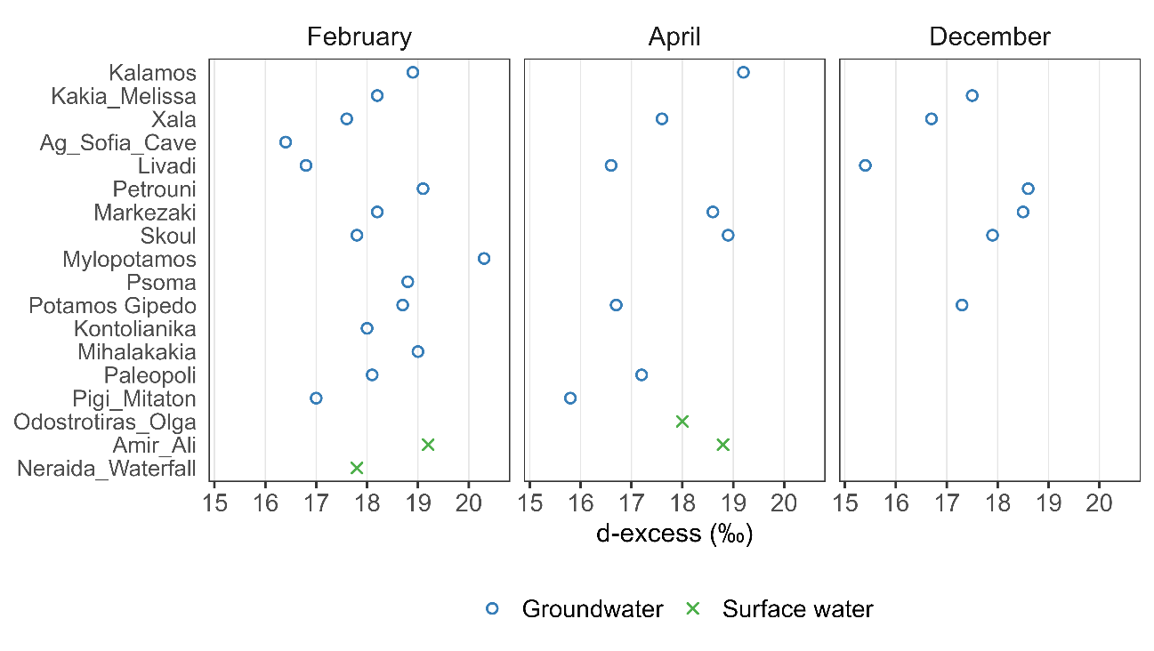
Fig. S3. Spatial and temporal variation of d-excess (‰) in groundwater and surface water samples collected during February, April, and December 2024.

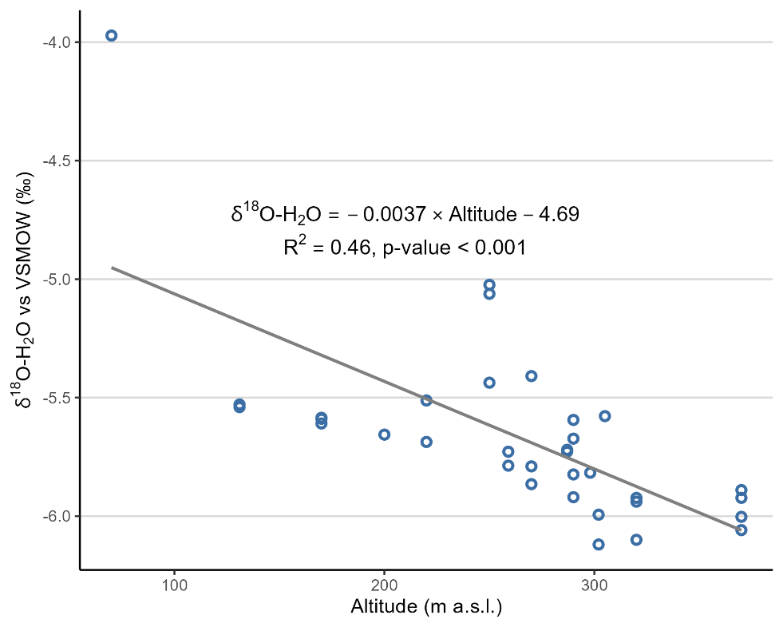
Fig. S4. Correlation between δ¹⁸O-H₂O and sampling altitude of the groundwater samples.

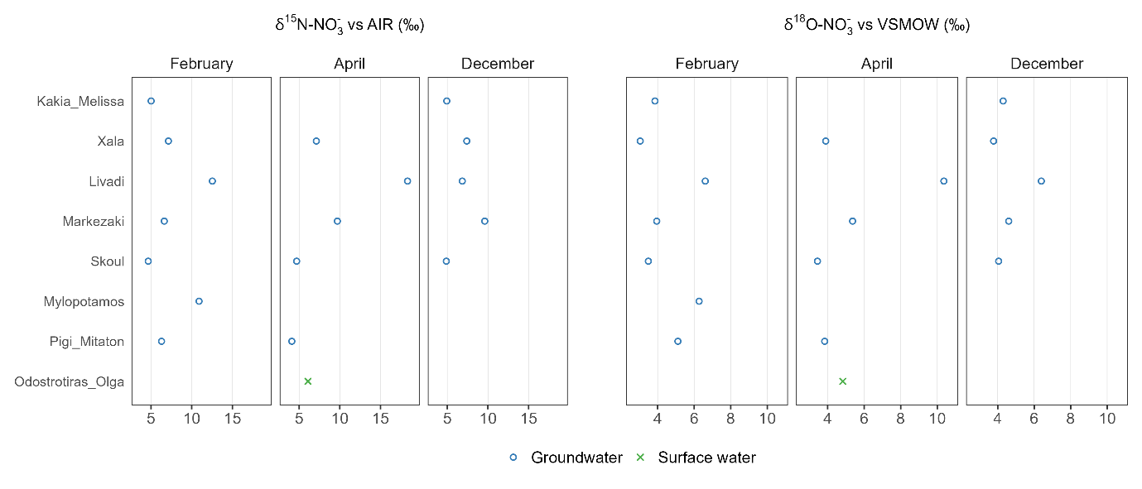
Fig. S5. Spatial and temporal variation of δ¹⁵N-NO₃⁻ and δ¹⁸O-NO₃⁻ values (‰) in groundwater and surface water samples collected during February, April, and December 2024.

