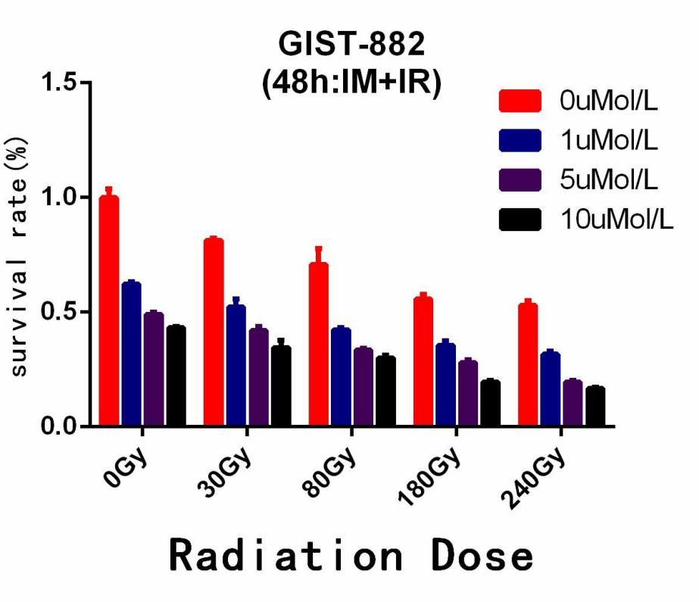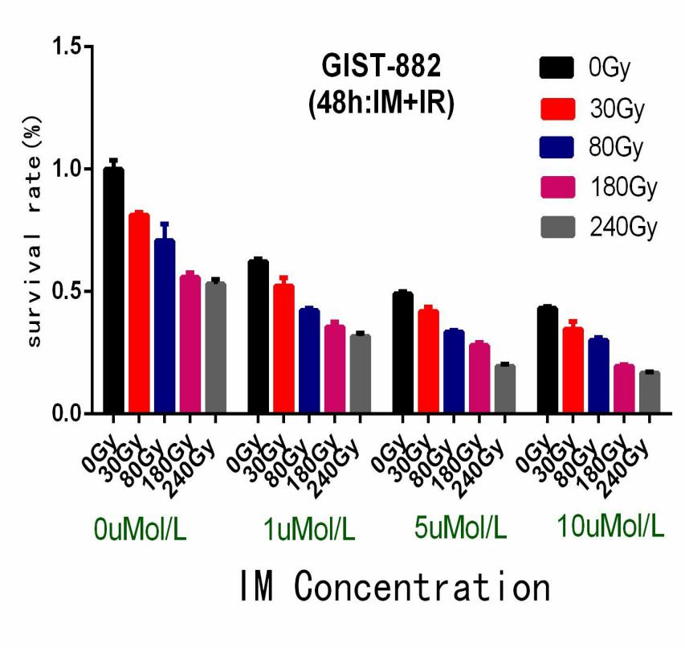
Extended Data Fig1A 1A 1A
Extended Data Fig1B 1B

Extended Data Fig 1A,B, Analysis of variance in factorial design Calibration model F=150.07 Sig=0.000；
Main effect of IM： F=325.54 Sig=0.000；Main effect of IR：F=325.26 Sig=0.000； Interaction effect of IM*IR：F=3.980 Sig=0.004；

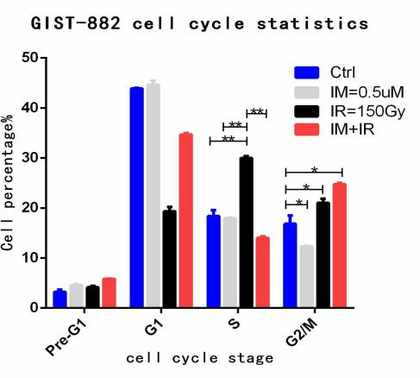
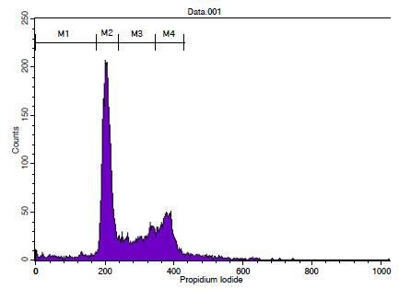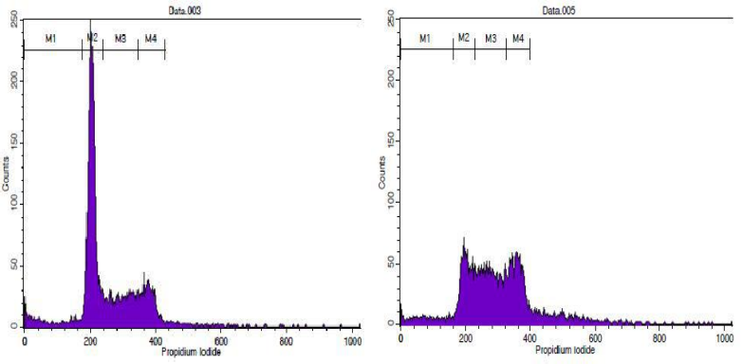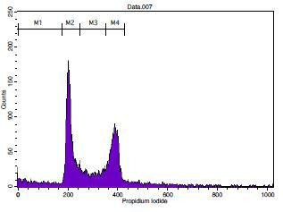

对照组 IM:0.5uM IR:150Gy IR+IM

Extended Data Fig 2A
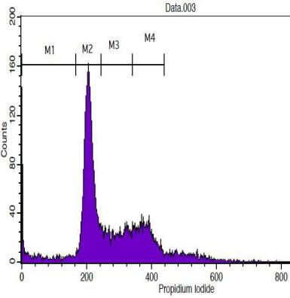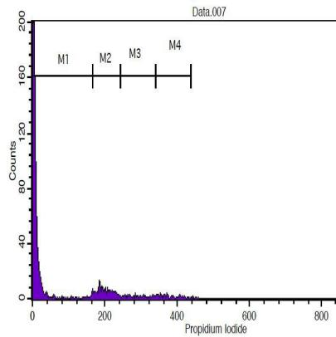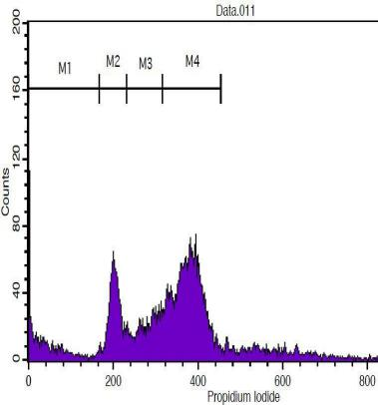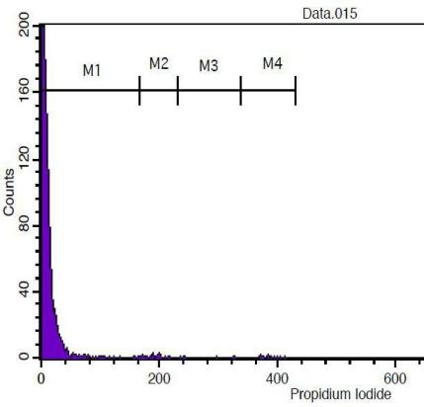
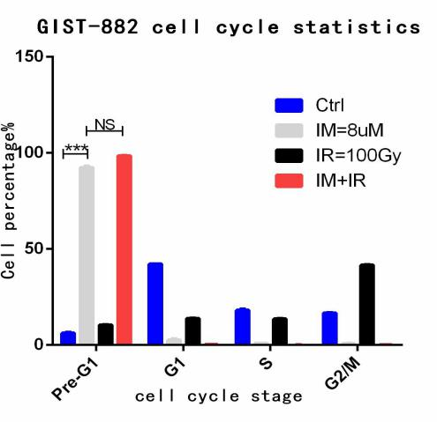

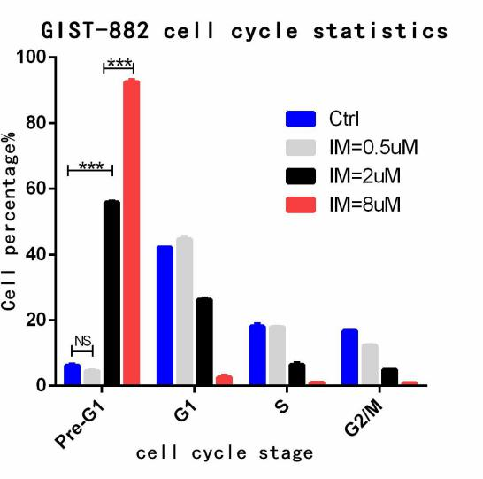
Extended Data Fig2C

对照组 IM:8uMol/L IR:100Gy IR:100Gy+IM: 8uMol/L

Extended Data Fig2B
Extended Data Fig 2A, When the IR dose is increased to 150Gy,the results showed that the cell cycle arrest rate of IR group in S phase (30.01%) was significantly higher than that of Control Group (18.35%)、IM=0.5uM(17,93%) and Combined Group（14.05%）, the difference was statistically significant (p1<0.01, p2<0.01, p3<0.01);
Extended Data Fig 2B, When IM concentration is increased to 8uM,the apoptosis rate of IM group and Gombined Group was 92.52%, 98.52% respectively,it shows that IM mainly leads to apoptosis;
Extended Data Fig 2C,Different concentration gradients of IM were analyzed, the apoptosis rates of Control Group、IM=0.5uM、IM=2uM and IM=8uM were (6.20%, 4.58%, 55.90%, 92.52%) respectively,further hinted IM inducing apoptosis of GIST-882 cells directly, which showed the sensitivity of targeted drugs;

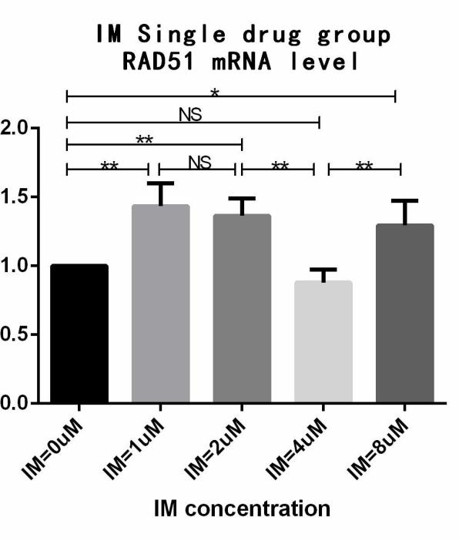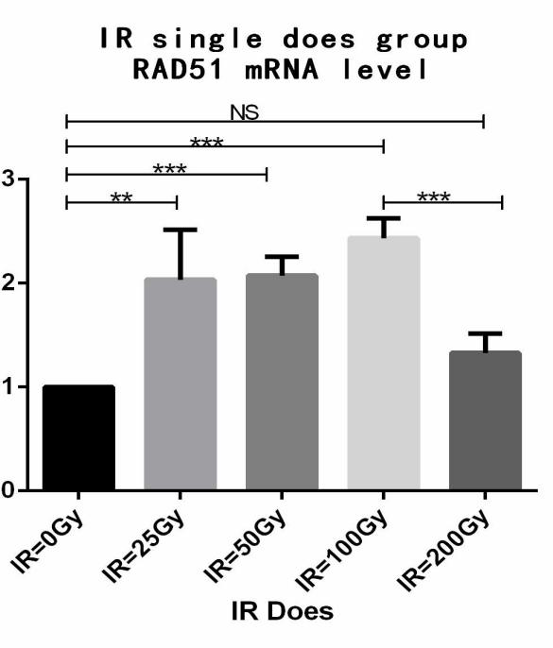

Extended Data Fig 3A Extended Data Fig3B
Extended Data Fig3A, In a certain range of IM concentration (1-4uM),the transcription level of Rad51 decreased with the increase of IM concentration (P < 0.01),it is suggested that IM can inhibit the transcription of Rad51 and enhance the damage of IR to GIST-882 cells;However, when IM concentration exceeded a certain value (8umol/L), the transcription level of Rad51 increased (P < 0.01),perhaps under the action of high concentration IM, GIST-882 cells developed resistance, which resulted in the increase of rebound transcription of Rad51 protein to maintain the stability of tumor cell genome; Extended Data Fig3B,Under certain dose of IR,the transcription level of Rad51 was generally increased (p1<0.01, p2<0.01, p3<0.01), showing that Rad51 is indeed one of the proteins that cause radiation tolerance,however, when the IR dose was too high (IR = 150Gy), the transcription level of Rad51 decreased rapidly (p<0.01),the results showed that the high dose of radiation led to the difficulty of cell self repair, and finally to apoptosis, so Rad51 transcription was down regulated.

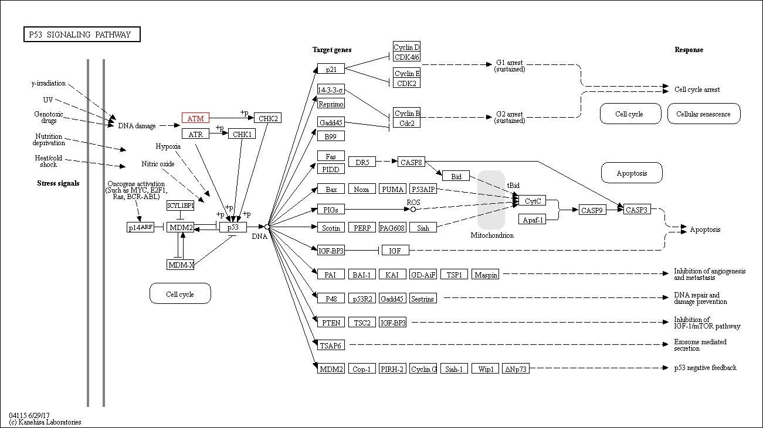Radiation-related DNA response axis
Radiation resistance
Raise RAD51 etc.
IR
DNA damage
γ-H2AX
ATR/ATM
p53
Repair
damaged DNA

Radiation resistance

IR DNA damage γ-H2AX ATR/ATM p53

Raise RAD51 etc.

Repair

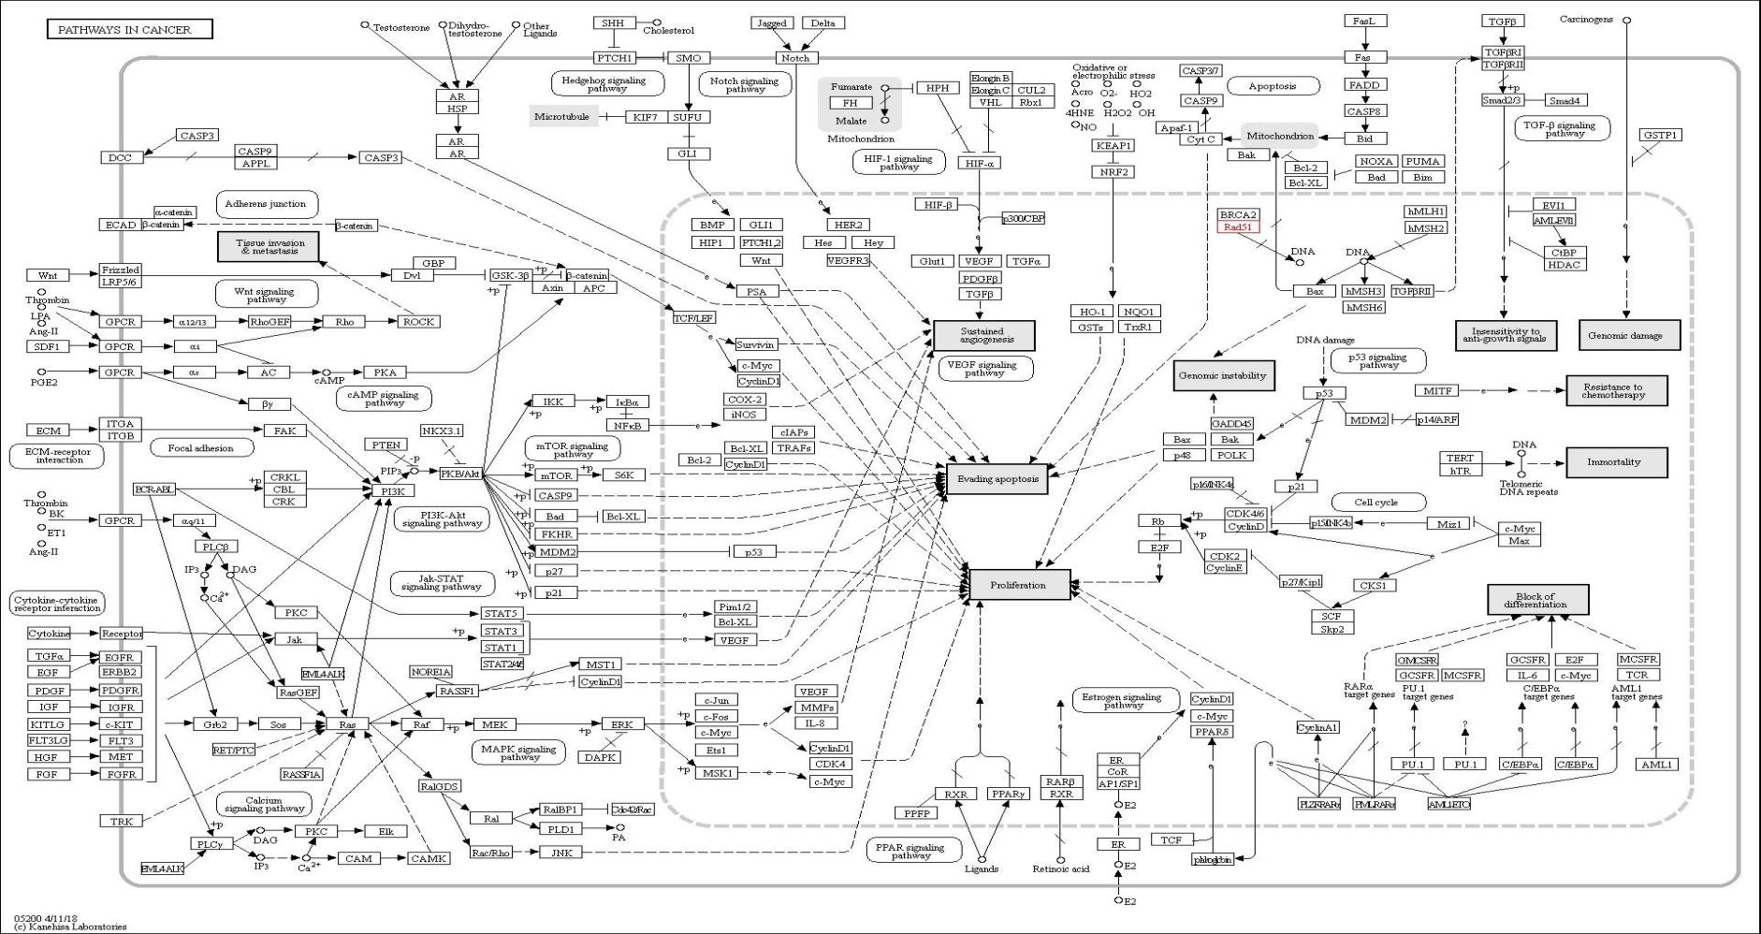damaged DNA
IM
Ras、PI3K等信号通路

