Fig. S1 Conserved domain analysis of VviTLPs in grapevine

Fig. S2 Multiple sequence alignment of VviTLP proteins in grapevine.

Fig. S3 Expression patterns of VviTLPs during developmental and ripening berry in grapevine. The transcriptional levels of VviTLPs during developmental and ripening berry were investigated based on the mean expression value of each gene in a public transcriptome data (Zhang et al. 2022). TH: Tonghua-3, TW: Tangwei, G: green hard, V: véraison, R: ripe stages.
Fig. S4 Expression profiles of four TLP genes under cold stress conditions. The grapevine ACTIN1 (Vitvi04g01613.t01) gene was used as an internal control to normalize expression levels. Data are shown as means ± SE from three biological replicates. Letters indicate significant differences in gene expression using one-way analysis of variance (ANOVA), followed by Duncan’s multiple range test (P < 0.05).

Fig. S5 Alignment of the coding sequences of five cloned TLP genes form Vitis amurensis ‘Shuangyou’.

Fig. S6 Identification of VamTLP1 transiently transformed grapevine. a DNA detection of wild-type (WT) ‘Chardonnay’ and overexpression lines (OE#1, OE#2, OE#3 and OE#4). b The expression of VamTLP1 in grapevine was detected by Real-Time Quantitative PCR (RT-qPCR).

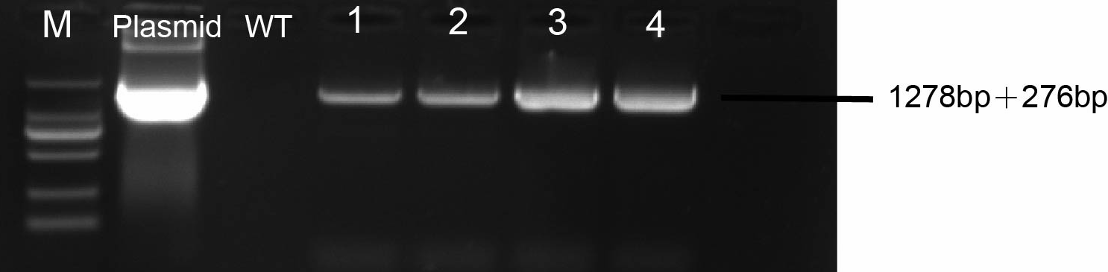

Fig.s7 OE-VaTLP1 transgenic calli assay. DNA detection of wild-type (WT) ‘Chardonnay’ and overexpression Calli.

