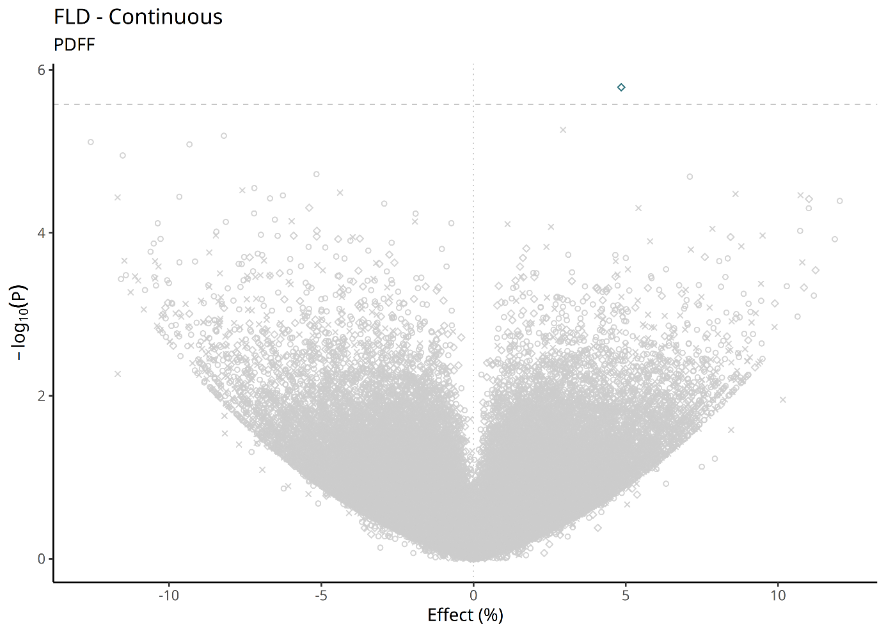
  - Extended Data Fig. 1. Gene-based burden test results for liver PDFF.
Volcano plot showing association results for liver PDFF. For each gene–phenotype association, the plotted point corresponds to the most significant combination of allele-frequency threshold, variant mask, and sex-specific analysis.
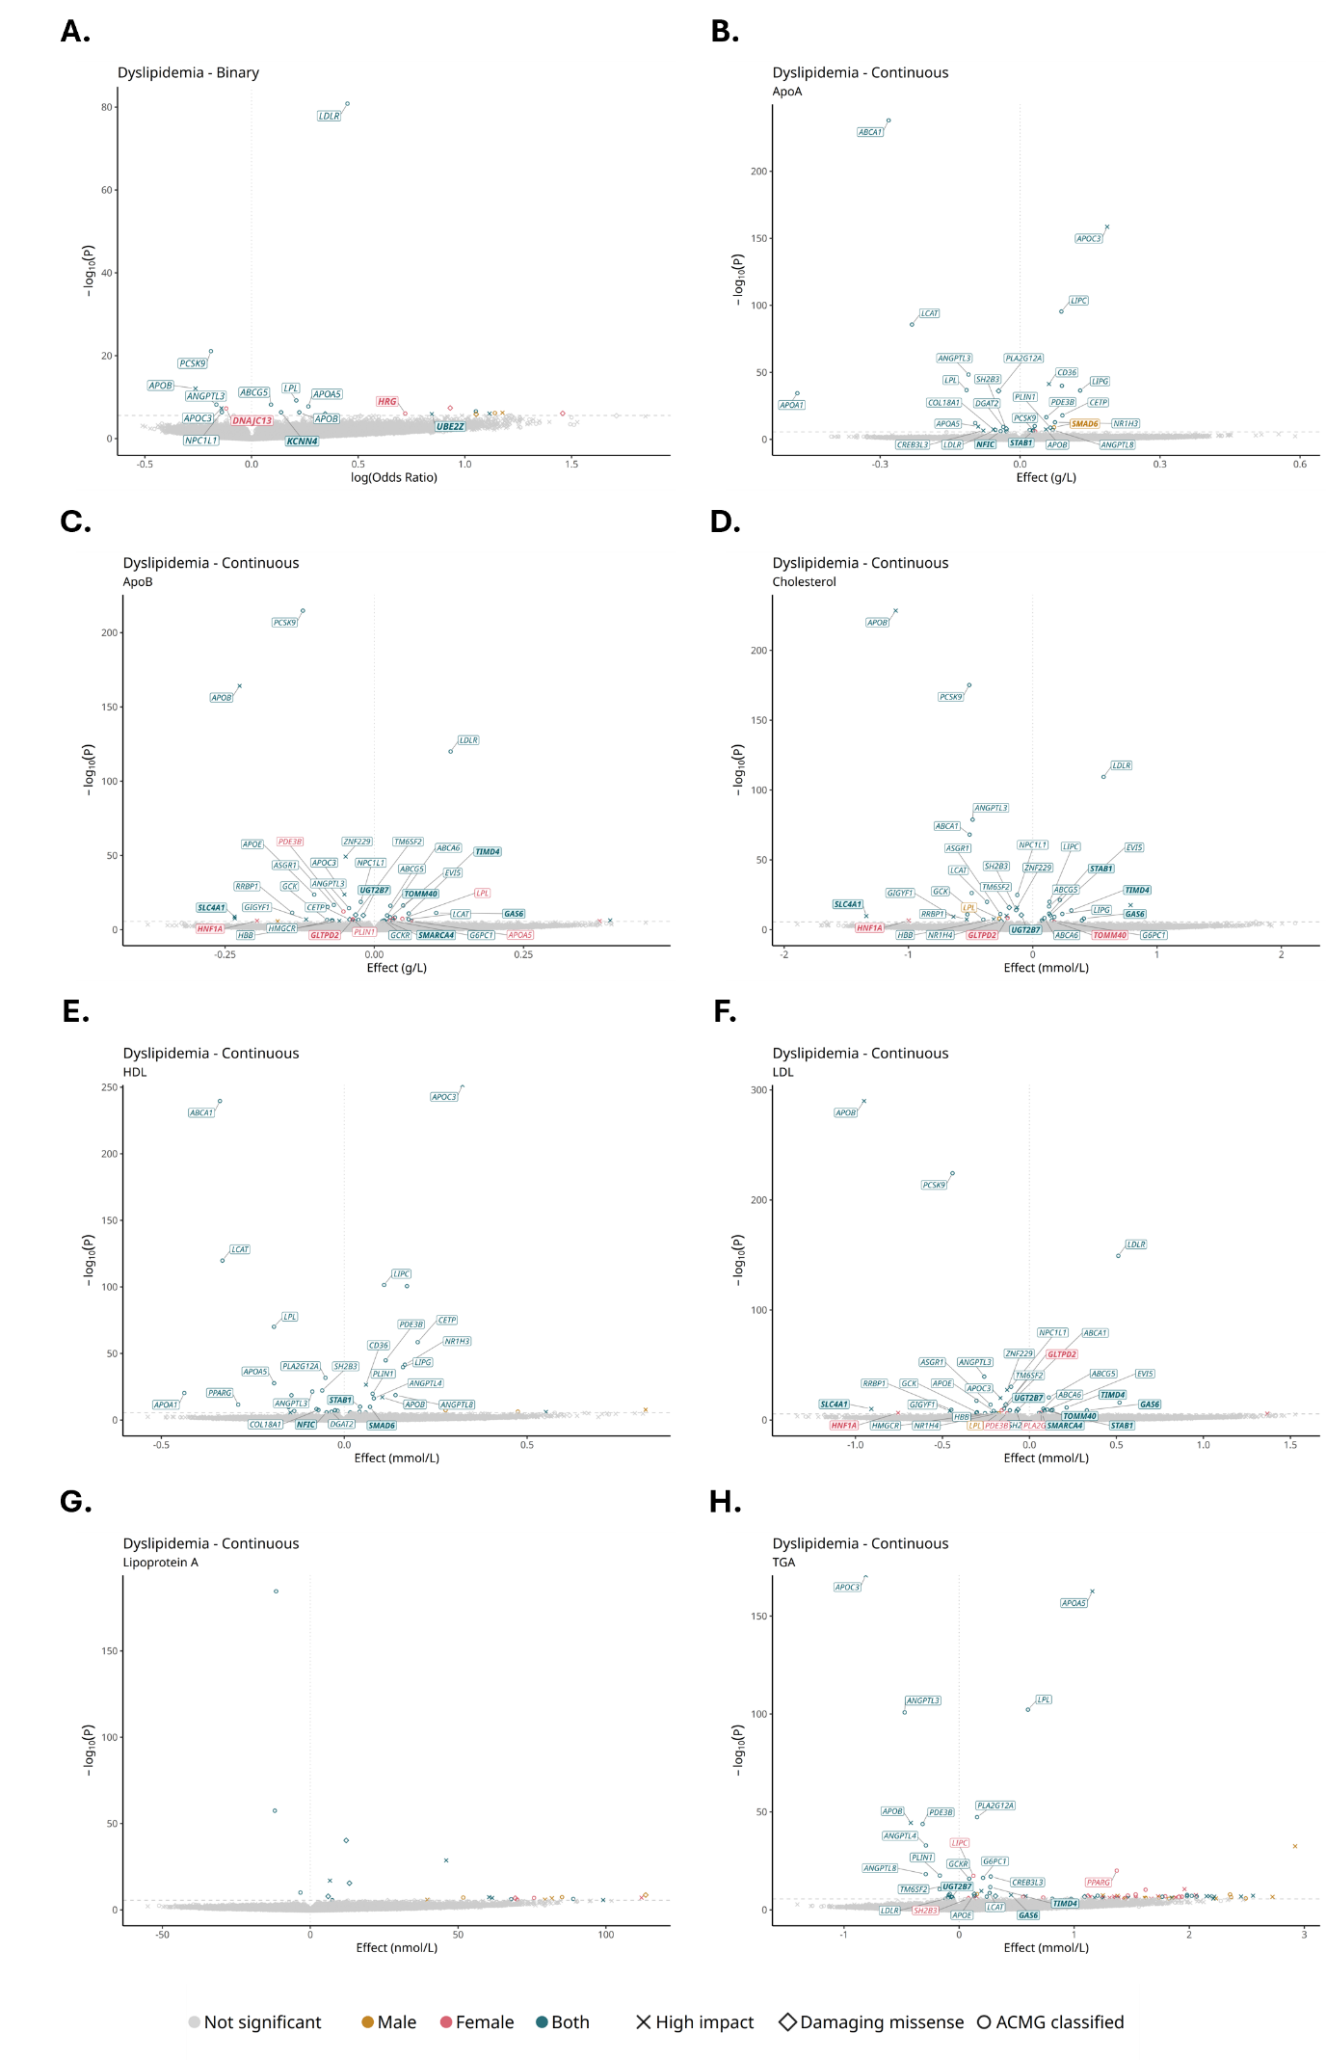
  - Extended Data Fig. 2. Gene-based burden test results for dyslipidemia traits.
Volcano plots show association results for (A) binary dyslipidemia, (B) apolipoprotein A, (C) apolipoprotein B, (D) total cholesterol, (E) HDL cholesterol, (F) LDL cholesterol, (G) lipoprotein(a), and (H) triglycerides. Known dyslipidemia-related genes and novel genes with supporting evidence are labelled. Novel genes are shown in bold and highlighted with boxed labels. For each gene–phenotype association, the plotted point corresponds to the most significant combination of allele-frequency threshold, variant mask, and sex-specific analysis.
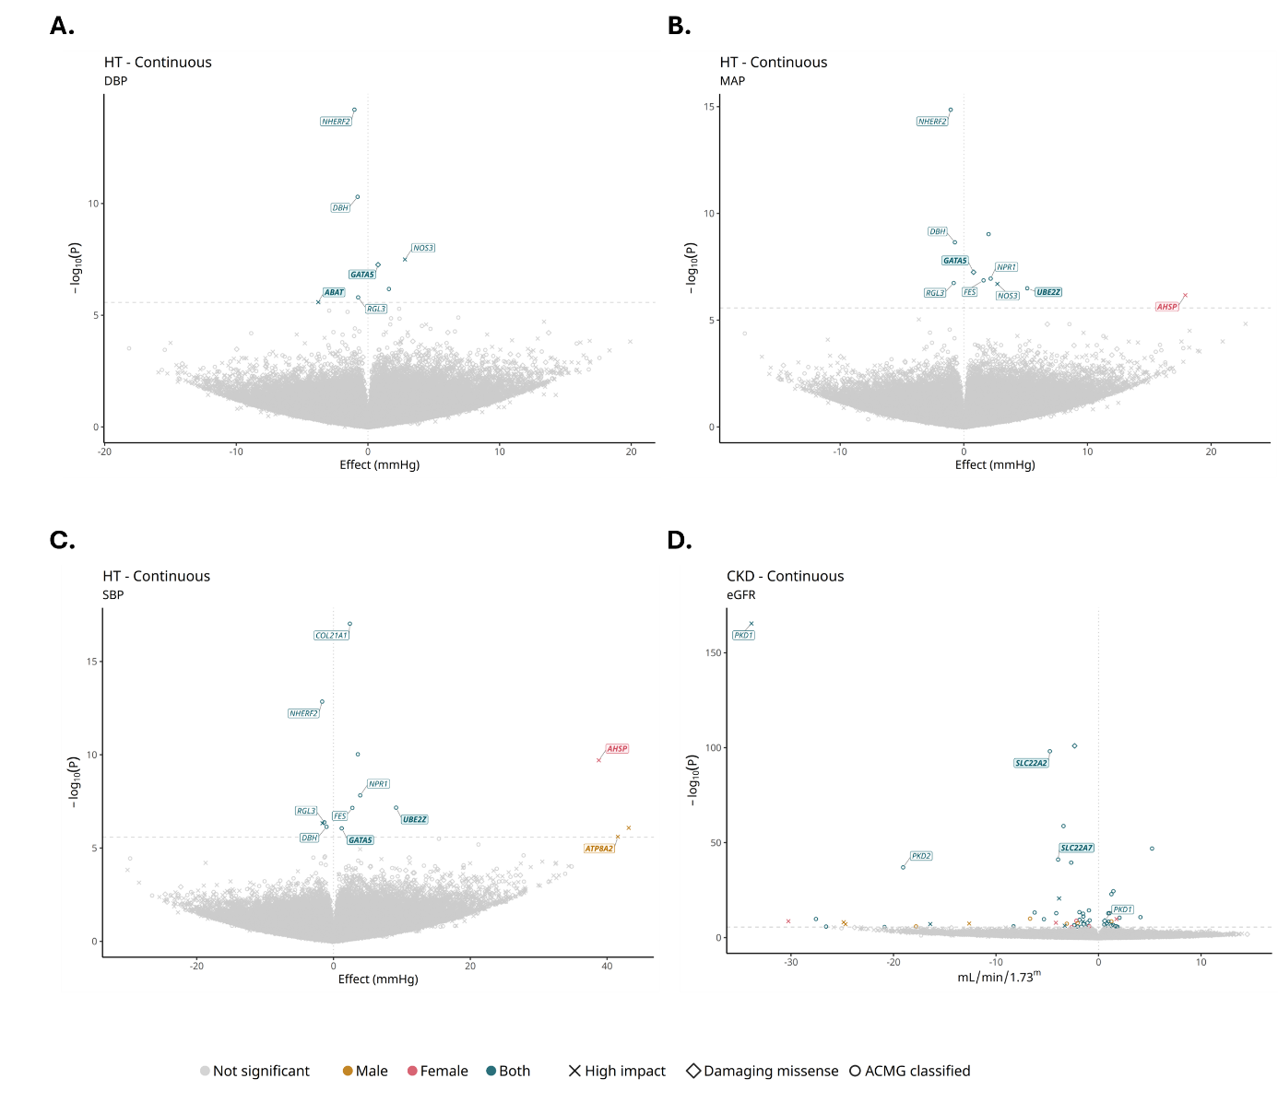

  - Extended Data Fig. 3. Gene-based burden test results for blood pressure and kidney function traits.
Volcano plots show association results for (A) diastolic blood pressure, (B) mean arterial pressure, (C) systolic blood pressure, and (D) estimated glomerular filtration rate. Known hypertension- and chronic kidney disease-related genes and novel genes with supporting evidence are labelled. Novel genes are shown in bold and highlighted with boxed labels. For each gene–phenotype association, the plotted point corresponds to the most significant combination of allele-frequency threshold, variant mask, and sex-specific analysis.

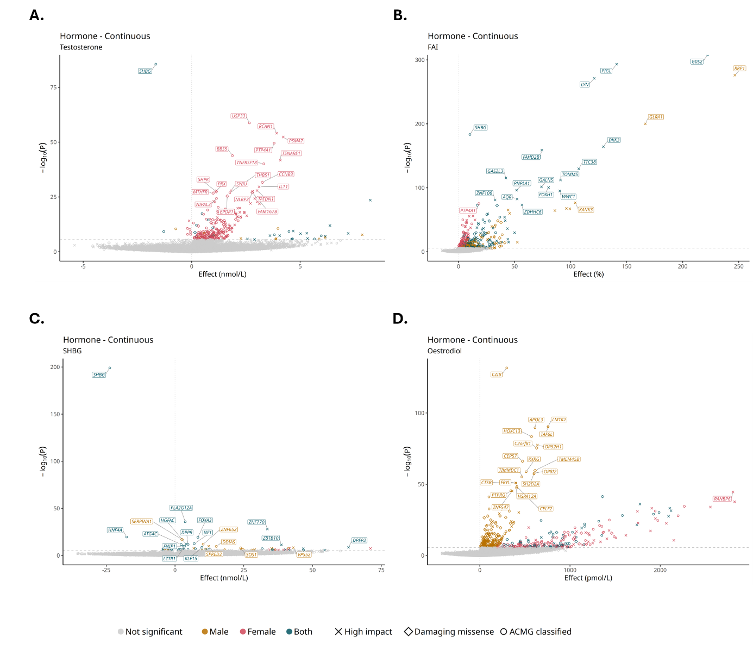
  - Extended Data Fig. 4. Gene-based burden test results for sex-hormone traits.
Volcano plots show association results for (A) testosterone, (B) free androgen index, (C) sex hormone-binding globulin, and (D) oestradiol levels. For each gene–phenotype association, the plotted point corresponds to the most significant combination of allele-frequency threshold, variant mask, and sex-specific analysis.

