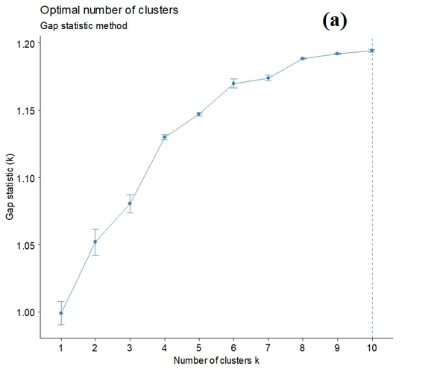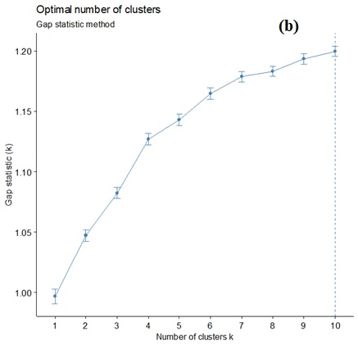

Figure S1. The Optimal number of clusters using Gap Statistic method: a) Hierarchical clustering, b) k-means clustering.

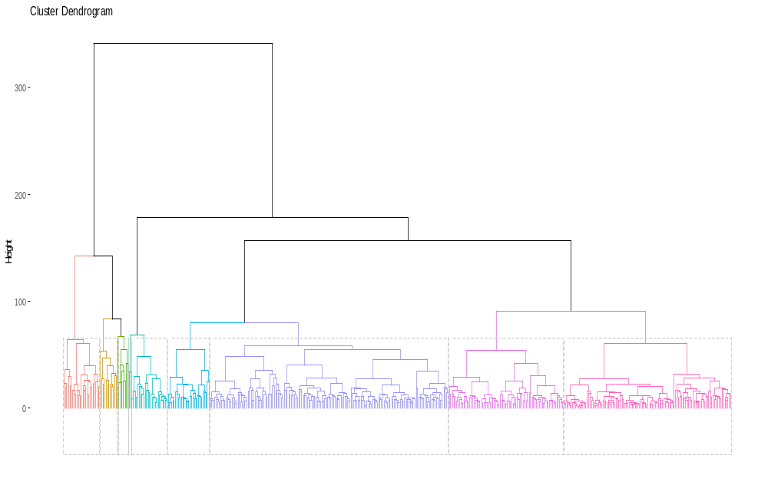

Figure S2. Cluster dendrogram of the 461 stations according to Ward’s method-Euclidean distance shows ten precipitation zones.

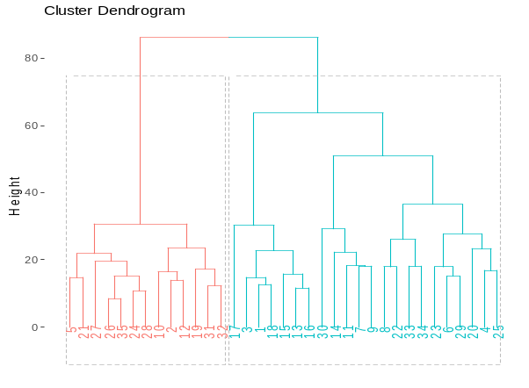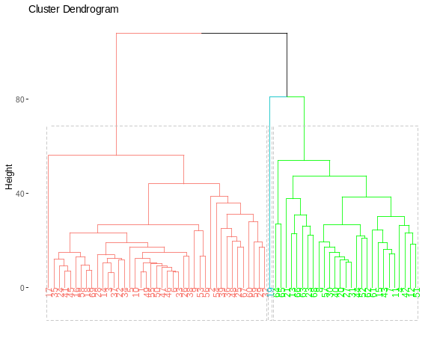
B
C
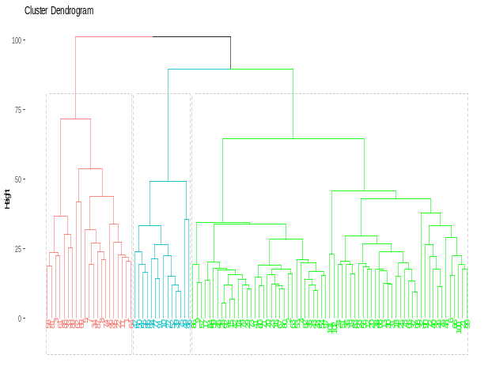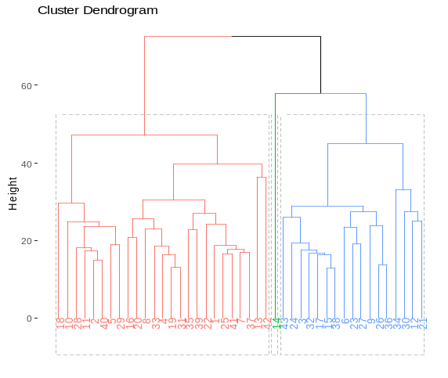
E
D
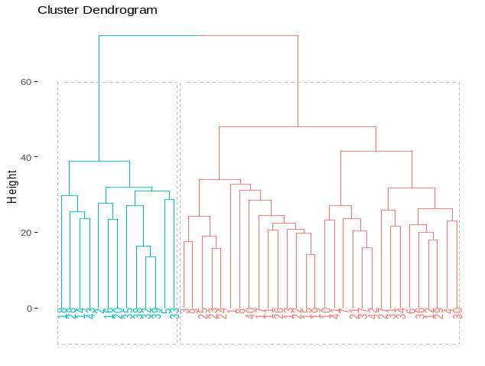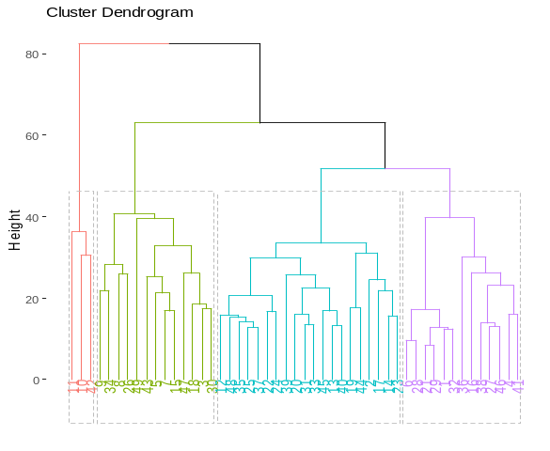
G
F

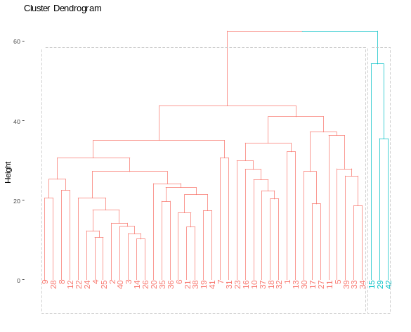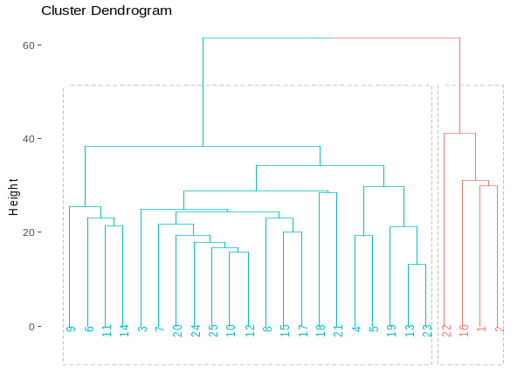
I
H
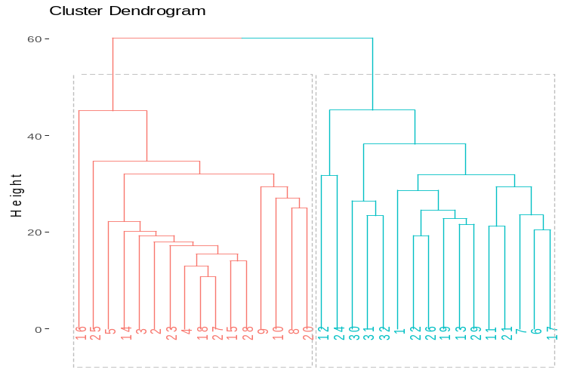
J

Figure S3. Cluster dendrograms for zone B to J.

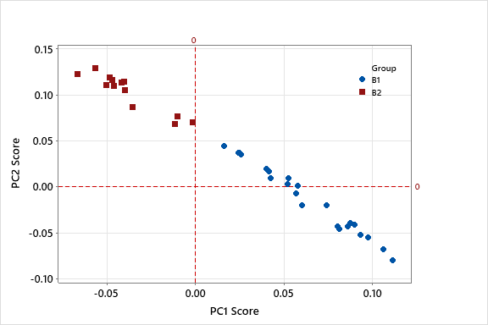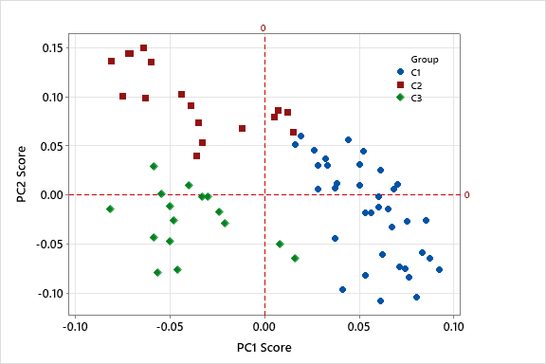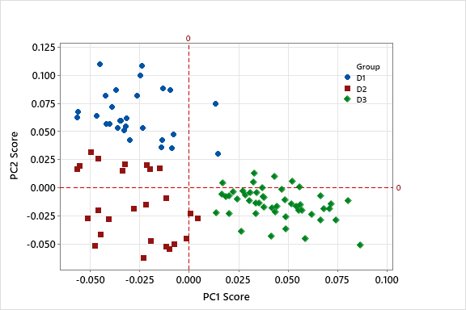
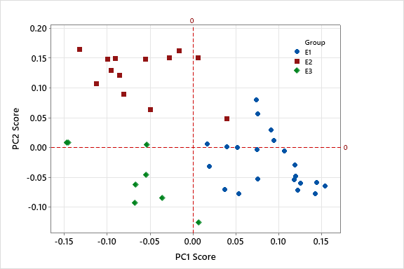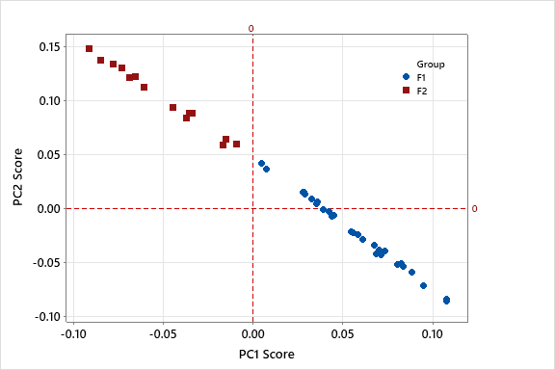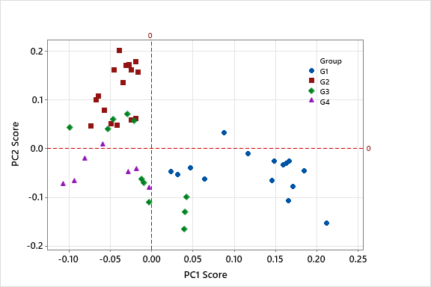
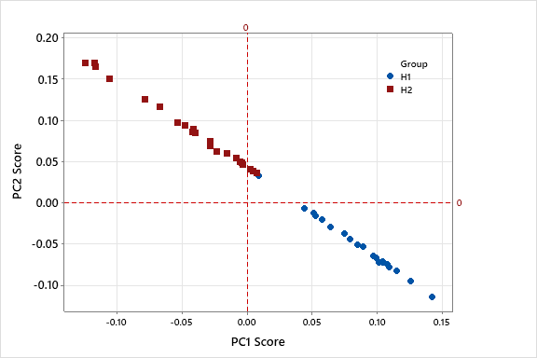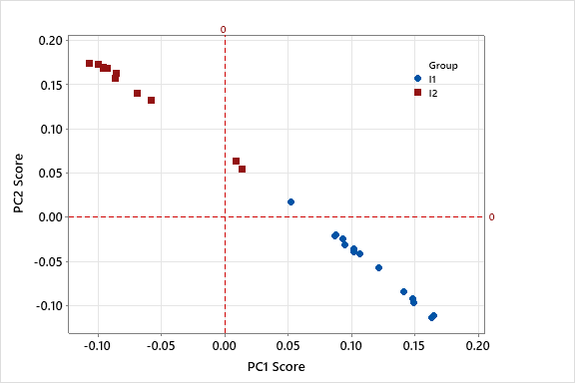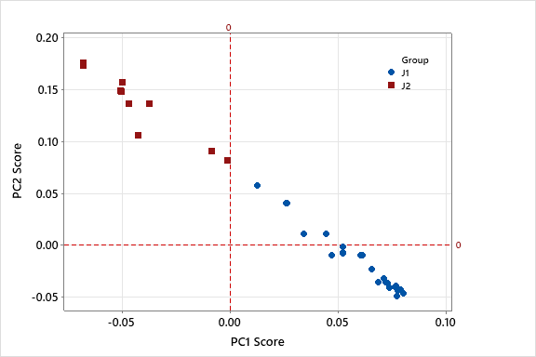

Figure S4. Score plots of PC1 vs PC2 for nine meso-precipitation zones (B to J).

Table S1. The optimal number of clusters in ten meso-climatological zones defined by various statistical indices.

Zone | K-Means Clustering | Hierarchical Clustering | Optimal Number of Cluster
A | Gap Statistic, Frey index | Gap Statistic, Frey index | 1
B | Cindex, Gap index, Mcclain index | Ch index, Gap index, Mcclain index | 2
C | Gap Statistic, Elbow, Kl index, Hartigan index, Ratkowsky index, Ball index, Hurbert, Dindex | Elbow, Hartigan index, Duda index, Pseudot2 index, Ratkowsky index, beale index, Ball index, Mcclain index, Hurbert, Dindex | 3
D | Cindex, Ratkowsky index, Ball index, Sdindex, Hurbert | Kl index, Hartigan index, Cindex, Ball index, Sdindex, Dindex | 3
E | Elbow, Cindex, Ball index, Frey index | Hartigan index, Ball index, Sdindex, Sdbw index, Hurbert, Dindex | 3
F | Silhouette, Kl index, Ch index, Duda index, Pseudot2 index, beale index, Gap index, Mcclain index, Tau index | Gap Statistic, Silhouette, Kl index, Ch index, beale index, Ptbiserial index, Gap index, Frey index, Gamma index, Tau index, Sdindex | 2
G | Kl index, Hartigan index, Ratkowsky index, Dunn index, Dindex | Cindex, Ratkowsky index, Sdbw index, Dindex | 4
H | Silhouette, Ch index, Cindex, Ptbiserial index, Gap index, Frey index, Mcclain index, Gamma index, Gplus index, Dunn index | Silhouette, Ch index, Cindex, Duda index, Pseudot2 index, Gap index, Mcclain index | 2
I | Silhouette, Kl index, Ch index, Duda index, Pseudot2 index, beale index, Ptbiserial index, Gap index, Mcclain index, Gamma index, Gplus index, Tau index, Dunn index | Silhouette, Kl index, Ch index, Cindex, Duda index, Pseudot2 index, beale index, Gap index, Mcclain index | 2
J | Gap Statistic, Silhouette, Kl index, Ch index, Cindex, Gap index | Kl index, Ch index, Gap index, Mcclain index | 2

Table S2. KMO and Bartlett's Test.
Zone |  | A | B | C | D | E | F | G | H | I | J
Kaiser-Meyer-Olkin Measure of Sampling Adequacy. |  | 0.963 | 0.964 | 0.979 | 0.984 | 0.978 | 0.978 | 0.977 | 0.976 | 0.970 | 0.957
Bartlett's Test of Sphericity | Approx. Chi-Square | 11230 | 16246 | 61794 | 75439 | 43988 | 23256 | 29952 | 28404 | 14831 | 15322
Bartlett's Test of Sphericity | df | 190 | 595 | 2346 | 5151 | 903 | 903 | 1176 | 861 | 300 | 528
Bartlett's Test of Sphericity | Sig. | 0.0001 | 0.0001 | 0.0001 | 0.0001 | 0.0001 | 0.0001 | 0.0001 | 0.0001 | 0.0001 | 0.0001

Table S3. Eigenvalues, % of the variance and % of the cumulative variance of different components in the non-rotational and rotational states.
Zone | Component | Initial Eigenvalues |  |  | Extraction Sums of Squared Loadings |  |  | Rotation Sums of Squared Loadings
Zone | No. | Total | % of Variance | Cumulative % | Total | % of Variance | Cumulative % | Total | % of Variance | Cumulative %
Zone A | 1 | 15 | 72 | 72 | 15 | 72 | 72 | - | - | -
Zone B | 1 | 19 | 54 | 54 | 19 | 54 | 54 | 13 | 37 | 37
Zone B | 2 | 4 | 11 | 65 | 4 | 11 | 65 | 10 | 27 | 65
Zone C | 1 | 54 | 78 | 78 | 54 | 78 | 78 | 25 | 37 | 37
Zone C | 2 | 3 | 4 | 82 | 3 | 4 | 82 | 18 | 27 | 63
Zone C | 3 | 2 | 3 | 85 | 2 | 3 | 85 | 15 | 22 | 85
Zone D | 1 | 73 | 72 | 72 | 73 | 72 | 72 | 32 | 31 | 31
Zone D | 2 | 4 | 4 | 76 | 4 | 4 | 76 | 26 | 25 | 56
Zone D | 3 | 4 | 3 | 79 | 4 | 3 | 79 | 24 | 23 | 79
Zone E | 1 | 36 | 83 | 83 | 36 | 83 | 83 | 15 | 36 | 36
Zone E | 2 | 2 | 5 | 88 | 2 | 5 | 88 | 14 | 32 | 67
Zone E | 3 | 2 | 4 | 92 | 2 | 4 | 92 | 10 | 24 | 92
Zone F | 1 | 29 | 66 | 66 | 29 | 66 | 66 | 18 | 42 | 42
Zone F | 2 | 3 | 7 | 73 | 3 | 7 | 73 | 13 | 31 | 73
Zone G | 1 | 33 | 67 | 67 | 33 | 67 | 67 | 11 | 23 | 23
Zone G | 2 | 3 | 7 | 74 | 3 | 7 | 74 | 11 | 22 | 46
Zone G | 3 | 2 | 4 | 78 | 2 | 4 | 78 | 10 | 21 | 66
Zone G | 4 | 1 | 2 | 80 | 1 | 2 | 80 | 7 | 14 | 80
Zone H | 1 | 31 | 73 | 73 | 31 | 73 | 73 | 18 | 42 | 42
Zone H | 2 | 2 | 5 | 78 | 2 | 5 | 78 | 15 | 36 | 78
Zone I | 1 | 18 | 72 | 72 | 18 | 72 | 72 | 11 | 42 | 42
Zone I | 2 | 2 | 8 | 80 | 2 | 8 | 80 | 10 | 38 | 80
Zone J | 1 | 18 | 56 | 56 | 18 | 56 | 56 | 15 | 44 | 44
Zone J | 2 | 4 | 11 | 67 | 4 | 11 | 67 | 7 | 23 | 67

