Supplemental Figures 1-10

The First Genome Assemblies of Blackflies (genus Simulium): Exploring Genomic Diversity across Africa
Neha Sirwaniª, Emily Hendrickson^{a,b}, Millicent Opoku^{a,c}, Sindew M. Feleke^{a,d}, Samson Otoo^{c}, Gemechu T Leta^{d}, Geremew Tasew^{d}, Tesfahun Bishaw^{e}, Getachew Tollera^{d}, Anusha Kodeª, Millicent Selassie Afatodzie^{c}, Kwadwo Kyereme Frempong^{c}, Daniel A. Boakye^{c,g}, Shannon M Hedtke^{a,e*+}, Warwick N Grant^{a+}
a - Department of Environment and Genetics, La Trobe University, Bundoora, Victoria, Australia
b – Current affiliation: Department of Cell and Developmental Biology, School of Biological Sciences, University of California San Diego, La Jolla, California, USA
c - Department of Parasitology, Noguchi Memorial Institute for Medical Research, College of Health Sciences, University of Ghana, Accra, Ghana
d - Ethiopian Public Health Institute (EPHI), Adis Ababa, Ethiopia
e - La Trobe Institute for Molecular Sciences, La Trobe University, Bundoora, Victoria, Australia
f - The End Fund, New York, USA
g – Federal Ministry of Health (FMoH), NTDs Program, Addis Ababa, Ethiopia
* Corresponding author: Shannon M Hedtke, S.Hedtke@latrobe.edu.au
+ contributed equally

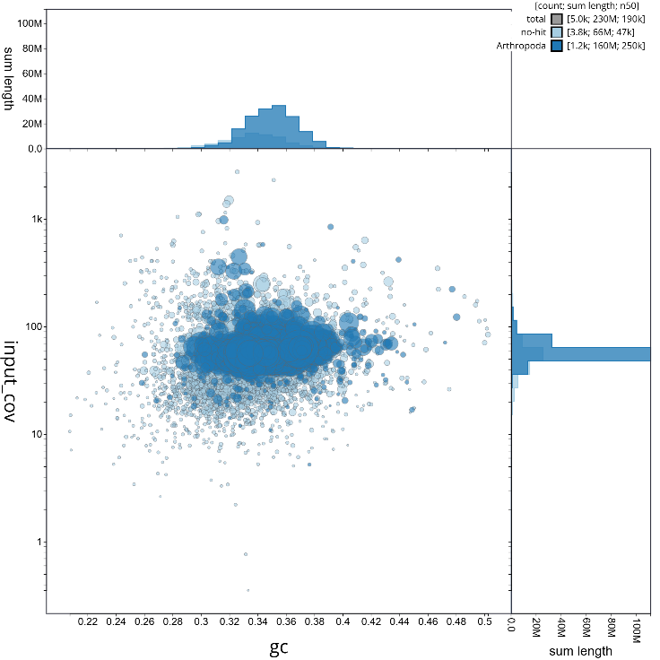
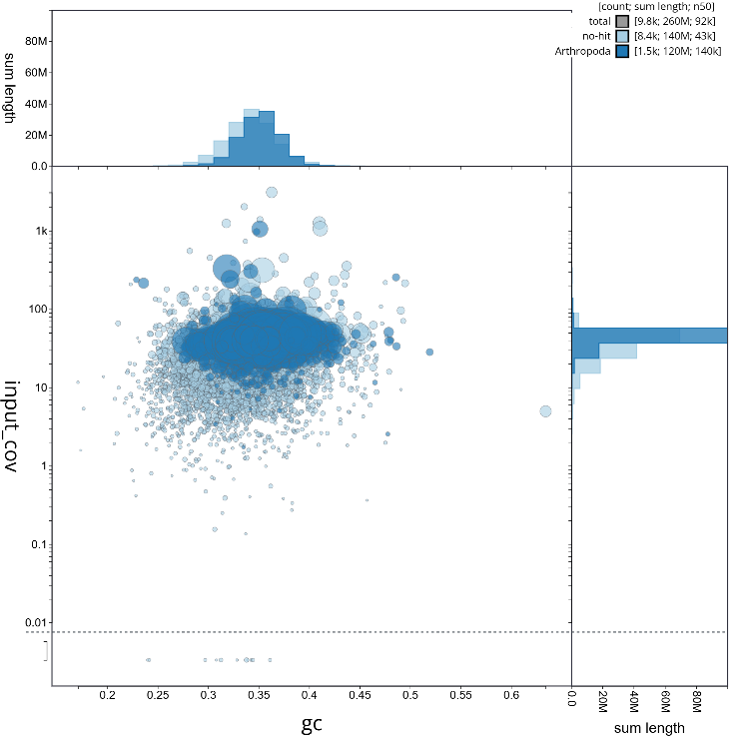
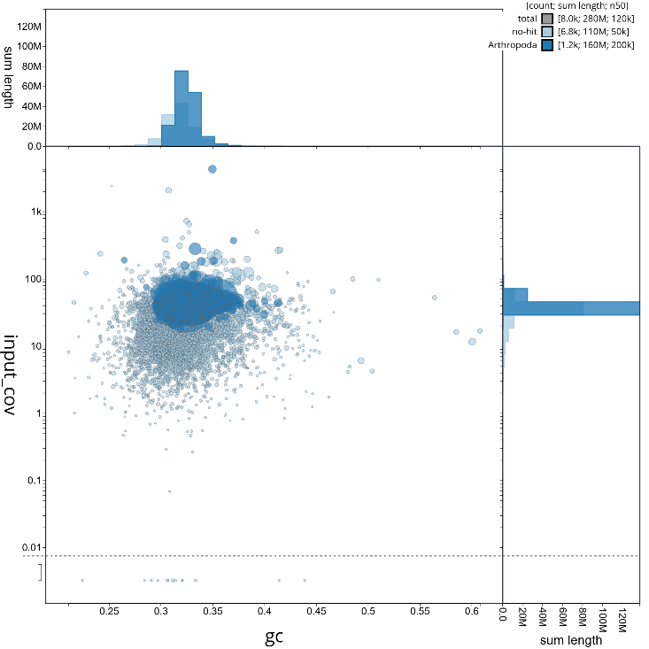
Supplemental Figures

Supplementary Figure 1: Blob plot of base coverage in input against GC proportion for sequences in assembly A) S. damnosum Ethiopia B) S. damnosum Ghana C) S. neavei Ethiopia. Sequences are coloured by phylum. Circles are sized in proportion to sequence length on a square-root scale, ranging from A) 367 to 1,413,847 B) 454 to 563,121. C) 506 to 1,255,581. Histograms show the distribution of sequence length sum along each axis.
A
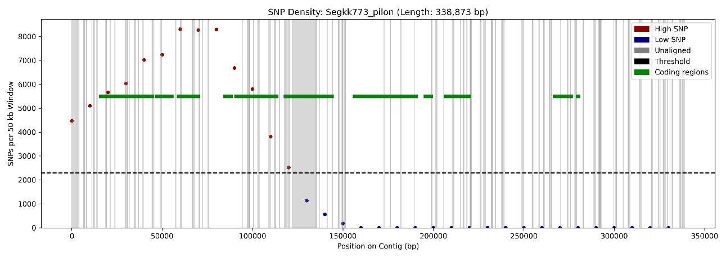
A
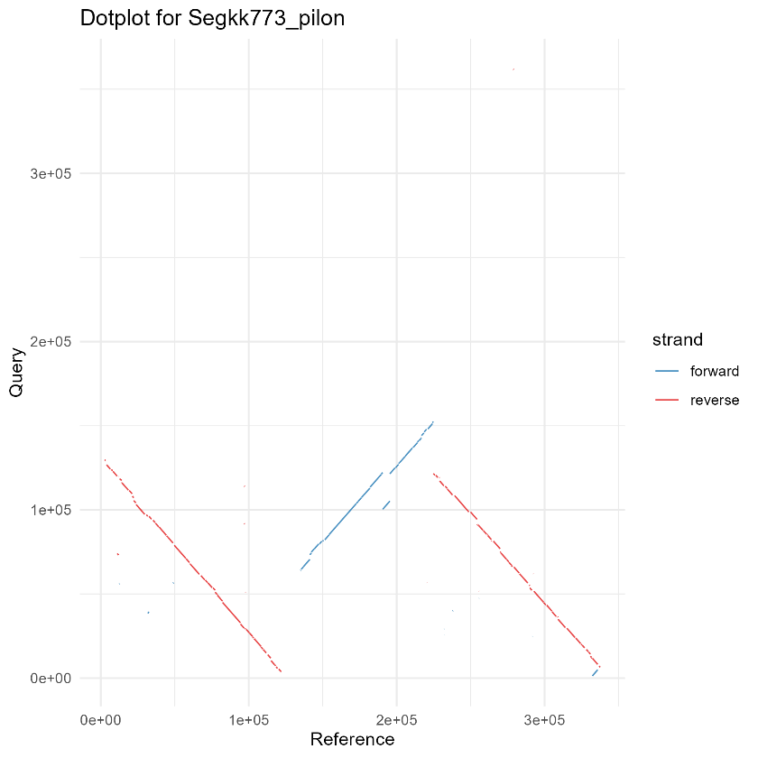
B
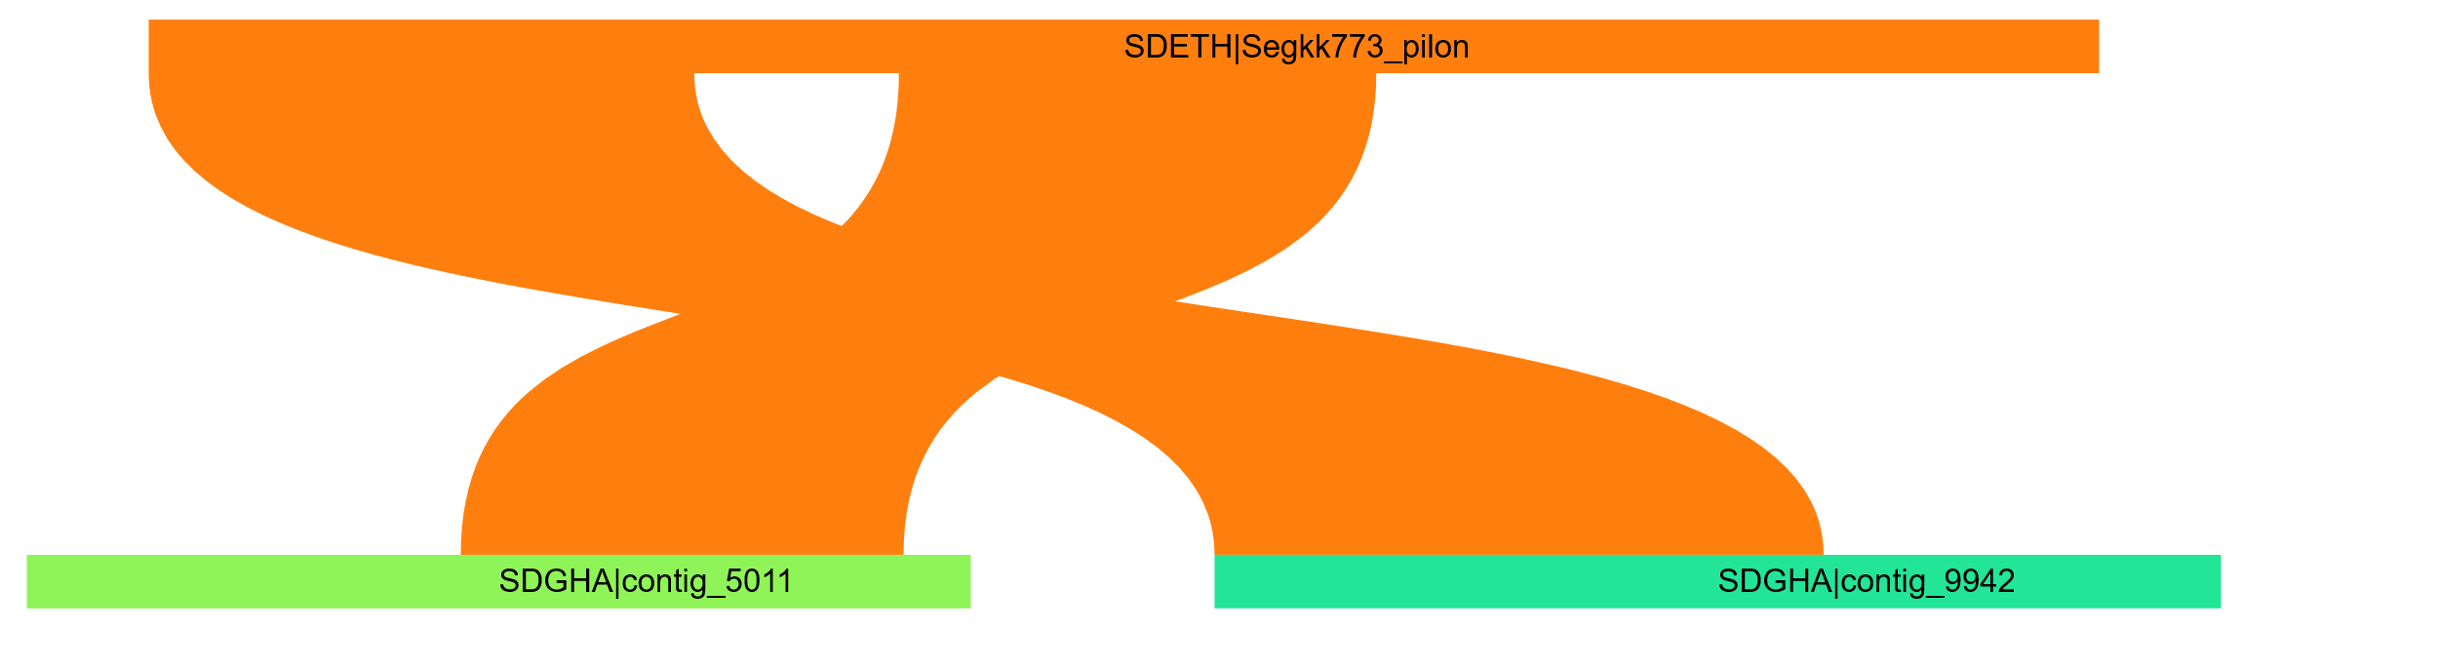
C
Supplementary Figure 2: Alignment between high single nucleotide variation reference (Ethiopian S. damnosum) contig 773 with query contig 5011 and contig 9942 (Ghanaian S. damnosum): A) Alignment plot with each dot represents cumulative variation in 50 kb window, with a sliding step of 10 kb. The red dots indicate regions of high genetic variation above the threshold (green dash line) and green lines indicate coding regions. The grey vertical lines indicate unaligned regions. B) Dot plot indicating reverse alignment of the two contigs. C) Sankey diagram indicating regions of high collinearity between the two contigs.

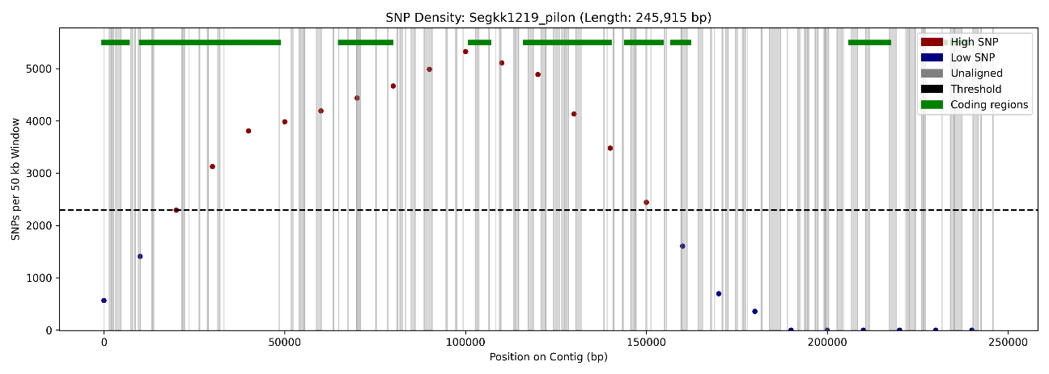
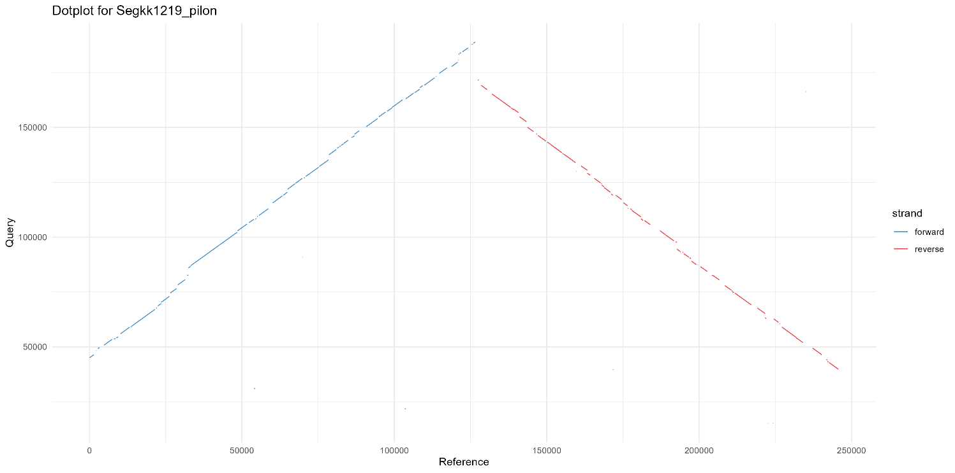

Supplementary Figure 3: Alignment between high single nucleotide variation reference (Ethiopian S. damnosum) contig 1219 with query contig 588 and contig 8733 (Ghanaian S. damnosum): A) Alignment plot with each dot represents cumulative variation in 50 kb window, with a sliding step of 10 kb. The red dots indicate regions of high genetic variation above the threshold (green dash line) and green lines indicate coding regions. The grey vertical lines indicate unaligned regions. B) Dot plot indicating forward alignment of contig 588 and reverse alignment of contig 8733. C) Sankey diagram indicating regions of high collinearity between the reference contig 1219 and query contig 588.
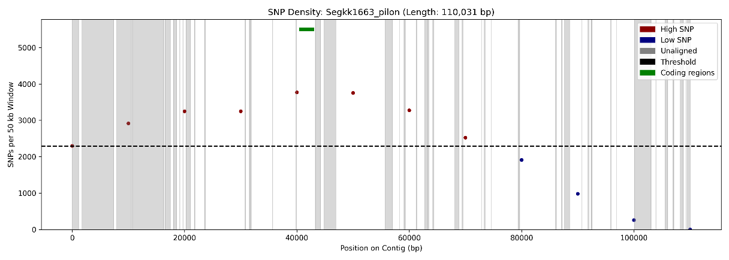
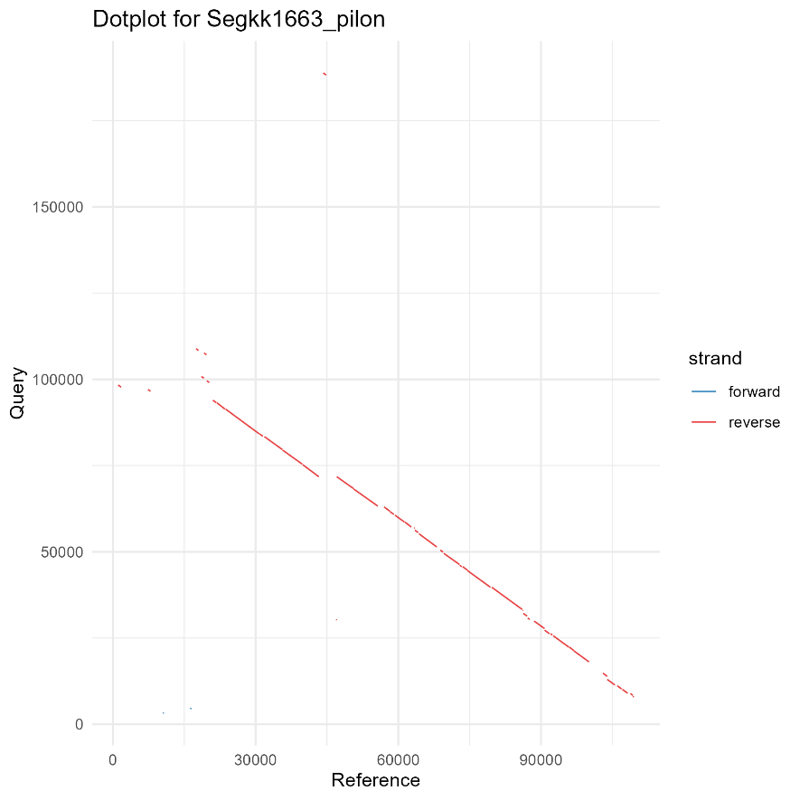
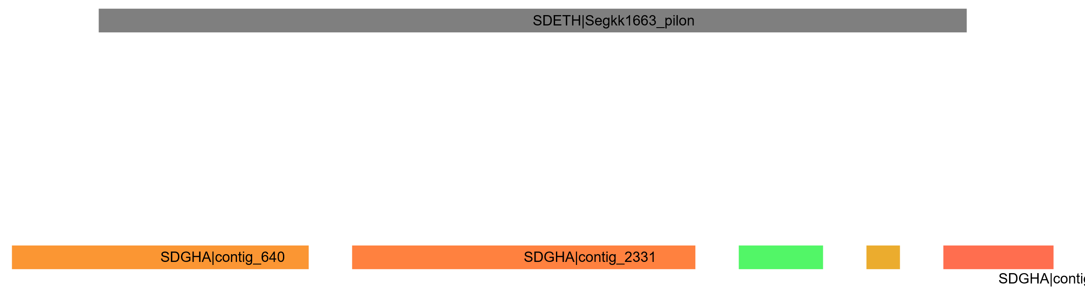
Supplementary Figure 4: Alignment between high single nucleotide variation reference (Ethiopian S. damnosum) contig 1663 with query contigs 10030, 640, 9760, 3202, and 2331 (Ghanaian S. damnosum): A) Alignment plot with each dot represents cumulative variation in 50 kb window, with a sliding step of 10 kb. The red dots indicate regions of high genetic variation above the threshold (green dash line) and green lines indicate coding regions. The grey vertical lines indicate unaligned regions. B) Dot plot indicating reverse alignment of contig 10030. C) Sankey diagram indicating no collinearity between the reference contig 1219 and query contigs 640, 2331, 9760, and 3202.

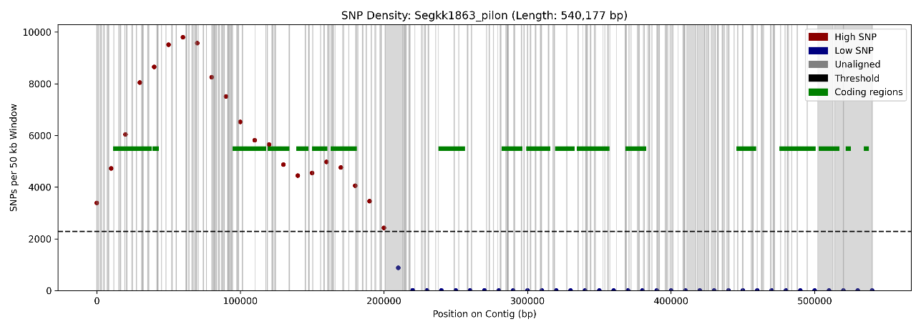
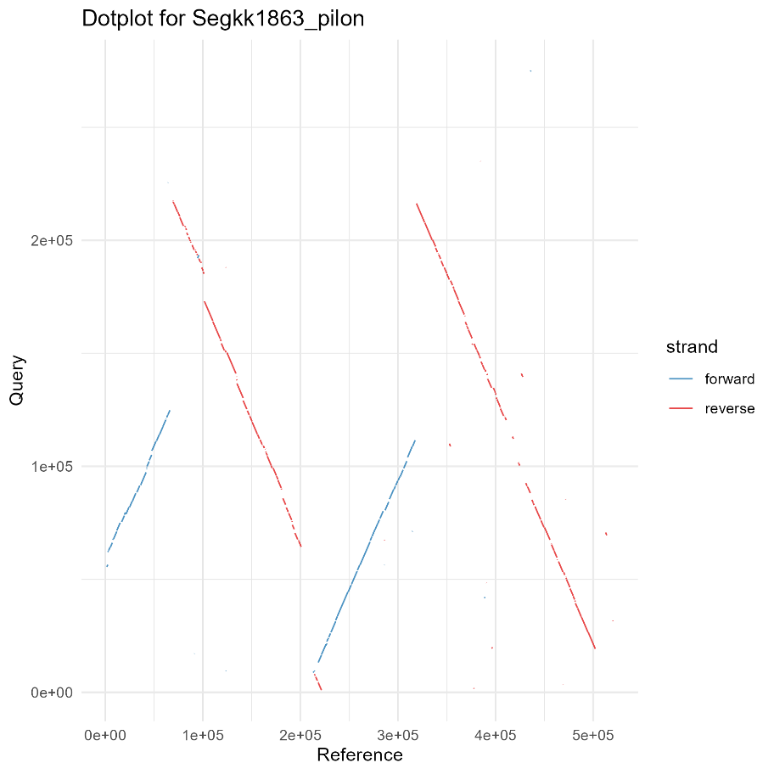
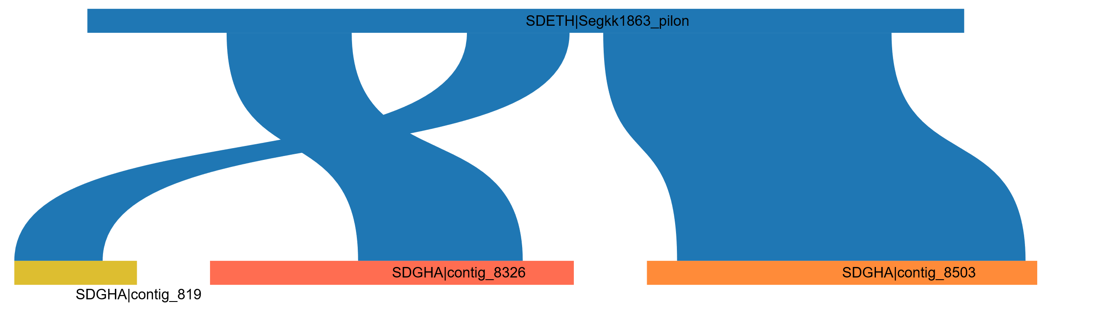
Supplementary Figure 5: Alignment between high single nucleotide variation reference (Ethiopian S. damnosum) contig 1863 with query contigs 8503, 8326, 819, and 6543 (Ghanaian S. damnosum): A) Alignment plot with each dot represents cumulative variation in 50 kb window, with a sliding step of 10 kb. The red dots indicate regions of high genetic variation above the threshold (green dash line) and green lines indicate coding regions. The grey vertical lines indicate unaligned regions. B) Dot plot indicating forward alignment of 6543, 819 and reverse alignment of contig, 8503 and 8326. C) Sankey diagram indicating no collinearity between the reference contig 1863 and query contigs 819, 8326, and 8503.

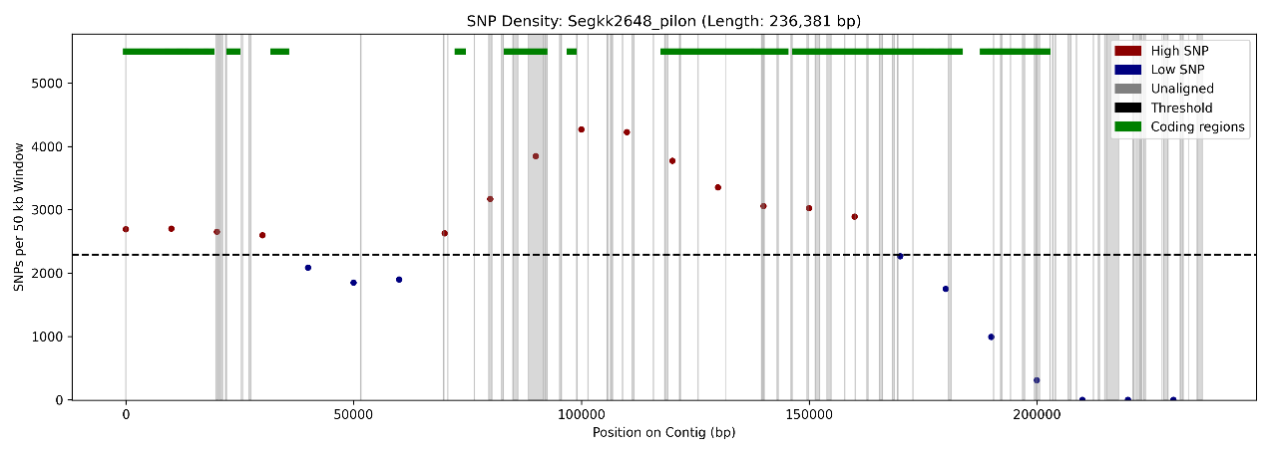
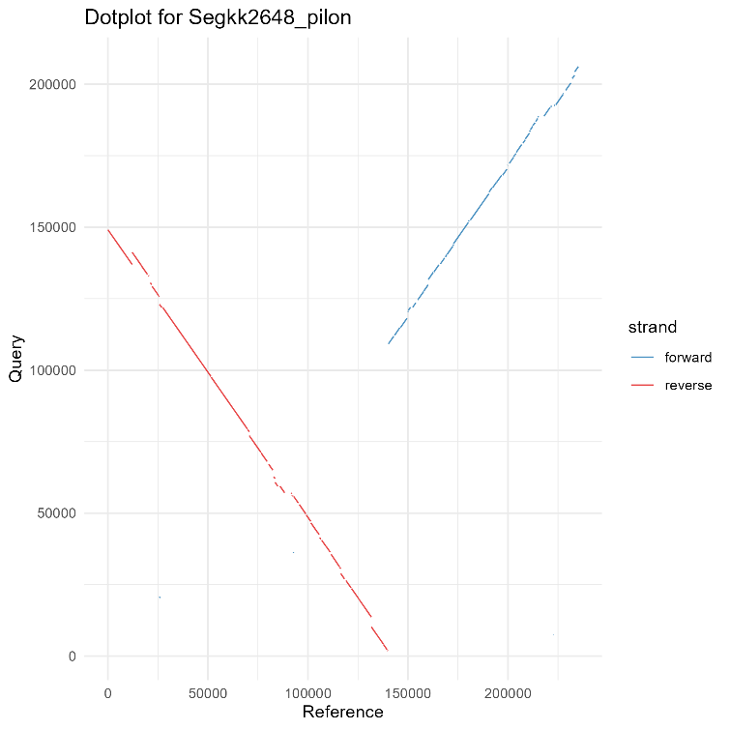

Supplementary Figure 6: Alignment between high single nucleotide variation reference (Ethiopian S. damnosum) contig 2648 with query contigs 1539 and 9828 (Ghanaian S. damnosum): A) Alignment plot with each dot represents cumulative variation in 50 kb window, with a sliding step of 10 kb. The red dots indicate regions of high genetic variation above the threshold (green dash line) and green lines indicate coding regions. The grey vertical lines indicate unaligned regions. B) Dot plot indicating reverse alignment of contig 1539 and forward alignment of contig 9828. C) Sankey diagram indicating regions of high collinearity between the reference contig 2648 and query contigs1539 and 9828.
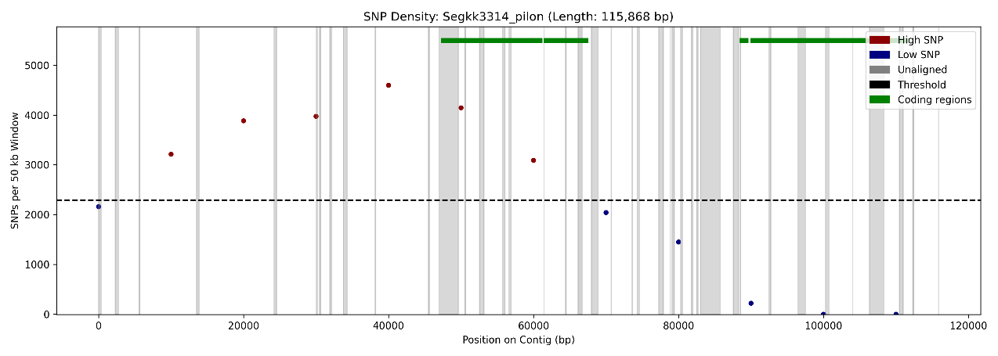
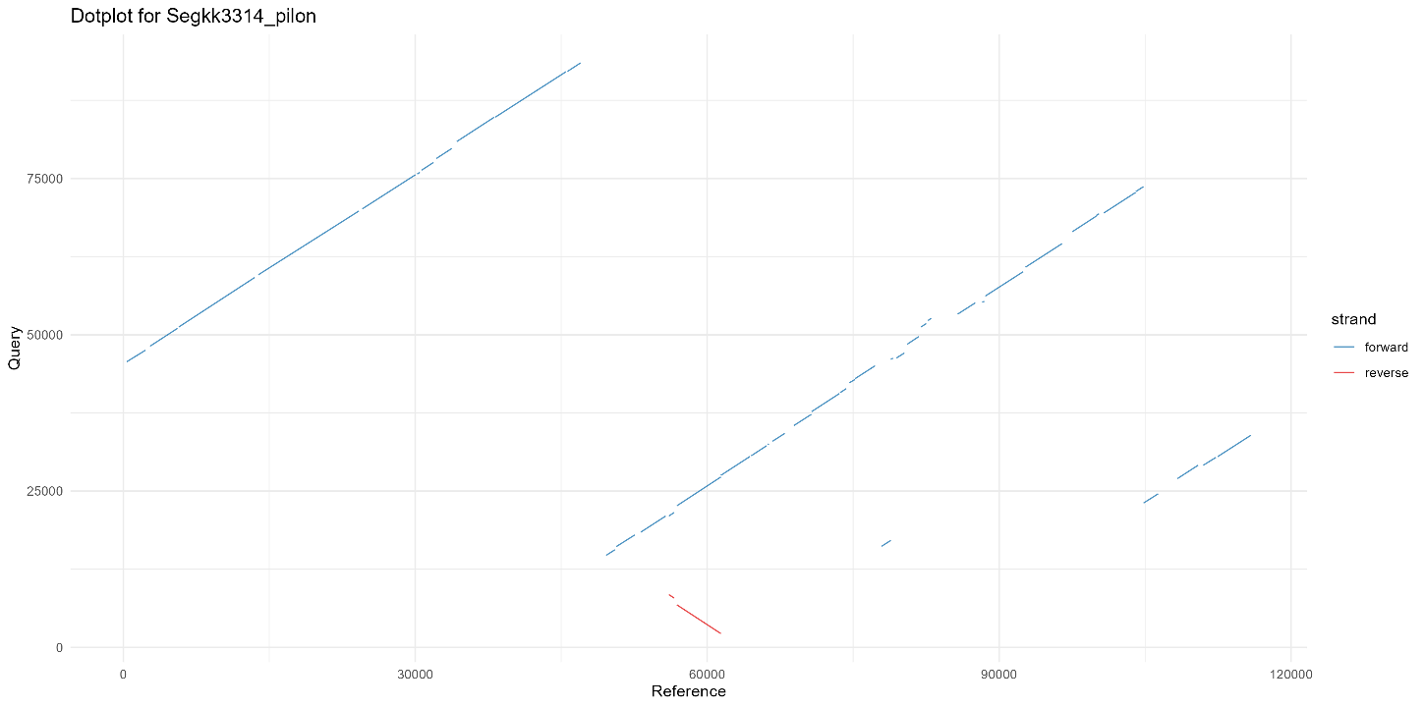
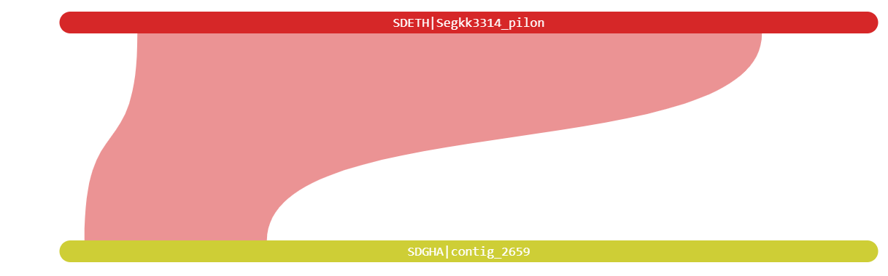
Supplementary Figure 7: Alignment between high single nucleotide variation reference (Ethiopian S. damnosum) contig 3314 with query contigs 2659, 1788, and 4675 (Ghanaian S. damnosum): A) Alignment plot with each dot represents cumulative variation in 50 kb window, with a sliding step of 10 kb. The red dots indicate regions of high genetic variation above the threshold (green dash line) and green lines indicate coding regions. The grey vertical lines indicate unaligned regions. B) Dot plot indicating reverse alignment of contig 1539 and forward alignment of contig 9828. C) Sankey diagram indicating regions of high collinearity between the reference contig 2648 and query contigs1539 and 9828.

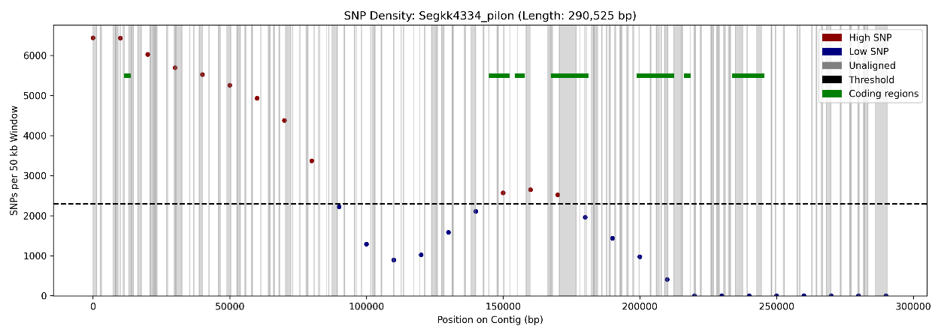
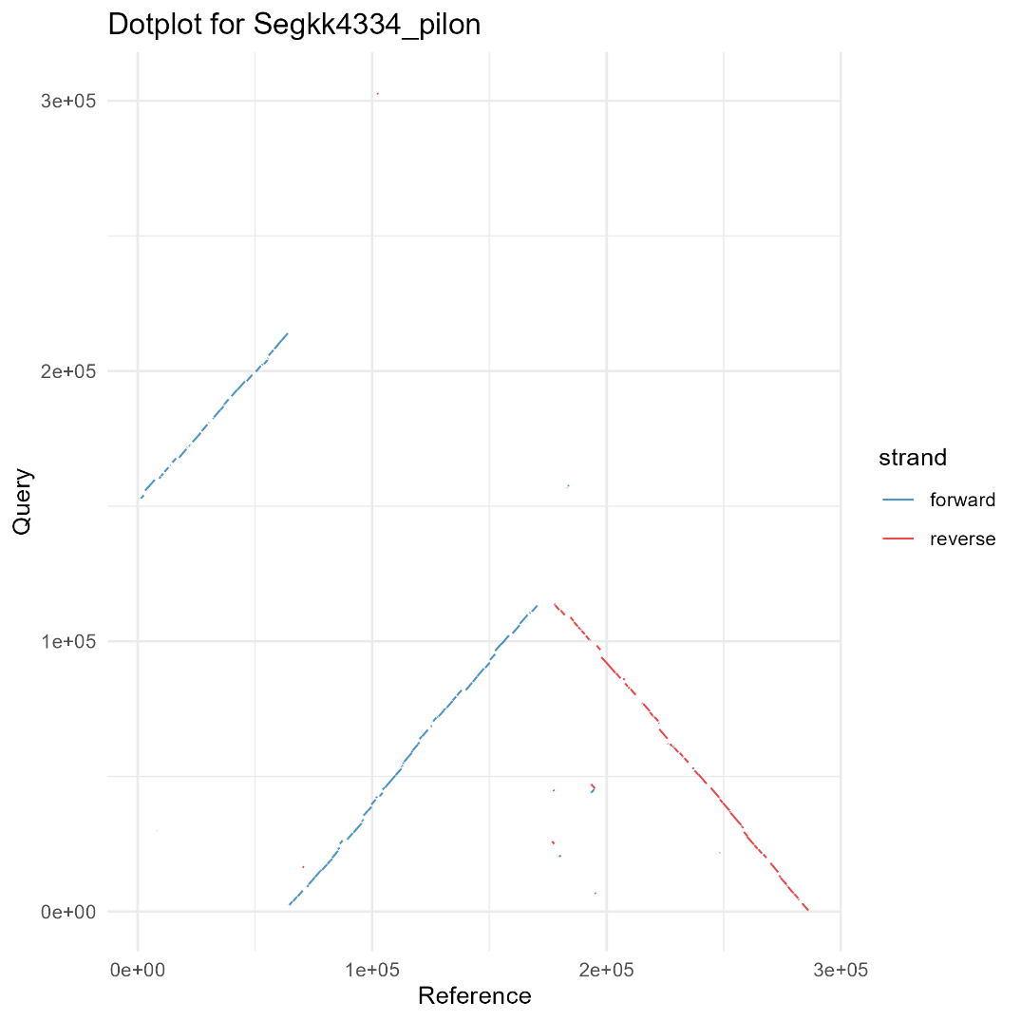
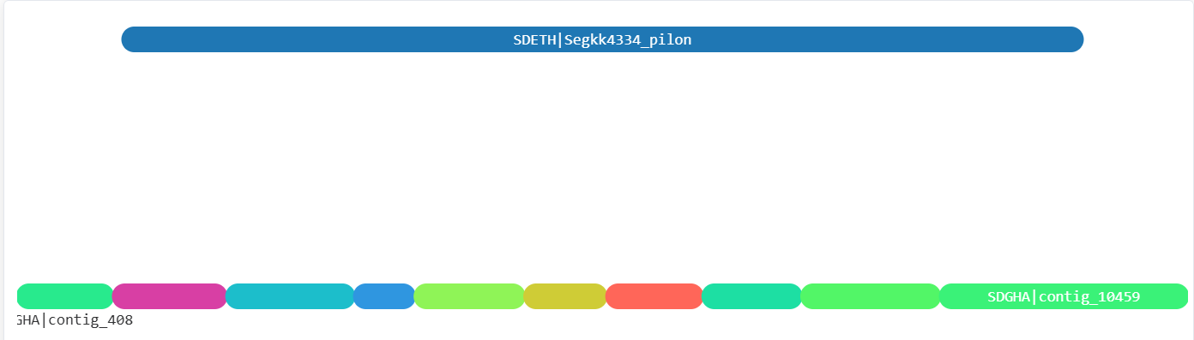
Supplementary Figure 8: Alignment between high single nucleotide variation reference (Ethiopian S. damnosum) contig 4334 with several query contigs 737, 6340, 647, 584, 5230, 6249, 6101, 5086, 10459, and 9636 (Ghanaian S. damnosum): A) Alignment plot with each dot represents cumulative variation in 50 kb window, with a sliding step of 10 kb. The red dots indicate regions of high genetic variation above the threshold (green dash line) and green lines indicate coding regions. The grey vertical lines indicate unaligned regions. B) Dot plot indicating forward alignment of contig 647, 6340 and reverse alignment of contig 737. C) Sankey diagram indicating no collinearity between the reference contig 4334 and query contigs.

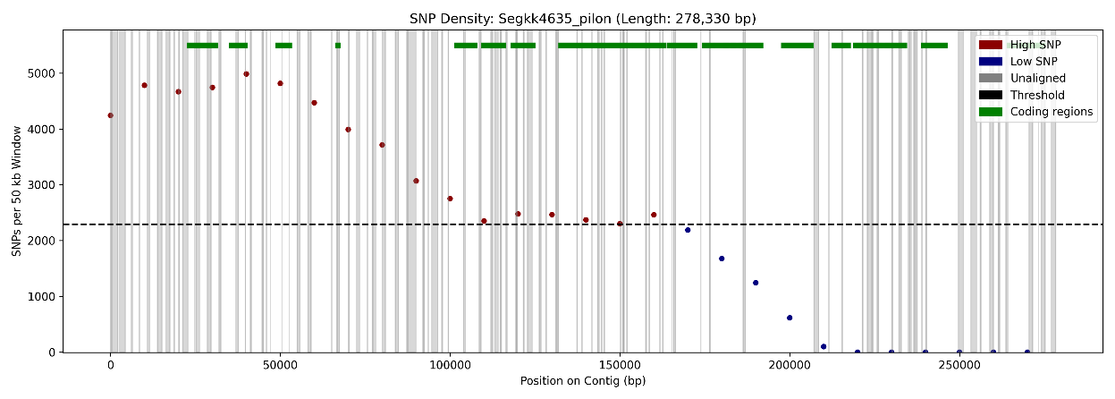
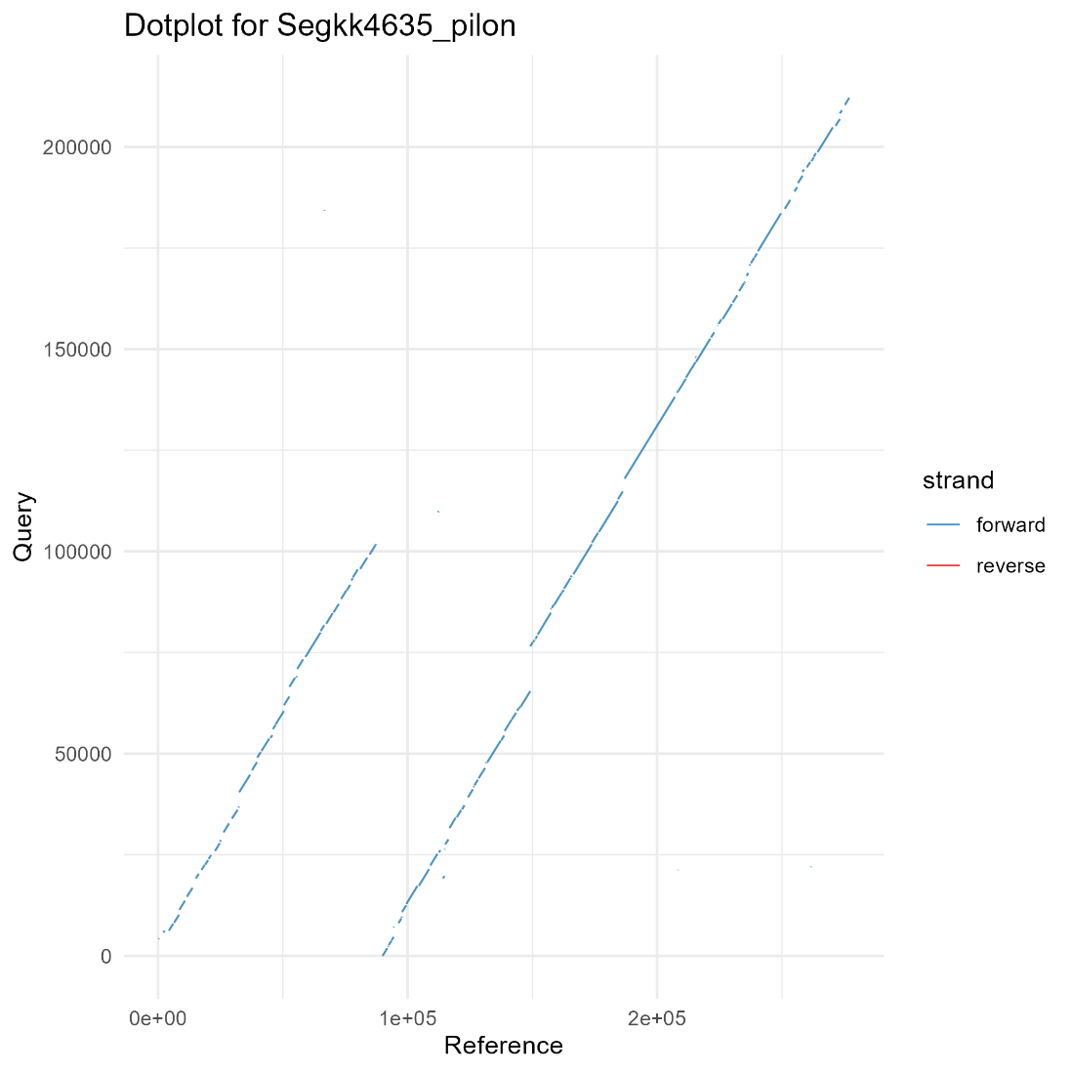

Supplementary Figure 9: Alignment between high single nucleotide variation reference (Ethiopian S. damnosum) contig 4635 with query contigs 9938 and 10023 (Ghanaian S. damnosum): A) Alignment plot with each dot represents cumulative variation in 50 kb window, with a sliding step of 10 kb. The red dots indicate regions of high genetic variation above the threshold (green dash line) and green lines indicate coding regions. The grey vertical lines indicate unaligned regions. B) Dot plot indicating forward alignments of contigs 9938 and 10023. C) Sankey diagram indicating regions of high collinearity between the reference contig 4635 and query contig 9938.

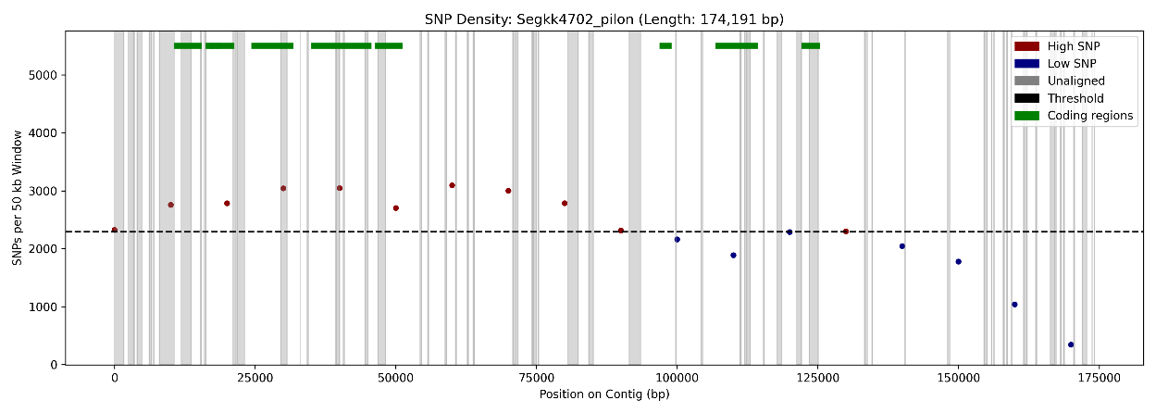
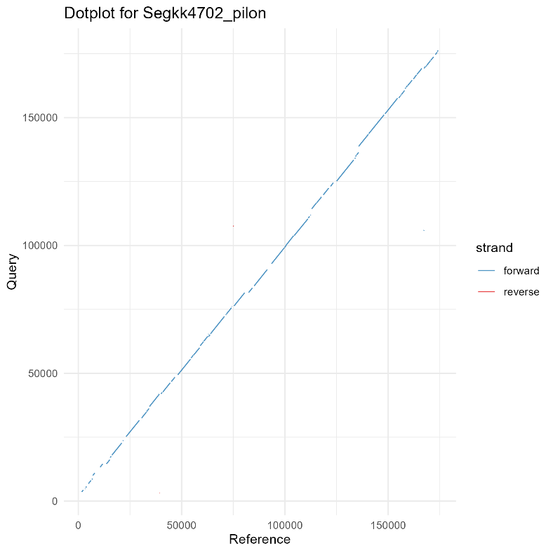

Supplementary Figure 10: Alignment between high single nucleotide variation reference (Ethiopian S. damnosum) contig 4702 with query contig 538 (Ghanaian S. damnosum): A) Alignment plot with each dot represents cumulative variation in 50 kb window, with a sliding step of 10 kb. The red dots indicate regions of high genetic variation above the threshold (green dash line) and green lines indicate coding regions. The grey vertical lines indicate unaligned regions. B) Dot plot indicating forward alignments of contig 538 with the reference. C) Sankey diagram indicating regions of high collinearity between the reference contig 4702 and query contig 538.

Supplemental Text 1. Discussion of GO-term association

Unique genes in S. neavei were associated with GO terms related to sensory perception, lipid biosynthesis, wing pattern formation, sperm competition, and regulation of cholinergic synaptic transmission in the nervous system. Gene families with signals of expansion relative to the inferred ancestral Simulium genome include those related to microtubule-based movement and outer dynein arm assembly (i.e., cell cilia development), male meiosis, visual perception, and Toll signalling pathways (i.e., immune system function). We speculate that these differences in S. neavei compared to other Simulium could reflect mechanisms for adaptation to their distinct ecological niche, including behaviours associated with locating mates, hosts, or locations for egg deposition.
Genes in regions identified as having a high proportion of single-nucleotide variants between Simulium damnosum from Ghana and Ethiopia include Retinoblastoma-family proteins, BHLH domain-containing transcription factors, and guanyl-nucleotide exchange factors, all of which are involved in key regulatory pathways. The presence of RNA-binding proteins, E2 ubiquitin-conjugating enzymes, and AAA+ ATPases further suggests potential roles in post-transcriptional regulation and protein homeostasis. Several uncharacterized proteins and domain-containing proteins (e.g. FCS-type, CASC1, CCD97-like) were also observed, which may represent novel or lineage-specific functions yet to be annotated in Simulium species. The detection of engulfment and cell motility proteins, cytochrome b5, and calcium homeostasis-related proteins points to possible roles in cell signalling and membrane dynamics. While many of the genes remain poorly annotated, the presence of repetitive entries (e.g. multiple instances of guanyl-nucleotide exchange factors, ATP synthase subunits, and threonine-tRNA ligases) may indicate recent duplication events or selective pressures acting on these genes.

