Hospital Fire Safety Education Questionnaire
First, thank you for being willing to complete the following information. If a major fire occurs in a hospital, a hospital fire may result in losses of life and property, and may even increase disease severity and lead to a longer hospital stay. The purpose of this study is to understand the hospital fire safety knowledge, attitudes, and behaviors of hospitalized patients, accompanying caregivers, and care attendants, as well as their acceptance of different educational methods. The results of this survey will be used only for research purposes and for no other purpose. There are no right or wrong answers, and your answers will not affect your treatment. Please feel at ease when completing this questionnaire!
Part I: Basic Information (Please fill in the appropriate information or check the box)
1.1 Sex: Male ___ Female ___ | 1.4 Occupation: _______
1.2 Age: ＿＿ | 1.5 Previous disaster-prevention experience: Yes ＿ No ＿
1.3 Education level: ＿＿＿ | 1.6 Previously attended a fire safety course:  Yes ＿＿ No ＿＿

Part II: Hospital Fire Safety Knowledge Scale (Please select the most appropriate answer on the right)
No. | Item | Yes | No
1 | Common causes of hospital fires include electrical short circuits.
2 | Fire requires three elements to ignite: oxygen, air, and heat.
3 | When charging a mobile phone, choosing a red outlet is safer.
4 | The reason extension cords are prohibited in hospitals is that they can easily become overloaded, causing the extension cord to overheat, scorch, or even catch fire.
5 | High-energy-consuming electrical appliances include hair dryers, electric blankets, electric kettles, and others.
6 | Ms. Chen’s father brought a 1200-watt hair dryer and a 900-watt electric kettle for his hospitalized father to use. The maximum current allowed for a wall outlet is only 15 amperes. If Ms. Chen uses both appliances at the same time, the electrical load is 25 amperes. Is it safe to plug both appliances into the same outlet?  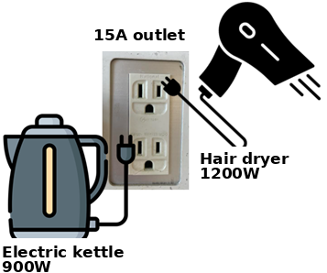  [Formula: Watts (W) / Volts (V) = Amperes (A)]
7 | When a fire occurs in a hospital, evacuation routes are divided into horizontal evacuation and vertical evacuation.
8 | During a hospital fire, if vertical evacuation is used, one must evacuate upward, because the higher floors make it easier to breathe fresh air.
9 | When I see a fire source or heavy smoke, the best evacuation time is 2.5 minutes.
10 | When a fire occurs, one should place a plastic bag over the head and pull it downward and inward tightly while escaping.
11 | After discovering flames, I will press the emergency bell to notify the nurse, then go to the corridor to pick up a fire extinguisher, aim the nozzle at the fire source first, and then begin extinguishing the fire.

Part III: Hospital Fire Safety Attitude Scale (Please select the most appropriate answer on the right)
No. | Item | Strongly agree  (5) | Agree (4) | No opinion (3) | Disagree (2) | Strongly disagree (1)
1 | I think a hospital fire is a very serious event.
2 | When hospitalized, I can pay attention to the location of emergency exits.
3 | When I come to the hospital, I think it is important to pay attention to evacuation signs.
4 | I think fires can be prevented.
5 | When I bring electrical appliances to the hospital for medical electricity needs, I will cooperate with the hospital’s inspection and use them only after electrical safety is confirmed.
6 | When I see outlets of different colors in the hospital, I can actively ask about the meaning of the different outlet colors to avoid danger.
7 | When I smell burning or see smoke, I should actively notify nursing staff.
8 | When charging my mobile phone, I will follow hospital regulations and plug it into the correct outlet.

Part IV: Hospital Fire Safety Behaviors (Please select the most appropriate answer on the right)
No. | Item | Always (5) | Often (4) | Some  times (3) | Rarely (2) | Never (1)
1 | When I do not need to charge or use an electrical appliance, I will remove the plug to reduce overheating caused by keeping the plug continuously inserted in the outlet.
2 | I can correctly demonstrate how to use a fire extinguisher.
3 | I can correctly open the fire hydrant switch and know the steps.
4 | I can quickly identify the nearest emergency exit according to the ward map.  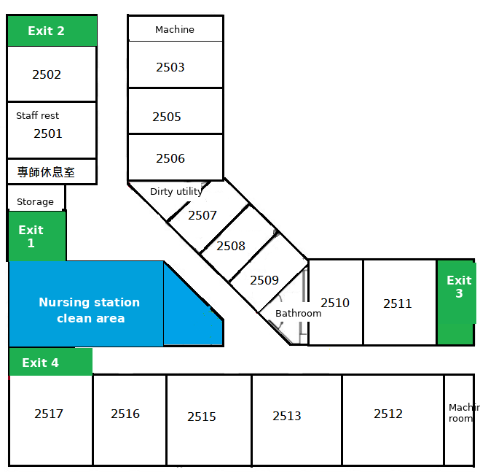  Figure, ward map

To understand your level of acceptance of different health education methods, please complete the following items.
No. | Item | Strongly agree (5) | Agree (4) | No opinion (3) | Disagree (2) | Strongly disagree (1)
1 | I think the interface of the hospital augmented reality fire safety education platform is clear.
2 | I think the hospital augmented reality fire safety education platform is easy to use.
3 | I think the hospital augmented reality fire safety education platform has too many inconsistencies.
4 | I think the hospital augmented reality fire safety education platform is very helpful for preventing hospital fires.
5 | I think the hospital augmented reality fire safety education platform helps me understand evacuation routes more clearly.
6 | I think the hospital augmented reality fire safety education platform helps me find emergency exits more quickly.
7 | I think the hospital augmented reality fire safety education platform helps me understand hospital fire safety regulations more clearly.
8 | The learning method of the hospital augmented reality fire safety education platform makes me feel it is very interesting.
This is the end of the questionnaire. Thank you for your response!

