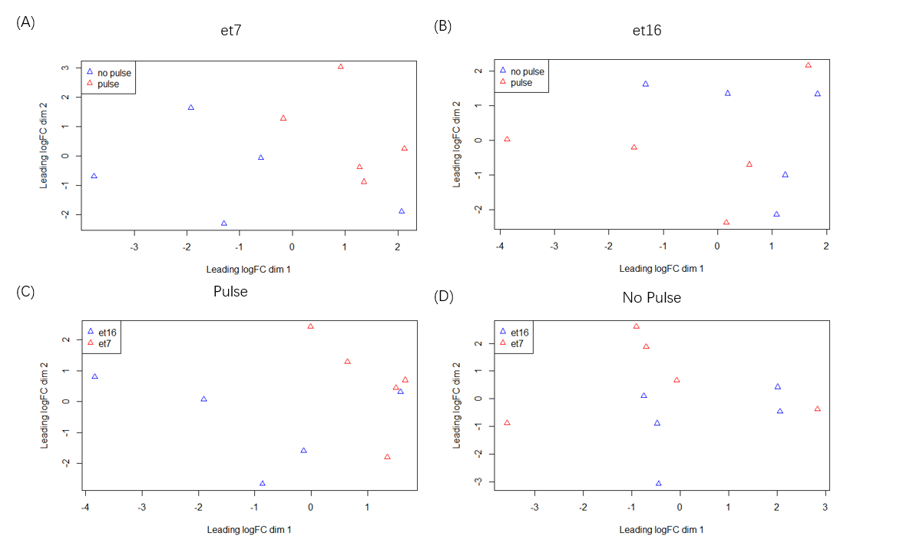

Figure S1: Multidimensional scaling (MDS) plots of transcriptomic responses represented in log Fold Change (logFC) with different light pulse treatments and collection time. Distances between samples correspond to leading biological coefficient of variation (BCV) between those samples. (A) and (B) show differences among samples with or without light pulse separated primarily on the dimension 1 and the influence of collection time on the dimension 2. (C) and (D) show differences among samples with different collection time separated primarily on the dimension 2 and the influence of light pulse on the dimension 1.

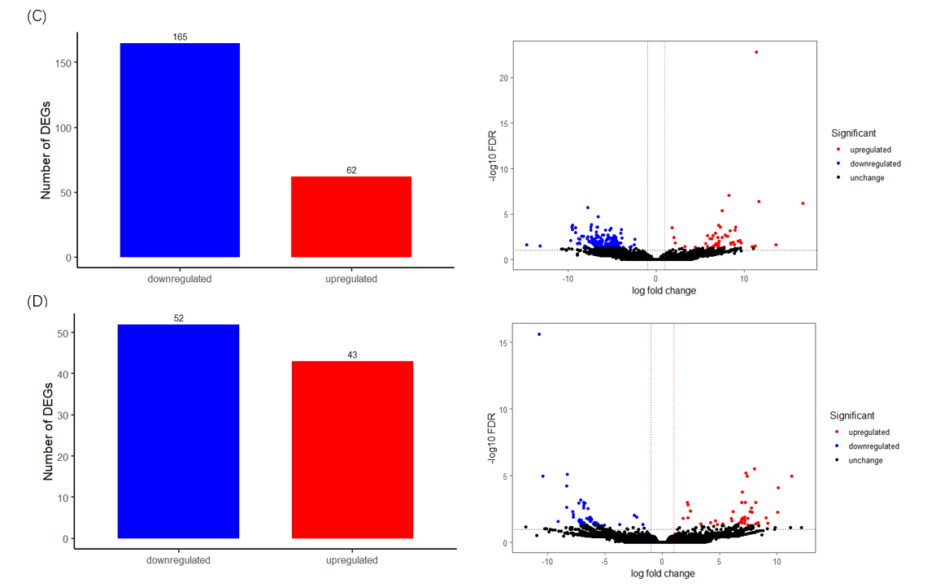
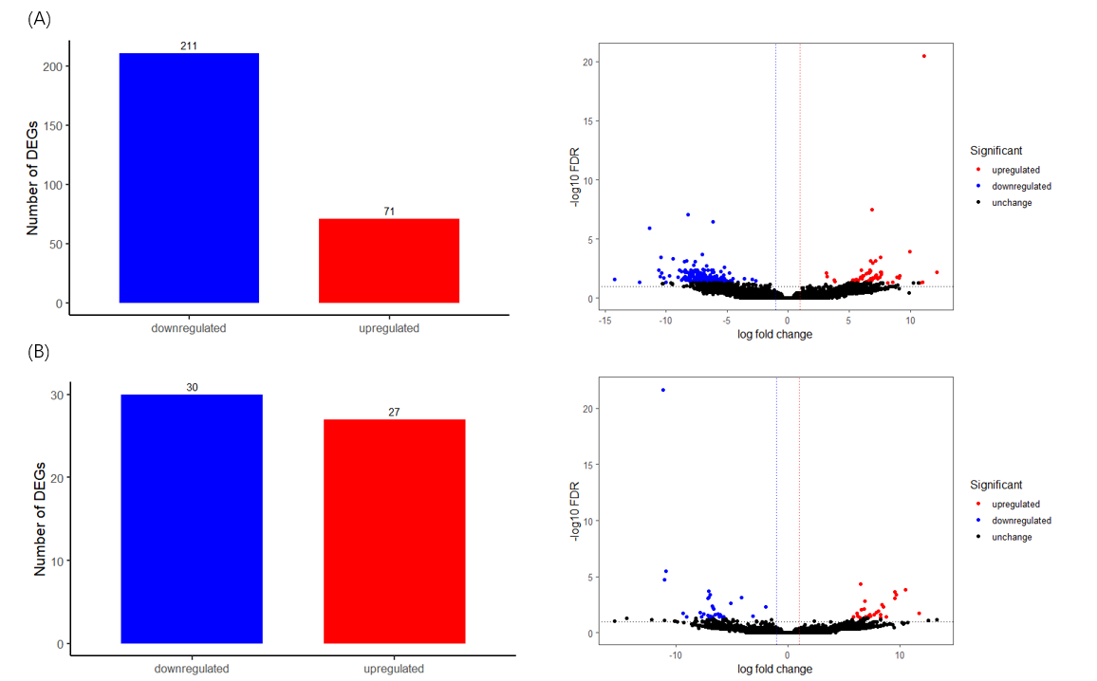
Figure S2: Identification of differentially expressed transcripts associated with light pulse and collection time response. Volcano plot showing the negative log₁₀ of the false discovery rate value (Y axis) against log₂ of the fold change (X-axis). The up and down regulated differentially expressed transcripts at a false discovery rate (FDR) < 0.05 with |log fold change|>1 are depicted in red and blue, respectively. (A) The differentially expressed transcripts of spiders given light pulse relative to spiders without light pulse at et7. (B) The differentially expressed transcripts of spiders given light pulse relative to spiders without light pulse at et16. (C) The differentially expressed transcripts of spiders collected at et7 relative to spiders collected at et16 with light pulse. (D) The differentially expressed transcripts of spiders collected at et7 relative to spiders collected at et16 without light pulse.
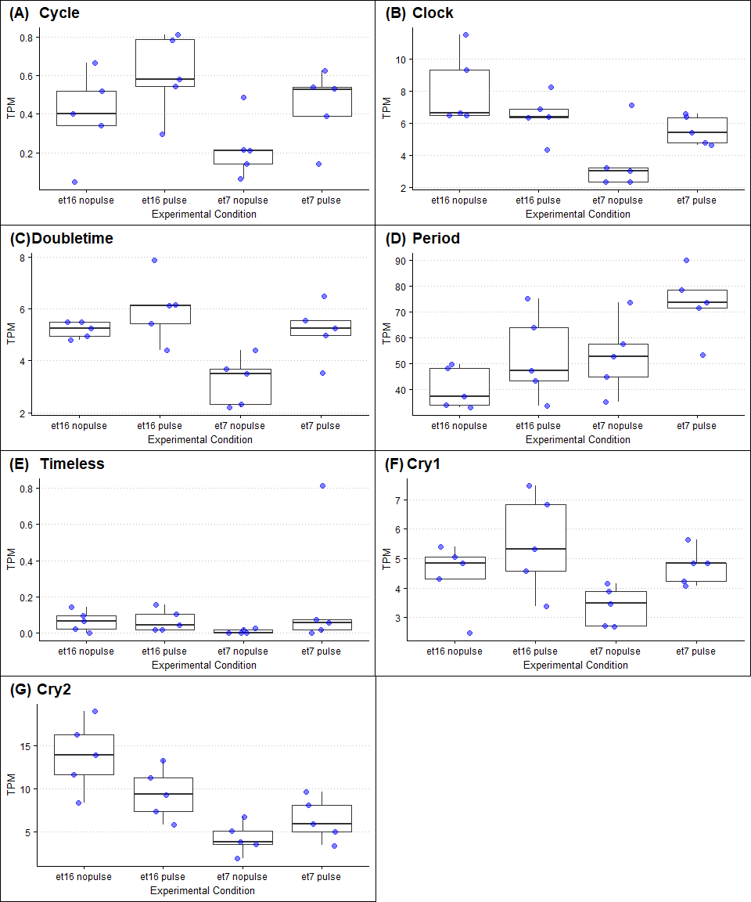

Figure S3: TPM values of seven canonical clock genes. The x axis represents different experimental conditions: the group receiving no light pulse and collected at et16, the group receiving light pulse and collected at et16, the group receiving no light pulse and collected at et7 as well as the group receiving no light pulse and collected at et7.

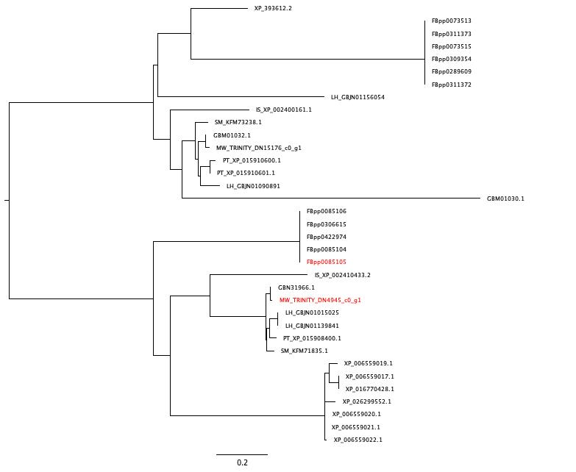
Figure S4: Maximum likelihood tree for Orthogroup containing Doubletime. The D. melanogaster Doubletime protein and the M. wittfeldae ortholog are colored red. Protein sequences are derived from M. witteldae (MW), Araneus ventricosus (GBM), Trichonephila clavipes (NC), Parasteatoda tepidariorum (PT), Latrodectus hesperus (LH), Stegodyphus mimosarum (SM), Ixodes scapularis (IS), Apis mellifera (XP), and D. melanogaster (FB).
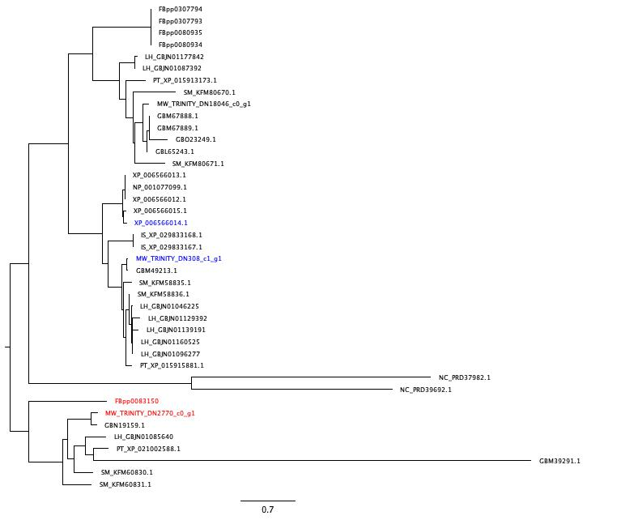

Figure S5: Maximum likelihood tree for Orthogroup containing cryptochromes. The D. melanogaster CRY1 protein and its M. wittfeldae ortholog are colored red. The A. mellifera CRY2 protein and its M. wittfeldae ortholog are colored blue. Protein sequences are derived from M. witteldae (MW), Araneus ventricosus (GBM), Trichonephila clavipes (NC), Parasteatoda tepidariorum (PT), Latrodectus hesperus (LH), Stegodyphus mimosarum (SM), Ixodes scapularis (IS), Apis mellifera (XP), and D. melanogaster (FB).

