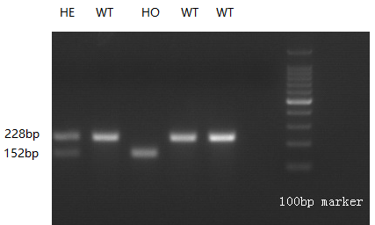
Supplementary Figure 1: Polymerase chain reaction validation of TRAIL-/- mouse genotypes. The primer sequences used were 5′-GCCTTCTAACTGTGACCTT-3′ and 5′-CACTCACCTGCTTCATCTC-3′. A 100 bp DNA ladder marker was purchased from Takara. Genomic DNA extracted from mouse tail was amplified, separated by 3% agarose gel electrophoresis, and visualized as shown above. The PCR product lengths for wild-type (WT) and homozygous mutant (HO) mice were 228 bp and 152 bp, respectively, while heterozygous (HE) mice yielded both 228 bp and 152 bp products.

