Supplementary Information:
Disaster-dependent effects of social network structure on risk communication
Jiam Song¹, Woi Sok Oh², Jonghun Kam¹*
¹Division of Environmental Science and Engineering, POSTECH, Pohang, 37673, South
Korea
²Department of System Design Engineering, University of Waterloo, Waterloo, N2L 3G1, Canada

*Corresponding author: Jonghun Kam (jhkam@postech.ac.kr)

This supplementary information includes:

Supplementary Figures S1-S7 and Tables S1-S7
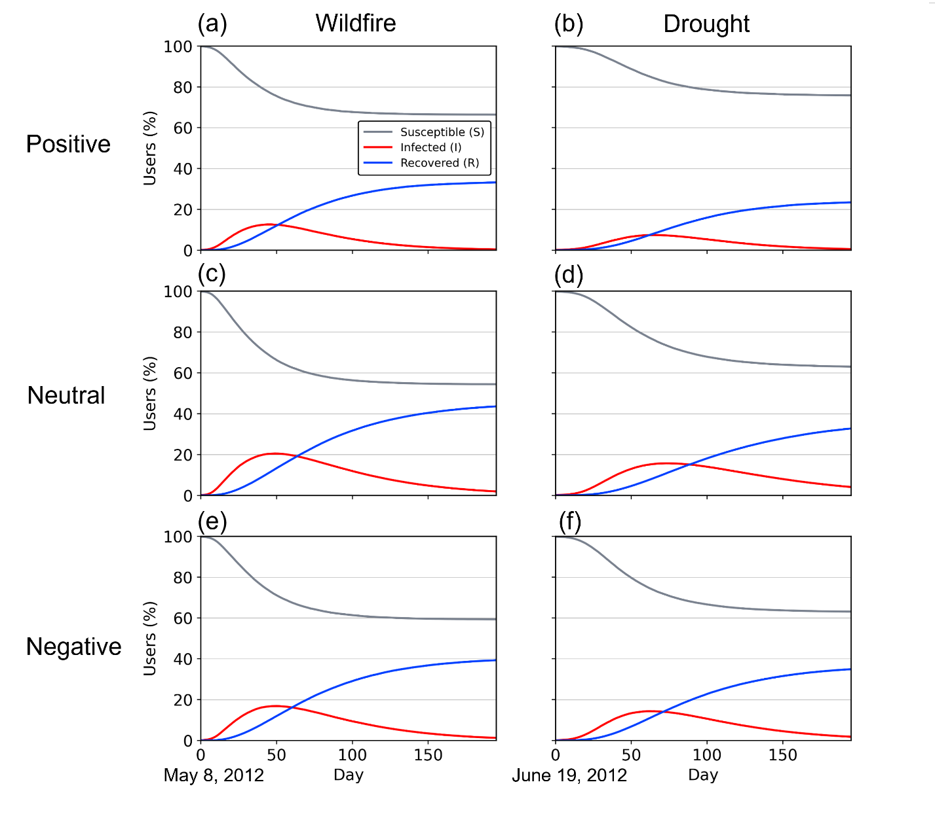
Supplementary Figure S1. Susceptible, Infected, and Recovered user dynamics of fitted fastSIR model by disaster type and sentiment. Panels show wildfire cases in (a, c, e) and drought cases in (b, d, f) ordered by positive, neutral, and negative sentiment. Lines indicate the median fastSIR results percentage of susceptible, infected, and recovered users over time.
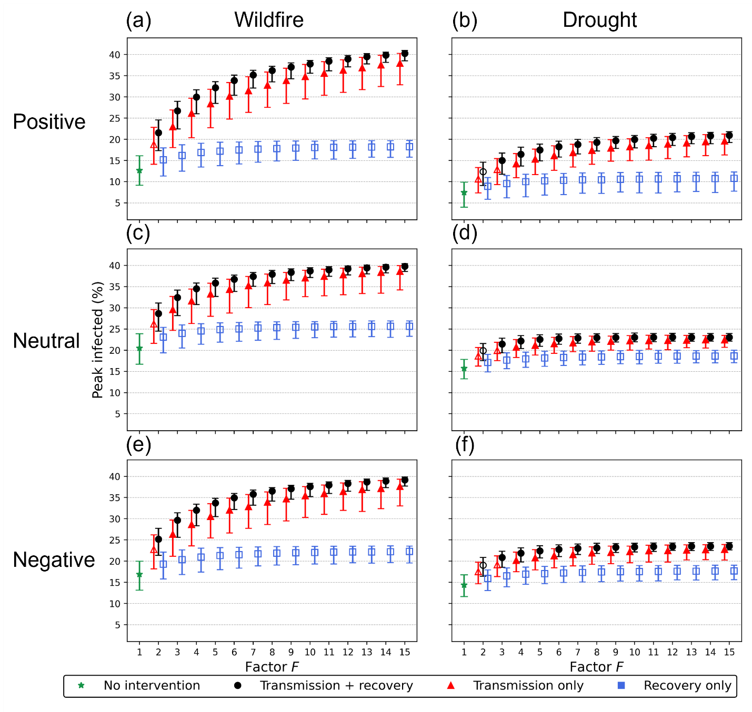
Supplementary Figure S2. Effects of changes in influential users’ target parameters on peak infected percentage. Panels show wildfire cases in (a, c, e) and drought networks in (b, d, f), ordered by positive, neutral, and negative sentiment. Points indicate median simulation outcomes with 95% confidence intervals. The x-axis shows the factor of parameter interventions, and the y-axis shows peak value of infected users. Black circles represent joint two-parameter interventions, increasing transmission probability and reducing recovery probability. Red triangles represent transmission-only interventions. Blue squares represent recovery-only interventions. Green stars represent no interventions. Filled markers indicate intervention outcomes whose 95% confidence intervals did not overlap with the calibrated baseline simulation (no intervention simulation), whereas empty markers indicate outcome whose 95% confidence intervals overlapped with the baseline.

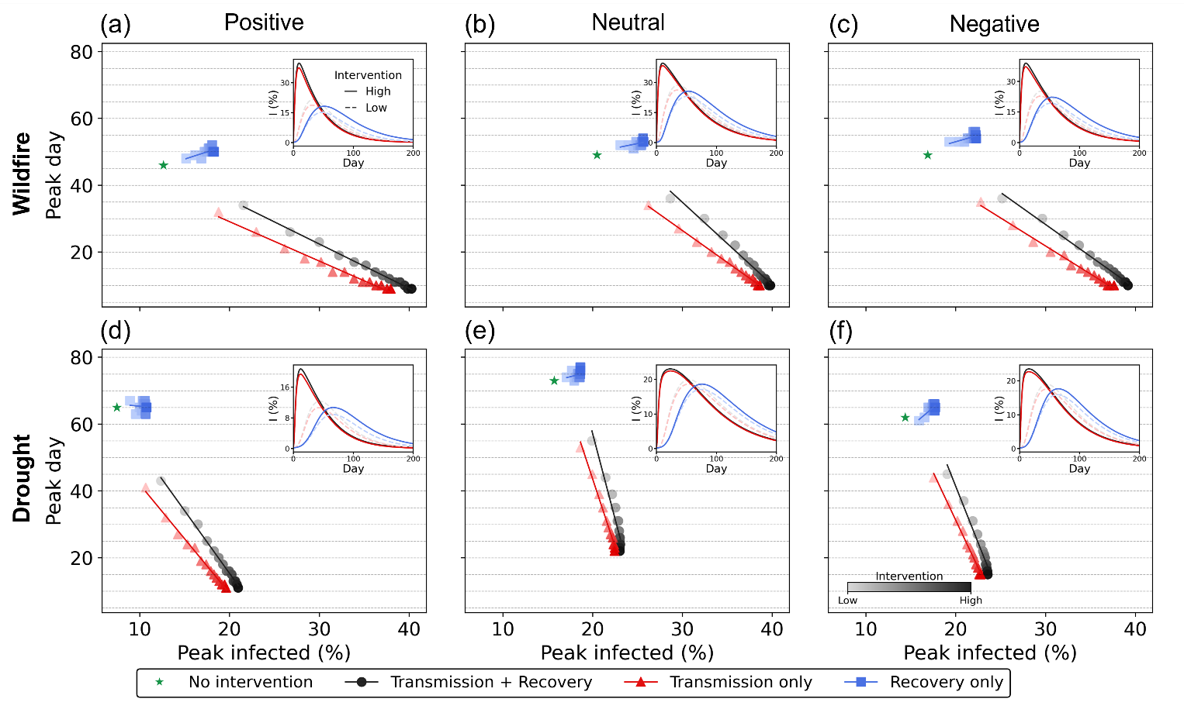
Supplementary Figure S3. Effects of changes in influential users’ target parameters on information diffusion based on PageRank centrality. Panels show wildfire cases in (a–c) and drought cases in (d–f), ordered by positive, neutral, and negative sentiment. Points indicate median simulation outcomes with 95% confidence intervals. The x-axis shows the peak percentage of infected users, and the y-axis shows peak timing of infected users. Black circles represent joint two-parameter interventions, increasing transmission probability and reducing recovery probability. Red triangles represent transmission-only interventions. Blue squares represent recovery-only interventions. Green stars represent no interventions. Marker color shade indicates the intervention factor. Lines show fitted response trends. Steeper negative slopes indicate timing-dominant improvement, whereas flatter slopes indicate extent-dominant improvement.
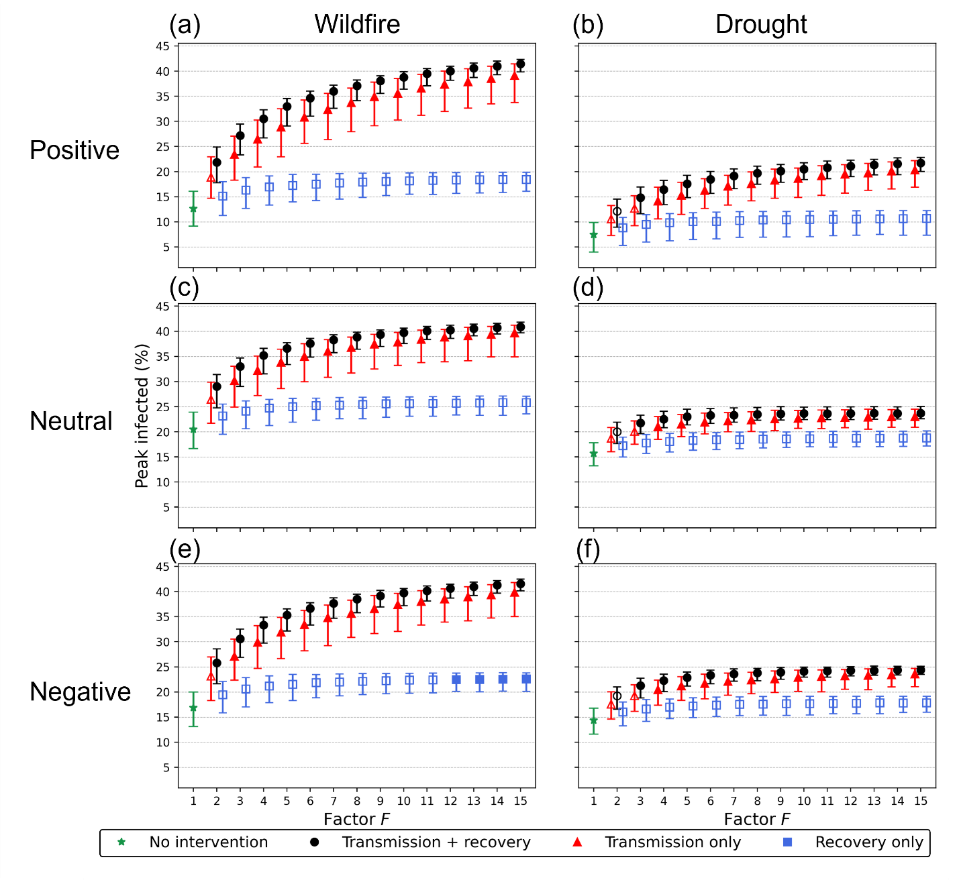
Supplementary Figure S4. Effects of changes in influential users’ target parameters on peak infected percentage based on PageRank centrality. Panels show wildfire cases in (a, c, e) and drought cases in (b, d, f), ordered by positive, neutral, and negative sentiment. Points indicate median simulation outcomes with 95% confidence intervals. The x-axis shows the factor of parameter interventions, and the y-axis shows peak value of infected users. Black circles represent joint two-parameter interventions, increasing transmission probability and reducing recovery probability. Red triangles represent transmission-only interventions. Blue squares represent recovery-only interventions. Green stars represent no interventions. Filled markers indicate intervention outcomes whose 95% confidence intervals did not overlap with the calibrated baseline simulation (no intervention simulation), whereas empty markers indicate outcome whose 95% confidence intervals overlapped with the baseline.

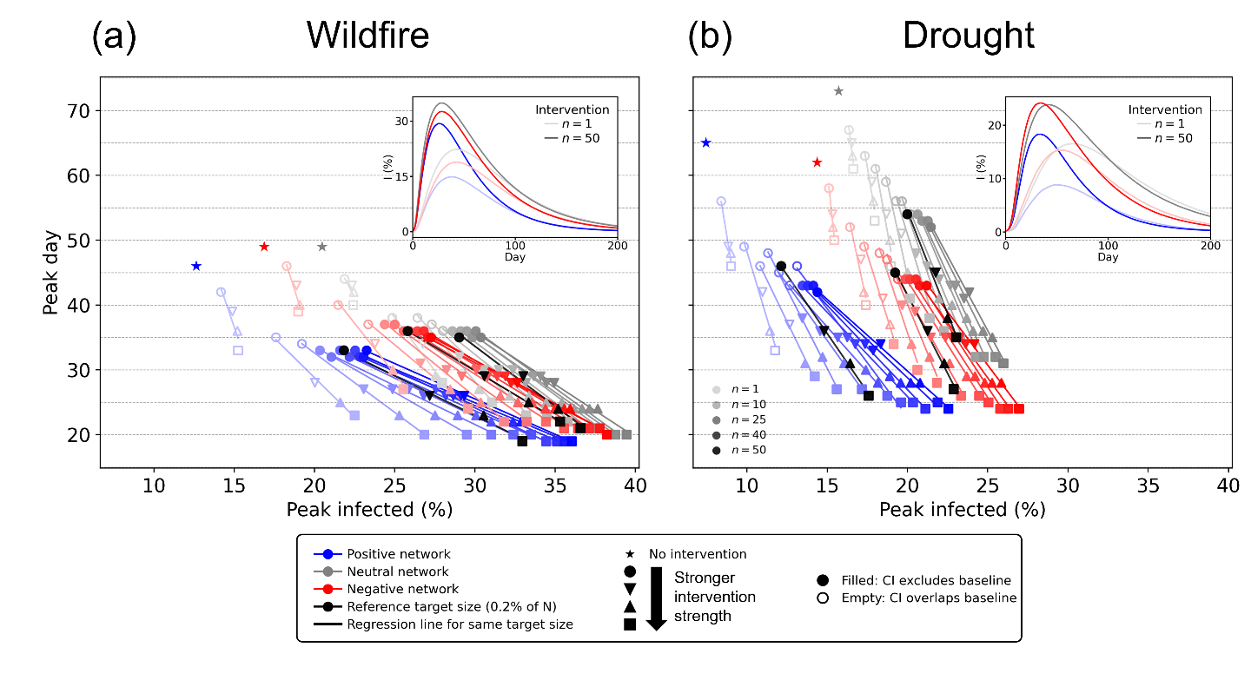
Supplementary Figure S5. Effects of broader influential users targeting information diffusion based on PageRank centrality. Scatter plots show median peak infected users and peak timing under different intervention factors and numbers of targeted influential users. Regression lines summarize intervention strength from low to high values (factor 2 to 5), and the marker color shade indicates broader targeting scenarios. Filled markers indicate intervention outcomes whose 95% confidence intervals did not overlap with the calibrated baseline simulation, whereas empty markers indicate outcome whose 95% confidence intervals overlapped with the baseline. Overall, broader targeting shifts the response curves from timing-dominant improvement with small targeting to extent dominant improvement with large targeting.

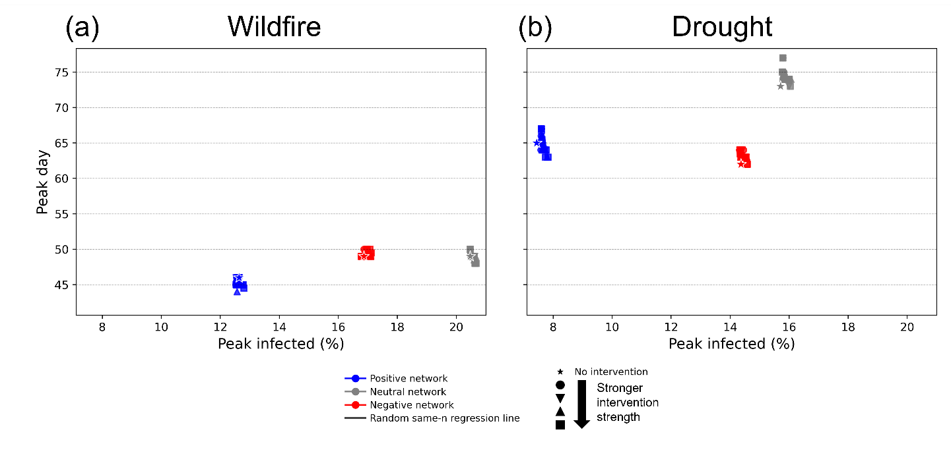
Supplementary Figure S6. Random-user targeting intervention experiments. Scatter plots show median peak infected users and peak timing under different intervention factors and numbers of targeted random users. Response curves summarize intervention changes from low to high. Overall, random targeting experiments produced no improvement in information diffusion compared with baseline results.

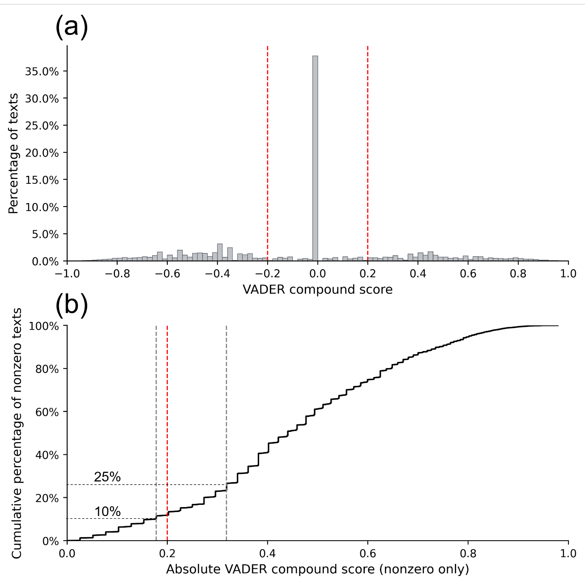
Supplementary Figure S7. Empirical justification of the VADER sentiment threshold. (a) Distribution of VADER compound scores for 18,559 unique texts. Red dashed vertical lines indicate the sentiment classification thresholds at −0.2 and 0.2. A large portion of texts had a compound score of exactly zero, indicating neutral or sentiment-ambiguous content. (b) Cumulative distribution of absolute VADER compound scores among nonzero observations. The red dashed line indicates the 0.2 threshold used to classify positive and negative sentiment, while gray dashed lines indicate the 10th and 25th percentiles of the absolute nonzero score distribution. The 0.2 cutoff lies just above the 10th percentile (0.178 score threshold) and below the 25th percentile (0.318 score threshold).

Supplementary Tables

Sentiment | Disaster | Text
Positive | Wildfire | Hoping that everyone's friends and family are safe from the wildfire in Central Washington. Best wishes go out to all those affected
Positive | Drought | Did not get a deer in San Angelo but loved seeing Texas so green. So thankful the drought in the great state of Texas is over
Neutral | Wildfire | Hazy Denver city skyline. Smokey from New Mexico wildfire. 82,000 acres burning
Neutral | Drought | In some parts of Indiana the shortfall is more extreme and we need 10-12" of rain to end drought across the state
Negative | Wildfire | Colorado wildfire now deemed most destructive in state history: At least 1 dead, 346 homes burned, 35,000 evacuated.
Negative | Drought | Arkansas' drought is so severe, Gov. Beebe just asked for a statewide disaster declaration. If Feds approve, farmers will get emergency
Supplementary Table S1. Representative examples of sentiment analysis on disaster-related Twitter texts. The sentiment text examples are selected from original Twitter/X dataset.

Supplementary Table S2. Top 30 betweenness centrality users in total wildfire network.
Rank | Betweenness top user | Degree | Betweenness
1 | CNN Breaking News | 1232 | 0.122
2 | Breaking News | 871 | 0.0928
3 | The Associated Press | 648 | 0.0874
4 | HuffPost | 675 | 0.0589
5 | Reuters | 533 | 0.0541
6 | The Denver Post | 356 | 0.0436
7 | Instagram | 488 | 0.0334
8 | Individual A | 136 | 0.0202
9 | CNNgo | 266 | 0.0192
10 | NBC News | 219 | 0.0180
11 | Mashable | 225 | 0.0178
12 | CNN | 243 | 0.0173
13 | Individual B | 39 | 0.0155
14 | TheNewDeal | 194 | 0.0152
15 | Fox News | 209 | 0.0145
16 | Denver Broncos | 194 | 0.0138
17 | Common Raven | 41 | 0.0129
18 | eBook Discovery | 181 | 0.0127
19 | HuffPost Green | 144 | 0.0123
20 | ONEREPUBLIC | 176 | 0.0116
21 | Individual J | 10 | 0.0105
22 | Foster The People | 156 | 0.0104
23 | The Nature Conservancy | 92 | 0.0103
24 | NASA | 150 | 0.00992
25 | Individual C | 133 | 0.00959
26 | Individual I | 19 | 0.00916
27 | Individual H | 83 | 0.00893
28 | Yahoo News | 132 | 0.00876
29 | Individual K | 25 | 0.00835
30 | Arizona News | 52 | 0.00823

Rank | Betweenness top user | Degree | Betweenness
1 | Individual C | 588 |  | 0.0703
2 | Individual D | 63 |  | 0.0328
3 | Reuters | 214 |  | 0.0310
4 | HuffPost | 320 |  | 0.0265
5 | The Associated Press | 148 |  | 0.0189
6 | Individual E | 71 |  | 0.0171
7 | Mother Jones | 205 |  | 0.0168
8 | Watchdog Progressive | 40 |  | 0.0164
9 | Breaking News | 149 |  | 0.0127
10 | Climate Reality | 114 |  | 0.0123
11 | Individual B | 26 |  | 0.0110
12 | 350 dot org | 171 |  | 0.0102
13 | HuffPost Green | 124 |  | 0.00966
14 | The New York Times | 110 |  | 0.00947
15 | The Weather Channel | 110 |  | 0.00944
16 | Individual R | 180 |  | 0.00904
17 | Boudreaux | 4 |  | 0.00898
18 | Institute of Agriculture and Natural Resources | 31 |  | 0.00880
19 | Individual U | 88 |  | 0.00823
20 | Texas Storm Chasers | 82 |  | 0.00820
21 | RT America | 48 |  | 0.00801
22 | Breaking News Storm | 100 |  | 0.00763
23 | BBC North America | 70 |  | 0.00707
24 | Individual X | 64 |  | 0.00695
25 | NPR | 87 |  | 0.00691
26 | Individual AC | 18 |  | 0.00687
27 | Flipboard News | 14 |  | 0.00681
28 | I AM | 12 |  | 0.00662
29 | NBC News | 90 |  | 0.00655
30 | Individual W | 70 |  | 0.00620
Supplementary Table S3. Top 30 betweenness centrality users in total drought network.

Supplementary Table S4. Top 30 degree users in wildfire networks.
Rank | Positive | Neutral | Negative
1 | CNN Breaking News | CNN Breaking News | CNN Breaking News
2 | Breaking News | Breaking News | Breaking News
3 | HuffPost | HuffPost | HuffPost
4 | The Associated Press | The Associated Press | The Associated Press
5 | Reuters | Reuters | Reuters
6 | Instagram | The Denver Post | Instagram
7 | The Denver Post | CNNgo | The Denver Post
8 | CNNgo | CNN | CNNgo
9 | Mashable | NBC News | CNN
10 | NBC News | Fox News | Mashable
11 | Denver Broncos | TheNewDeal | NBC News
12 | eBook Discovery | eBook Discovery | Fox News
13 | ONEREPUBLIC | NASA | NASA
14 | Foster The People | HuffPost Green | HuffPost Green
15 | NASA | Individual A | Individual A
16 | HuffPost Green | Individual C | Individual C
17 | Individual A | Yahoo News | Yahoo News
18 | Individual C | Loud Pak109 | Loud Pak109
19 | Yahoo News | Breaking Weather by AccuWeather | Breaking Weather by AccuWeather
20 | Loud Pak109 | NPR | NPR
21 | NPR | Individual F | Los Angeles Times
22 | Individual F | Los Angeles Times | The New York Times
23 | The New York Times | The New York Times | Mother Jones
24 | Mother Jones | Mother Jones | Individual G
25 | Individual G | The Nature Conservancy | The Nature Conservancy
26 | The Nature Conservancy | ThinkProgress | ThinkProgress
27 | ThinkProgress | Individual H | Individual H
28 | Individual H | Individual P | Individual M
29 | Good Morning America | Good Morning America | Good Morning America
30 | Anderson Cooper 360 | Reuters U.S. News | Reuters U.S. News

Rank | Positive | Neutral | Negative
1 | Individual C | Individual C | Individual C
2 | HuffPost | HuffPost | HuffPost
3 | Reuters | Reuters | Reuters
4 | Mother Jones | Mother Jones | Mother Jones
5 | Individual R | 350 dot org | 350 dot org
6 | The Associated Press | Sorry, I'm Texan | Breaking News
7 | HuffPost Green | Breaking News | The Associated Press
8 | Climate Reality | The Associated Press | HuffPost Green
9 | The Weather Channel | HuffPost Green | Climate Reality
10 | The New York Times | Climate Reality | The New York Times
11 | ESPN Stats & Info | Individual AE | The Weather Channel
12 | Individual S | The New York Times | Breaking News Storm
13 | Individual T | The Weather Channel | Individual S
14 | Individual U | ESPN Stats & Info | NBC News
15 | Fox News | Individual S | Individual U
16 | NPR | NBC News | Individual V
17 | Individual V | Individual U | The Atlantic
18 | Texas Storm Chasers | Fox News | Climate Power
19 | Individual E | NPR | Individual E
20 | Individual W | Individual V | BBC North America
21 | BBC North America | Texas Storm Chasers | Individual W
22 | Individual X | The Atlantic | Individual X
23 | Individual D | Climate Power | Individual D
24 | Individual Y | Individual E | Individual Y
25 | Scientific American | Individual W | Scientific American
26 | Individual Z | The Wall Street Journal | Climate Central
27 | Individual AA | Individual X | NRDC
28 | Climate Central | Individual D | AgriNews
29 | NRDC | Individual Y | UTFollowTrain
30 | AgriNews | Scientific American | AGBULL
Supplementary Table S5. Top 30 degree centrality users in drought networks.

Supplementary Table S6. Regression line of changes in influential users’ target parameters on information diffusion based on betweenness centrality.
Disaster |  | Wildfire |  |  | Drought
Sentiment |  | Positive | Neutral | Negative | Positive | Neutral | Negative
Experiments | Coefficient
Transmission-only interventions | Slope | -1.18 | -1.91 | -1.68 | -3.26 | -8.15 | -5.70
Transmission-only interventions | Intercept | 52.68 | 83.72 | 72.10 | 74.51 | 206.48 | 145.26
Transmission-only interventions | R² | 0.98 | 1.00 | 0.99 | 0.99 | 0.99 | 0.99
Recovery-only interventions | Slope | 0.87 | 0.54 | 0.76 | -0.23 | 0.67 | 2.27
Recovery-only interventions | Intercept | 34.78 | 38.86 | 37.74 | 67.71 | 62.4 | 25.28
Recovery-only interventions | R² | 0.51 | 0.29 | 0.45 | 0.01 | 0.08 | 0.64
Joint two-parameter interventions | Slope | -1.32 | -2.47 | -1.91 | -3.75 | -10.21 | -6.77
Joint two-parameter interventions | Intercept | 62.11 | 108.89 | 85.58 | 90.27 | 261.29 | 176.64
Joint two-parameter interventions | R² | 1.00 | 0.98 | 0.99 | 1.00 | 0.92 | 0.96

Supplementary Table S7. Regression line of changes in influential users’ target parameters on information diffusion based on PageRank.
Disaster |  | Wildfire |  |  | Drought
Sentiment |  | Positive | Neutral | Negative | Positive | Neutral | Negative
Experiments | Coefficient
Transmission-only interventions | Slope | -1.04 | -1.86 | -1.51 | -3.24 | -7.95 | -5.40
Transmission-only interventions | Intercept | 48.38 | 83.40 | 68.82 | 76.34 | 205.20 | 140.17
Transmission-only interventions | R² | 0.99 | 1.00 | 0.99 | 0.98 | 0.98 | 0.99
Recovery-only interventions | Slope | 1.32 | 0.60 | 0.66 | 1.12 | 0.49 | 0.00
Recovery-only interventions | Intercept | 27.61 | 37.78 | 40.68 | 55.68 | 66.67 | 64.49
Recovery-only interventions | R² | 0.65 | 0.39 | 0.27 | 0.17 | 0.04 | 0.00
Joint two-parameter interventions | Slope | -1.23 | -2.22 | -1.71 | -3.56 | -9.20 | -6.38
Joint two-parameter interventions | Intercept | 59.81 | 101.23 | 81.13 | 89.41 | 242.00 | 170.62
Joint two-parameter interventions | R² | 1.00 | 0.99 | 0.99 | 1.00 | 0.90 | 0.97

