Supplementary Information
EffiFusion-GAN: Efficient Fusion Generative Adversarial Network for Speech Enhancement
Bin Wen, Tien-Ping Tan*
Universiti Sains Malaysia, Penang, Malaysia
* Corresponding author: tienping@usm.my

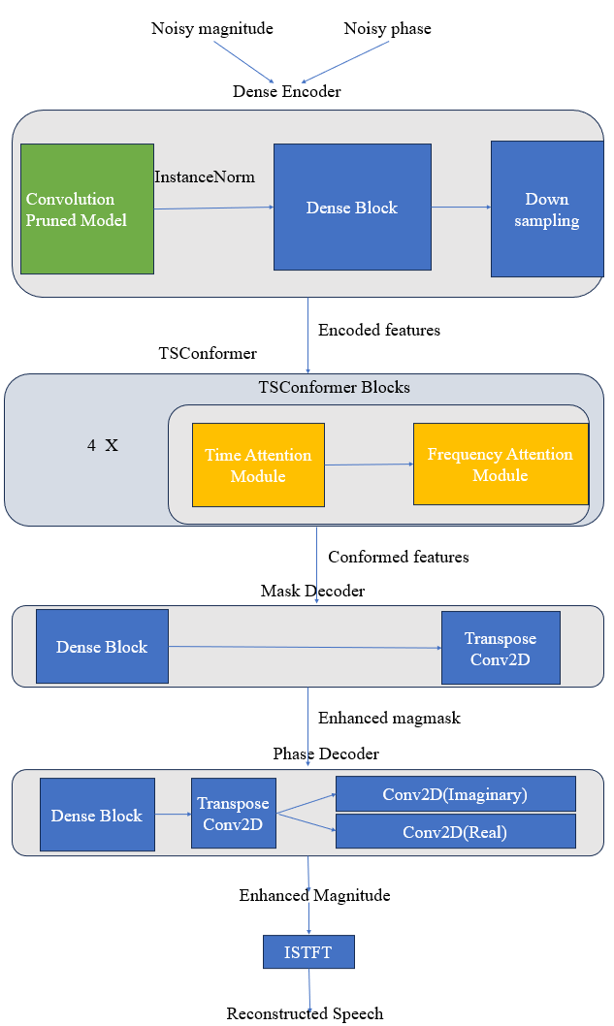
Supplementary Figure S1. Generator architecture.

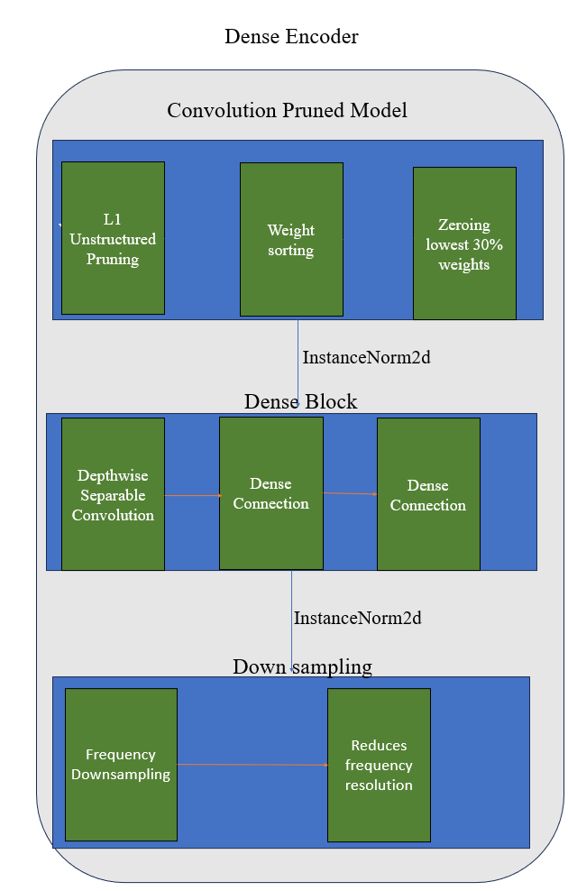
Supplementary Figure S2. Dense encoder architecture.

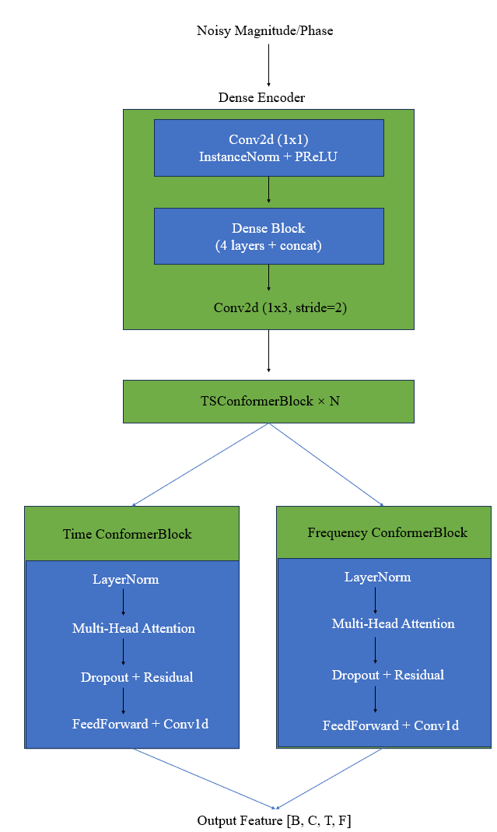
Supplementary Figure S3. Residual multi-head attention block.

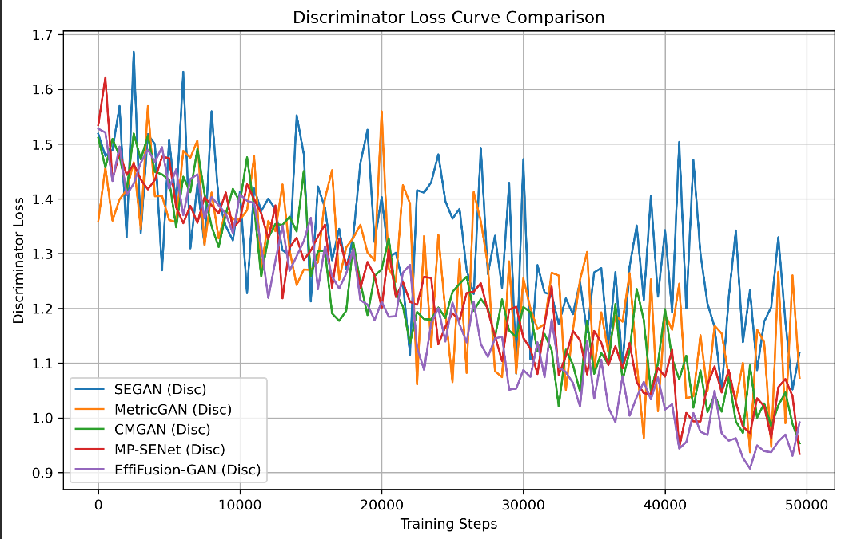
Supplementary Figure S4. Discriminator-loss trajectories for the compared systems. The curves are presented as a descriptive comparison because the adversarial objectives and scales differ across systems.

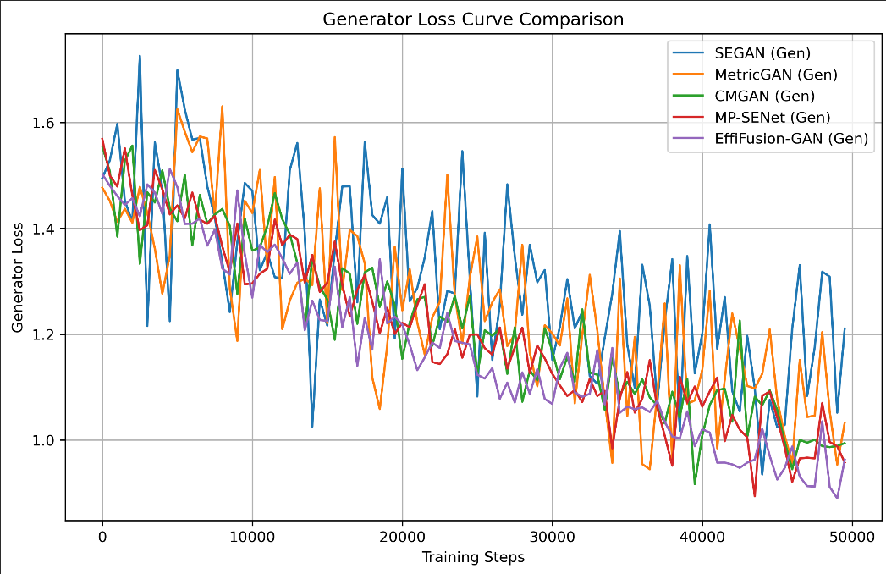
Supplementary Figure S5. Generator-loss trajectories for the compared systems. The curves are presented as a descriptive comparison because the adversarial objectives and scales differ across systems.

