Supplementary data
Plant Cell Tissue and Organ Culture
Special Issue on the Biotechnology of Ornamental Plants

Somatic embryogenesis from young inflorescences of the giant bamboo Dendrocalamus asper (Schult f.) Backer ex Heyne
Thiago Sanches Ornellas^{1,3}, Yohan Fritsche¹, Edison Cardona Medina¹, and Miguel Pedro Guerra^{1, 2}
¹ Graduate Program in Plant Genetic Resources, Plant Developmental Physiology and Genetics Laboratory, Federal University of Santa Catarina, Rod. Admar Gonzaga, 1346, Florianópolis, SC, 88034-001, Brazil.
² Graduate Program in Agricultural and Natural Ecosystems, Federal University of Santa Catarina, Curitibanos, SC, 89520-000, Brazil
³ Santa Catarina State Bamboo Association, Florianópolis, SC 88063-200, Brazil

Corresponding author: Miguel P. Guerra, email: miguel.guerra@ufsc.br

Supplementary table
Table S1 Reports of micropropagation from flower structures of some important Bambusa' and Dendrocalamus' species.
Species | Pathway | Explant | PGRs |  | References
Species | Pathway | Explant | Callus Induction | Plant  Regeneration | References
B. oldhamii | SE | Young inflorescences | 2,4- D (13.4 µM ) + Kin (9.3 µM) | 2,4-D (13.4 µM ) + Kin (9.3 µM) | Yeh and Chang (1986 a)
B. beecheyana var. beecheyana | SE | Young inflorescences | 2,4 – D (13.4 µM ) + Kin (9.3 µM) | NAA + IBA | Yeh and Chang (1986 b)
Sinocalamus latiflora  (= B. oldhamii) | SE | Anthers | 2,4 – D (4.5 µM) + BAP (4,4 µM) | - | Tsay et al. (1990); Tsay et al. (1996)
B. oldhamii,  D. latiflorus, and D. asper | SE | Immature inflorescences | 2,4-D (13,5 - 27 µM) | NAA (1,4 – 5,4 µM) + BAP (2,2 – 8,8 µM) | Prutpongse and Gavinlertvatana (1992)
D. giganteus | Indirect Org. | In vitro-regenerated spikelets | 2,4-D (33.9 µM) + NAA (16.1 µM) | - | Ramanayake and Wanniarachchi (2003)
B. edulis | Direct Org; SE | Inflorescences | 2,4-D (45.3µM) | - | Lin et al. (2005)
B. balcooa | SE | Pseudospikelets | 2,4-D  (4.5 µM) | BAP  (22.2 µM) | Gillis et al. (2007)
D. latiflorus | SE | Inflorescences | 2,4 – D  (13.4 µM ) + Kin (9.3 µM) | TDZ  (0.45 µM) | Lin et al. (2007)
D. asper | Direct Org. | Young and mature inflorescences | - | BAP  (31.1 µM) | Arya et al. (2008)
B. multiplex | SE | Spikelets | 2,4-D  (18.1 µM) | Kin (13.9 µM) + BAP (13.3 µM) | Yuan et al. (2009)
D. latiflorus | SE | Anthers | BAP (1,33 µM) + NAA (5.37 µM) + PAA (110.17 µM) | BAP (8.89 μM) + Kin (2.32 μM) +  NAA (1,08 μM) + PAA (110.17 μM) | Qiao et al. (2013)
PGR – Plant growth regulator; SE – Somatic embryogenesis; Org. – Organogenesis; 2,4-D – Dichlorophenoxyacetic acid; Kin – Kinetin; NAA – Naphthaleneacetic acid; IBA -Indoleacetic acid; TDZ – Thiadiazuron; BAP – Benzylaminopurine; PAA – Phenylacetic acid.

Supplementary figure

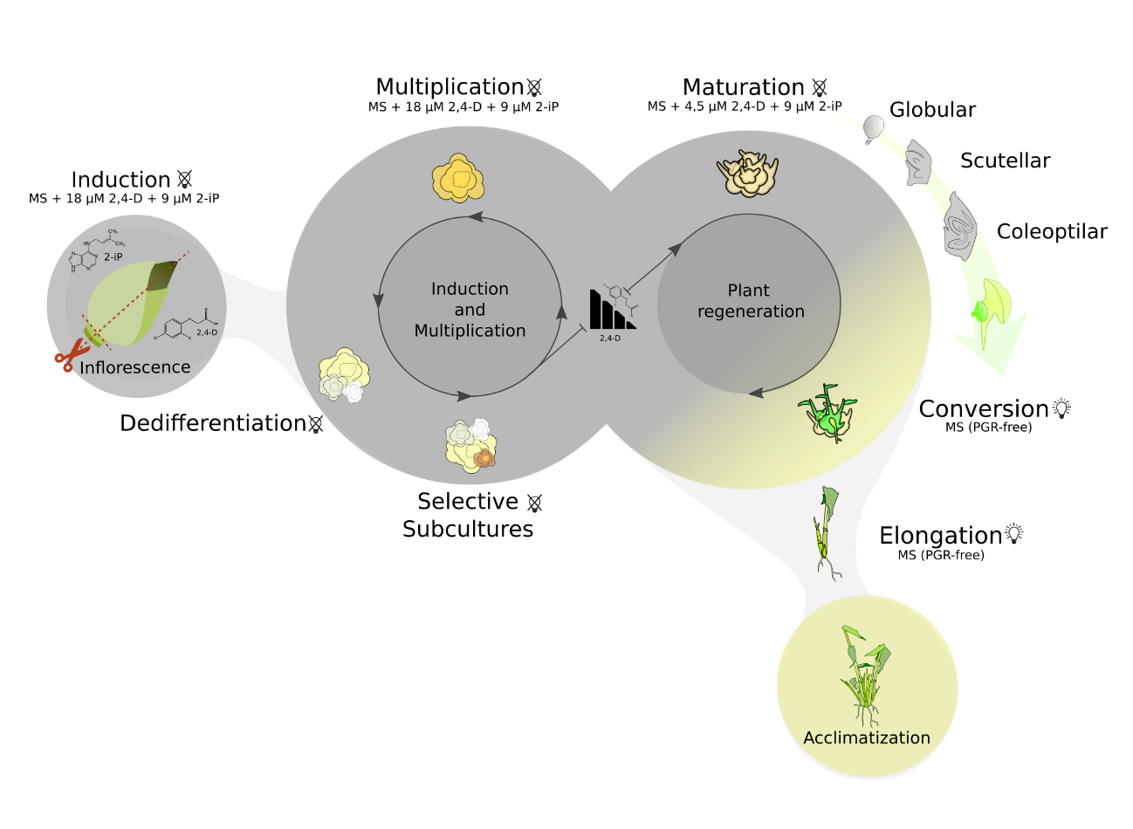
Fig. S1 Graphic summary of in vitro somatic embryogenesis protocol for the giant bamboo Dendrocalamus asper

