Supplemental information for
Soil and vegetation patterns along a toposequence in a dolomite peak-cluster depression catchment
Qingmei Meng^{a,b,d}, Zhiyong Fu^{a,d *}, Sheng Wang^{c}, Hongsong Chen^{a,d}
ªKey Laboratory of Agro-ecological Processes in Subtropical Region, Institute of Subtropical Agriculture, Chinese Academy of Sciences, Changsha, Hunan, 410125, China
^{b}Forestry College, Guangxi University, No. 100 Daxue Road, Nanning 530004, China
^{c}Key laboratory of Environment Change and Resources Use in Beibu Gulf, (Nanning Normal University), Ministry of Education, Nanning, Guangxi 530001, China
^{d}Huanjiang Observation and Research Station for Karst Ecosystems, Chinese Academy of Sciences, Huanjiang, Guangxi 547100, China

* Corresponding author: Zhiyong Fu
Tel: +86-731- 84619720; Fax: +86-731-84612685; Email: zyfu@isa.ac.cn
Postal address: Institute of Subtropical Agriculture, Chinese Academy of Sciences, Changsha, Hunan, 410125, China
Table S1 Soil profiles photos of different topographic positions
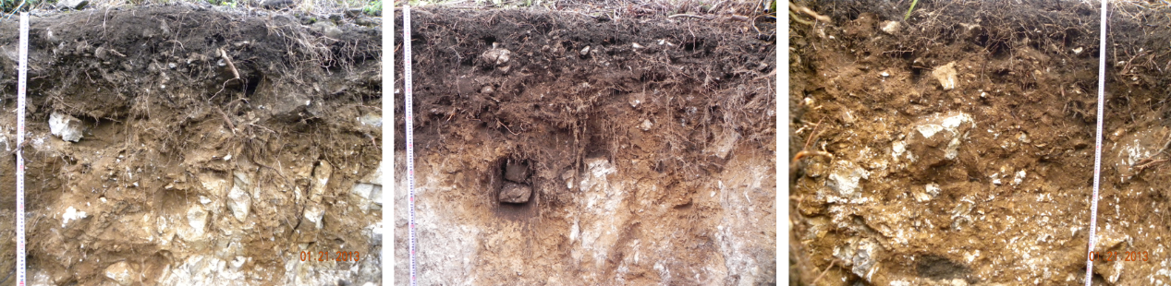
Upper-slope (well drained Entisol)
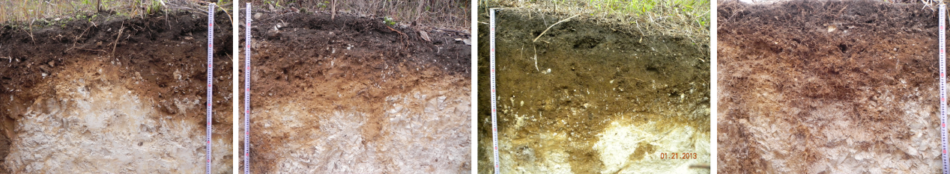
Middle-slope (well drained Inceptisol)
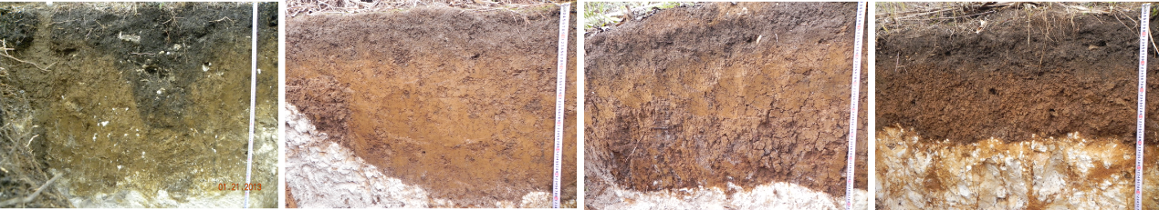
Lower-slope (moderate drained Semi-alfisol)
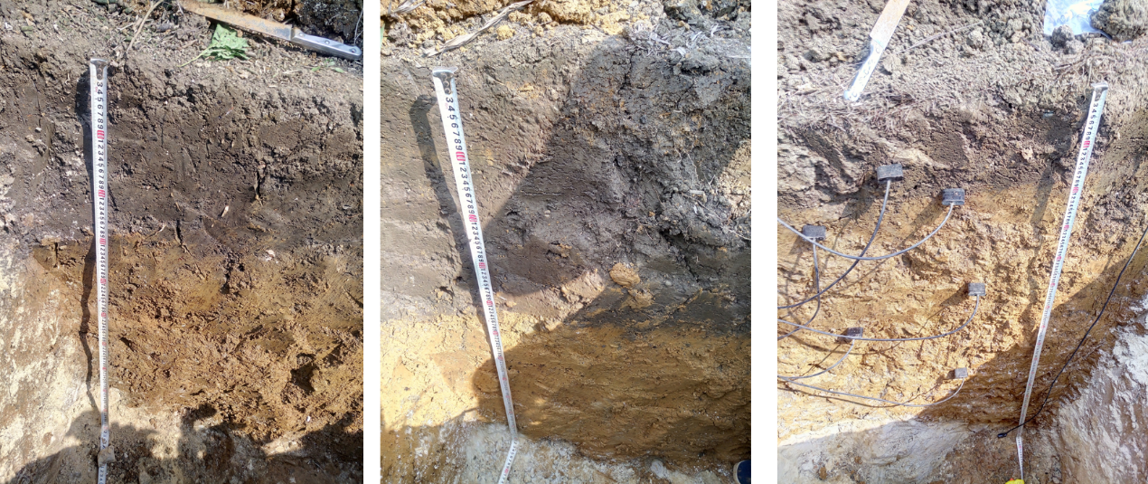
Depression (poorly drained Alfiso)

Table S2 Pedon scale average nutrient content of gravel (>2mm) component
Topographic position  （soil type） | Soil profile | TN  (g/kg) | TP  (g/kg) | TK  (g/kg) | organic matter  (g/kg)
upper-slope | U1 | 0.0023 | 0.0041 | 0.0020 | 0.0079
(Entisol) | U2 | 0.0015 | 0.0057 | 0.0000 | 0.0046
 | U3 | 0.0010 | 0.0008 | 0.0000 | 0.0000
middle-slope | M1 | 0.0041 | 0.0010 | 0.0000 | 0.0009
(Inceptisol) | M2 | 0.0025 | 0.0095 | 0.0000 | 0.0009
 | M3 | 0.0033 | 0.0021 | 0.0000 | 0.0068
 | M4 | 0.0016 | 0.0000 | 0.0000 | 0.0000
lower-slope | L1 | 0.0023 | 0.0023 | 0.0000 | 0.0079
(Semi-alfisol) | L2 | 0.0017 | 0.0000 | 0.0000 | 0.0013
 | L3 | 0.0029 | 0.0000 | 0.0000 | 0.0026
 | L4 | 0.0017 | 0.0000 | 0.0000 | 0.0033
depression | D1 | 0.0021 | 0.0070 | 0.0002 | 0.0029
（Alfisol） | D2 | 0.0036 | 0.0022 | 0.0005 | 0.0000
 | D3 | 0.0025 | 0.0036 | 0.0015 | 0.0059

Table S3 Soil genetic horizon chemical properties for different topographic positions
Topographic position  (soil type) | Soil profile | Soil genetic horizons | Soil thickness (cm) | TN  (g/kg) | TP  (g/kg) | TK  (g/kg) | Organic matter  (g/kg) | TN  (kg/m²) | TP  (kg/m²) | TK  (kg/m²) | Organic matter  (kg/m²)
Upper  -Slope  (Entisol) | U1 | A | 0-25 | 4.53 | 1.12 | 5.92 | 49.16 | 0.33 | 0.08 | 0.44 | 3.62
Upper  -Slope  (Entisol) | U1 | C | 25-59 | 3.80 | 0.44 | 0.49 | 8.98 | 0.59 | 0.07 | 0.08 | 1.39
Upper  -Slope  (Entisol) | U2 | A | 0-17 | 4.45 | 0.99 | 5.09 | 30.89 | 0.44 | 0.10 | 0.50 | 3.04
Upper  -Slope  (Entisol) | U2 | AC | 17-42 | 1.41 | 0.50 | 2.94 | 10.23 | 0.10 | 0.04 | 0.21 | 0.72
Upper  -Slope  (Entisol) | U2 | C | 42-69 | 0.01 | 0.06 | 0.00 | 2.75 | 0.00 | 0.00 | 0.00 | 0.14
Upper  -Slope  (Entisol) | U3 | A | 0-22 | 3.76 | 1.09 | 0.90 | 42.00 | 0.17 | 0.05 | 0.04 | 1.92
Upper  -Slope  (Entisol) | U3 | AC | 22-40 | 1.90 | 0.15 | 0.00 | 2.53 | 0.07 | 0.01 | 0.00 | 0.09
Upper  -Slope  (Entisol) | U3 | C | >40 | n.a. | n.a. | n.a. | n.a. | n.a. | n.a. | n.a. | n.a.
Middle  -Slope  (Inceptisol) | M1 | A | 0-22 | 3.77 | 1.58 | 3.67 | 53.41 | 0.23 | 0.10 | 0.23 | 3.32
Middle  -Slope  (Inceptisol) | M1 | AC | 22-48 | 1.89 | 0.86 | 1.37 | 47.64 | 0.24 | 0.11 | 0.17 | 5.97
Middle  -Slope  (Inceptisol) | M1 | C | 48-71 | 0.92 | 0.21 | 0.00 | 3.82 | 0.03 | 0.01 | 0.00 | 0.13
Middle  -Slope  (Inceptisol) | M2 | A | 0-25 | 3.52 | 1.05 | 8.65 | 36.20 | 0.37 | 0.11 | 0.90 | 3.76
Middle  -Slope  (Inceptisol) | M2 | AC | 25-51 | 3.44 | 0.57 | 10.34 | 11.99 | 0.29 | 0.05 | 0.88 | 1.01
Middle  -Slope  (Inceptisol) | M2 | C | 51-72 | 1.44 | 0.23 | 0.00 | 3.49 | 0.10 | 0.02 | 0.00 | 0.25
Middle  -Slope  (Inceptisol) | M3 | A | 0-18 | 3.60 | 1.09 | 11.48 | 44.90 | 0.27 | 0.08 | 0.87 | 3.39
Middle  -Slope  (Inceptisol) | M3 | AC | 18-53 | 0.33 | 0.31 | 0.00 | 8.32 | 0.03 | 0.03 | 0.00 | 0.70
Middle  -Slope  (Inceptisol) | M3 | C | 53-75 | 0.08 | 0.06 | 0.00 | 3.07 | 0.00 | 0.00 | 0.00 | 0.06
Middle  -Slope  (Inceptisol) | M4 | A | 0-40 | 1.98 | 1.02 | 0.58 | 41.03 | 0.08 | 0.04 | 0.02 | 1.59
Middle  -Slope  (Inceptisol) | M4 | AC | 40-60 | 1.20 | 0.47 | 0.00 | 16.79 | 0.06 | 0.02 | 0.00 | 0.83
Middle  -Slope  (Inceptisol) | M4 | C | >60 | n.a. | n.a. | n.a. | n.a. | n.a. | n.a. | n.a. | n.a.
Lower  -Slope  (Semi-alfisol) | L1 | A | 0-20 | 4.19 | 1.26 | 5.46 | 38.31 | 0.84 | 0.25 | 1.09 | 7.68
Lower  -Slope  (Semi-alfisol) | L1 | B | 20-45 | 0.57 | 1.21 | 1.27 | 24.38 | 0.16 | 0.35 | 0.37 | 7.04
Lower  -Slope  (Semi-alfisol) | L1 | C | 45-80 | 1.21 | 0.21 | 0.00 | 3.87 | 0.61 | 0.11 | 0.00 | 1.96
Lower  -Slope  (Semi-alfisol) | L2 | A | 0-25 | 1.45 | 1.20 | 9.99 | 42.93 | 0.37 | 0.31 | 2.54 | 10.91
Lower  -Slope  (Semi-alfisol) | L2 | B | 25-61 | 0.32 | 0.77 | 5.30 | 19.99 | 0.14 | 0.33 | 2.25 | 8.48
Lower  -Slope  (Semi-alfisol) | L2 | C | >61 | n.a. | n.a. | n.a. | n.a. | n.a. | n.a. | n.a. | n.a.
Lower  -Slope  (Semi-alfisol) | L3 | A | 0-15 | 2.89 | 1.15 | 11.21 | 43.59 | 0.47 | 0.19 | 1.82 | 7.06
Lower  -Slope  (Semi-alfisol) | L3 | B | 15-90 | 4.33 | 0.75 | 10.55 | 17.90 | 3.90 | 0.68 | 9.51 | 16.14
Lower  -Slope  (Semi-alfisol) | L3 | C | >90 | n.a. | n.a. | n.a. | n.a. | n.a. | n.a. | n.a. | n.a.
Lower  -Slope  (Semi-alfisol) | L4 | A | 0-15 | 3.65 | 1.16 | 9.79 | 45.86 | 0.57 | 0.18 | 1.54 | 7.21
Lower  -Slope  (Semi-alfisol) | L4 | B | 15-71 | 0.11 | 0.75 | 8.18 | 16.76 | 0.07 | 0.49 | 5.35 | 10.96
Lower  -Slope  (Semi-alfisol) | L4 | C | >71 | n.a. | n.a. | n.a. | n.a. | n.a. | n.a. | n.a. | n.a.
Depression  (Alfisol) | D1 | A | 0-20 | 1.70 | 0.83 | 5.86 | 36.52 | 0.42 | 0.21 | 1.46 | 9.11
Depression  (Alfisol) | D1 | B | 20-100 | 1.31 | 0.69 | 6.18 | 24.72 | 1.27 | 0.67 | 5.97 | 23.88
Depression  (Alfisol) | D1 | C | 100-120 | 0.10 | 0.27 | 4.31 | 18.79 | 0.03 | 0.07 | 1.15 | 4.99
Depression  (Alfisol) | D2 | A | 0-25 | 1.79 | 1.15 | 7.31 | 42.46 | 0.57 | 0.37 | 2.32 | 13.49
Depression  (Alfisol) | D2 | B | 25-110 | 1.71 | 1.03 | 7.31 | 36.63 | 1.88 | 1.14 | 8.04 | 40.32
Depression  (Alfisol) | D2 | C | 110-120 | 1.09 | 0.81 | 2.85 | 24.85 | 0.16 | 0.12 | 0.41 | 3.58
Depression  (Alfisol) | D3 | A | 0-28 | 1.72 | 0.94 | 6.37 | 37.34 | 0.63 | 0.35 | 2.35 | 13.78
Depression  (Alfisol) | D3 | B | 28-97 | 1.24 | 0.62 | 4.97 | 25.31 | 1.21 | 0.60 | 4.83 | 24.61
Depression  (Alfisol) | D3 | C | 97-113 | 0.23 | 0.28 | 3.31 | 19.73 | 0.05 | 0.06 | 0.73 | 4.35
n.a.: not analysed.

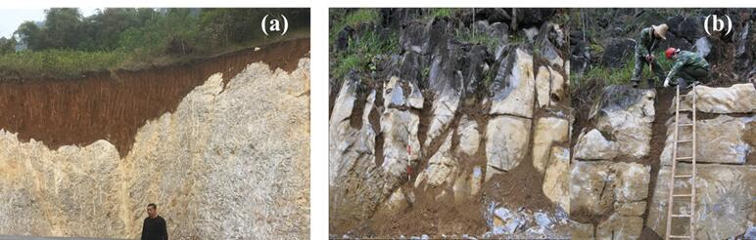
Fig S1 The difference structures of soil-epikarst system in dolomite and limestone slopes
- dolomite slope (b)limestone slope

