Supplementary

Table 1. Comparison of cognitive performance between baseline and follow-up
 | Baseline | Follow up | p
MMSE | 23.43±4.69 | 22.57±6.53 | 0.198
AVLT_LDR | 1.39±2.43 | 1.65±2.4 | 0.162
AVLT_REC | 16.74±3.71 | 17.22±3.73 | 0.522
Total_AVLT | 32.35±14.49 | 32.48±14.30 | 0.950
AFT | 11.61±6.26 | 11.39±5.77 | 0.729
BNT | 20.09±5.00 | 19.30±6.54 | 0.165
STT A | 98.52±41.54 | 96.13±37.05 | 0.695
STT B | 203.74±78.04 | 204.17±103.70 | 0.980
HpVr | 3.70±0.43 | 3.552±0.447 | ＜0.001
Data are presented as mean ± standard deviation. Paired samples t-tests were used to compare baseline and follow-up measurements within the CI group. Abbreviations: MMSE, Mini-Mental State Examination; AVLT-LDR, Auditory Verbal learning Test long time delayed free-recall; AVLT-REC, Auditory Verbal Learning Test recognition scores (24 items); AFT, animal fluency test; BNT, Boston Naming Test; STT A, shape trials test Part A; STT B, shape trials Part B; HpVr, hippocampal volume ratio.

Table 2. Regional [¹⁸F] PSS232 SUVr in CU and CI Participants at baseline and follow-up

 | CU | CI_base | CI_follow | p_{（CU vs CI_base)} | p_{（CU vs CI_FU)} | p_{（CI_base vs CI_FU)}
Frontal | 1.763±0.196 | 1.629±0.220 | 1.463±0.151 | 0.063 | ＜0.001 | ＜0.001
Hippocampus | 2.191±0.185 | 1.948±0.198 | 1.793±0.191 | ＜0.001 | ＜0.001 | ＜0.001
ParaHippocampus | 2.086±0.140 | 1.966±0.216 | 1.841±0.204 | 0.064 | ＜0.001 | 0.001
Occipital | 1.590±0.157 | 1.484±0.155 | 1.418±0.139 | 0.048 | 0.001 | 0.025
Parietal | 1.745±0.207 | 1.612±0.195 | 1.454±0.155 | 0.053 | ＜0.001 | ＜0.001
PosteriorCingulate | 1.766±0.223 | 1.642±0.220 | 1.426±0.154 | 0.098 | ＜0.001 | ＜0.001
Precuneus | 1.731±0.209 | 1.601±0.180 | 1.454±0.157 | 0.048 | ＜0.001 | ＜0.001
TemporalLateral | 1.916±0.146 | 1.816±0.209 | 1.739±0.176 | 0.119 | 0.003 | 0.048
TemporalMedial | 1.978±0.124 | 1.869±0.204 | 1.760±0.179 | 0.073 | ＜0.001 | 0.003

Data are presented as mean ± standard deviation. p-values represent comparisons between CU and CI groups at baseline (CU vs CI_base) and follow-up (CU vs CI_follow), and longitudinal changes within the CI group (CI_base vs CI_follow) using independent samples t-tests and paired t-tests, respectively. Statistical significance was set at α = 0.0167 (Bonferroni correction for three comparisons per region). Abbreviations: CU, cognitively unimpaired; CI, cognitively impaired; SUVr, standardized uptake value ratio; base, baseline; follow, follow-up.

Table 3. Partial correlation analysis between baseline [¹⁸F] PSS232 SUVr and cognition change rate.

 |  | Frontal | Hippocampus | ParaHippocampus | Occipital | Parietal | Posterior  Cingulate | Precuneus | Temporal  Lateral | Temporal  Medial
MMSE | r_{cov} | -0.325 | 0.041 | -0.091 | -0.303 | -0.335 | -0.149 | -0.394 | -0.290 | -0.218
MMSE | p_{cov} | 0.163 | 0.864 | 0.704 | 0.195 | 0.149 | 0.530 | 0.086 | 0.214 | 0.355
STT A | r_{cov} | 0.111 | 0.244 | 0.313 | 0.169 | 0.134 | 0.074 | 0.184 | 0.324 | 0.368
STT A | p_{cov} | 0.640 | 0.299 | 0.180 | 0.476 | 0.574 | 0.757 | 0.438 | 0.164 | 0.110
STT B | r_{cov} | 0.185 | -0.020 | 0.140 | 0.148 | 0.129 | 0.216 | 0.158 | 0.026 | 0.164
STT B | p_{cov} | 0.436 | 0.933 | 0.556 | 0.532 | 0.589 | 0.360 | 0.506 | 0.915 | 0.490
AVLT LDR | r_{cov} | -0.297 | 0.540 | 0.178 | -0.684 | -0.460 | -0.297 | -0.297 | -0.306 | 0.180
AVLT LDR | p_{cov} | 0.628 | 0.347 | 0.775 | 0.203 | 0.436 | 0.628 | 0.628 | 0.616 | 0.773
AVLT REC | r_{cov} | -0.515 | -0.473 | -0.357 | -0.458 | -0.526 | -0.370 | -0.517 | -0.530 | -0.416
AVLT REC | p_{cov} | 0.020 | 0.035 | 0.122 | 0.042 | 0.017 | 0.108 | 0.020 | 0.016 | 0.068
AVLT Total | r_{cov} | -0.458 | -0.281 | -0.317 | -0.443 | -0.455 | -0.344 | -0.397 | -0.515 | -0.434
AVLT Total | p_{cov} | 0.042 | 0.230 | 0.174 | 0.051 | 0.044 | 0.138 | 0.083 | 0.020 | 0.056
BNT | r_{cov} | -0.405 | -0.586 | -0.451 | -0.559 | -0.452 | -0.498 | -0.441 | -0.414 | -0.418
BNT | p_{cov} | 0.077 | 0.007 | 0.046 | 0.010 | 0.045 | 0.025 | 0.051 | 0.069 | 0.066
AFT | r_{cov} | -0.616 | -0.487 | -0.510 | -0.673 | -0.645 | -0.539 | -0.680 | -0.682 | -0.634
AFT | p_{cov} | 0.005 | 0.034 | 0.026 | 0.002 | 0.003 | 0.017 | 0.001 | 0.001 | 0.004
Abbreviations: MMSE, Mini-Mental State Examination; AVLT-LDR, Auditory Verbal learning Test long time delayed free-recall; AVLT-REC, Auditory Verbal Learning Test recognition scores (24 items); AFT, animal fluency test; BNT, Boston Naming Test; STT A, shape trials test Part A; STT B, shape trials Part B; HpVr, hippocampal volume ratio.

Figure 1. Longitudinal mGluR5 loss is greater in visually amyloid positive CI patients.
VOI-based plots showing longitudinal changes in mGluR5 availability across nine brain regions in CI patients. Participants were stratified by visual assessment of Aβ PET imaging into an Aβ-positive group (Aβ+visual; red) and a visually Aβ-negative group (Aβ-visual; blue). The results from paired t-tests (p-values shown) demonstrate a significant and widespread longitudinal decline in mGluR5 availability in the visually Aβ-positive group across most regions. Abbreviations: CI, Cognitively Impaired; SUVr, Standardized Uptake Value ratio.

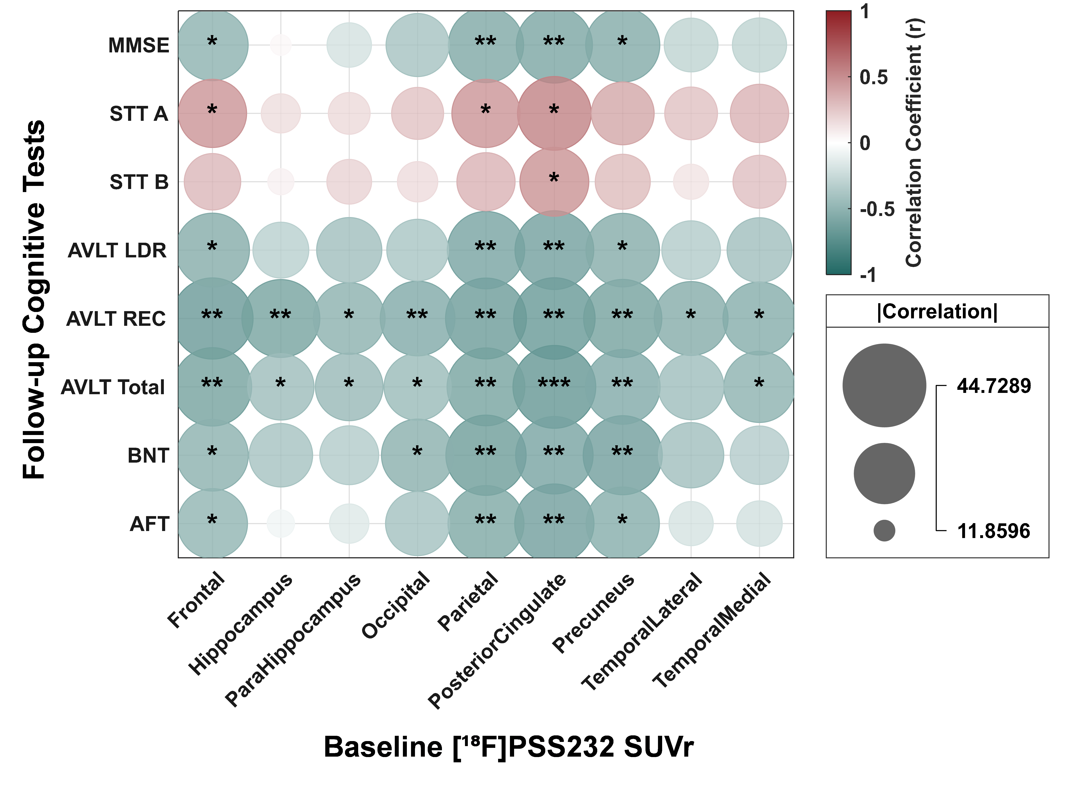
Figure 2. Partial correlation analysis between baseline [¹⁸F] PSS232 SUVr and follow-up cognitive performance.
The partial correlations (adjusted for age, sex, and education) between baseline mGluR5 availability and cognitive test scores at follow-up. Each bubble represents a correlation coefficient, with bubble size proportional to the absolute correlation strength and color indicating the direction and magnitude of the relationship. Bubble Size = |r| × 50 + 10. * p < 0.05, ** p < 0.01, *** p < 0.001, **** p < 0.0001.
Abbreviations: MMSE, Mini-Mental State Examination; STT A B, Shape trials test A and B; AVLT-LDR, Auditory Verbal learning Test long time delayed free-recall; AVLT-REC, Auditory Verbal Learning Test recognition scores (24 items); BNT, Boston Naming Test; AFT, Animal Fluency Test.

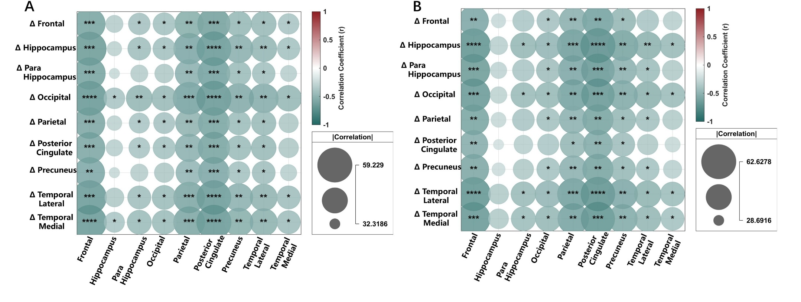
Figure 3. Correlations between baseline regional [¹⁸F]PSS232 SUVr and its longitudinal change (ΔSUVr) across brain regions. (A) Unadjusted Pearson correlations. (B) Partial correlations adjusted for age, sex, and education. Each bubble represents a correlation coefficient, with bubble size proportional to the absolute correlation strength and color indicating the direction and magnitude of the relationship. Bubble Size = |r| × 50 + 10. * p < 0.05, ** p < 0.01, *** p < 0.001, **** p < 0.0001.

