Supplementary material
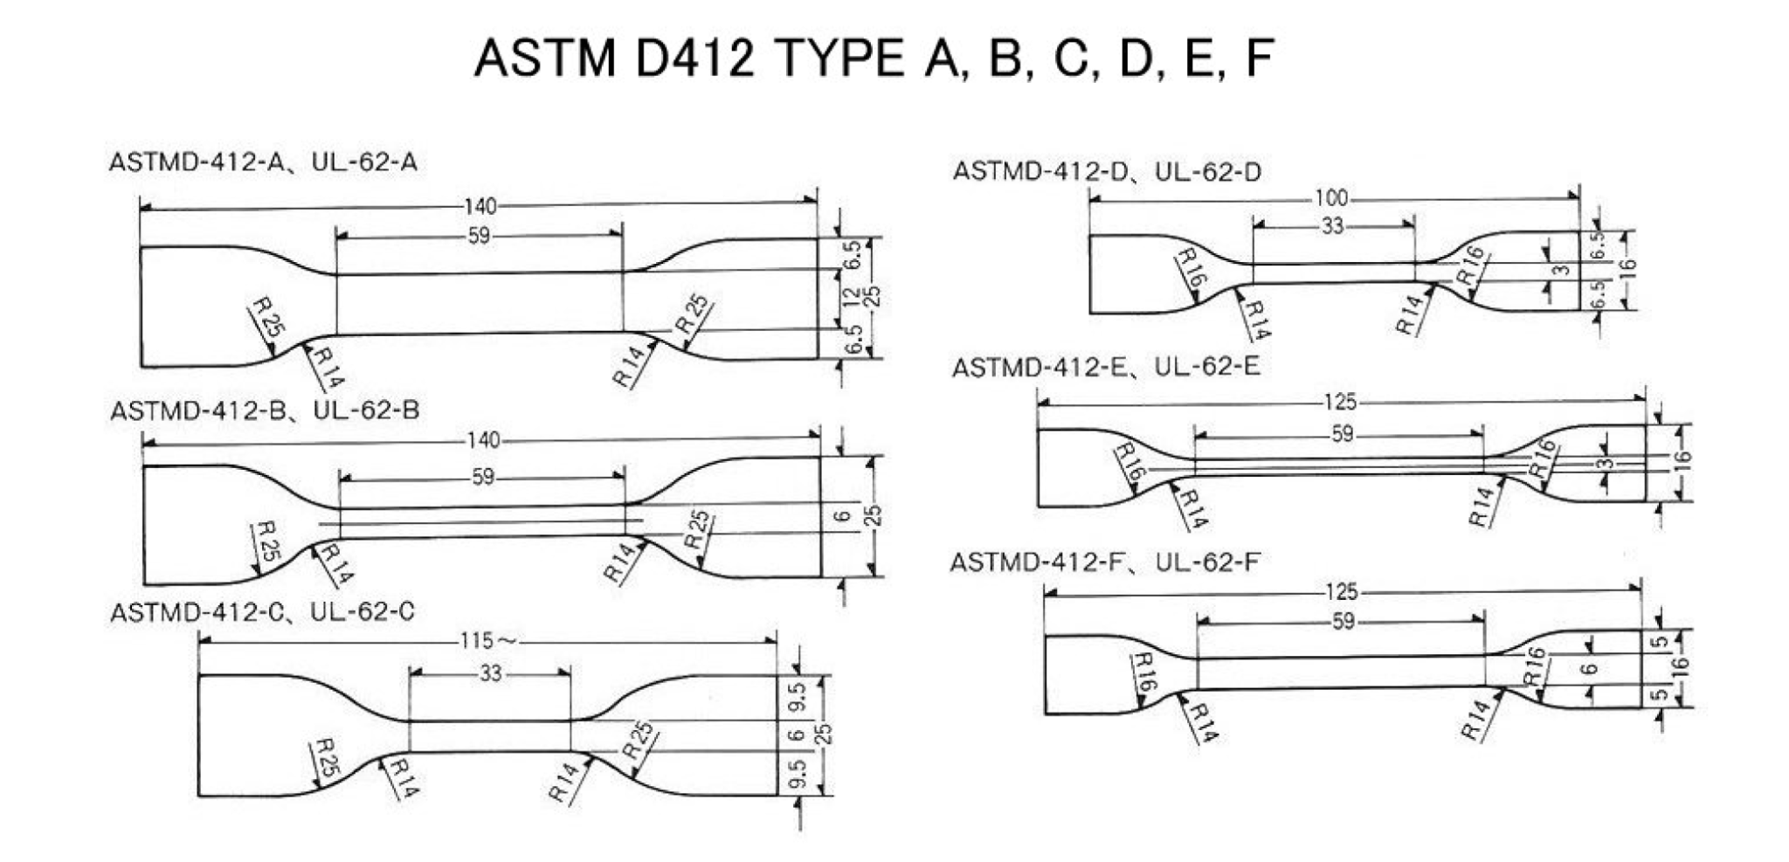
Supplementary Figure 1. Dimensions of ASTM D412 specimen types A, B, C, D, E, and F. The Type C geometry used in the present study is included among the standardized dumbbell-shaped specimens.

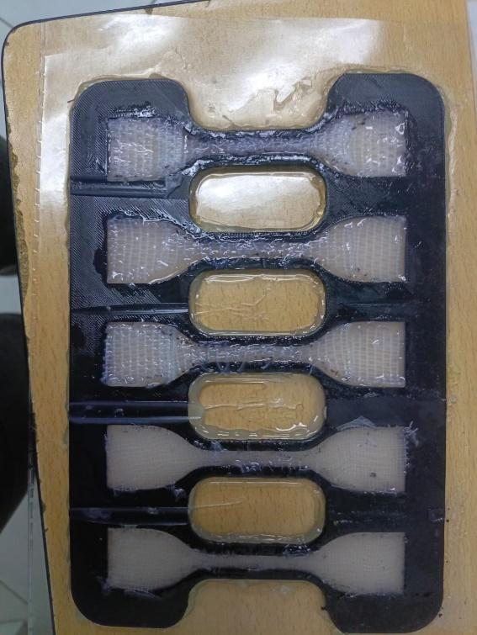
Supplementary Figure 2. Biopolymer laminate specimens fabricated using a 3D-printed mold prior to mechanical testing.
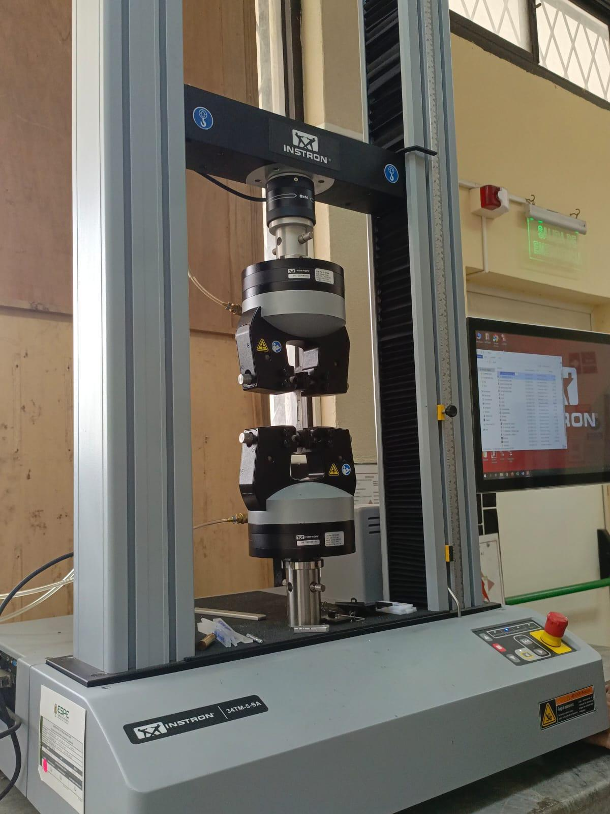
Supplementary Figure 3. Tensile testing setup using an Instron universal testing machine for mechanical characterization of the fabricated specimens.
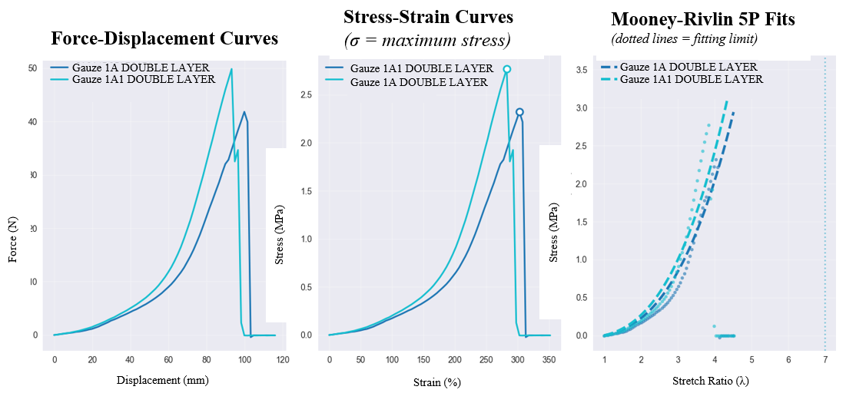

Supplementary Figure 4. Tensile test results for Gauze Family 1 in the double-layer configuration.
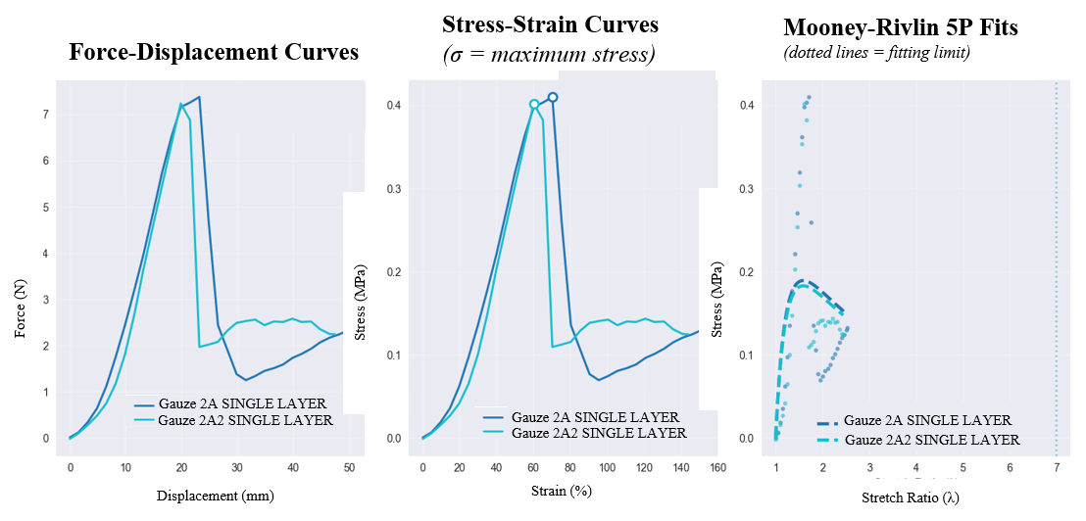
Supplementary Figure 5. Tensile test results for Gauze Family 2 in the single-layer configuration.
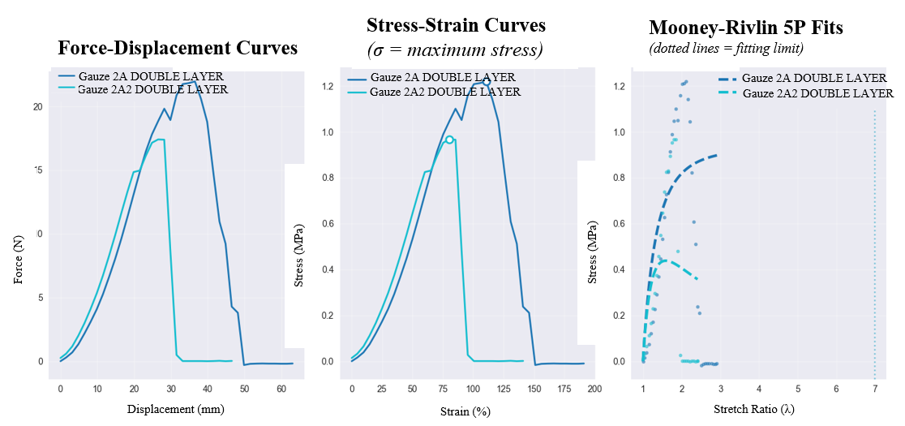
Supplementary Figure 6. Tensile test results for Gauze Family 2 in the double-layer configuration.
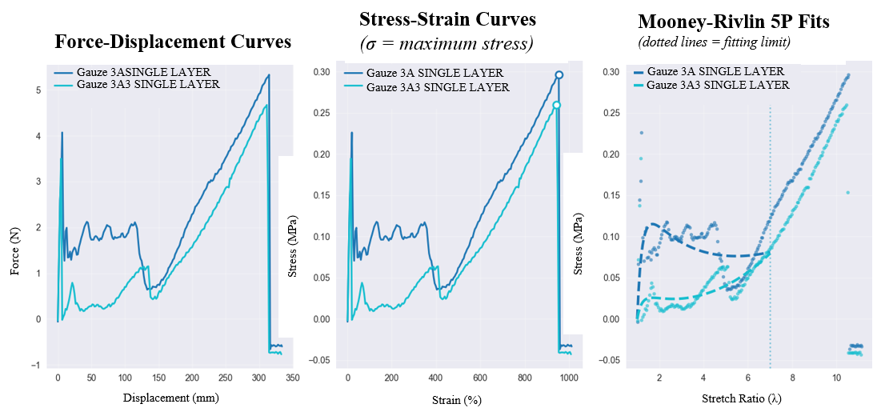
Supplementary Figure 7. Tensile test results for Gauze Family 3 in the single-layer configuration.
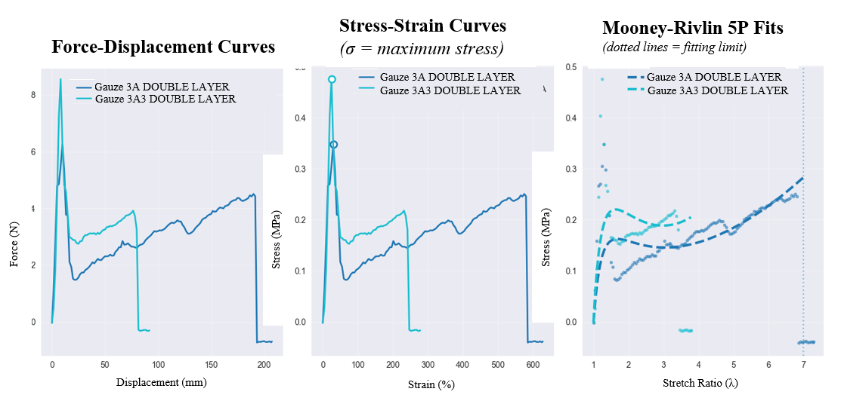

Supplementary Figure 8. Tensile test results for Gauze Family 3 in the double-layer configuration.

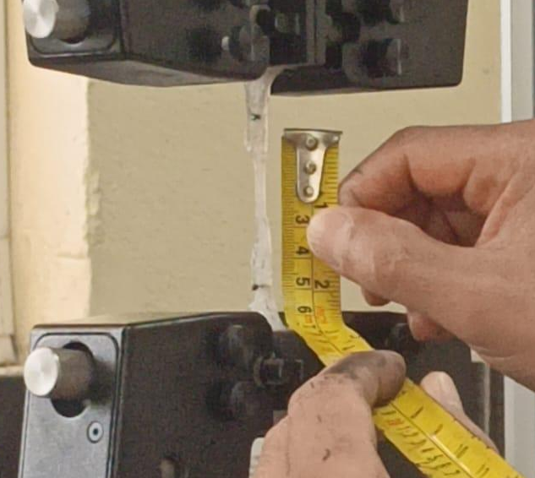

Supplementary Figure 9. Measurement of specimen stretching and deformation during tensile testing.
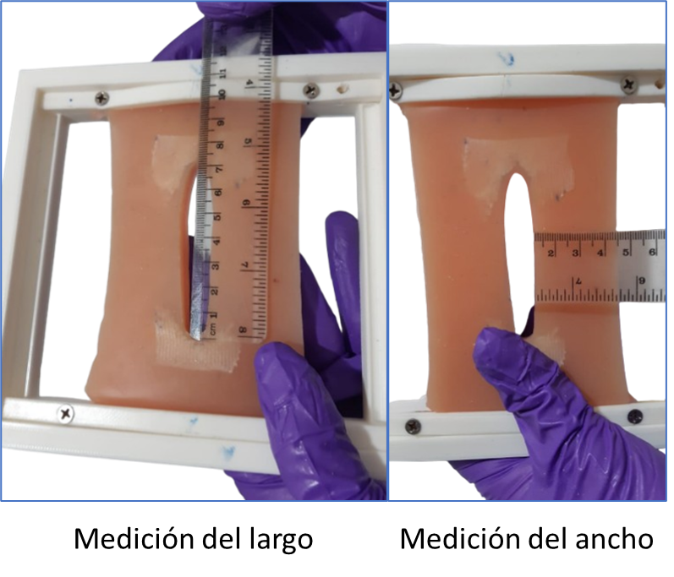
Supplementary Figure 10. Initial measurement of the length and width of the opening in the simulation prototype; Two-panel photograph showing baseline measurement of the prototype opening using a ruler, with one panel measuring length and the other measuring width.
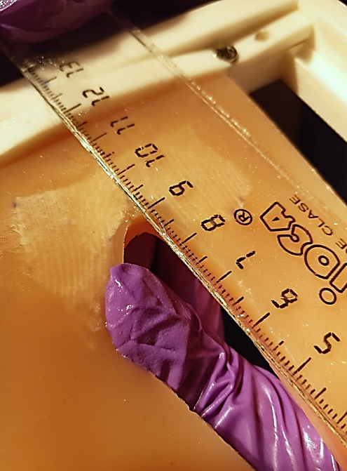´
Supplementary Figure 11. Measurement of the superficial tear in the upper frontal region of the prototype; Close-up photograph showing measurement of a superficial tear in the upper frontal region of the prototype using a ruler.

