PdSn Bimetallic Catalysts Prepared by Electroless Deposition for Enhanced n-Butane Dehydrogenation to Butenes
Hemant K Nayakª and Pramod M Gawal^{a,b*}

ªDepartment of Chemical Engineering, Indian Institute of Technology Guwahati, Assam-781039, India
^{b}Department of Chemistry, Pusan National University, Busan, 46241 South Korea

Table S1. Comparison of the present PdSn catalysts with reported catalysts for n-butane dehydrogenation in terms of synthesis method, reaction conditions, and catalytic performance.
Catalyst | Feed | Feed flow rate (mL/min) | Reaction temp (°C) | Performance |  |  | Ref.
 |  |  |  | Butane conversion (%) | Yield (%) | Selectivity (%) | Ref.
PdSn/AlS | C₄H₁₀:H₂: N₂ = 1:3:6 | 100 | 550 | 56.85 | 39.3 | 53.35 | Present study
PdSn/Z | C₄H₁₀:H₂: N₂ = 1:3:6 | 100 | 550 | 64.35 | 45.55 | 52.56 | Present study
PdSn/Sl | C₄H₁₀:H₂: N₂ = 1:3:6 | 100 | 550 | 68.33 | 50.65 | 51.81 | Present study
Pd-Pt/Al | C₄H₁₀:H₂: N₂ = 1:3:6 | 100 | 550 | 50 | 42.2 | 86 | [1]
Ni-Fe/CeO₂ | C₄H₁₀:CO₂:Ar = 1:2:17 | 40 | 600 | 18.7 | 6.7 | 30.6 | [2]
Ni-Fe/ZrO₂ | C₄H₁₀:CO₂:Ar = 1:2:17 | 40 | 600 | 35.1 | 1.4 | 85.7 | [2]
Pt-Sn/Al₂O₃ | C₄H₁₀:H₂:N₂ = 1:1:1 | - | 575 | 33.8 | 9.9 | 29.2 | [3]
Cr-V & Cr-V/MCM-41 | - | - | 525-600 | 20.1 | 17.8 | 88.5 | [4]
Pt-Cu/Al₂O_{3,} | C₄H₁₀:H₂:N₂ 1:1:1 | - | 500 | 21.1 | 19.2 | 91.1 | [5]
PdCu/Al₂O₃ | C₄H₁₀:H₂:N₂ 1:1:1 | - | 500 | 16.0 | 14.8 | 92.7 | [5]
Pt-Sn/ZSM-5 | H₂/C₄H₁₀ = 0.25 | - | 585 | 26.6 | 22.9 | 86.31 | [6]

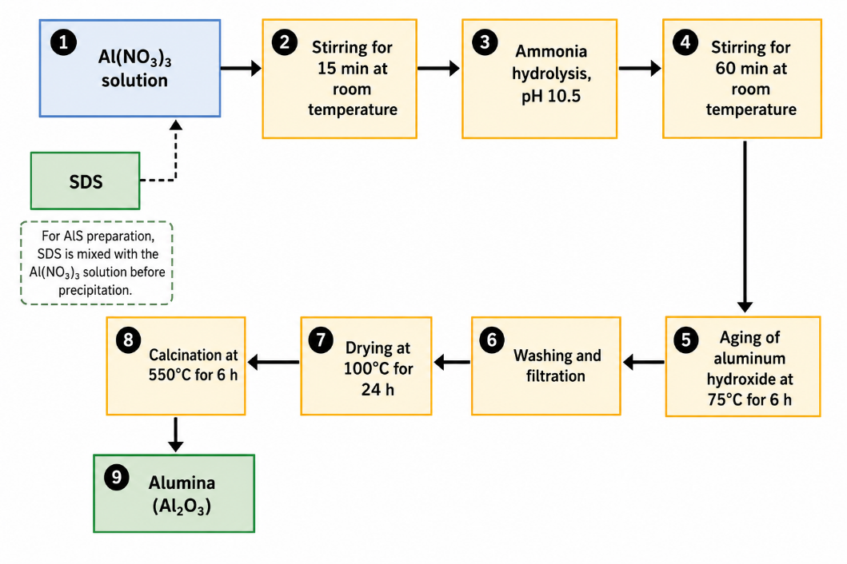
Figure S1. Schematic representation of the synthesis of alumina (Al₂O₃) support by the precipitation method.
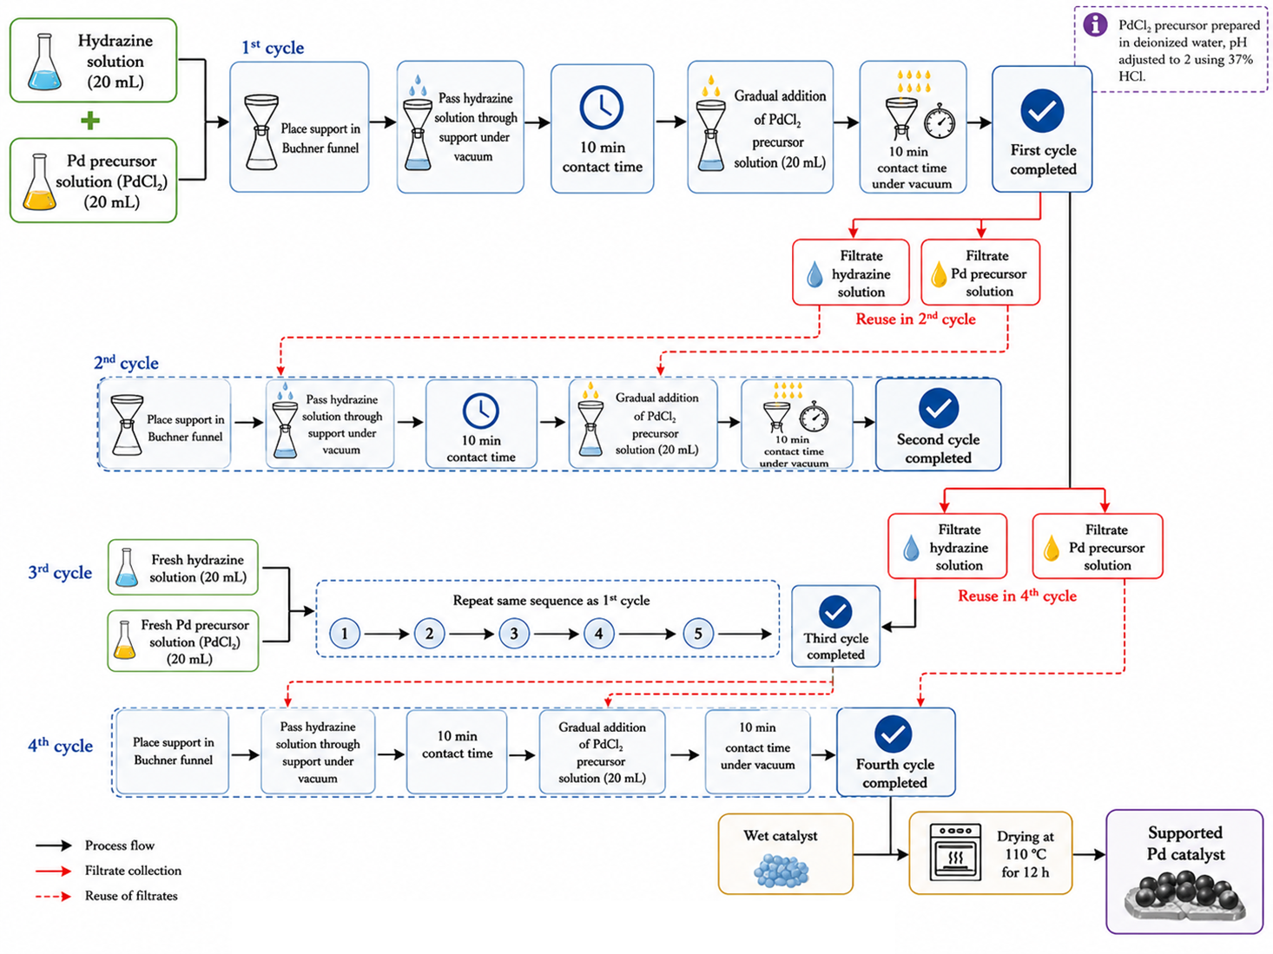

Figure S2. Schematic illustration of the electroless deposition method for the synthesis of supported Pd catalysts.
References
1. Saxena R, De M (2021) Enhanced performance of supported Pd-Pt bimetallic catalysts prepared by modified electroless deposition for butane dehydrogenation. Appl Catal A Gen 610:117933. https://doi.org/10.1016/j.apcata.2020.117933
2. Li X, Yan B, Yao S, et al (2018) Oxidative dehydrogenation and dry reforming of n -butane with CO 2 over NiFe bimetallic catalysts. Appl Catal B Environ 231:213–223. https://doi.org/10.1016/j.apcatb.2018.02.063
3. Natarajan P, Abbas H, Yoon S, Jung K (2018) One-pot synthesis of Pt – Sn bimetallic mesoporous alumina catalysts with worm-like pore structure for n-butane dehydrogenation. J Ind Eng Chem 63:380–390. https://doi.org/10.1016/j.jiec.2018.02.038
4. Ajayi BP, Jermy BR, Ogunronbi KE, Abussaud BA (2013) n-Butane dehydrogenation over mono and bimetallic MCM-41 catalysts under oxygen free atmosphere. Catal Today 204:189–196. https://doi.org/10.1016/j.cattod.2012.07.013
5. Veldurthi S, Shin C, Joo O, Jung K (2012) Promotional effects of Cu on Pt / Al 2 O 3 and Pd / Al 2 O 3 catalysts during n-butane dehydrogenation. Catal Today 185:88–93. https://doi.org/10.1016/j.cattod.2011.11.021
6. Nawaz Z, Qing S, Jixian G, et al (2010) Effect of Si/Al ratio on performance of Pt–Sn-based catalyst supported on ZSM-5 zeolite for n-butane conversion to light olefins. J Ind Eng Chem 16:57–62. https://doi.org/10.1016/j.jiec.2010.01.021

