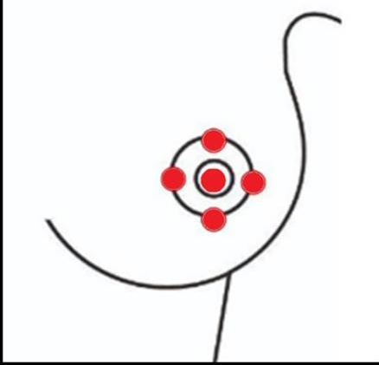
Appendix 1. Demonstration of PBMT application points in nipple trauma.

Source: author, 2024

