Appendix 6. Intergroup comparison of injury severity assessed by the Nipple Trauma Score over time.
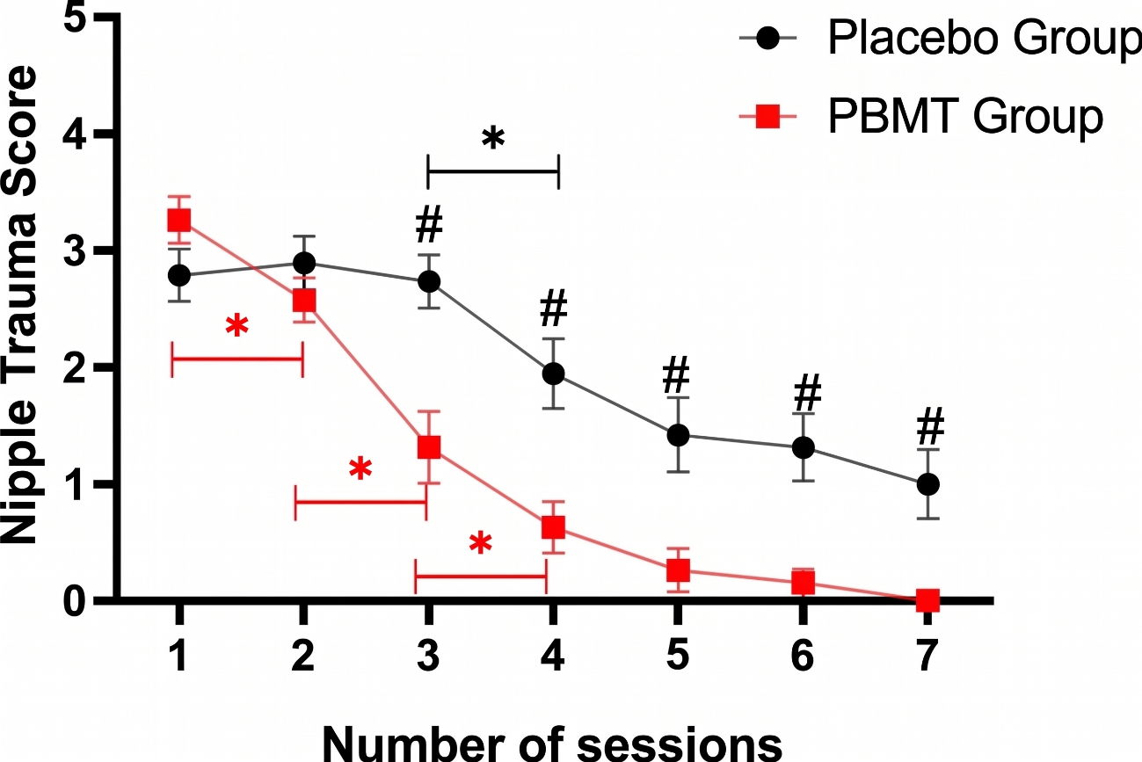Legend: # Statistically significant difference between the groups.

