Appendix 7. Comparison of the evolution of the nipple lesion area (mm²) throughout the sessions in the placebo and PBMT groups.
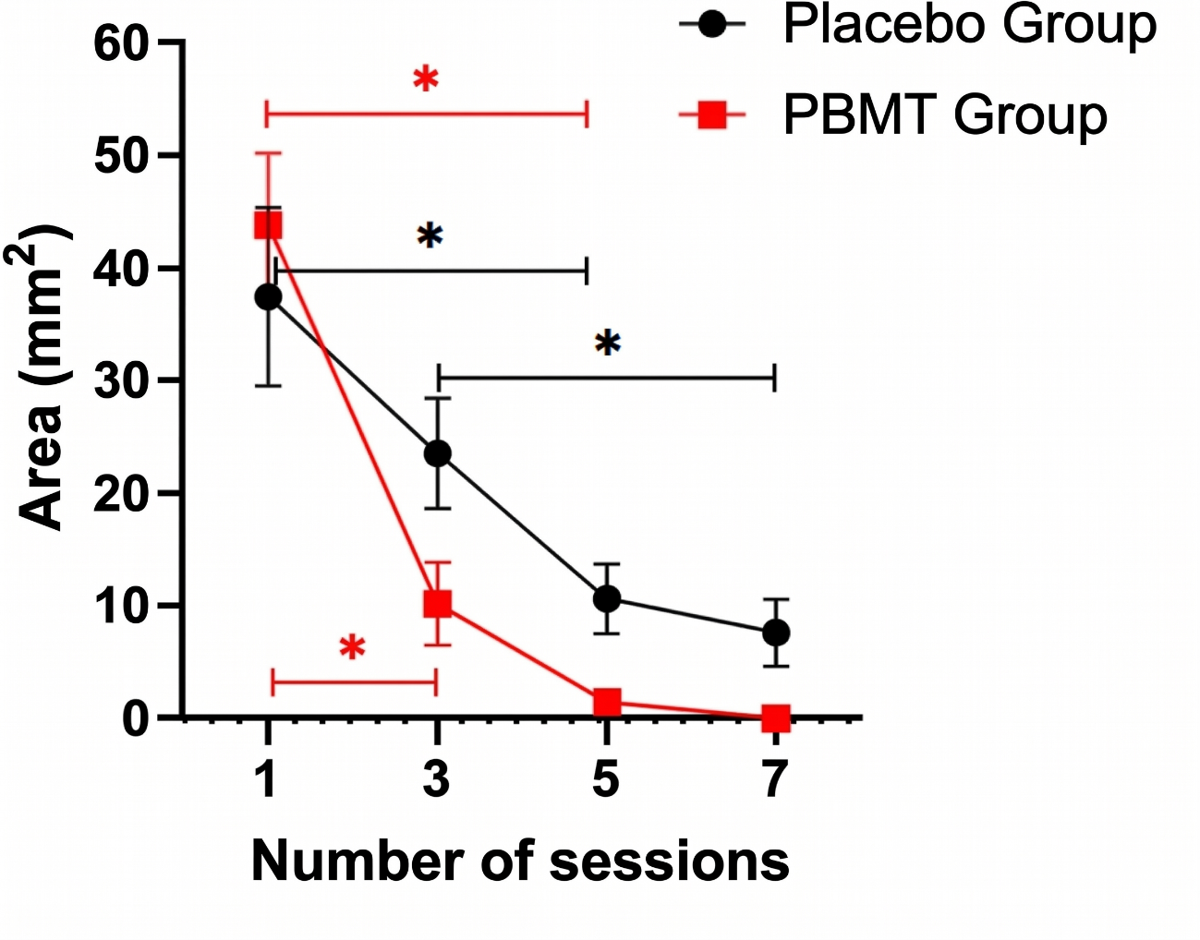
Legend: Mean bars ± standard deviation. * Statistically significant intragroup difference (comparison between sessions within the same group) Source: Authors, 2025.

