Appendix 2. Image analysis and area delimitation using the Quantikov program.
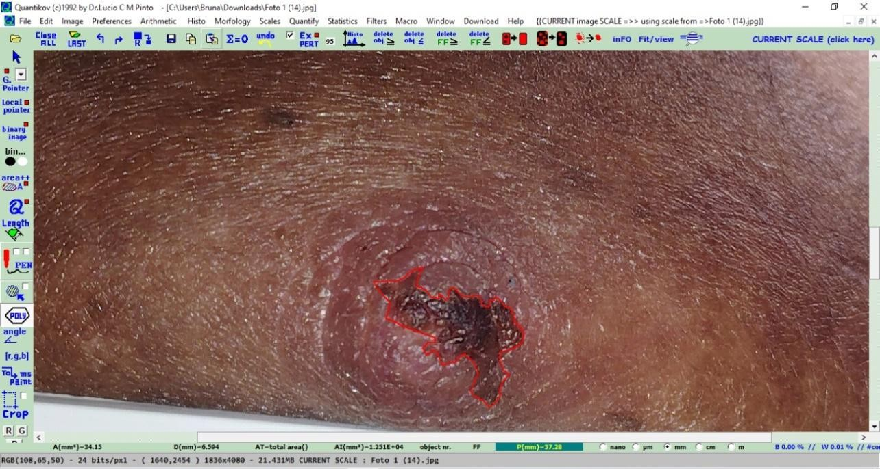

Source: author, 2024.

