Supplementary material for Bacterial DNA invasion triggers transposable element proliferation and genome expansion

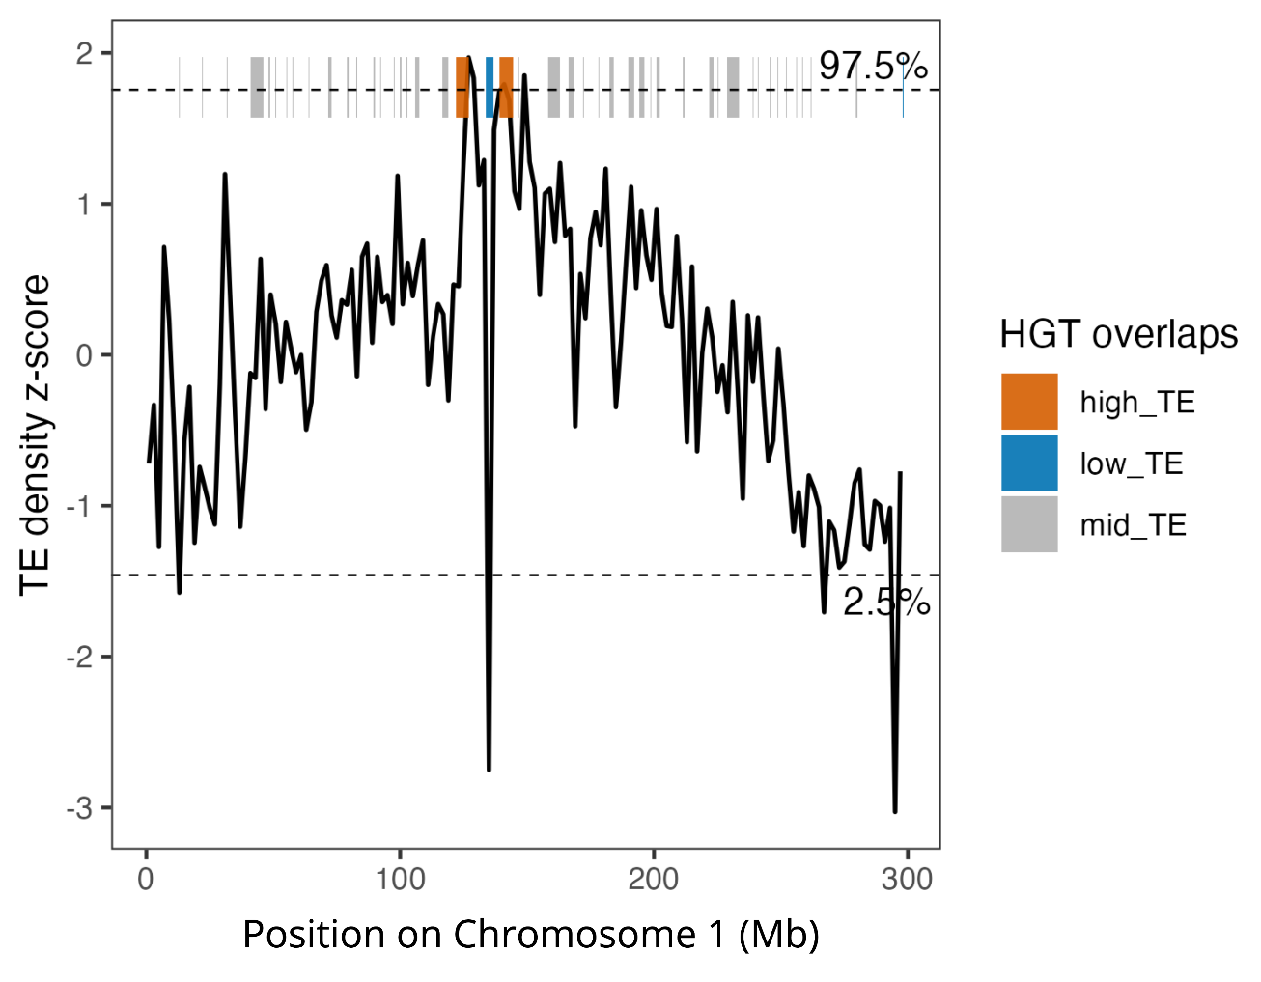
Supplementary Figure 1. Z-score transformed TE density in sliding 2 Mb windows across Chromosome 1 of C. caryae. HGTs located within the upper (97.5th percentile) and lower (2.5th percentile) tails of the TE density distribution are indicated by orange and blue bars, respectively. Gray bars indicate HGTs falling outside these tails.

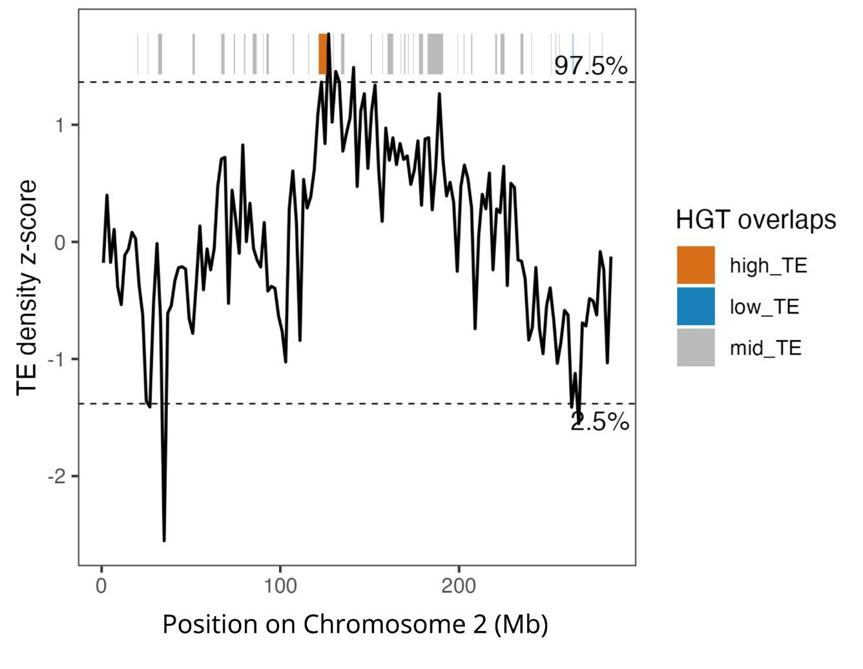
Supplementary Figure 2. Z-score transformed TE density by type in sliding 2 Mb windows across Chromosome 2 of C. caryae. HGTs located within the upper (97.5th percentile) and lower (2.5th percentile) tails of the TE density distribution are indicated by orange and blue bars, respectively. Gray bars indicate HGTs falling outside these tails.

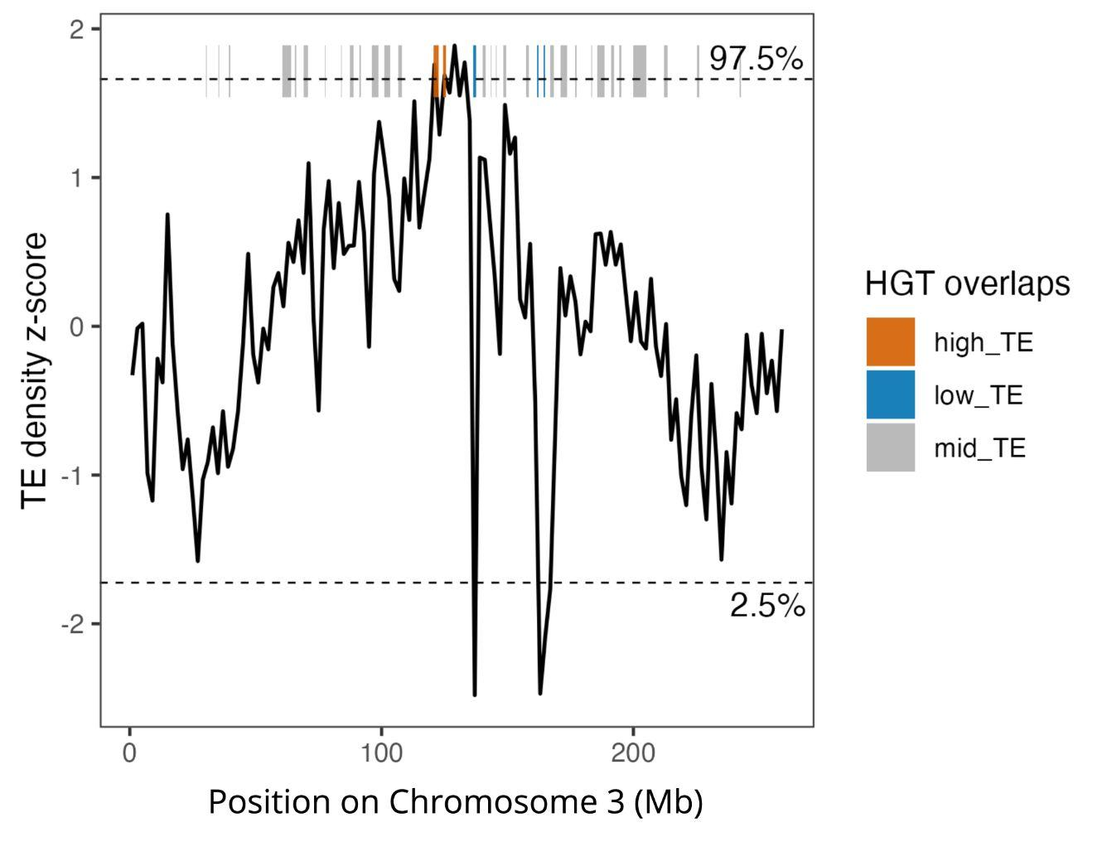
Supplementary Figure 3. Z-score transformed TE density by type in sliding 2 Mb windows across Chromosome 3 of C. caryae. HGTs located within the upper (97.5th percentile) and lower (2.5th percentile) tails of the TE density distribution are indicated by orange and blue bars, respectively. Gray bars indicate HGTs falling outside these tails.

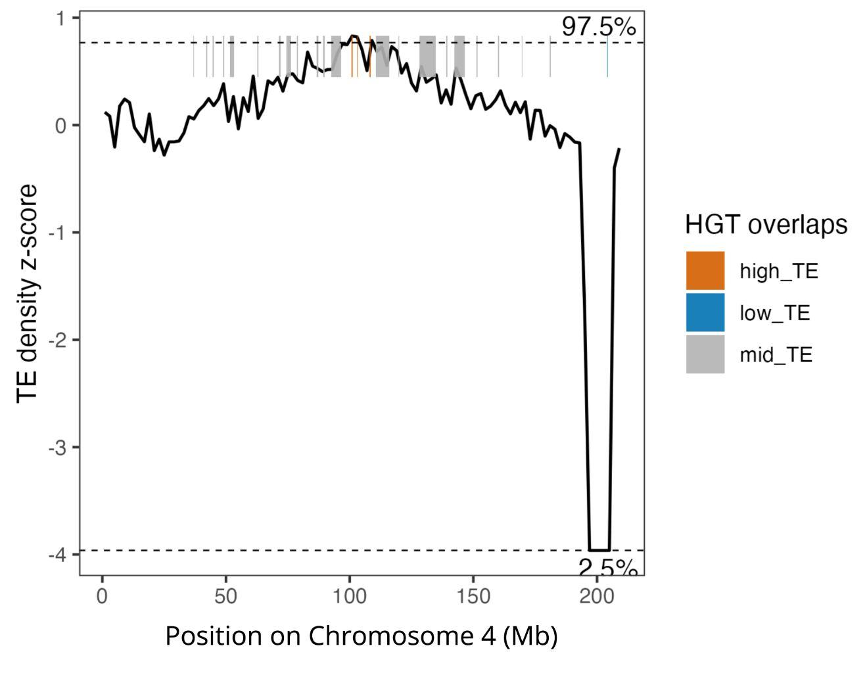
Supplementary Figure 4. Z-score transformed TE density by type in sliding 2 Mb windows across Chromosome 4 of C. caryae. HGTs located within the upper (97.5th percentile) and lower (2.5th percentile) tails of the TE density distribution are indicated by orange and blue bars, respectively. Gray bars indicate HGTs falling outside these tails.

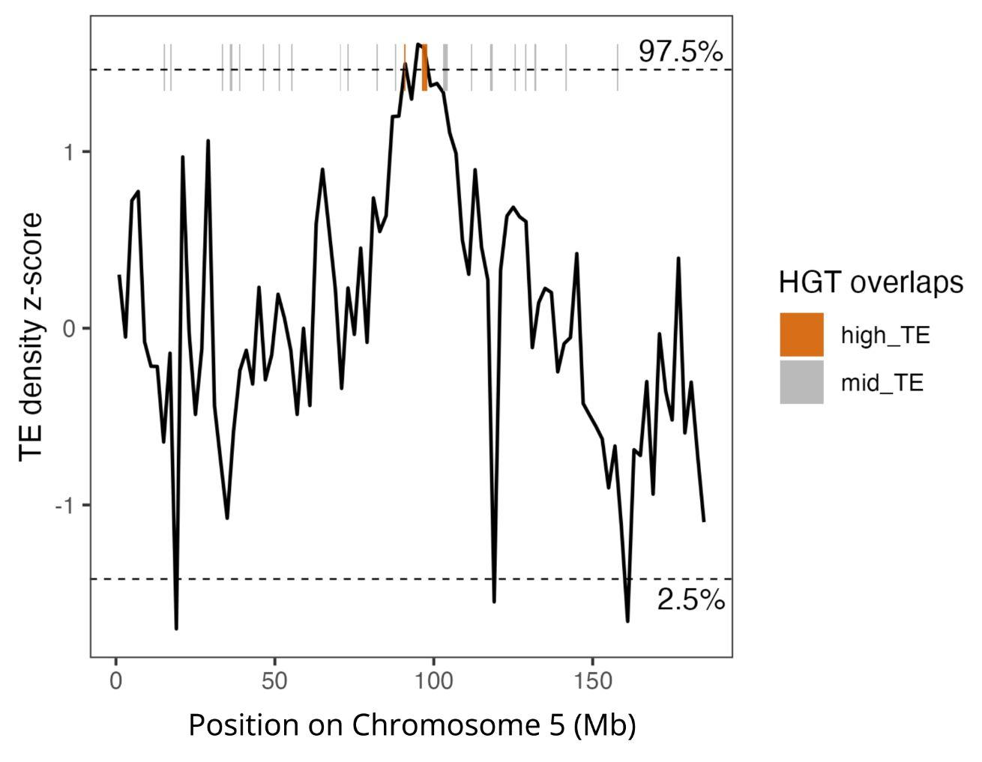
Supplementary Figure 5. Z-score transformed TE density by type in sliding 2 Mb windows across Chromosome 5 of C. caryae. HGTs located within the upper (97.5th percentile) tail of the TE density distribution are indicated by orange bars. Gray bars indicate HGTs falling outside this tail.

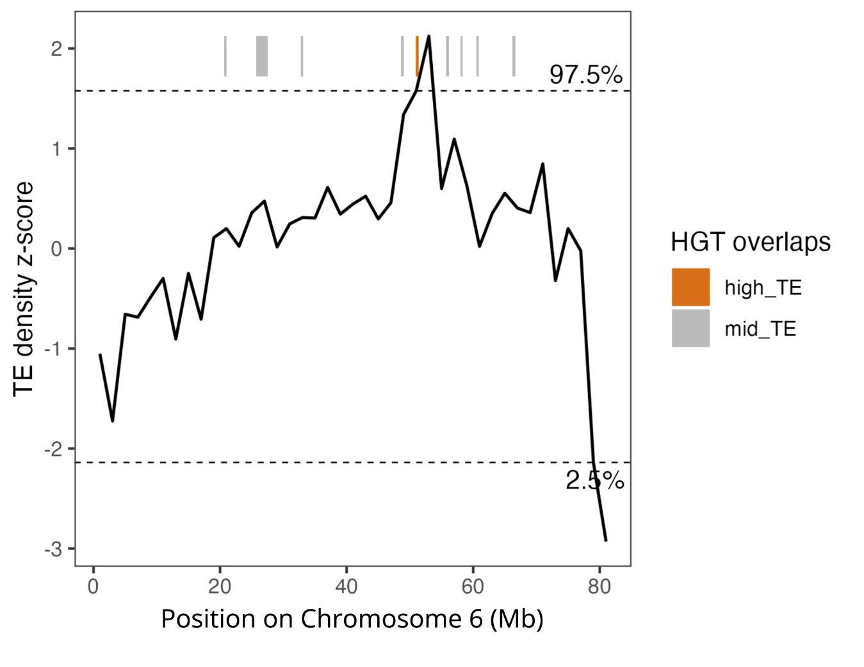
Supplementary Figure 6. Z-score transformed TE density by type in sliding 2 Mb windows across Chromosome 6 of C. caryae. HGTs located within the upper (97.5th percentile) and lower (2.5th percentile) tails of the TE density distribution are indicated by orange and blue bars, respectively. Gray bars indicate HGTs falling outside these tails.

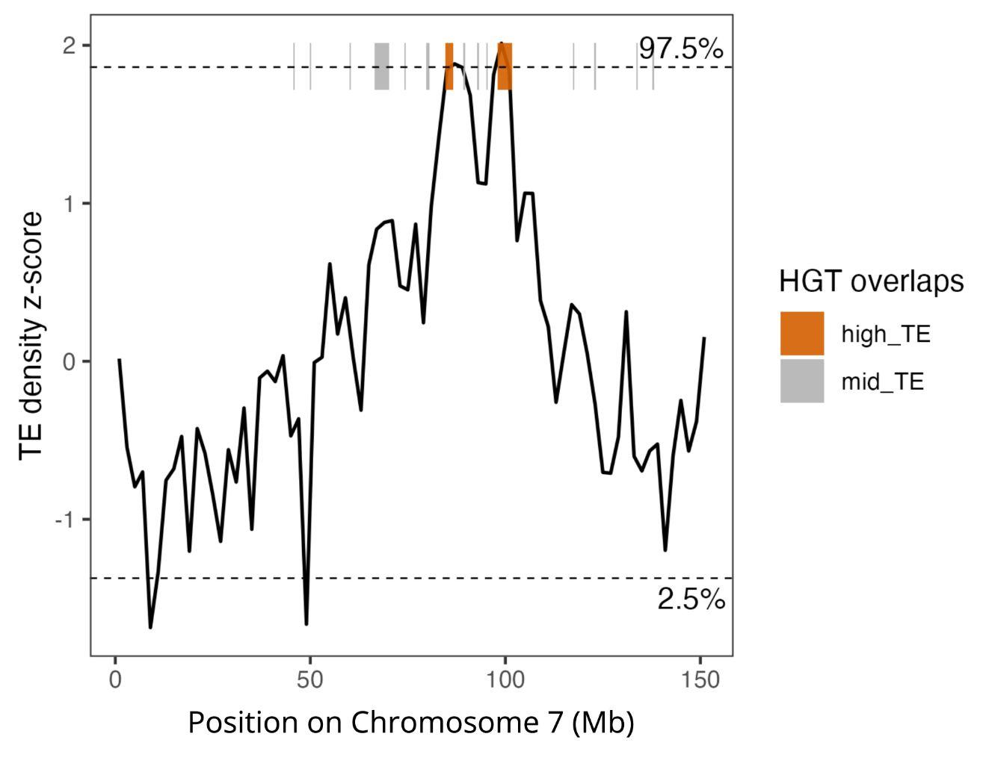
Supplementary Figure 7. Z-score transformed TE density by type in sliding 2 Mb windows across Chromosome 7 of C. caryae. HGTs located within the upper (97.5th percentile) tail of the TE density distribution are indicated by orange bars. Gray bars indicate HGTs falling outside this tail.

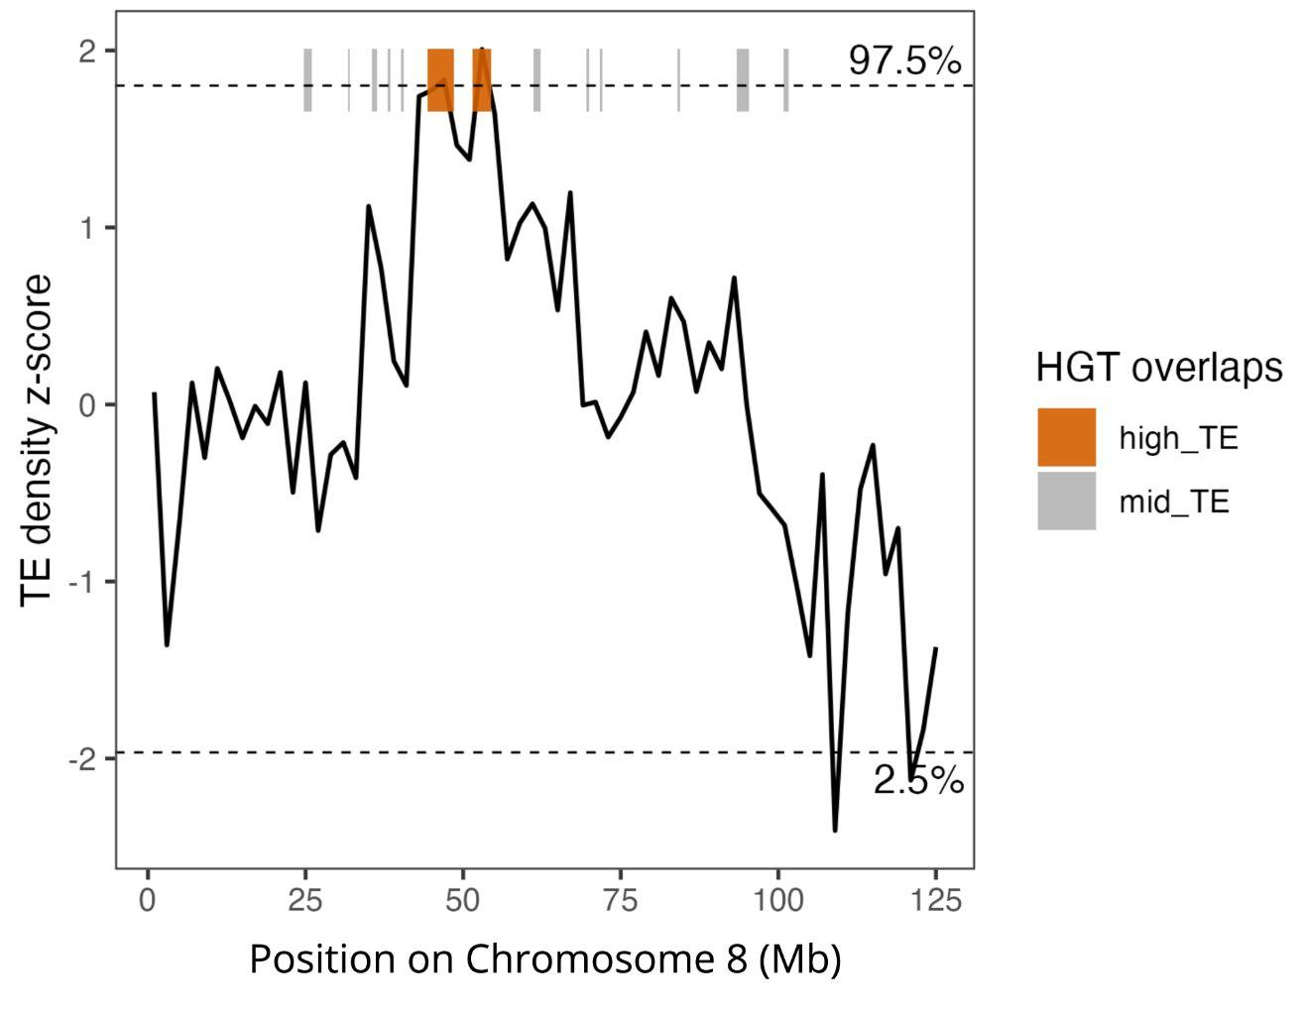
Supplementary Figure 8. Z-score transformed TE density by type in sliding 2 Mb windows across Chromosome 8 of C. caryae. HGTs located within the upper (97.5th percentile) tail of the TE density distribution are indicated by orange bars. Gray bars indicate HGTs falling outside this tail.

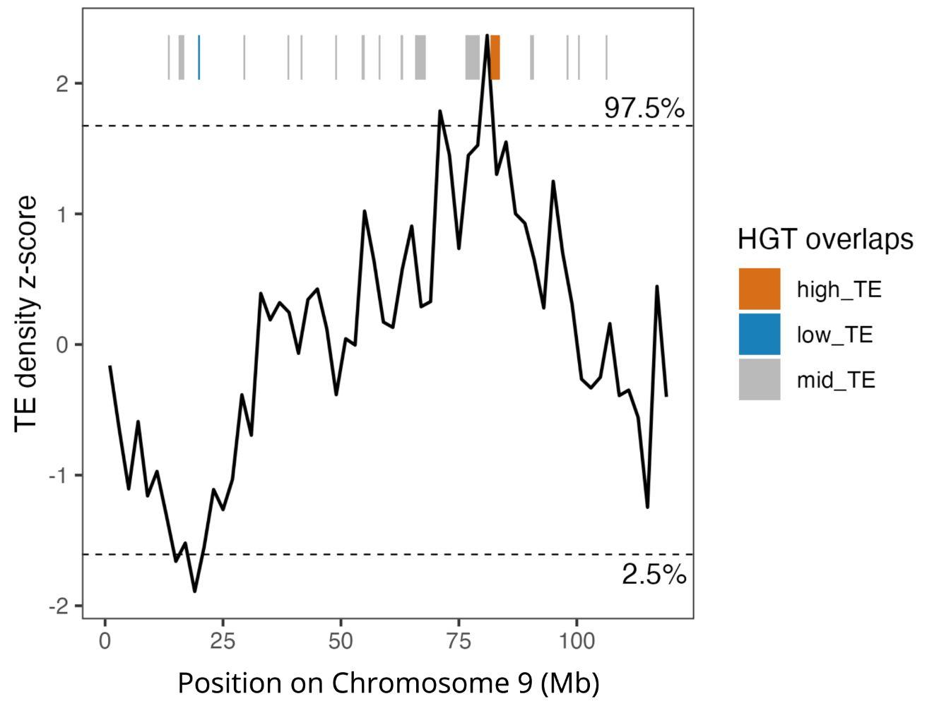
Supplementary Figure 9. Z-score transformed TE density by type in sliding 2 Mb windows across Chromosome 9 of C. caryae. HGTs located within the upper (97.5th percentile) and lower (2.5th percentile) tails of the TE density distribution are indicated by orange and blue bars, respectively. Gray bars indicate HGTs falling outside these tails.

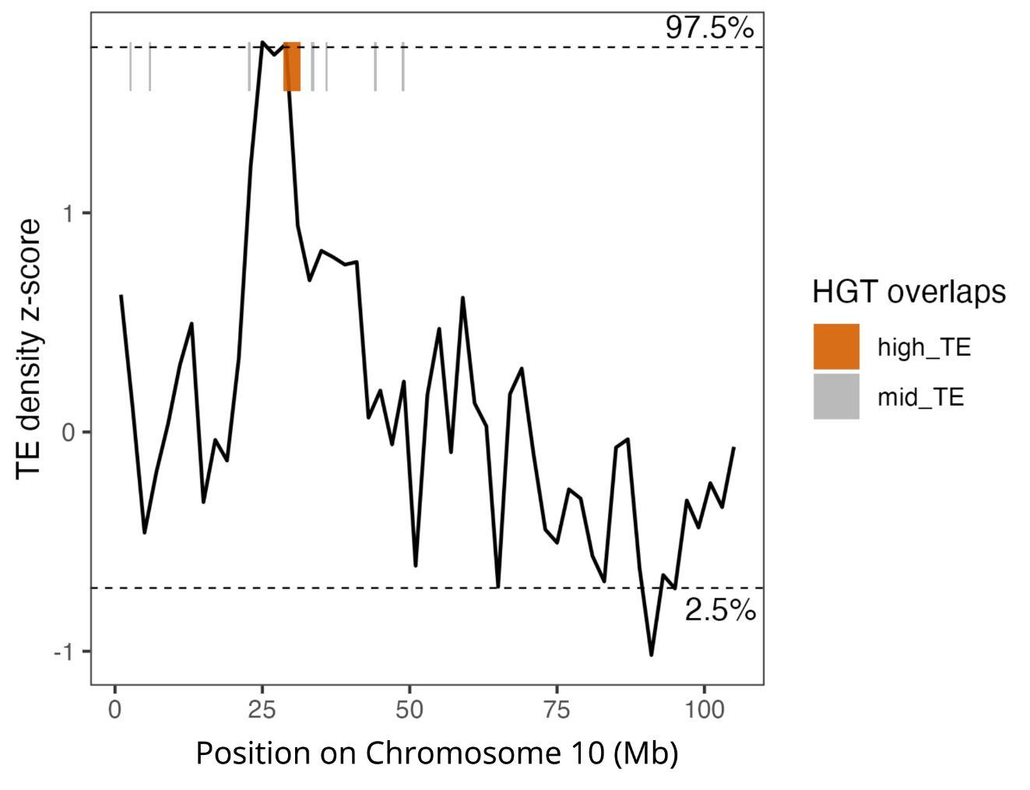
Supplementary Figure 10. Z-score transformed TE density by type in sliding 2 Mb windows across Chromosome 10 of C. caryae. HGTs located within the upper (97.5th percentile) tail of the TE density distribution are indicated by orange bars. Gray bars indicate HGTs falling outside this tail.

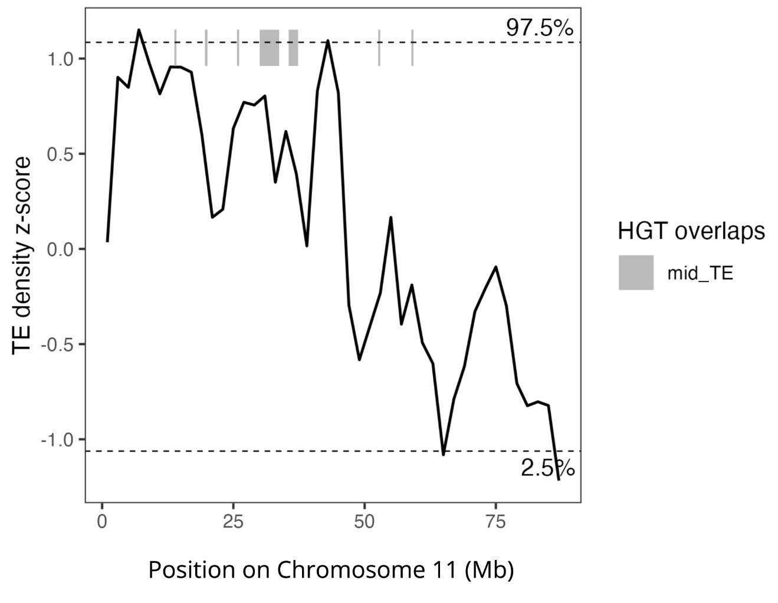
Supplementary Figure 11. Z-score transformed TE density by type in sliding 2 Mb windows across Chromosome 11 of C. caryae. Horizontally transferred DNA sequences (HGTs) located outside of the tails of the TE density distribution are indicated with gray bars.

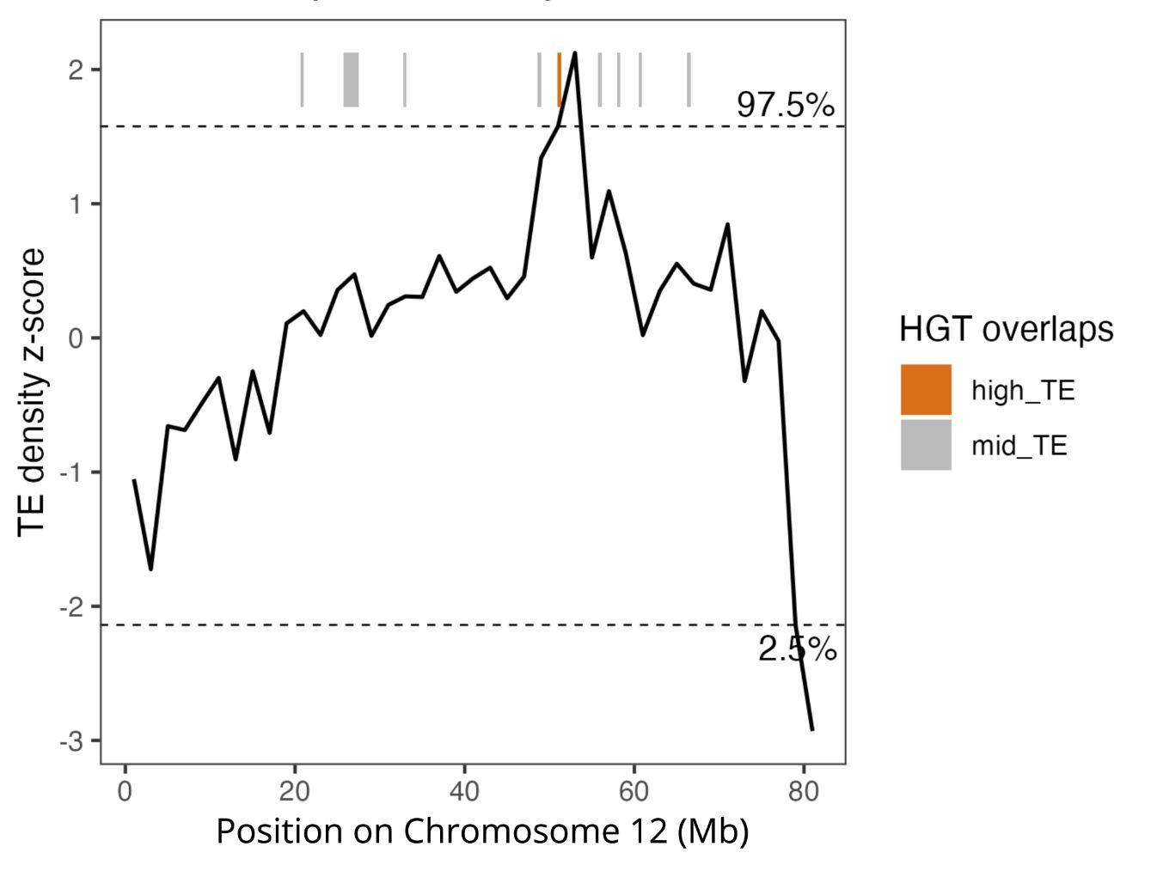
Supplementary Figure 12. Z-score transformed TE density by type in sliding 2 Mb windows across Chromosome 12 of C. caryae. HGTs located within the upper (97.5th percentile) tail of the TE density distribution are indicated by orange bars. Gray bars indicate HGTs falling outside this tail.

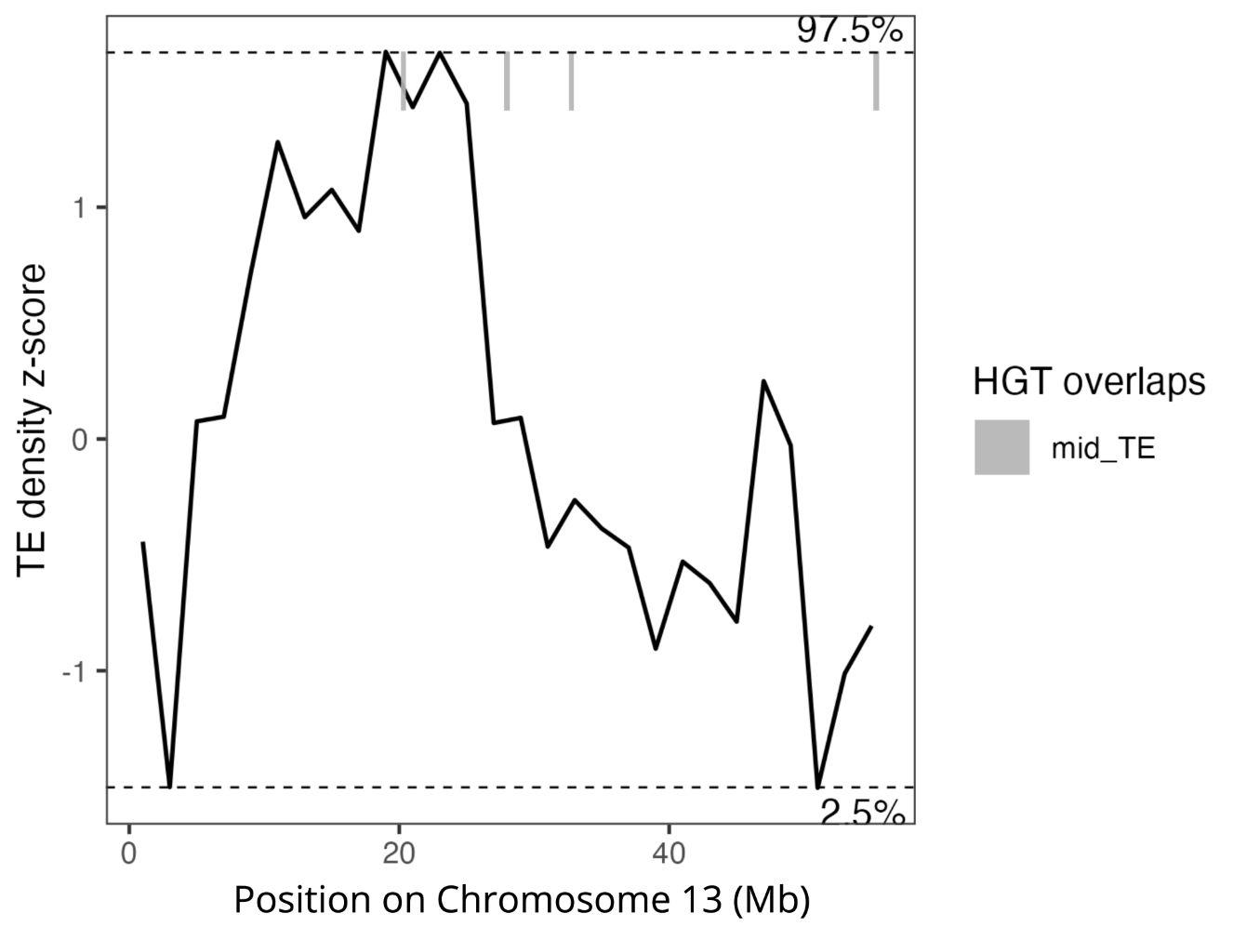
Supplementary Figure 13. Z-score transformed TE density by type in sliding 2 Mb windows across Chromosome 13 of C. caryae. Horizontally transferred DNA sequences (HGTs) located outside of the tails of the TE density distribution are indicated with gray bars.

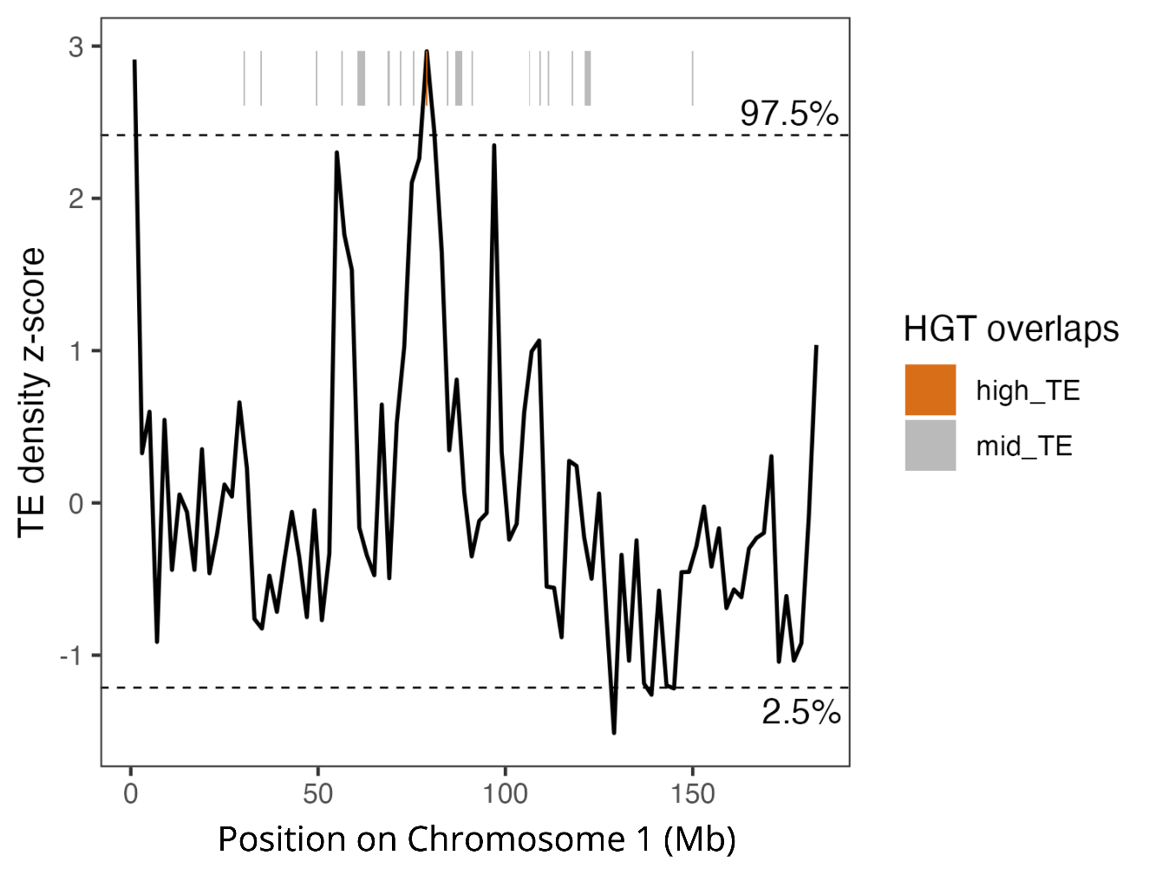
Supplementary Figure 14. Z-score transformed TE density by type in sliding 2 Mb windows across Chromosome 1 of C. nanulus. HGTs located within the upper (97.5th percentile) tail of the TE density distribution are indicated by orange bars. Gray bars indicate HGTs falling outside this tail.

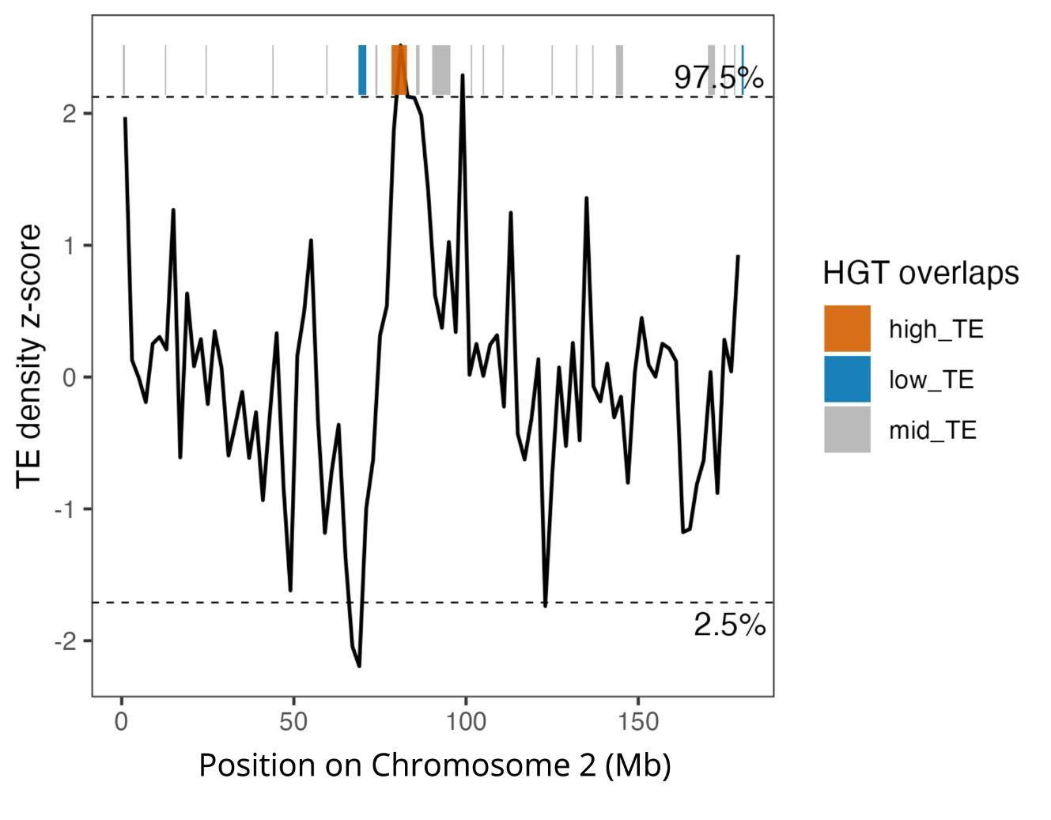
Supplementary Figure 15. Z-score transformed TE density by type in sliding 2 Mb windows across Chromosome 2 of C. nanulus. HGTs located within the upper (97.5th percentile) and lower (2.5th percentile) tails of the TE density distribution are indicated by orange and blue bars, respectively. Gray bars indicate HGTs falling outside these tails.

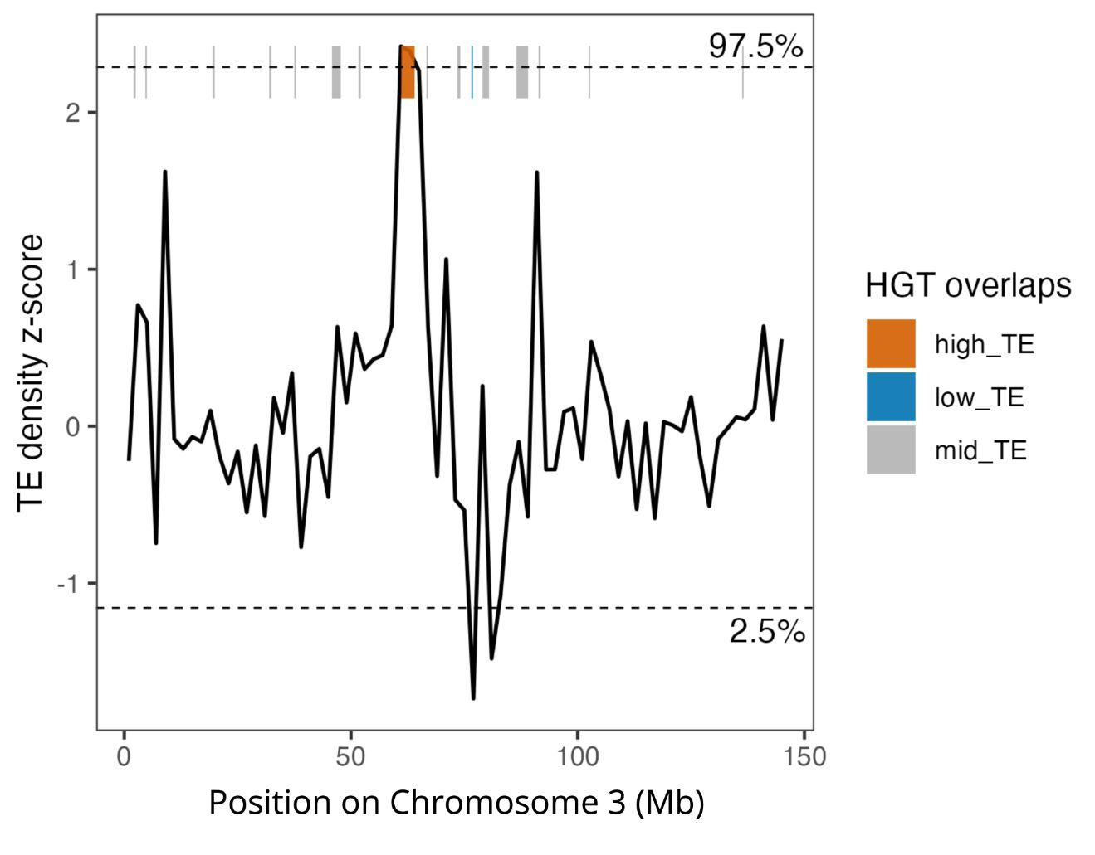
Supplementary Figure 16. Z-score transformed TE density by type in sliding 2 Mb windows across Chromosome 3 of C. nanulus. HGTs located within the upper (97.5th percentile) and lower (2.5th percentile) tails of the TE density distribution are indicated by orange and blue bars, respectively. Gray bars indicate HGTs falling outside these tails.

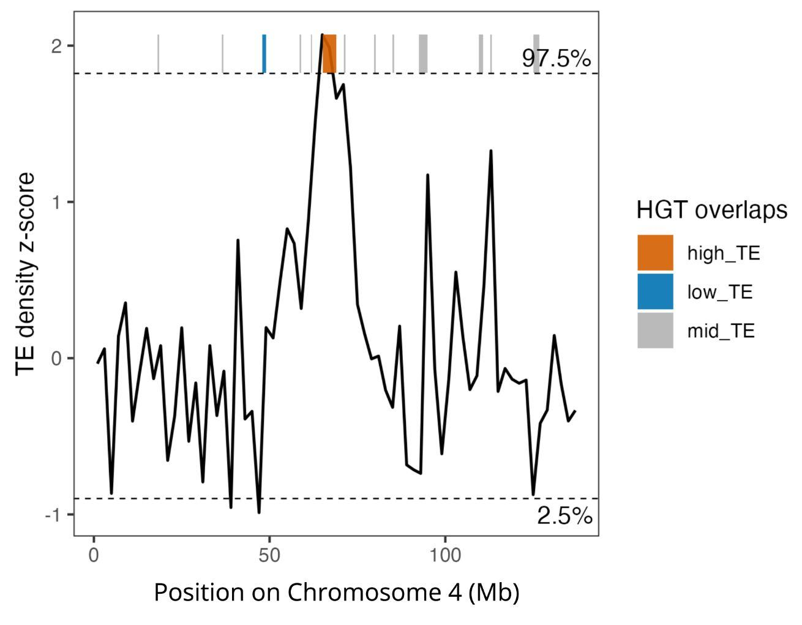
Supplementary Figure 17. Z-score transformed TE density by type in sliding 2 Mb windows across Chromosome 4 of C. nanulus. HGTs located within the upper (97.5th percentile) and lower (2.5th percentile) tails of the TE density distribution are indicated by orange and blue bars, respectively. Gray bars indicate HGTs falling outside these tails.

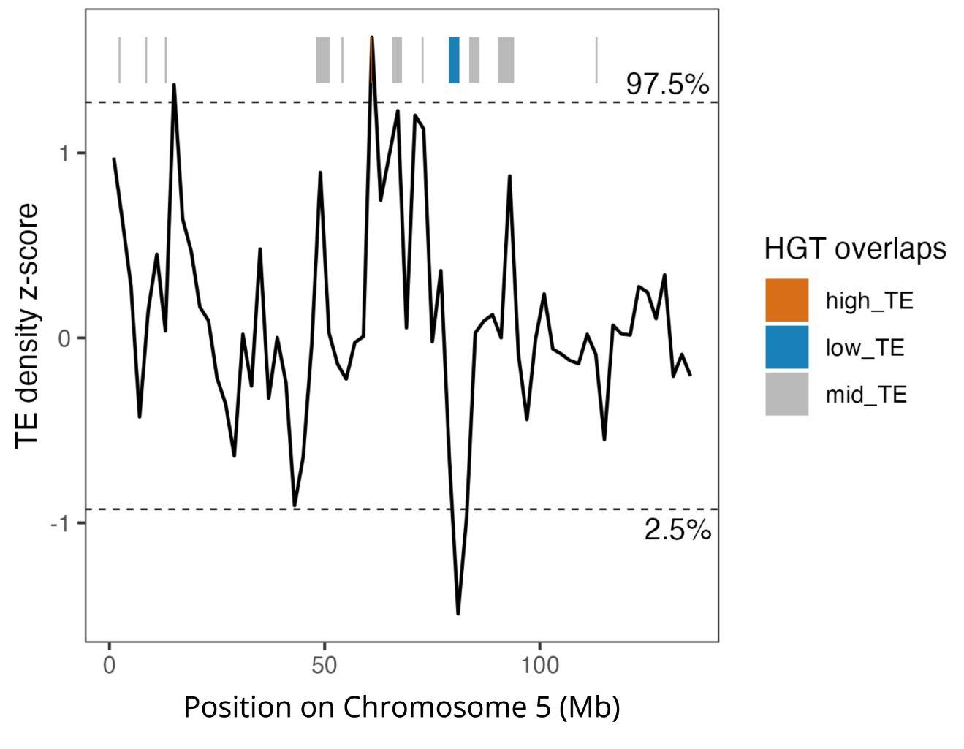
Supplementary Figure 18. Z-score transformed TE density by type in sliding 2 Mb windows across Chromosome 5 of C. nanulus. HGTs located within the upper (97.5th percentile) and lower (2.5th percentile) tails of the TE density distribution are indicated by orange and blue bars, respectively. Gray bars indicate HGTs falling outside these tails.

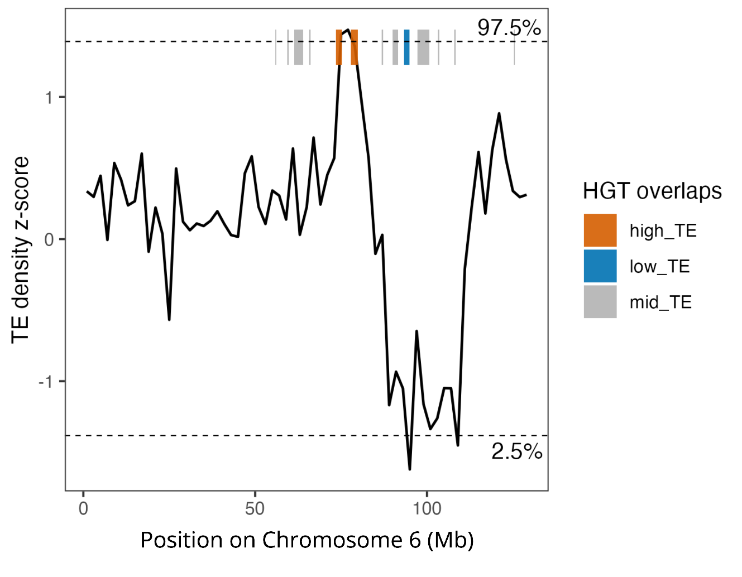
Supplementary Figure 19. Z-score transformed TE density by type in sliding 2 Mb windows across Chromosome 6 of C. nanulus. HGTs located within the upper (97.5th percentile) and lower (2.5th percentile) tails of the TE density distribution are indicated by orange and blue bars, respectively. Gray bars indicate HGTs falling outside these tails.

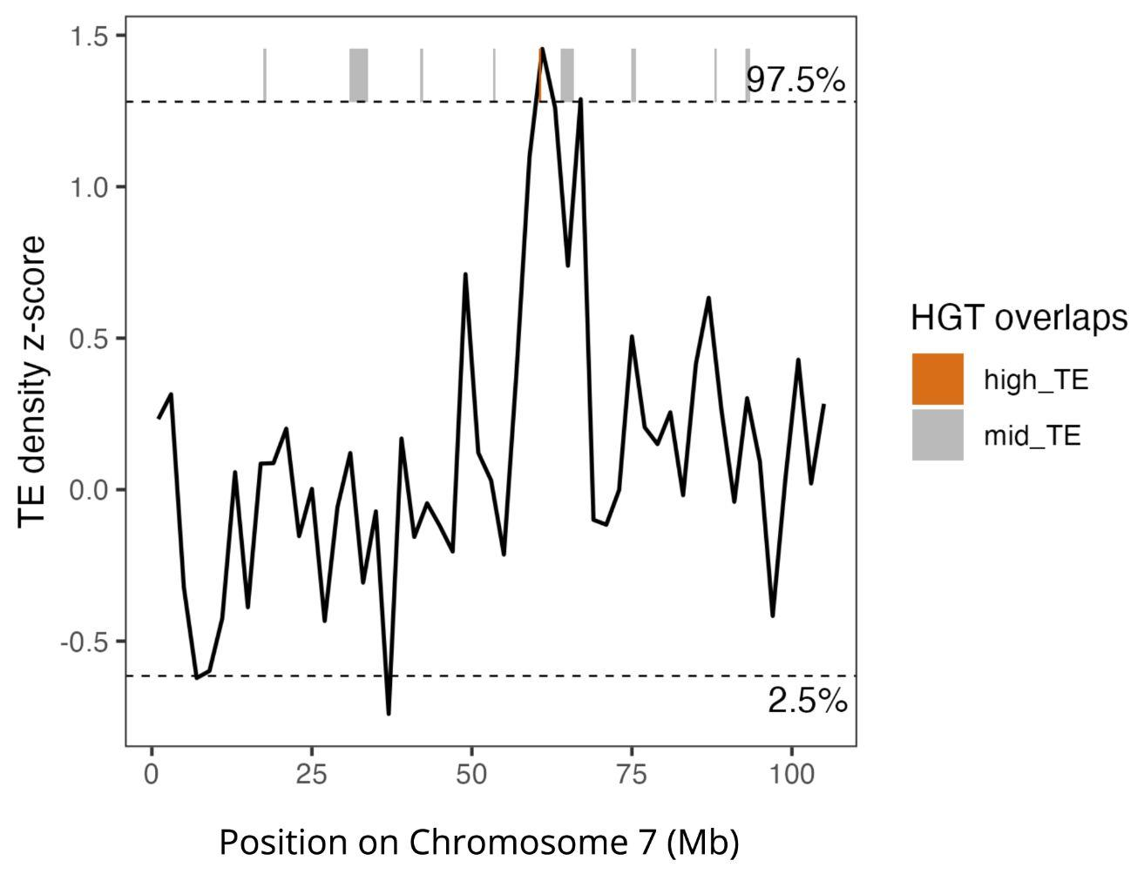
Supplementary Figure 20. Z-score transformed TE density by type in sliding 2 Mb windows across Chromosome 7 of C. nanulus. HGTs located within the upper (97.5th percentile) tail of the TE density distribution are indicated by orange bars. Gray bars indicate HGTs falling outside this tail.

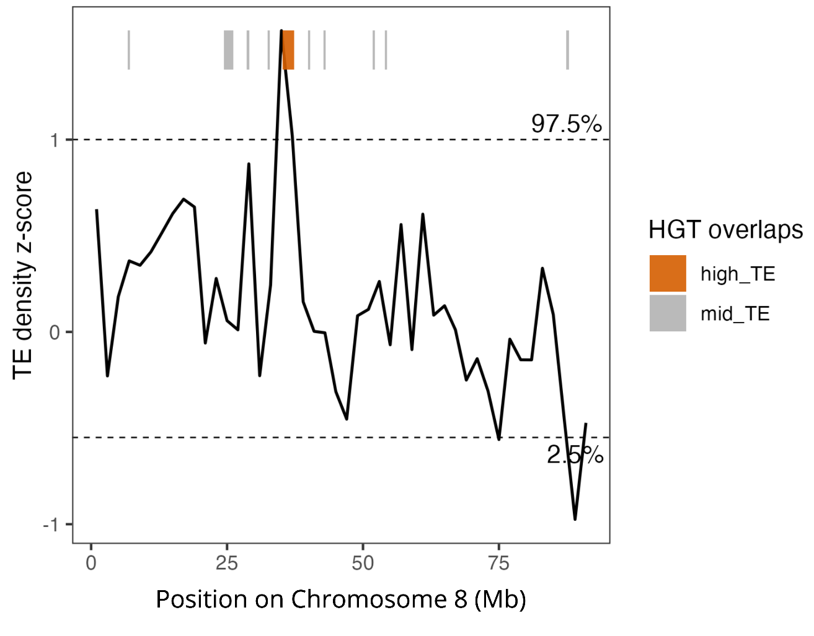
Supplementary Figure 21. Z-score transformed TE density by type in sliding 2 Mb windows across Chromosome 8 of C. nanulus. HGTs located within the upper (97.5th percentile) tail of the TE density distribution are indicated by orange bars. Gray bars indicate HGTs falling outside this tail.

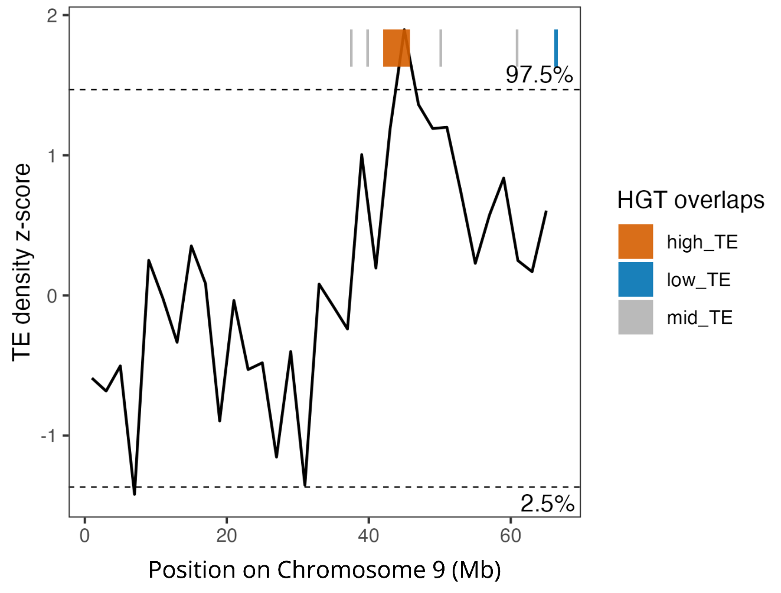
Supplementary Figure 22. Z-score transformed TE density by type in sliding 2 Mb windows across Chromosome 9 of C. nanulus. HGTs located within the upper (97.5th percentile) and lower (2.5th percentile) tails of the TE density distribution are indicated by orange and blue bars, respectively. Gray bars indicate HGTs falling outside these tails.

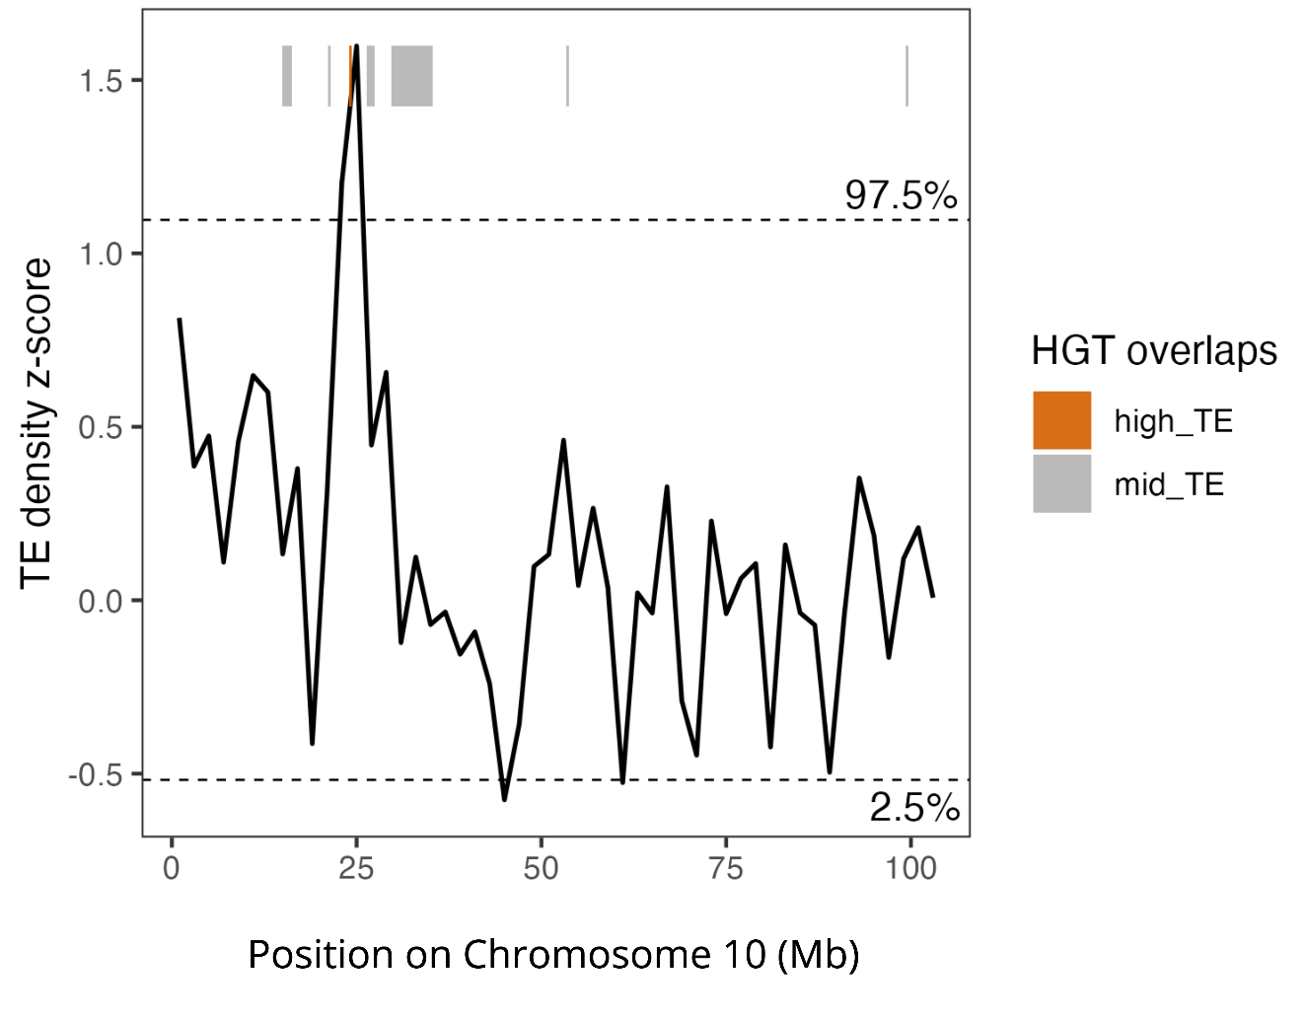
Supplementary Figure 23. Z-score transformed TE density by type in sliding 2 Mb windows across Chromosome 10 of C. nanulus. HGTs located within the upper (97.5th percentile) tail of the TE density distribution are indicated by orange bars. Gray bars indicate HGTs falling outside this tail.

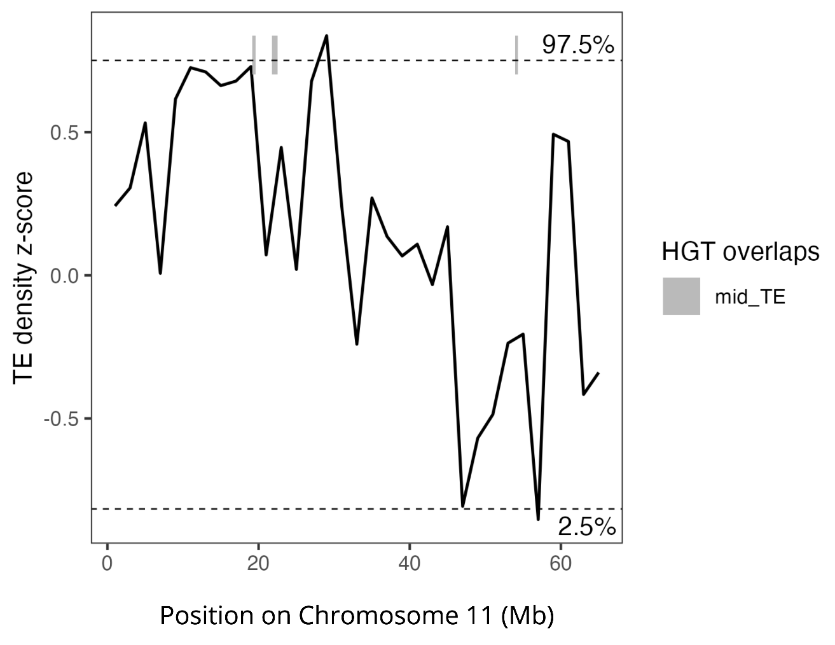
Supplementary Figure 24. Z-score transformed TE density by type in sliding 2 Mb windows across Chromosome 11 of C. nanulus. Horizontally transferred DNA sequences (HGTs) located outside of the tails of the TE density distribution are indicated with gray bars.

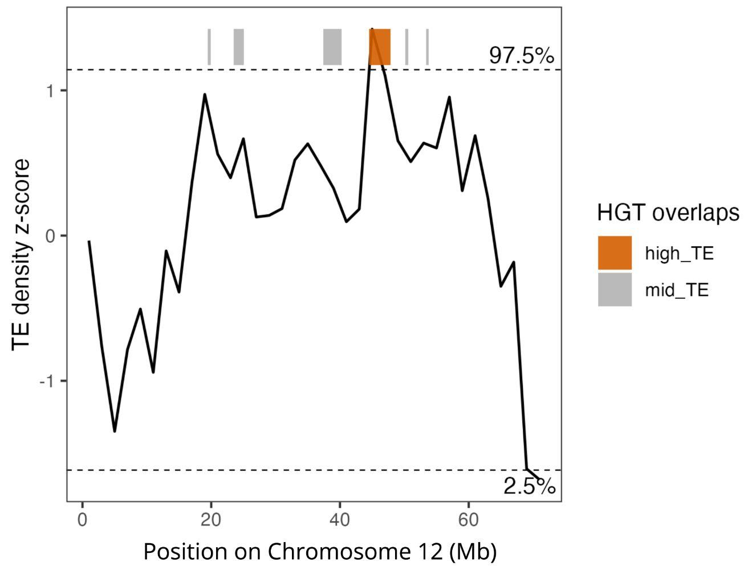
Supplementary Figure 25. Z-score transformed TE density by type in sliding 2 Mb windows across Chromosome 12 of C. nanulus. HGTs located within the upper (97.5th percentile) tail of the TE density distribution are indicated by orange bars. Gray bars indicate HGTs falling outside this tail.

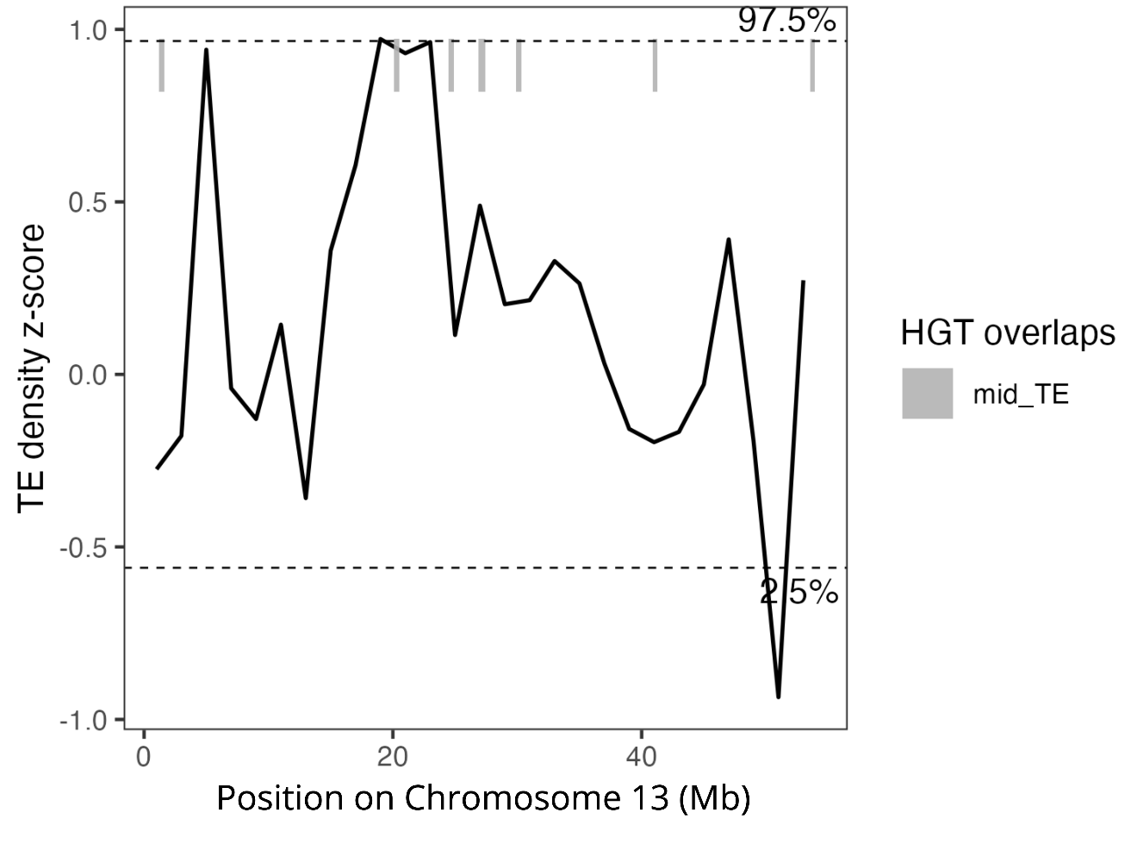
Supplementary Figure 26. Z-score transformed TE density by type in sliding 2 Mb windows across Chromosome 13 of C. nanulus. Horizontally transferred DNA sequences (HGTs) located outside of the tails of the TE density distribution are indicated with gray bars.

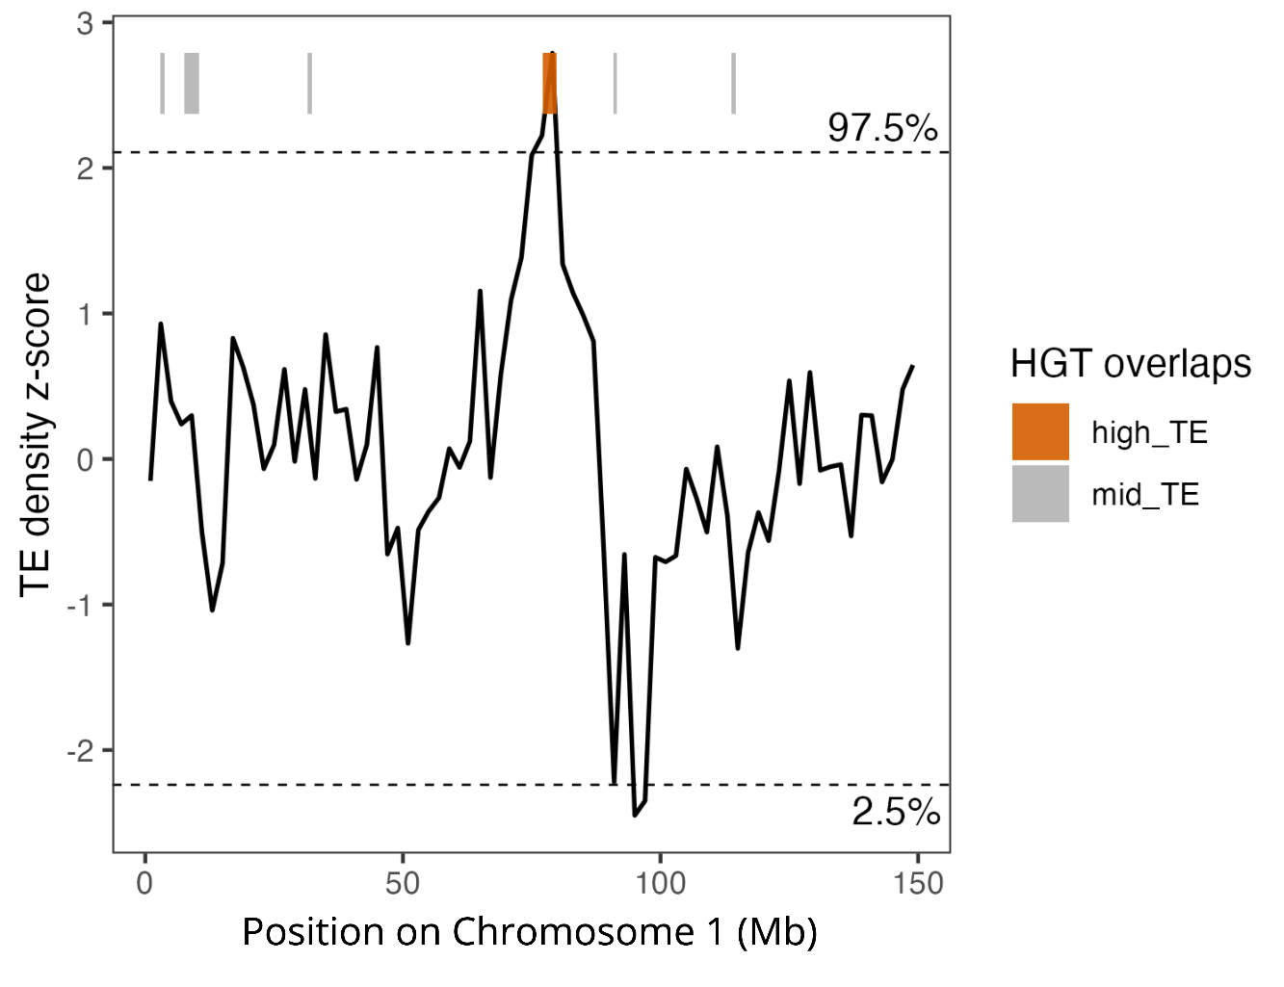
Supplementary Figure 27. Z-score transformed TE density by type in sliding 2 Mb windows across Chromosome 1 of C. glandium. HGTs located within the upper (97.5th percentile) tail of the TE density distribution are indicated by orange bars. Gray bars indicate HGTs falling outside this tail.

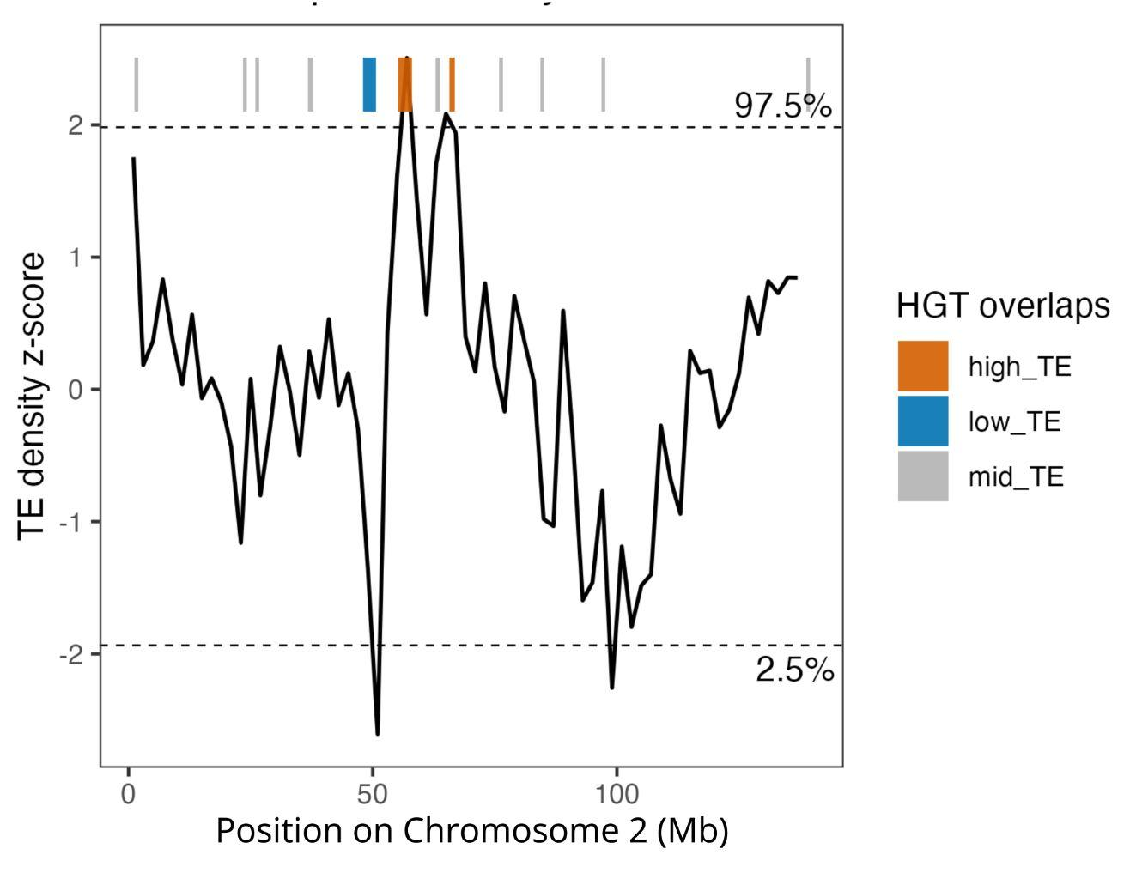
Supplementary Figure 28. Z-score transformed TE density by type in sliding 2 Mb windows across Chromosome 2 of C. glandium. HGTs located within the upper (97.5th percentile) and lower (2.5th percentile) tails of the TE density distribution are indicated by orange and blue bars, respectively. Gray bars indicate HGTs falling outside these tails.

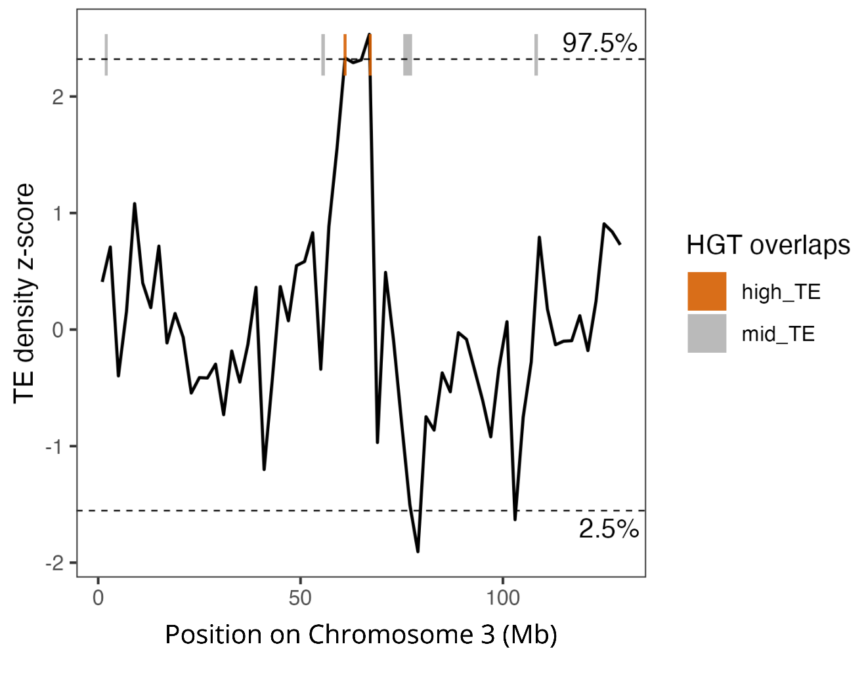
Supplementary Figure 29. Z-score transformed TE density by type in sliding 2 Mb windows across Chromosome 3 of C. glandium. HGTs located within the upper (97.5th percentile) tail of the TE density distribution are indicated by orange bars. Gray bars indicate HGTs falling outside this tail.

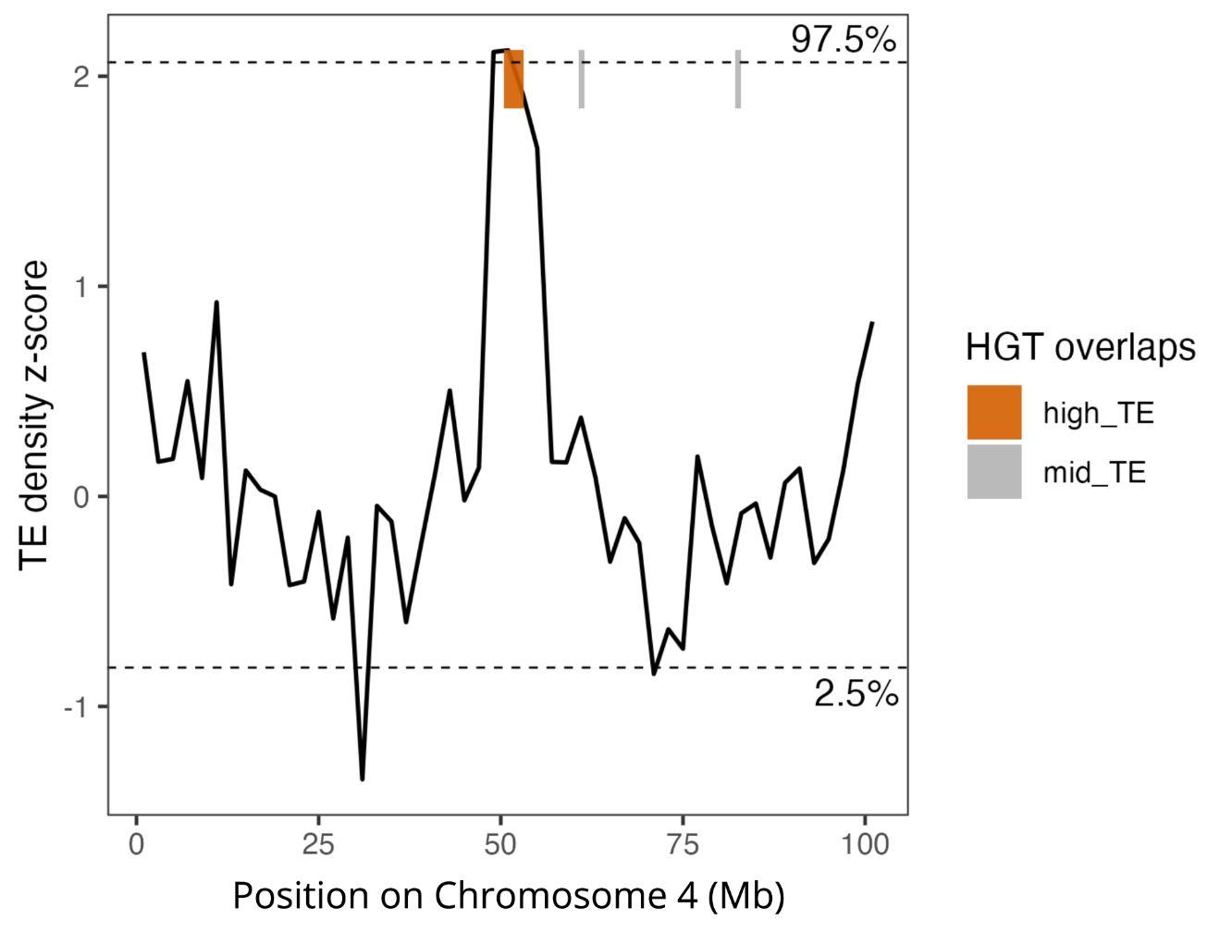
Supplementary Figure 30. Z-score transformed TE density by type in sliding 2 Mb windows across Chromosome 4 of C. glandium. HGTs located within the upper (97.5th percentile) tail of the TE density distribution are indicated by orange bars. Gray bars indicate HGTs falling outside this tail.

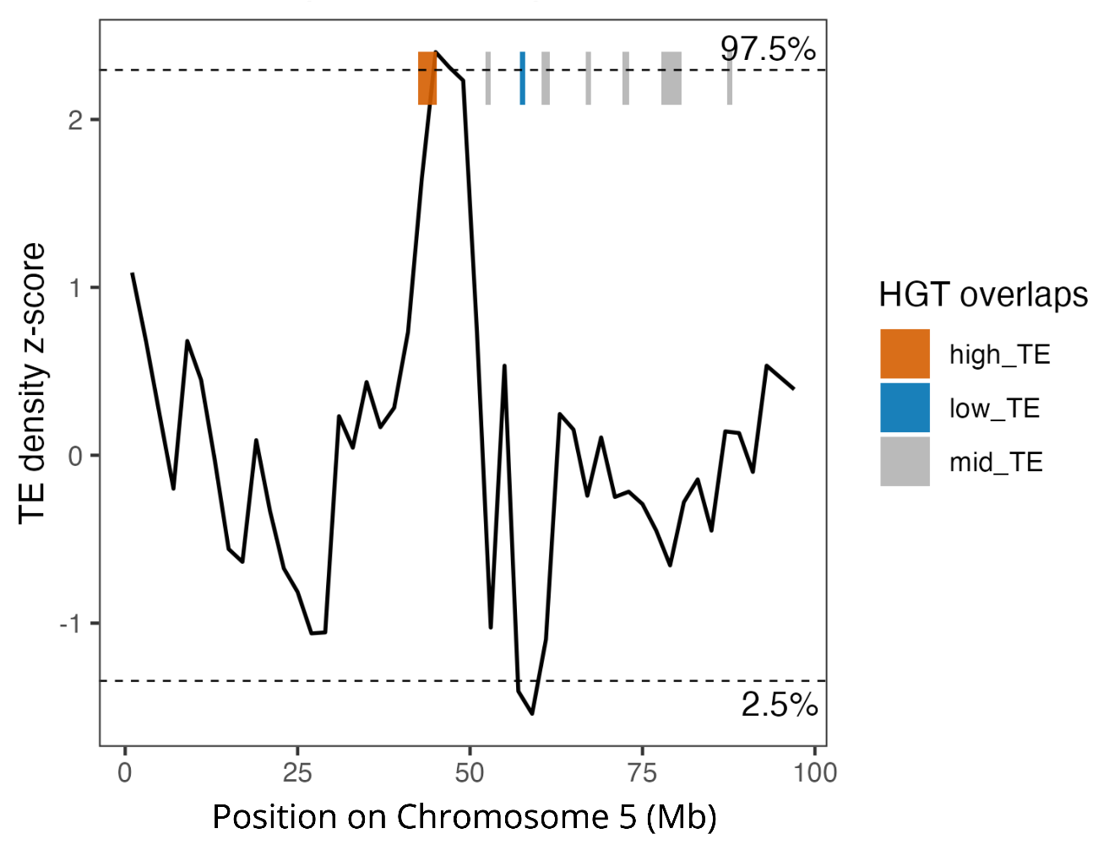
Supplementary Figure 31. Z-score transformed TE density by type in sliding 2 Mb windows across Chromosome 5 of C. glandium. HGTs located within the upper (97.5th percentile) and lower (2.5th percentile) tails of the TE density distribution are indicated by orange and blue bars, respectively. Gray bars indicate HGTs falling outside these tails.

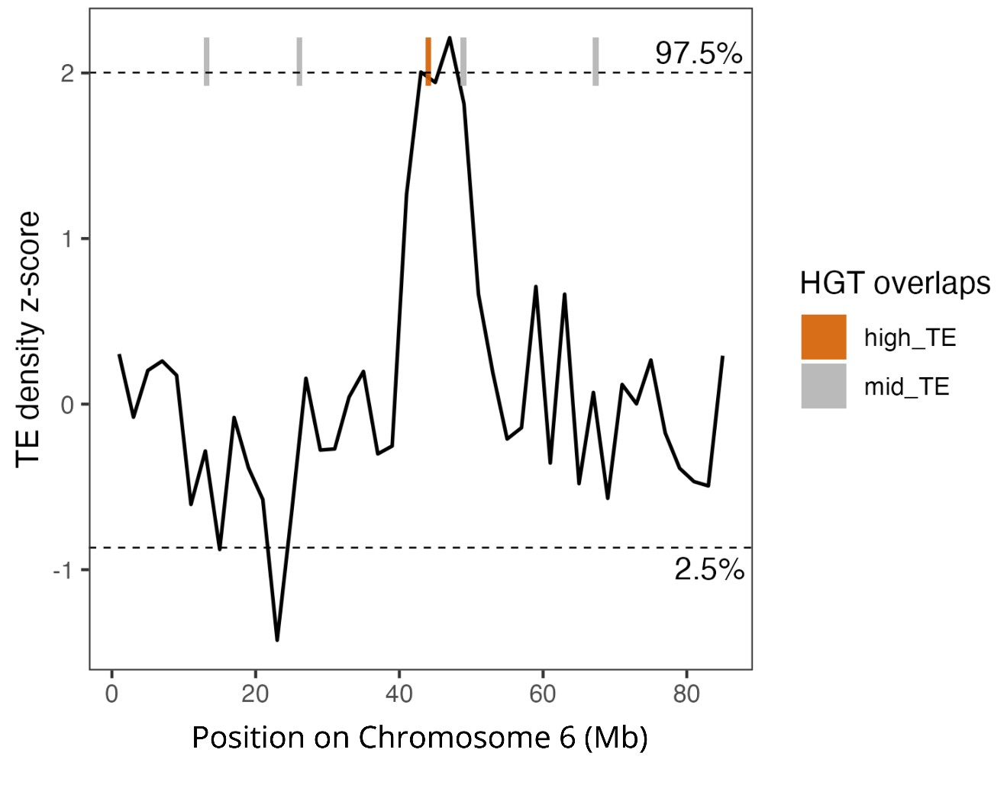
Supplementary Figure 32. Z-score transformed TE density by type in sliding 2 Mb windows across Chromosome 6 of C. glandium. HGTs located within the upper (97.5th percentile) tail of the TE density distribution are indicated by orange bars. Gray bars indicate HGTs falling outside this tail.

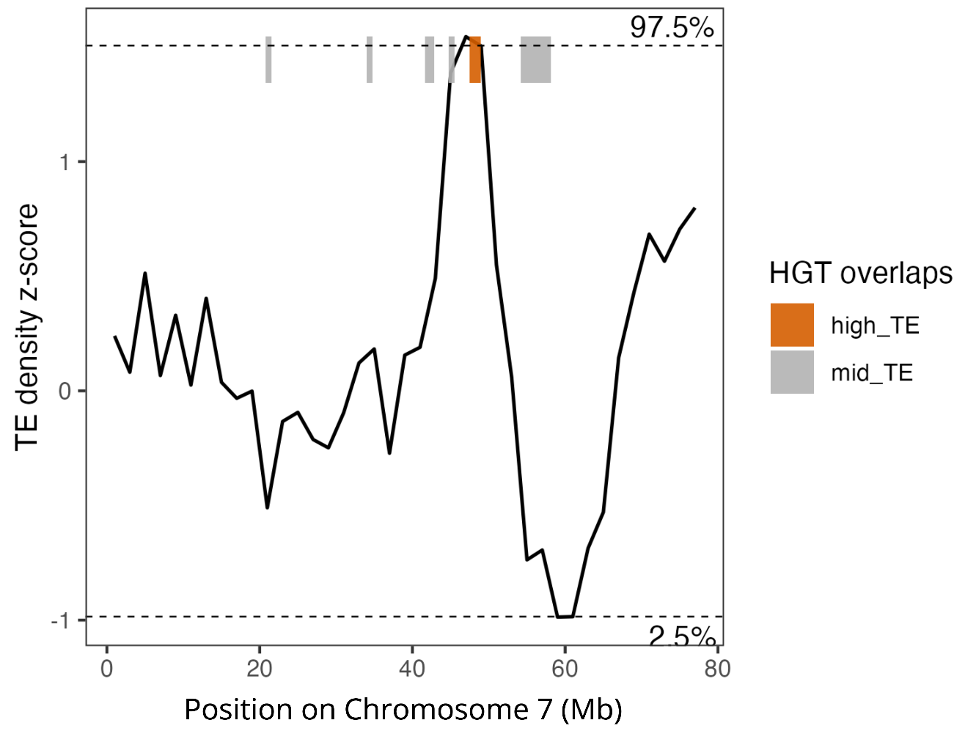
Supplementary Figure 33. Z-score transformed TE density by type in sliding 2 Mb windows across Chromosome 7 of C. glandium. HGTs located within the upper (97.5th percentile) tail of the TE density distribution are indicated by orange bars. Gray bars indicate HGTs falling outside this tail.

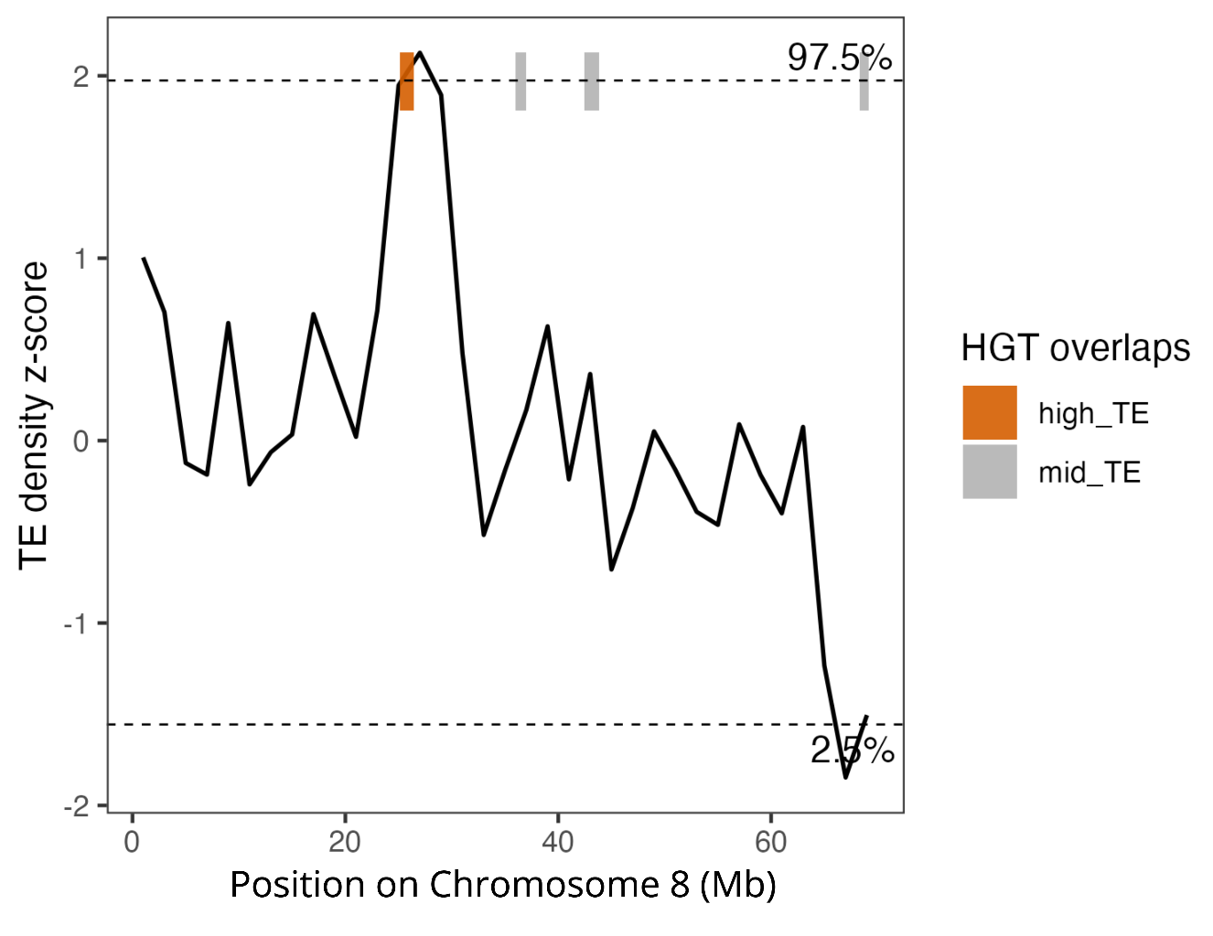
Supplementary Figure 34. Z-score transformed TE density by type in sliding 2 Mb windows across Chromosome 8 of C. glandium. HGTs located within the upper (97.5th percentile) tail of the TE density distribution are indicated by orange bars. Gray bars indicate HGTs falling outside this tail.

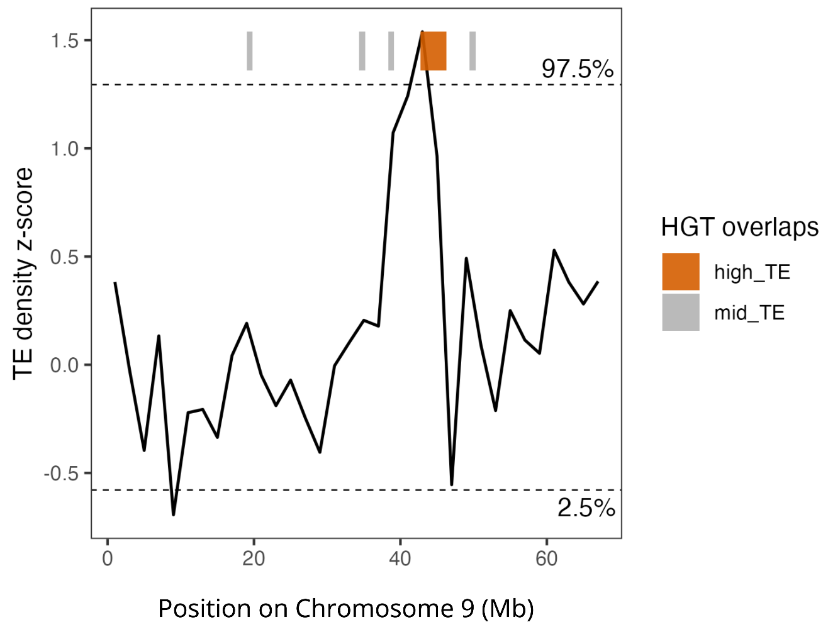
Supplementary Figure 35. Z-score transformed TE density by type in sliding 2 Mb windows across Chromosome 9 of C. glandium. HGTs located within the upper (97.5th percentile) tail of the TE density distribution are indicated by orange bars. Gray bars indicate HGTs falling outside this tail.

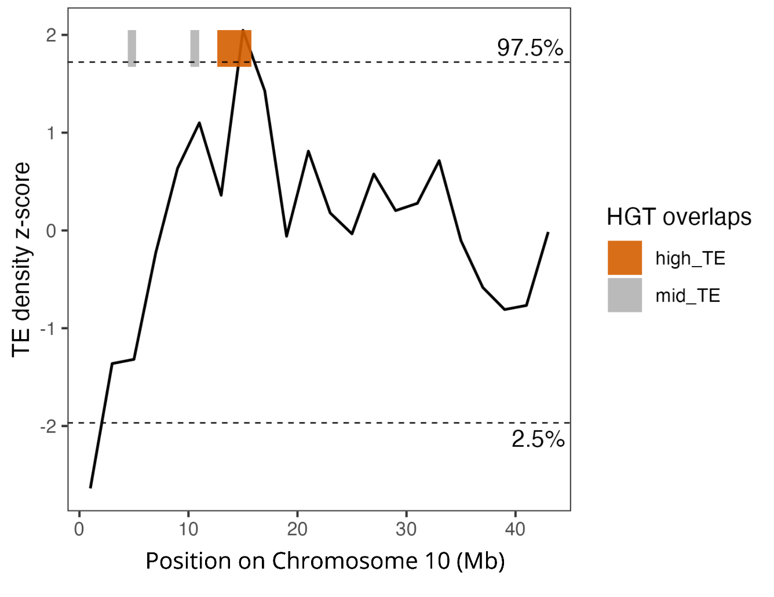
Supplementary Figure 36. Z-score transformed TE density by type in sliding 2 Mb windows across Chromosome 10 of C. glandium. HGTs located within the upper (97.5th percentile) tail of the TE density distribution are indicated by orange bars. Gray bars indicate HGTs falling outside this tail.

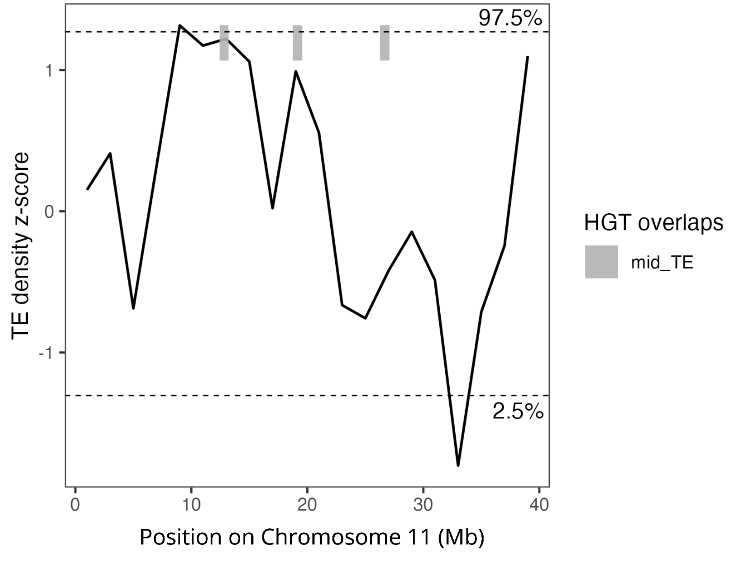
Supplementary Figure 37. Z-score transformed TE density by type in sliding 2 Mb windows across Chromosome 11 of C. glandium. Horizontally transferred DNA sequences (HGTs) located outside of the tails of the TE density distribution are indicated with gray bars.

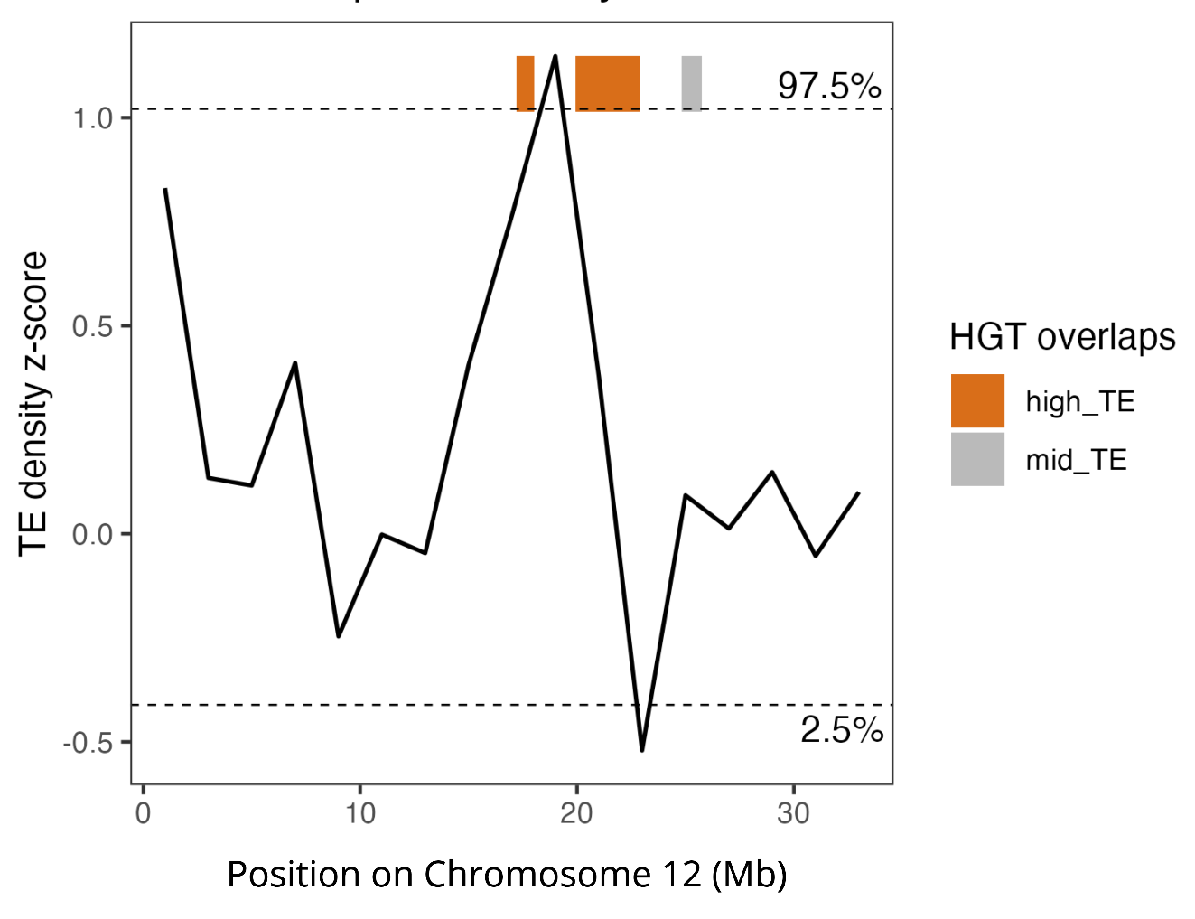
Supplementary Figure 38. Z-score transformed TE density by type in sliding 2 Mb windows across Chromosome 12 of C. glandium. HGTs located within the upper (97.5th percentile) tail of the TE density distribution are indicated by orange bars. Gray bars indicate HGTs falling outside this tail.

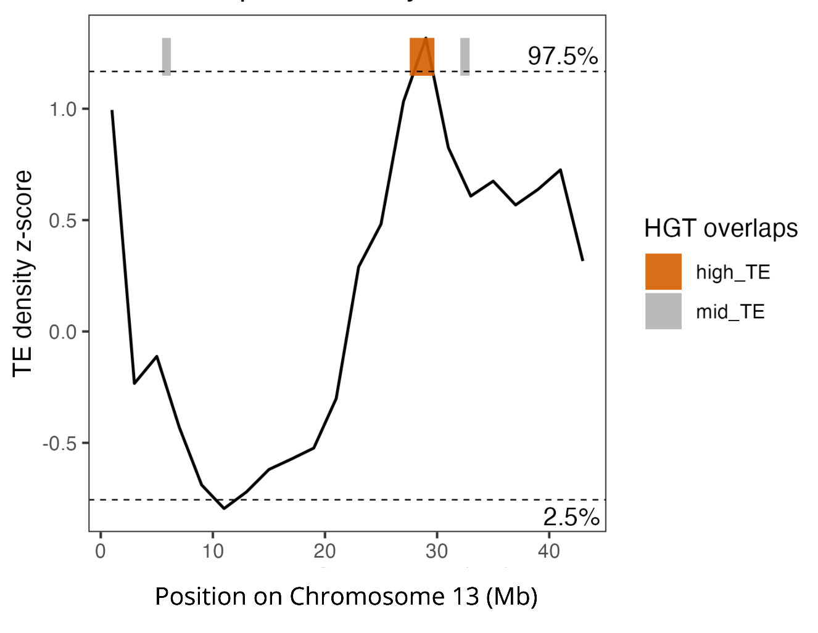
Supplementary Figure 39. Z-score transformed TE density by type in sliding 2 Mb windows across Chromosome 13 of C. glandium. HGTs located within the upper (97.5th percentile) tail of the TE density distribution are indicated by orange bars. Gray bars indicate HGTs falling outside this tail.

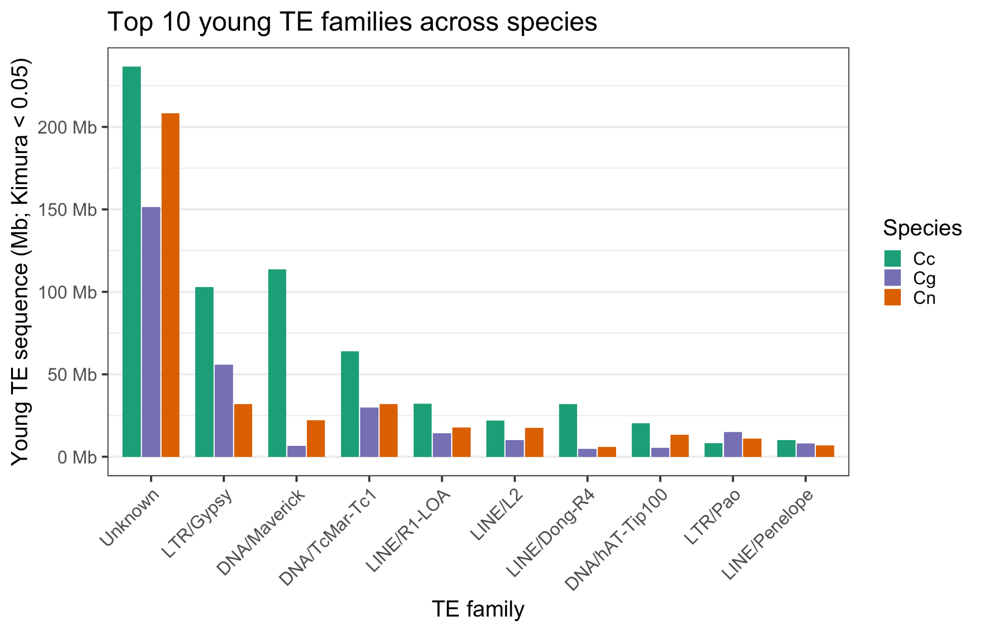
Supplementary Figure 40. Top 10 young (Kimura D < 0.05) genome-wide TE families across Curculio species: C. caryae (Cc, teal), C. glandium (Cg, purple), and C. nanulus (Cn, orange).

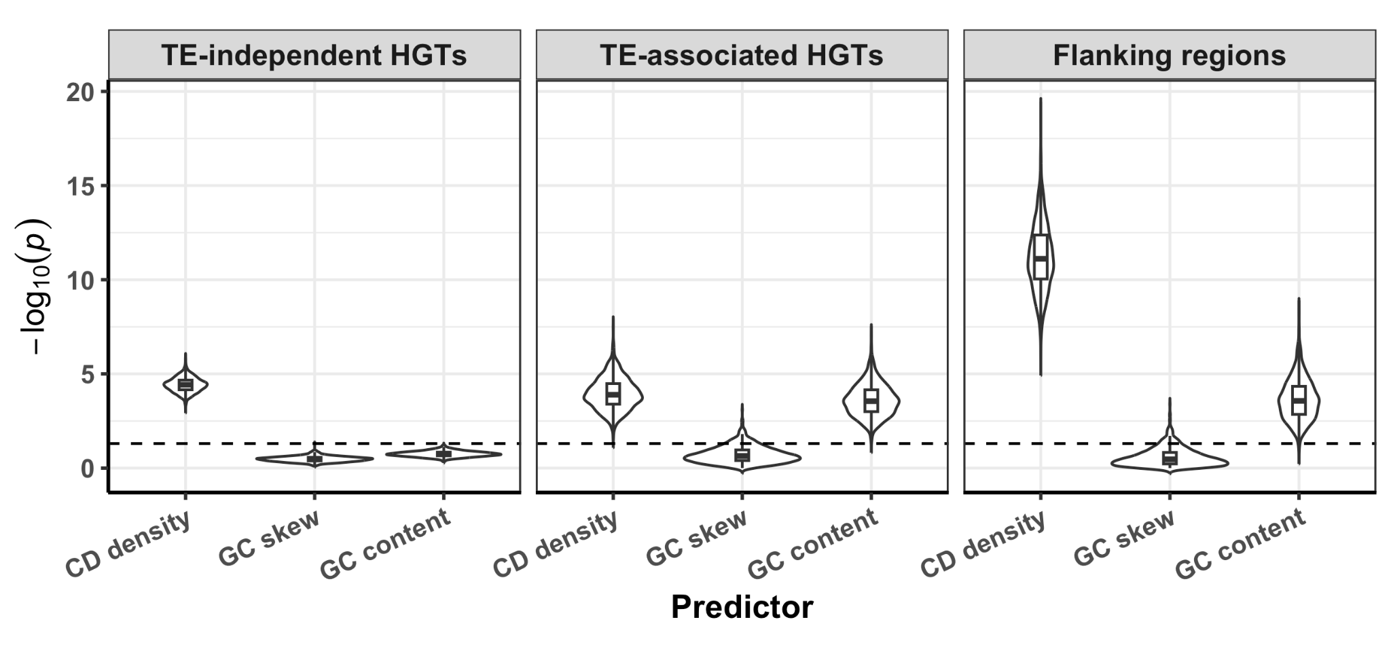
Supplementary Figure 41. Violin plots with embedded box plots summarizing the distributions of z-test -log₁₀(p-values) for testing the null hypothesis that the regression coefficient β_{j} for a given predictor j is zero (H₀: β_{j} = 0), with the alternative hypothesis that β_{j} is not equal to zero (H₀: β_{j} ≠ 0). The distribution summaries are based on 500 chromosome-matched multinomial regression replicates. Each model had three predictors: coding sequence (CD) density, GC skew, and GC content. The models predicted four response classes: TE-independent HGT cores, TE-associated HGT cores, HGT flanking windows, and chromosome-matched background windows as the reference class. The horizontal dashed lines denote the significance threshold of -log₁₀(0.05).

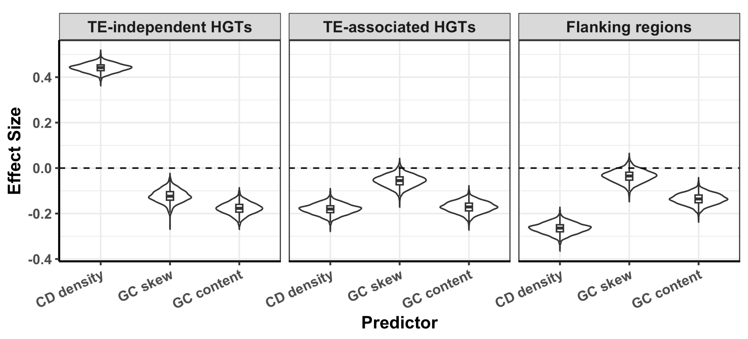
Supplementary Figure 42. Violin plots with embedded box plots summarizing the distributions of predictor effect sizes (regression coefficient values) across 500 chromosome-matched multinomial regression replicates. Each model had three predictors: coding sequence (CD) density, GC skew, and GC content. The models predicted four response classes: TE-associated HGT cores, TE-independent HGT cores, HGT flanking windows, and chromosome-matched background windows as the reference class. Positive coefficients indicate increased log odds of assignment to that response class for windows with higher values of the corresponding predictor, whereas negative coefficients indicate decreased log odds, relative to background. The horizontal dashed lines denote a regression coefficient of zero, indicating no association between the predictor and the response class.

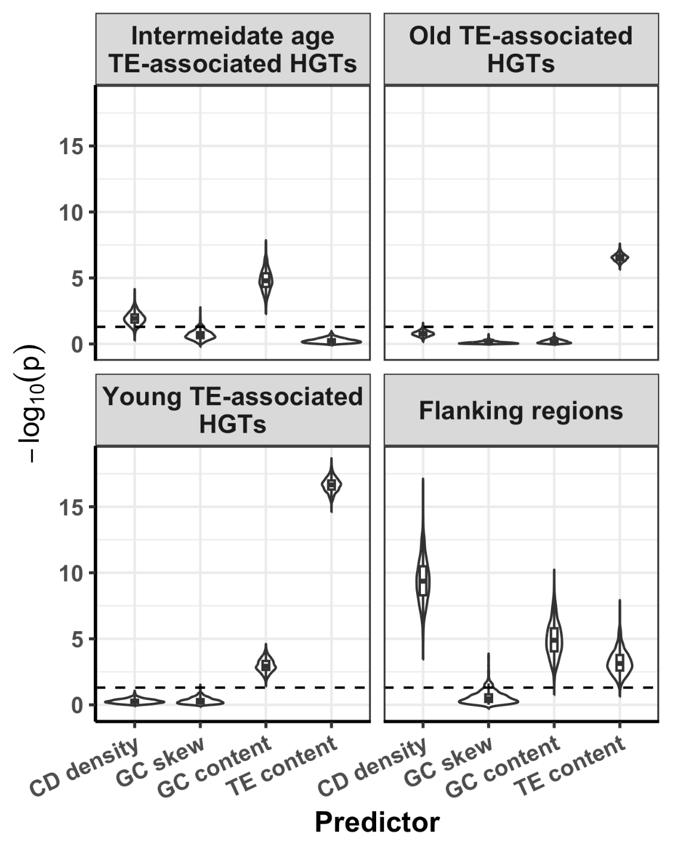
Supplementary Figure 43. Violin plots with embedded box plots summarizing the distributions of z-test -log₁₀ (p-values) for testing the null hypothesis that the regression coefficient β_{j} for a given predictor j is zero (H₀: β_{j} = 0), with the alternative hypothesis that β_{j} is not equal to zero (H₀: β_{j} ≠ 0). The distribution summaries are based on 500 chromosome-matched multinomial regression replicates. Each model had four predictors: coding sequence (CD) density, GC skew, GC content, and TE content. The models predicted five response classes: TE-associated HGT cores based on TE age as young, intermediate, and old, HGT flanking windows, and chromosome-matched background windows as the reference class. The horizontal dashed lines denote the significance threshold of -log₁₀(0.05).

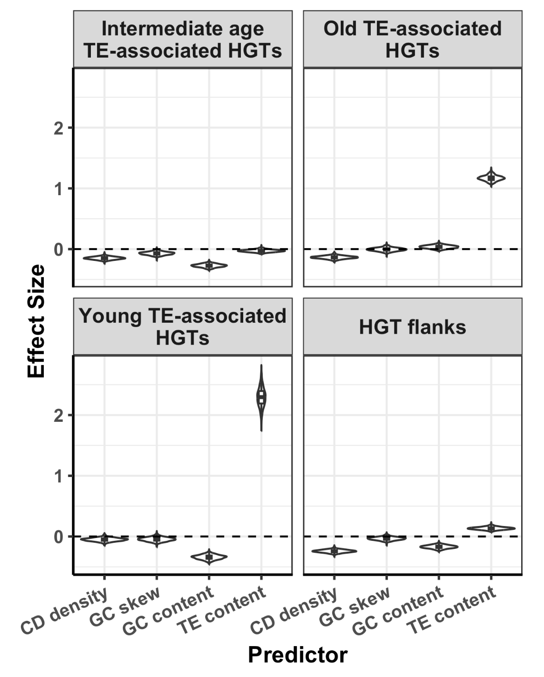
Supplementary Figure 44. Violin plots with embedded box plots summarizing the distributions of predictor effect sizes (regression coefficient values) across 500 chromosome-matched multinomial regression analyses. Each model had five predictors: coding sequence (CD) density, GC skew, GC content, and TE content. The models predicted five response classes: TE-associated HGT cores based on TE age as young, intermediate, and old, HGT flanking windows, and chromosome-matched background windows as the reference class. Positive coefficients indicate increased log odds of assignment to that response class for windows with higher values of the corresponding predictor, whereas negative coefficients indicate decreased log odds, relative to background. The horizontal dashed lines denote a regression coefficient of zero, indicating no association between the predictor and the response class.
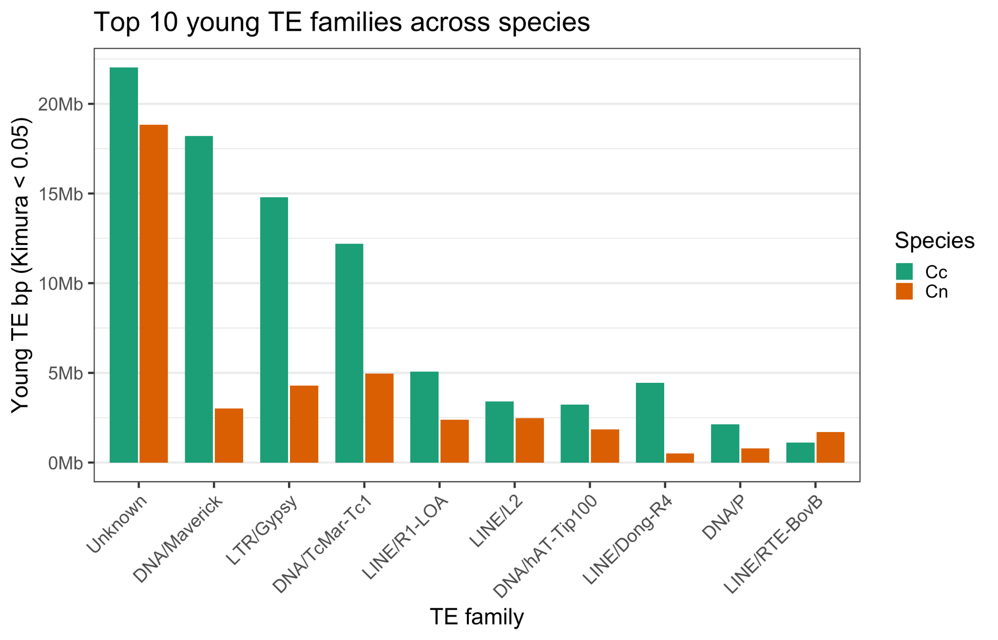
Supplementary Figure 45. Top 10 young (Kimura D < 0.05) node-specific TE families in C. caryae (Cc, teal) and C. nanulus (Cn, orange).

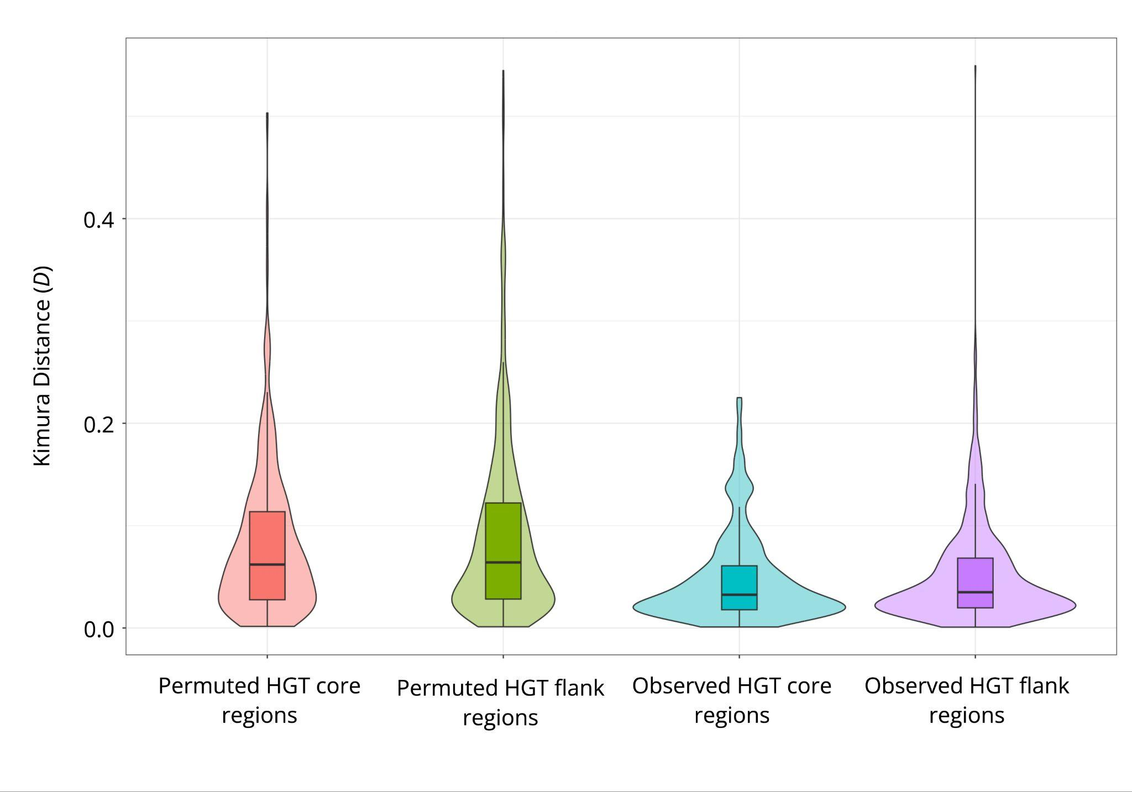
Supplementary Figure 46. Violin plots with embedded box plots summarizing the distribution of Maverick ages (Kimura D) across permuted HGT core, permuted HGT flank, observed HGT core, and observed HGT flank regions.

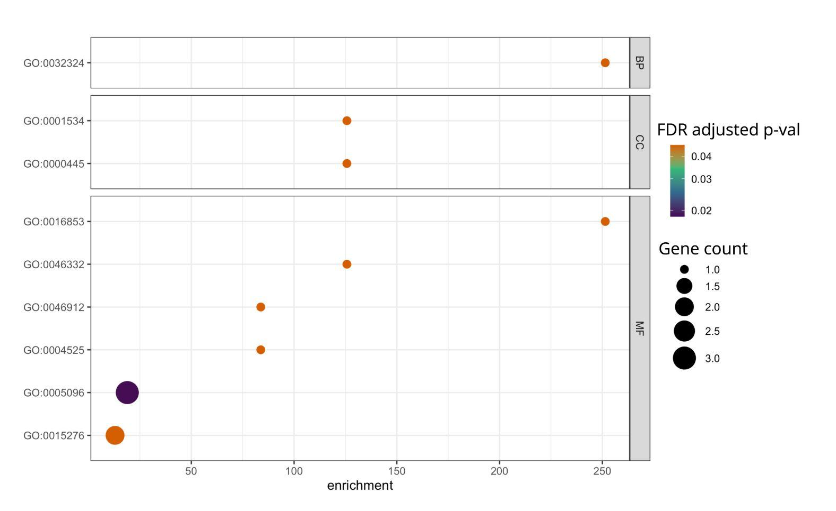
Supplemental Figure 47. Enriched Gene Ontology (GO) terms associated with HGTs in C. caryae by category: BP = biological process, CC = cellular component, and MF = molecular function. Gradient coloration represents FDR-adjusted p-values, and gene count indicates the number of genes associated with each enriched term.

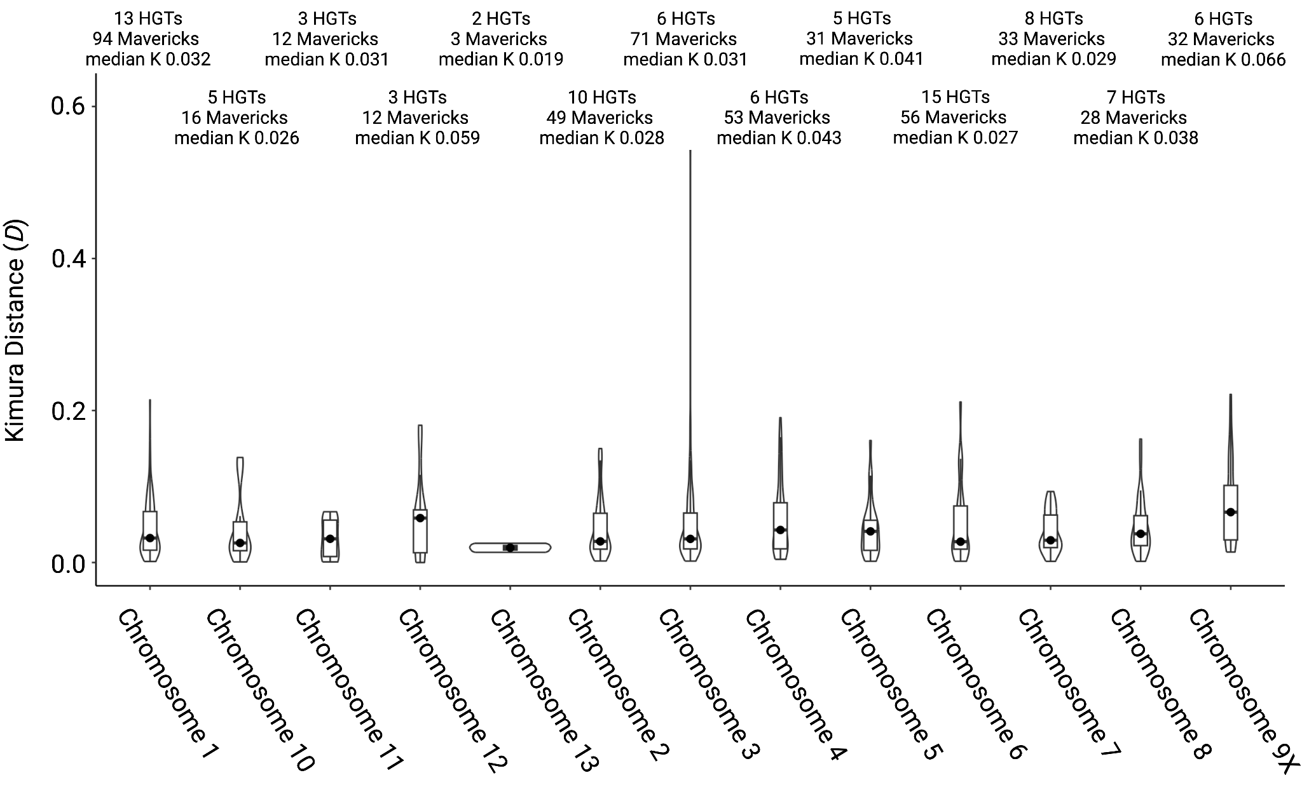
Supplemental Figure 48. Violin plots with embedded box plots summarizing the distribution of Kimura D estimates for Mavericks encapsulating HGTs in C. caryae. Chromosome 9 corresponds to the X chromosome.

Supplementary Table 1. Counts and cumulative sizes of structural variants (SVs), TEs and repeats, and HGT regions across homologous chromosomes in Curculio species: C. caryae (Cc), C. nanulus (Cn), and C. glandium (Cg).

Homologous chromosome | Species-specific SVs >100 bp (size in Mb) | TEs and repeats (size in Mb) | HGT regions (size in kb)
Cc: 1 | 21,047 (263.09) | 355,659 (237.79) | 235 (928.06)
Cn: 1 | 23,759 (143.80) | 247,606 (133.89) | 26 (87.353)
Cg: 2 | 2,233 (137.69) | 225,385 (96.01) | 18 (58.05)
Cc: 2 | 37,472 (223.79) | 355,564 (225.38) | 75 (201.28)
Cn: 2 | 22,632 (142.24) | 251,738 (132.40) | 44 (129.97)
Cg: 1 | 2,208 (149.66) | 250,654 (107.15) | 12 (​​32.10)
Cc: 3 | 34,856 (205.48) | 320,544 (203.06) | 213 (932.97)
Cn: 3 | 19,672 (112.92) | 201,874 (104.25) | 32 (93.78)
Cg: 3 | 2,131 (129.61) | 214,146 (89.96) | 10 (27.05)
Cc: 4 | 21,531 (180.09) | 246,615 (156.21) | 51 (140.09)
Cn: 4 | 18,736 (108.14) | 194,417 (100.35) | 29 (86.44)
Cg: 4 | 1,669 (101.45) | 166,216 (70.39) | 8 (22.01)
Cc: 5 | 20,885 (155.91) | 238,793 (144.07) | 30 (89.65)
Cn: 5 | 18,354 (104.93) | 189,479 (97.58) | 29 (87.44)
Cg: 5 | 1,799 (97.84) | 158,256 (66.13) | 15 (45.93)
Cc: 7 | 18,023 (127.05) | 193,038 (114.34) | 31 (87.39)
Cn: 7 | 15,910 (80.01) | 147,303 (73.86) | 20 (61.99)
Cg: 6 | 1,645 (85.93) | 137,784 (58.90) | 5 (16.19)
Cc: 6 | 16,665 (135.95) | 192,167 (119.76) | 56 (158.88)
Cn: 6 | 15,714 (102.89) | 166,981 (87.99) | 28 (84.54)
Cg: 7 | 1,716 (76.8) | 113,913 (49.42) | 14 (36.36)
Cc: 10 | 14,726 (85.21) | 140,387 (73.36) | 14 (40.68)
Cn: 8 | 15,224 (80.56) | 125,292 (62.22) | 15 (41.63)
Cg: 8 | 1,291 (70.47) | 111,304 (46.46) | 13 (31.77)
Cc: 8 | 14,450 (105.92) | 162,234 (93.20) | 27 (79.73)
Cn: 9 | 13,904 (69.67) | 85,170 (42.94) | 15 (46.37)
Cg: 9 | 1,424 (67.65) | 104,771 (43.83) | 9 (22.56)
Cc: 12 | 11,293 (67.98) | 109,530 (56.71) | 12 (32.79)
Cn: 10 | 11,824 (55.65) | 140,140 (70.45) | 14 (43.92)
Cg: 10 | 905 (45.32) | 67,686 (28.04) | 11 (29.99)
Cc: 13 | 6,741 (48.56) | 72,574 (37.91) | 4 (8.48)
Cn: 13 | 7,463 (44.075) | 70,424 (32.34) | 10 (29.76)
Cg: 11 | 727 (40.68) | 54,183 (26.72) | 3 (9.35)
Cc: 11 | 8,998 (76.39) | 111,643 (65.12) | 12 (33.22)
Cn: 12 | 8,949 (52.86) | 100,271 (47.09) | 17 (57.18)
Cg: 12 | 628 (34.46) | 41,986 (20.14) | 10 (27.67)
Cc: 9  (X chromosome) | 14,276 (97.82) | 131,038 (93.20) | 30 (75.68)
Cn: 11  (X chromosome) | 11,198 (44.26) | 85,119 (44.32) | 4 (11.54)
Cg: 13  (X chromosome) | 2,217 (42.29) | 58,444 (24.89) | 8 (18.46)

Supplementary Table 2. Ccb HGT annotations for Chromosomes 1 (C1) and 3 (C3). Bolded rows denote genes with significant branch-site likelihood ratio tests for positive selection.

Gene ID | Protein annotation | C1 fragments | C3 fragments | C1 coordinates | C3 coordinates
WP_395479791.1 | ATP-dependent chaperone ClpB | 1 | 1 | 134011286-  134013155 | 136812448-  136814956
WP_395479792.1 | transcription antiterminator/RNA stability regulator CspE | 1 | 1 | 134205796-  134206005 | 136615288-  136615488
WP_395480257.1 | ATP-dependent zinc metalloprotease FtsH | 1 | 1 | 134041437-  134043351 | 136841934-  136843849
WP_395480164.1 | type I glyceraldehyde-3-phosphate dehydrogenase | 1 | 1 | 134532379-  134533350 | 137265139-  137266109
WP_395479678.1 | chaperonin GroEL | 1 | 2 | 134156614-  134158268 | 137177374-  137179012; 137221463-  137222914
WP_395479659.1 | isoleucine--tRNA ligase | 1 | 1 | 134001521-  134004334 | 136804177-  136807004
WP_395479776.1 | translation initiation factor IF-2 | 1 | 1 | 134033583-  134036180 | 136836113-  136837077
WP_395479794.1 | leucine--tRNA ligase | 1 | 1 | 134201489-  134204062 | 136617191-  136619771
WP_395479804.1 | lipoyl synthase | 1 | 2 | 134191493-  134192395 | 136514630-  136515532;  136628929-  136629831
WP_395479660.1 | signal peptidase II | 1 | 1 | 134004334-  134004799 | 136807004-  136807469
WP_395479801.1 | peptidoglycan DD-transpeptidase MrdA | 1 | 1 | 134196682-[\n]134198534 | 136622725-136624567
WP_395480236.1 | NADH-quinone oxidoreductase subunit NuoG | 1 | 1 | 134515014-134517720 | 137247472-137250161
WP_395479860.1 | two-component system response regulator PhoP | 1 | 2 | 134246882-134247452 | 136523760-136524425; 136572776-136573441
WP_395479690.1 | pyruvate kinase | 1 | 2 | 134136677-134138116 | 137198008-137199435; 137201040-137202467
WP_395479665.1 | transcription termination factor Rho | 1 | 1 | 134220083-134221345 | 136597410-136598672
WP_395479658.1 | bifunctional riboflavin kinase/FAD synthetase | 1 | 1 | 134000742-134001468 | 136803206-136804124
WP_395480165.1 | signal peptide peptidase SppA | 1 | 1 | 134529506-134531177 | 137262271-137263938
WP_395480266.1 | translational GTPase TypA | 1 | 1 | 134283263-134285056 | 137224800-137226590
WP_395479685.1 | 2-octaprenyl-6-methoxyphenyl hydroxylase | 1 | 2 | 134144156-134145323 | 137190796-137191961; 137208508-137209676
WP_395479688.1 | glucose-6-phosphate dehydrogenase | 1 | 2 | 134139312-134140447 | 137195331-137196774; 137203701-137205144
WP_395479664.1 | proline--tRNA ligase | 1 | 1 | 134214784-134216504 | 136602250-136603991
WP_395479677.1 | co-chaperone GroES | 1 | 1 | 134158315-134158608 | 137177034-137177327
WP_395479781.1 | DEAD/DEAH family ATP-dependent RNA helicase | 1 | 1 | 134027062-134028334 | 136827634-136829330
WP_395479784.1 | 3-deoxy-7-phosphoheptulonate synthase | 1 | 1 | 134017859-134018869 | 136819167-136819807
WP_395479763.1 | acetyl-CoA carboxylase biotin carboxylase subunit |  | 1 |  | 136849019-136849673
WP_395480224.1 | pyruvate dehydrogenase (acetyl-transferring), homodimeric type |  | 1 |  | 136703291-136705035
WP_395479942.1 | arginine--tRNA ligase | 1 |  | 134321652-134323387
WP_395480018.1 | shikimate kinase AroK |  | 1 |  | 136692605-136693119
WP_395479814.1 | archaetidylserine decarboxylase | 1 |  | 134180320-134181189
WP_395480232.1 | cytidine deaminase |  | 1 |  | 137318499-137319314
WP_395479875.1 | ATP-dependent Clp protease ATP-binding subunit ClpX | 1 |  | 134308438-134309712
WP_395480167.1 | cardiolipin synthase |  | 1 |  | 137256671-137257852
ACICP0_RS01840 | (d)CMP kinase | 1 |  | 134404298-134404935
WP_395480219.1 | magnesium/cobalt transporter CorA | 1 |  | 134434714-134435659
WP_395479880.1 | ubiquinol oxidase subunit II | 1 |  | 134297338-134298157
WP_395479881.1 | cytochrome o ubiquinol oxidase subunit I | 1 |  | 134295226-134297220
WP_395480211.1 | ribosome biogenesis GTPase Der | 1 |  | 134448976-134449738
WP_395479918.1 | molecular chaperone DnaK | 2 |  | 134253849-134255290; 271083270-271083644
WP_395480154.1 | dipeptide/tripeptide permease DtpA |  | 1 |  | 137329703-137331149
WP_395479887.1 | 1-deoxy-D-xylulose-5-phosphate synthase |  | 2 |  | 137234124-137235917; 137227594-137229398
WP_395479830.1 | phosphopyruvate hydratase |  | 1 |  | 137155687-137156966
WP_395479636.1 | 3-hydroxyacyl-ACP dehydratase FabZ | 1 |  | 134371636-134372091
ACICP0_RS03070 | cell division protein FtsW |  | 1 |  | 136560104-136561200
WP_395479870.1 | cell division protein FtsZ |  | 2 |  | 136554166-136554764; 136638432-136639042
WP_395480233.1 | class II fumarate hydratase |  | 1 |  | 137338087-137339433
WP_395479771.1 | phosphoglucosamine mutase | 1 |  | 134039140-134040456
WP_395479890.1 | glutamine--fructose-6-phosphate transaminase (isomerizing) | 1 |  | 134272349-134274188
WP_395479984.1 | glycine--tRNA ligase subunit alpha | 1 |  | 134344071-134344975
WP_395479985.1 | glycine--tRNA ligase subunit beta | 1 |  | 134341993-134344053
WP_395479873.1 | xanthine phosphoribosyltransferase | 1 |  | 134314626-134315087
WP_395479600.1 | glutamate--cysteine ligase | 1 |  | 134416623-134417111
WP_395479732.1 | protease modulator HflC | 1 |  | 134067855-134068853
WP_395480163.1 | histone-like nucleoid-structuring protein H-NS |  | 1 |  | 137267742-137268142
WP_395479808.1 | molecular chaperone HtpG | 2 |  | 134185083-134186956; 134189638-134189741
WP_395479616.1 | integration host factor subunit beta | 1 |  | 134402094-134402377
WP_395480226.1 | translation initiation factor IF-3 |  | 1 |  | 136679537-136680084
WP_395479630.1 | 1-deoxy-D-xylulose-5-phosphate reductoisomerase | 1 |  | 134379728-134380923
WP_395480141.1 | 4-(cytidine 5'-diphospho)-2-C-methyl-D-erythritol kinase |  | 1 |  | 137303168-137304015
WP_395480214.1 | flavodoxin-dependent (E)-4-hydroxy-3-methylbut-2-enyl-diphosphate synthase | 1 |  | 134443396-134444501
WP_395480245.1 | (2E,6E)-farnesyl-diphosphate-specific ditrans,polycis-undecaprenyl-diphosphate synthase | 1 |  | 134378806-134379533
WP_395479909.1 | 3-deoxy-8-phosphooctulonate synthase |  | 1 |  | 136669688-136670530
WP_395479874.1 | endopeptidase La | 1 |  | 134309917-134312242
WP_395480225.1 | dihydrolipoyl dehydrogenase |  | 1 |  | 136700382-136701816
WP_395479638.1 | lipid-A-disaccharide synthase | 1 |  | 134369696-134370818
WP_395479871.1 | UDP-3-O-acyl-N-acetylglucosamine deacetylase |  | 2 |  | 136553153-136554051; 136639157-136640055
WP_395479722.1 | cystathionine beta-lyase | 1 |  | 134082788-134083960
WP_395480008.1 | methionine adenosyltransferase |  | 1 |  | 136709752-136710876
WP_395480134.1 | septum site-determining protein MinD |  | 1 |  | 137281853-137282665
WP_395479714.1 | membrane-bound lytic murein transglycosylase MltC | 1 |  | 134093035-134094096
WP_395479858.1 | tRNA 2-thiouridine(34) synthase MnmA | 1 |  | 134243406-134244529
WP_395479759.1 | rod shape-determining protein MreC | 1 |  | 134063160-134063981
WP_395479695.1 | UDP-N-acetylglucosamine 1-carboxyvinyltransferase | 1 |  | 134128210-134129446
WP_395479868.1 | UDP-N-acetylmuramate--L-alanine ligase |  | 2 |  | 136557379-136558377; 136634831-136635829
WP_395480261.1 | UDP-N-acetylmuramoyl-L-alanyl-D-glutamate--2,6-diaminopimelate ligase |  | 1 |  | 136565065-136566435
WP_395479717.1 | A/G-specific adenine glycosylase | 1 |  | 134091633-134092462
WP_395480176.1 | NADH-quinone oxidoreductase subunit A | 1 |  | 134510056-134510324
WP_395479774.1 | transcription termination factor NusA |  | 1 |  | 136837121-136838586
WP_395479623.1 | 2-oxoglutarate dehydrogenase complex dihydrolipoyllysine-residue succinyltransferase | 1 |  | 134386914-134388104
WP_395479812.1 | oligoribonuclease | 1 |  | 134182206-134182742
WP_395479906.1 | leucyl aminopeptidase |  | 1 |  | 136677432-136678358
WP_395480016.1 | glucose-6-phosphate isomerase |  | 1 |  | 136695734-136697346
WP_395479617.1 | 6-phosphogluconolactonase | 1 |  | 134397434-134398412
WP_395479861.1 | two-component system sensor histidine kinase PhoQ |  | 2 |  | 136571316-136572764; 136524437-136525882
WP_395480240.1 | metalloprotease PmbA | 1 |  | 134450640-134451977
WP_395479656.1 | nicotinate phosphoribosyltransferase |  | 1 |  | 136798399-136799600
WP_395480143.1 | aminoacyl-tRNA hydrolase |  | 1 |  | 137305868-137306432
WP_395479832.1 | glutamine hydrolyzing CTP synthase |  | 1 |  | 137156994-137158623
WP_395479599.1 | recombinase RecA | 1 |  | 134421914-134422906
WP_395480179.1 | exodeoxyribonuclease V subunit beta | 1 |  | 134497423-134499278
WP_395480123.1 | lipopolysaccharide heptosyltransferase RfaC |  | 1 |  | 137375170-137376093
WP_395480002.1 | 50S ribosomal protein L1 |  | 1 |  | 136722923-136723607
WP_395480001.1 | 50S ribosomal protein L10 |  | 1 |  | 136723950-136724202
WP_395480000.1 | 50S ribosomal protein L7/L12 |  | 1 |  | 136724452-136724824
WP_395480190.1 | 50S ribosomal protein L16 | 1 |  | 134484908-134485310
WP_395479999.1 | DNA-directed RNA polymerase subunit beta |  | 2 |  | 136725154-136727774; 136727782-136729112
WP_395479998.1 | DNA-directed RNA polymerase subunit beta' |  | 1 |  | 136729205-136731079
WP_395479940.1 | RNA pyrophosphohydrolase |  | 1 |  | 136543213-136543701
WP_395479615.1 | 30S ribosomal protein S1 | 1 |  | 134402458-134404144
WP_395480200.1 | 30S ribosomal protein S5 | 1 |  | 134462941-134463428
WP_395480197.1 | 30S ribosomal protein S8 | 1 |  | 134482306-134482698
WP_395480206.1 | 30S ribosomal protein S11 | 1 |  | 134459877-134460261
WP_395479963.1 | 16S rRNA (guanine(966)-N(2))-methyltransferase RsmD |  | 1 |  | 136748028-136748551
WP_395479620.1 | succinate dehydrogenase flavoprotein subunit | 1 |  | 134391905-134393672
ACICP0_RS03110 | preprotein translocase subunit SecA |  | 2 |  | 136549490-136551997; 136641211-136643722
WP_395480203.1 | preprotein translocase subunit SecY | 1 |  | 134460961-134462270
WP_395479634.1 | molecular chaperone Skp | 1 |  | 134373247-134373744
WP_395479959.1 | transcriptional regulator SlyA | 1 |  | 134330553-134330980
WP_395479724.1 | spermidine N1-acetyltransferase | 1 |  | 134077399-134077937
WP_395480221.1 | Fe-S cluster assembly protein SufB |  | 1 |  | 136751499-136752985
WP_395479640.1 | tRNA adenosine(34) deaminase TadA | 1 |  | 134364325-134364642
WP_395479856.1 | thiamine/thiamine pyrophosphate ABC transporter permease | 1 |  | 134238793-134240350
WP_395480026.1 | threonine--tRNA ligase |  | 2 |  | 136680660-136681890; 136680090-136680633
WP_395480015.1 | metalloprotease TldD |  | 1 |  | 136698690-136700122
WP_395480138.1 | type I DNA topoisomerase |  | 1 |  | 137289396-137291967
WP_395479650.1 | elongation factor Tu |  | 1 |  | 136771958-136773080
WP_395479935.1 | 4-hydroxy-3-polyprenylbenzoate decarboxylase |  | 1 |  | 136533483-136534953
WP_395479718.1 | uracil phosphoribosyltransferase | 1 |  | 134089785-134090410
WP_395480122.1 | lipid IV(A) 3-deoxy-D-manno-octulosonic acid transferase |  | 1 |  | 137384137-137385348
WP_395480259.1 | tol-pal system protein YbgF |  | 1 |  | 137150885-137151306
WP_395479922.1 | membrane protein insertase YidC | 1 |  | 134248610-134250247
WP_395479923.1 | membrane protein insertion efficiency factor YidD | 1 |  | 134248360-134248597
WP_395480242.1 | fructose-1-phosphate/6-phosphogluconate phosphatase | 1 |  | 134417204-134417763
WP_395479621.1 | succinate dehydrogenase iron-sulfur subunit | 1 |  | 134391172-134391884
WP_395479709.1 | MBL fold metallo-hydrolase | 1 |  | 134115558-134116146
WP_395479723.1 | single-stranded DNA-binding protein | 1 |  | 134079177-134079696
WP_395479760.1 | rod shape-determining protein | 1 |  | 134062011-134063050
WP_395479846.1 | metal ABC transporter permease | 1 |  | 134178515-134179307
WP_395480022.1 | YchF/TatD family DNA exonuclease |  | 1 |  | 136687410-136688080
WP_395480142.1 | ribose-phosphate pyrophosphokinase |  | 1 |  | 137304282-137305231
WP_395480158.1 | 2-hydroxyacid dehydrogenase |  | 1 |  | 137342741-137343736
WP_395480207.1 | DNA-directed RNA polymerase subunit alpha | 1 |  | 134458242-134459201
ACICP0_RS03380 | DNA polymerase III subunit chi |  | 1 |  | 136676868-136677295

Supplementary Table 3. Pairwise Jukes-Cantor genetic distances estimated across four Ccb-derived homologous regions: the Chromosome 1 region, the upstream Chromosome 3 region (A), the downstream Chromosome 3 region (B), the extrachromosomal contig (JAKZMK010000236.1), and the Ccb reference genome.

 | Chromosome 1 | Chromosome 3A | Chromosome 3B | Ccb genome | JAKZMK010000236.1
Chromosome 1 | - | 0.0277 | 0.0560 | 0.222 | 0.00162
Chromosome 3A |  | - | 0.110 | 0.217 | 0.0143
Chromosome 3B |  |  | - | 0.229 | 0.0253
Ccb genome |  |  |  | - | 0.214

Supplementary Table 4. Genome-wide repeat family composition in C. caryae. Counts and cumulative sizes are shown for each TE family in regions classified as old or young based on the Kimura D thresholds described in Methods.
TE family | Counts of old TEs | Counts of young TEs | Cumulative size of old TEs (bp) | Cumulative size of young TEs (bp) | Proportion of young TE counts (col2/[col1+2) | Proportion of young TE size col4/(col3+4)
Unknown | 973,281 | 297,975 | 368,832,962 | 236,460,405 | 0.234 | 0.391
DNA/Maverick | 141,401 | 45,094 | 103,679,464 | 113,497,558 | 0.242 | 0.523
LTR/Gypsy | 102,346 | 43,780 | 73,303,501 | 102,943,396 | 0.300 | 0.584
DNA/TcMar-Tc1 | 110,048 | 43,108 | 34,797,779 | 63,913,645 | 0.281 | 0.647
LINE/R1-LOA | 99,143 | 26,974 | 53,294,578 | 32,231,503 | 0.214 | 0.377
LINE/Dong-R4 | 28,058 | 14,077 | 20,127,356 | 31,967,322 | 0.334 | 0.614
LINE/L2 | 49,374 | 14,496 | 18,841,058 | 21,892,504 | 0.227 | 0.537
DNA/hAT-Tip100 | 38,478 | 16,050 | 14,290,869 | 20,424,795 | 0.294 | 0.588
DNA/P | 26,179 | 10,282 | 7,917,624 | 11,940,737 | 0.282 | 0.601
LINE/I | 8,261 | 3,554 | 5,440,727 | 10,762,498 | 0.301 | 0.664
LINE/Penelope | 25,131 | 11,384 | 7,916,460 | 10,210,735 | 0.312 | 0.563
LINE/I-Jockey | 60,745 | 6,476 | 31,856,392 | 8,741,410 | 0.096 | 0.215
LTR/Pao | 14,986 | 3,833 | 7,358,761 | 8,151,393 | 0.204 | 0.526
LINE/CR1 | 18,860 | 6,495 | 8,024,478 | 7,571,152 | 0.256 | 0.485
LINE/RTE-BovB | 49,019 | 5,938 | 23,477,268 | 6,994,769 | 0.108 | 0.230
DNA/TcMar-m44 | 10,357 | 6,712 | 3,106,917 | 6,675,792 | 0.393 | 0.682
DNA/Academ-1 | 31,907 | 6,620 | 11,319,228 | 6,241,069 | 0.172 | 0.355
DNA/Crypton-I | 12,571 | 6,397 | 3,205,642 | 5,933,605 | 0.337 | 0.649
LTR/Copia | 7,146 | 2,796 | 3,639,347 | 5,702,881 | 0.281 | 0.610
DNA/hAT-Ac | 13,572 | 5,356 | 3,225,804 | 5,427,226 | 0.283 | 0.627
DNA/CMC-Chapaev-3 | 7,419 | 3,830 | 2,170,790 | 3,778,964 | 0.340 | 0.635
DNA/hAT-Blackjack | 4,003 | 2,560 | 908,160 | 3,623,481 | 0.390 | 0.800
DNA/CMC-Transib | 13,861 | 2,256 | 3,856,709 | 3,429,823 | 0.140 | 0.471
DNA/hAT-Tag1 | 3,326 | 2,381 | 902,899 | 3,118,653 | 0.417 | 0.775
LTR/DIRS | 2,705 | 1,330 | 1,414,810 | 3,112,689 | 0.330 | 0.688
LINE | 8,379 | 3,616 | 2,482,089 | 3,042,868 | 0.301 | 0.551
DNA | 13,209 | 2,767 | 2,825,787 | 2,912,762 | 0.173 | 0.508
DNA/MULE-MuDR | 5,001 | 2,060 | 1,316,320 | 2,662,063 | 0.292 | 0.669
RC/Helitron | 3,222 | 2,012 | 682,616 | 1,805,910 | 0.384 | 0.726
LINE/R1 | 9,841 | 992 | 4,927,087 | 1,596,994 | 0.092 | 0.245
DNA/PiggyBac | 10,682 | 1,934 | 3,003,633 | 1,580,541 | 0.153 | 0.345
DNA/Crypton-V | 9,767 | 812 | 2,116,807 | 1,523,719 | 0.077 | 0.419
DNA/PIF-ISL2EU | 4,853 | 924 | 1,203,164 | 1,203,482 | 0.160 | 0.500
DNA/TcMar-Mariner | 29,155 | 1,395 | 6,204,198 | 1,155,689 | 0.046 | 0.157
DNA/Crypton-A | 3,202 | 1,898 | 797,748 | 1,118,009 | 0.372 | 0.584
DNA/hAT-hATm | 3,311 | 770 | 1,113,751 | 1,097,921 | 0.189 | 0.496
DNA/PIF-Harbinger | 11,632 | 1,137 | 3,247,565 | 1,028,550 | 0.089 | 0.241
DNA/TcMar-Fot1 | 7,340 | 588 | 2,977,426 | 890,098 | 0.074 | 0.230
DNA/Sola-1 | 2,029 | 422 | 598,101 | 637,317 | 0.172 | 0.516
DNA/MULE-NOF | 18 | 162 | 8,959 | 577,712 | 0.900 | 0.985
DNA/hAT-Charlie | 7,059 | 1,223 | 1,504,390 | 569,520 | 0.148 | 0.275
DNA/Merlin | 3,943 | 761 | 2,114,116 | 543,556 | 0.162 | 0.205
DNA/CMC-EnSpm | 1,662 | 216 | 208,814 | 542,776 | 0.115 | 0.722
DNA/TcMar-Pogo | 3,229 | 542 | 905,917 | 463,905 | 0.144 | 0.339
LINE/RTE | 2,423 | 576 | 426,344 | 427,680 | 0.192 | 0.501
LINE/RTE-RTE | 5,417 | 333 | 3,131,003 | 416,433 | 0.058 | 0.117
DNA/Sola-2 | 71 | 189 | 42,950 | 412,220 | 0.727 | 0.906
DNA/Ginger-2 | 1,731 | 494 | 445,313 | 342,540 | 0.222 | 0.435
DNA/TcMar-Tigger | 4,146 | 263 | 1,169,562 | 311,588 | 0.060 | 0.210
SINE/5S-Deu-L2 | 4,230 | 1,451 | 891,936 | 299,471 | 0.255 | 0.251
DNA/hAT-hAT19 | 314 | 300 | 96,011 | 289,610 | 0.489 | 0.751
LINE/CRE | 956 | 154 | 372,149 | 154,666 | 0.139 | 0.294
DNA/hAT-hobo | 258 | 324 | 76,252 | 135,410 | 0.557 | 0.640
DNA/Kolobok-E | 746 | 187 | 81,816 | 109,145 | 0.200 | 0.572
DNA/TcMar-ISRm11 | 74 | 54 | 38,270 | 38,360 | 0.422 | 0.501
DNA/P-Fungi | 308 | 28 | 60,178 | 28,566 | 0.083 | 0.322
LINE/R2 | 135 | 3 | 81,543 | 7,827 | 0.022 | 0.088
DNA/hAT-hATx | 288 | 10 | 124,293 | 1,467 | 0.034 | 0.012

Supplementary Table 5. Genome-wide repeat family composition in C. nanulus. Counts and cumulative sizes are shown for each TE family in regions classified as old or young based on the Kimura D thresholds described in Methods.
TE family | Counts of old TEs | Counts of young TEs | Cumulative size of old TEs (bp) | Cumulative size of young TEs (bp) | Proportion of young TE counts (col2/[col1+2) | Proportion of young TE size col4/(col3+4)
Unknown | 860198 | 260337 | 302511088 | 208,232,464 | 0.232 | 0.408
DNA/TcMar-Tc1 | 80666 | 26423 | 23127520 | 31989071 | 0.247 | 0.58
LTR/Gypsy | 44402 | 12243 | 24497727 | 31863409 | 0.216 | 0.565
DNA/Maverick | 33164 | 7098 | 21049344 | 22138849 | 0.176 | 0.513
LINE/R1-LOA | 76653 | 17104 | 40687808 | 17760158 | 0.182 | 0.304
LINE/L2 | 32337 | 11171 | 13849309 | 17604366 | 0.257 | 0.56
LINE/RTE-BovB | 61032 | 9083 | 33051603 | 13526336 | 0.13 | 0.29
DNA/hAT-Tip100 | 36628 | 14475 | 12368538 | 13298514 | 0.283 | 0.518
LTR/Pao | 20461 | 5576 | 9273342 | 10939533 | 0.214 | 0.541
DNA/Academ-1 | 33921 | 7455 | 13040093 | 8988532 | 0.18 | 0.408
LINE/Penelope | 20346 | 8566 | 6447707 | 6848810 | 0.296 | 0.515
LINE/Dong-R4 | 3271 | 2460 | 2265263 | 5847783 | 0.429 | 0.721
DNA/P | 19102 | 5079 | 4814945 | 5377613 | 0.21 | 0.528
LINE/I-Jockey | 42426 | 3664 | 25562598 | 4947234 | 0.079 | 0.162
LINE/CR1 | 10254 | 4057 | 3829837 | 4725926 | 0.283 | 0.552
DNA/hAT-Ac | 12018 | 5323 | 2227163 | 4013086 | 0.307 | 0.643
LINE/RTE-RTE | 10414 | 2644 | 5790173 | 3884001 | 0.202 | 0.401
DNA/CMC-Transib | 9056 | 3801 | 3024239 | 3237049 | 0.296 | 0.517
DNA/TcMar-m44 | 6211 | 3207 | 1788629 | 2905524 | 0.341 | 0.619
LTR/Unknown | 10003 | 2602 | 5278446 | 2865878 | 0.206 | 0.352
LINE/I | 9375 | 1935 | 5217129 | 2855489 | 0.171 | 0.354
DNA/hAT-Tag1 | 4475 | 2519 | 1033830 | 2783305 | 0.36 | 0.729
RC/Helitron | 4790 | 2064 | 1120022 | 2591361 | 0.301 | 0.698
LTR/Copia | 2749 | 1718 | 1081923 | 2515427 | 0.385 | 0.699
DNA/Crypton-I | 11594 | 2313 | 2666221 | 2007677 | 0.166 | 0.43
DNA/hAT-Blackjack | 6069 | 2737 | 1111437 | 1665107 | 0.311 | 0.6
DNA | 9460 | 1606 | 1740290 | 1325904 | 0.145 | 0.432
LINE/R1 | 10262 | 1130 | 5448623 | 1137964 | 0.099 | 0.173
DNA/PIF-Harbinger | 9246 | 1267 | 2319490 | 1017153 | 0.121 | 0.305
DNA/PiggyBac | 5812 | 819 | 1471122 | 983247 | 0.124 | 0.401
DNA/MULE-MuDR | 6013 | 956 | 1522523 | 831278 | 0.137 | 0.353
DNA/CMC-Chapaev-3 | 5359 | 975 | 1555815 | 796680 | 0.154 | 0.339
DNA/TcMar-Mariner | 36584 | 1550 | 6938399 | 610651 | 0.041 | 0.081
DNA/Sola-1 | 3330 | 513 | 769268 | 604814 | 0.133 | 0.44
LTR/DIRS | 2998 | 388 | 1042305 | 551993 | 0.115 | 0.346
DNA/PIF-ISL2EU | 3805 | 576 | 818300 | 544116 | 0.131 | 0.399
DNA/hAT-hATm | 3146 | 670 | 940214 | 540416 | 0.176 | 0.365
LINE | 1589 | 446 | 273277 | 491207 | 0.219 | 0.643
DNA/TcMar-Fot1 | 6482 | 360 | 2362612 | 476519 | 0.053 | 0.168
DNA/Crypton-V | 3456 | 591 | 690060 | 423050 | 0.146 | 0.38
DNA/hAT-Charlie | 2149 | 368 | 563546 | 411466 | 0.146 | 0.422
DNA/TcMar-Pogo | 3297 | 404 | 866928 | 342591 | 0.109 | 0.283
LTR | 2358 | 228 | 699280 | 321452 | 0.088 | 0.315
DNA/Sola-2 | 245 | 119 | 86740 | 250419 | 0.327 | 0.743
DNA/Crypton-A | 1056 | 288 | 334374 | 249879 | 0.214 | 0.428
LINE/RTE | 375 | 138 | 374971 | 226368 | 0.269 | 0.376
DNA/hAT-hATx | 1170 | 291 | 359224 | 217521 | 0.199 | 0.377
DNA/P-Fungi | 213 | 75 | 99828 | 207693 | 0.26 | 0.675
DNA/TcMar-ISRm11 | 121 | 188 | 72152 | 193501 | 0.608 | 0.728
DNA/Ginger-2 | 1881 | 290 | 587495 | 183350 | 0.134 | 0.238
DNA/Kolobok-E | 363 | 94 | 86261 | 179904 | 0.206 | 0.676
DNA/TcMar-Tigger | 4560 | 279 | 1021166 | 151625 | 0.058 | 0.129
LINE/CRE | 830 | 110 | 356181 | 139651 | 0.117 | 0.282
DNA/MULE-NOF | 33 | 141 | 5363 | 134550 | 0.81 | 0.962
DNA/CMC-Chapaev | 234 | 55 | 85393 | 125985 | 0.19 | 0.596
DNA/hAT-hAT5 | 129 | 73 | 60617 | 118998 | 0.361 | 0.663
DNA/PIF-Spy | 198 | 40 | 111411 | 107056 | 0.168 | 0.49
SINE/5S-Deu-L2 | 2359 | 568 | 680975 | 85843 | 0.194 | 0.112
DNA/hAT-hAT19 | 826 | 201 | 138464 | 85611 | 0.196 | 0.382
DNA/CMC-EnSpm | 233 | 26 | 65423 | 54667 | 0.1 | 0.455
DNA/hAT-hobo | 177 | 140 | 46377 | 52914 | 0.442 | 0.533
DNA/Zator | 72 | 83 | 6888 | 43826 | 0.535 | 0.864
DNA/Merlin | 77 | 44 | 21021 | 16412 | 0.364 | 0.438
LINE/R2 | 309 | 7 | 165209 | 125 | 0.022 | 0.001
LINE/CR1-Zenon | 233 | 0 | 25961 | 0 | 0.0 | 0.0

Supplementary Table 6. Genome-wide repeat family composition in C. glandium. Counts and cumulative sizes are shown for each TE family in regions classified as old or young based on the Kimura D thresholds described in Methods.
TE family | Counts of old TEs | Counts of young TEs | Cumulative size of old TEs (bp) | Cumulative size of young TEs (bp) | Proportion of young TE counts (col2/[col1+2) | Proportion of young TE size col4/(col3+4)
Unknown | 743872 | 250051 | 191785851 | 151502164 | 0.252 | 0.441
LTR/Gypsy | 45924 | 31407 | 22461590 | 55787330 | 0.406 | 0.713
DNA/TcMar-Tc1 | 116649 | 33615 | 32025015 | 29768072 | 0.224 | 0.482
LTR/Pao | 22403 | 11226 | 10771189 | 15084764 | 0.334 | 0.583
LINE/R1-LOA | 44497 | 10659 | 13030921 | 14172632 | 0.193 | 0.521
LINE/L2 | 36957 | 8537 | 15664468 | 10065055 | 0.188 | 0.391
LINE/Penelope | 17216 | 10663 | 4852781 | 8059290 | 0.382 | 0.624
DNA/Academ-1 | 25865 | 7488 | 6151110 | 7379495 | 0.225 | 0.545
DNA/TcMar-m44 | 9500 | 7420 | 2301472 | 6814775 | 0.439 | 0.748
DNA/Maverick | 8958 | 2322 | 3764669 | 6665791 | 0.206 | 0.639
LINE/CR1 | 12905 | 4637 | 5246366 | 5881359 | 0.264 | 0.529
DNA/hAT-Tip100 | 17266 | 8160 | 3691537 | 5501090 | 0.321 | 0.598
LINE/Dong-R4 | 1249 | 2491 | 668075 | 4762971 | 0.666 | 0.877
DNA/Crypton-I | 10389 | 4863 | 2821320 | 4312149 | 0.319 | 0.604
LINE/I | 8536 | 2592 | 4651643 | 4254887 | 0.233 | 0.478
LINE/RTE-BovB | 20074 | 2433 | 7066956 | 3667257 | 0.108 | 0.342
DNA/P | 10564 | 4183 | 2418784 | 3373657 | 0.284 | 0.582
LTR/Unknown | 5695 | 4349 | 2208040 | 3140765 | 0.433 | 0.587
LTR/Copia | 4420 | 1994 | 1671567 | 3035052 | 0.311 | 0.645
LINE/RTE-RTE | 2496 | 1124 | 1636015 | 2061595 | 0.310 | 0.558
DNA/hAT-hATm | 1592 | 1491 | 587392 | 1922984 | 0.484 | 0.766
DNA | 5455 | 2678 | 1030447 | 1907902 | 0.329 | 0.649
LINE/I-Jockey | 12222 | 1741 | 4421364 | 1742375 | 0.125 | 0.283
DNA/Sola-1 | 5058 | 2447 | 1103116 | 1732967 | 0.326 | 0.611
RC/Helitron | 1903 | 1892 | 339178 | 1572617 | 0.499 | 0.823
DNA/CMC-Transib | 6354 | 1215 | 1482578 | 1239609 | 0.161 | 0.455
DNA/CMC-EnSpm | 2192 | 1470 | 617442 | 1041833 | 0.401 | 0.628
DNA/CMC-Chapaev-3 | 4327 | 909 | 1306944 | 1011536 | 0.174 | 0.436
DNA/PIF-Harbinger | 4790 | 1150 | 1122901 | 965153 | 0.194 | 0.462
DNA/PIF-ISL2EU | 3036 | 1470 | 386093 | 951258 | 0.326 | 0.711
DNA/hAT-Ac | 2838 | 1336 | 502184 | 797476 | 0.320 | 0.614
DNA/PiggyBac | 7941 | 1169 | 2657553 | 755198 | 0.128 | 0.221
DNA/TcMar-Fot1 | 3916 | 725 | 1435248 | 717265 | 0.156 | 0.333
LINE | 2200 | 1061 | 725017 | 629303 | 0.325 | 0.465
DNA/Crypton-V | 4457 | 693 | 634542 | 584270 | 0.135 | 0.479
DNA/hAT-Charlie | 625 | 394 | 121299 | 505776 | 0.387 | 0.807
DNA/TcMar-Tigger | 758 | 400 | 125732 | 327220 | 0.345 | 0.722
DNA/MULE-MuDR | 1578 | 486 | 320271 | 316670 | 0.235 | 0.497
DNA/Crypton-A | 843 | 525 | 287581 | 290684 | 0.384 | 0.503
DNA/TcMar-Mariner | 8400 | 410 | 1328198 | 290543 | 0.047 | 0.179
LTR/DIRS | 1439 | 153 | 590006 | 234679 | 0.096 | 0.285
DNA/Sola-2 | 253 | 267 | 25990 | 231561 | 0.513 | 0.899
DNA/PIF-Spy | 173 | 160 | 41185 | 209842 | 0.480 | 0.836
DNA/hAT-Tag1 | 1467 | 378 | 341837 | 196726 | 0.205 | 0.365
DNA/Ginger-1 | 50 | 332 | 3984 | 192706 | 0.869 | 0.980
DNA/hAT-Blackjack | 6555 | 436 | 1577829 | 168779 | 0.062 | 0.097
DNA/hAT-hAT19 | 1676 | 191 | 371910 | 166050 | 0.102 | 0.309
LINE/R1 | 4644 | 119 | 1614508 | 139193 | 0.025 | 0.079
DNA/Kolobok-E | 1870 | 346 | 435300 | 128692 | 0.156 | 0.228
DNA/hAT-hATx | 702 | 173 | 108731 | 104353 | 0.198 | 0.490
DNA/TcMar-Pogo | 475 | 137 | 133787 | 101343 | 0.224 | 0.431
DNA/TcMar-ISRm11 | 468 | 94 | 158617 | 98868 | 0.167 | 0.384
DNA/CMC-Chapaev | 158 | 76 | 27970 | 53379 | 0.325 | 0.656
DNA/Ginger-2 | 406 | 15 | 114491 | 23142 | 0.036 | 0.168
SINE/tRNA-V | 188 | 75 | 37941 | 15488 | 0.285 | 0.290
LTR | 7 | 4 | 2604 | 3007 | 0.364 | 0.536
LINE/R2 | 145 | 1 | 76491 | 2404 | 0.007 | 0.030
LINE/RTE | 947 | 3 | 201869 | 93 | 0.003 | 0.000
LINE/CRE | 245 | 1 | 46362 | 28 | 0.004 | 0.001
LINE/RTE-X | 103 | 0 | 47729 | 0 | 0.000 | 0.000

