Supplemental Information

Supplemental Table
Table S1. Climate zones ¹ and 57 representative cities
Zones | Description | Representative Cities
0A | Extremely Hot Humid | Bangkok (Thailand) | Singapore | Manila (Philippines)
0B | Extremely Hot Dry | Abu Dhabi (United Arab Emirates) | Guantanamo Bay Nas (Cuba) | Ahmedabad (India)
1A | Very Hot Humid | Hong Kong (China) | Campina Grande (Brazil) | Veracruz (Mexico)
1B | Very Hot Dry | New Delhi (India) | Richmond (Australia) | Yuanjiang (China)
2A | Hot Humid | Fuzhou (China) | Sao Paulo (Brazil) | Tunis (Tunisia)
2B | Hot Dry | Cairo (Egypt) | Amritsar (India) | Makindu (Kenya)
3A | Warm Humid | Guiyang (China) | Istanbul (Turkey) | Roma Ciampino (Italy)
3B | Warm Dry | Adelaide (Australia) | Cozzo Spadaro (Spain) | Melilla (Spain)
3C | Warm Marine | Kunming (China) | Katanning (Australia) | Santander (Spain)
4A | Mixed Humid | Beijing (China) | Brussels (Belgium) | Lyon (France)
4B | Mixed Dry | Madrid (Spain) | Tianjin (China) | AnYang (China)
4C | Mixed Marine | Seattle (America) | Vancouver (Canada) | San Francisco (America)
5A | Cool Humid | Yingkou (China) | Birmingham (UK) | Hamburg (Germany)
5B | Cool Dry | Taiyuan (China) | Cheyenne (America) | Lanzhou (China)
5C | Cool Marine | Comox (Canada) | Sandspit (Canada) | Ketchikan (America)
6A | Cold Humid | Changchun (China) | Moskva (Russia) | Gander (Canada)
6B | Cold Dry | Chifeng (China) | Alamosa (America) | Datong (China)
7 | Very Cold | Harbin (China) | Anchorage (America) | Ostersund (Sweden)
8 | Subarctic/Arctic | Mohe (China) | Yakutsk (Russia) | Churchill (Canada)
Table S2. The specification of the liquid cooling system ²⁻⁴
Equipment | Parameter | Value
Secondary pump | Mass flow rate (m3/h) | 2.1
 | Rated power (kW) | 0.252
Heat exchanger | Effectiveness | 0.8
Primary pump | Mass flow rate (m3/h) | 2.1
 | Rated power (kW) | 0.252
Dry cooler | Design inlet fluid temperature (℃) | 45
 | Design outlet fluid temperature (℃) | 40
 | Specific capacity (kJ/kg·℃) | 3.5 (water with propylene glycol)
 | Design air flow rate (kg/h) | 33768
 | Design fluid flow rate (kg/h) | 5292
 | Rated fan power (kW) | 1.76
Closed-circuit  cooling tower | Design air flow rate (kg/h) | 20227
 | Design fluid flow rate (kg/h) | 5554
 | Design inlet fluid temperature (℃) | 34
 | Design outlet fluid temperature (℃) | 29
 | Rated power (kW) | 1.1
Spray pump | Rated power (kW) | 0.25

Supplemental Figures
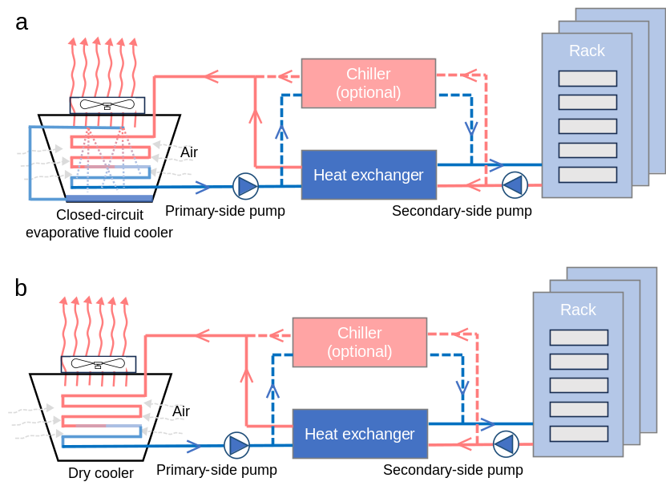
Figure S1. Schematic of evaporative-cooled (a) and dry-cooled liquid cooling systems (b)
Note: For free-cooling mode, the chiller is inactive, and cooling towers serve as the primary source of chilled water for the data center.
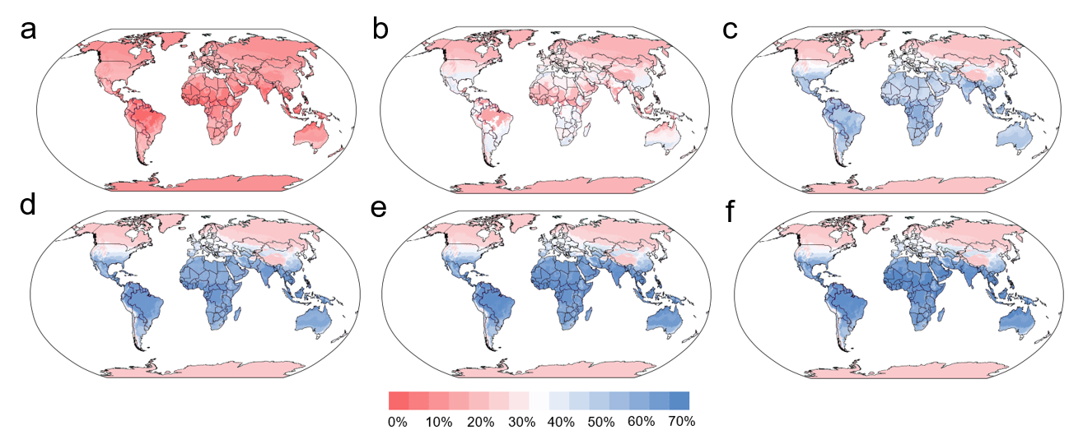
Figure S2. Global map of cooling energy savings and overall energy performance of dry-cooled liquid cooling systems under different inlet water temperatures. a-f, Global maps of cooling energy savings of 25 °C, 30 °C, 35 °C, 40 °C, 45 °C and 50 °C relative to a baseline inlet water temperature 20 °C, respectively.

Supplemental References
1. ASHRAE (2021). Standard 169-2021, Climatic Data for Building Design Standards.
2. Qu, S., Duan, K., Guo, Y., Feng, Y., Wang, C., and Xing, Z. (2024). Real-time optimization of the liquid-cooled data center based on cold plates under different ambient temperatures and thermal loads. Applied Energy 363, 123101.
3. Lu, T., Lü, X., Välisuo, P., Zhang, Q., and Clements-Croome, D. (2024). Innovative approaches for deep decarbonization of data centers and building space heating networks: Modeling and comparison of novel waste heat recovery systems for liquid cooling systems. Applied Energy 357, 122473.
4. https://baltimoreaircoil.com/products/closed-circuit-cooling-towers/series-v-closed-circuit-cooling-tower.

