Supplementary Figure S1
A schematic diagram of the experiments undertaken in this study
Supplementary Figure S2
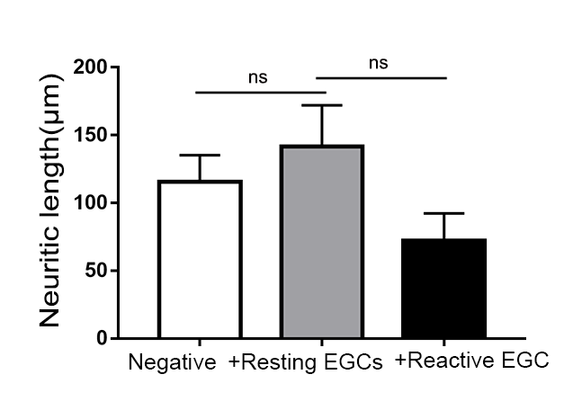
Neuritic length
One-way ANOVA, n = 6, ns no significant difference.

