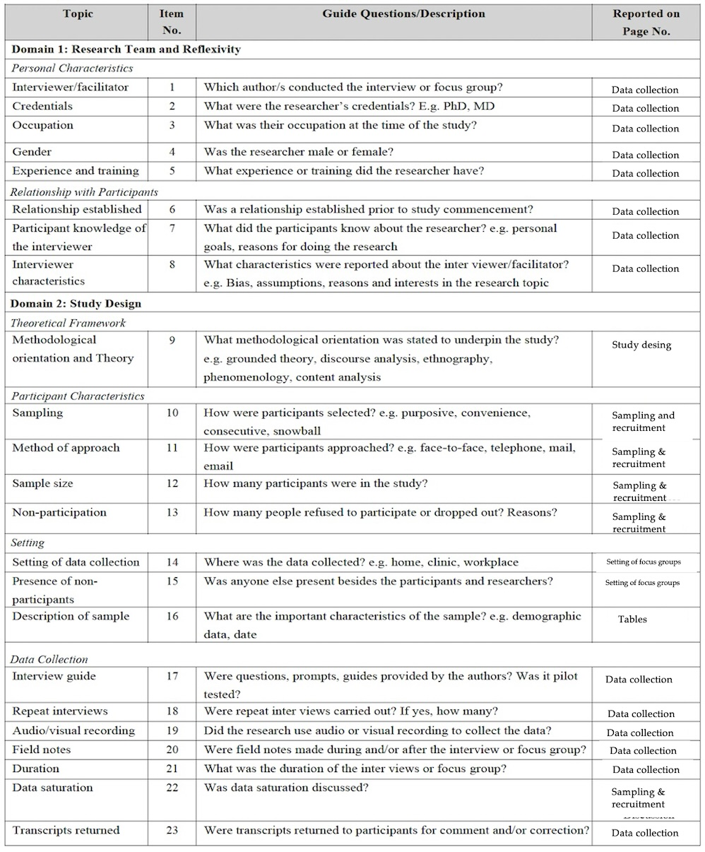
Supplementary Table 1. Consolidated criterio for reporting qualitative research Checklist ¹⁷

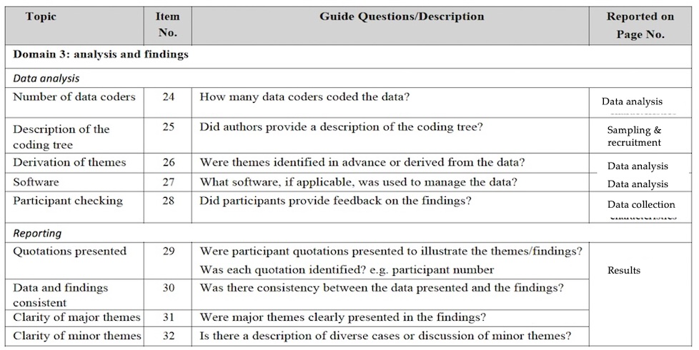

Supplementary Table 2. Anthropometric and Body Composition Measurements

Variable | Measurement | M ±SD
Weight (kg) | Baseline | 58.5 ± 3.0
Weight (kg) | PI | 62.2 ± 9.8
Weight (kg) | 1 -monthPI | 58.1 ± 3.6
BMI | Baseline | 23.6 ± 0.8
BMI | PI | 24.7 ± 2.1
BMI | 1 -monthPI | 23.3 ± 0.9
RD circumference (cm) | Baseline | 27.7 ± 1.3
RD circumference (cm) | PI | 27.2 ± 1.3
RD circumference (cm) | 1 -monthPI | 27.5 ± 1.1
LI circumference (cm) | Baseline | 27.3 ± 1.0
LI circumference (cm) | PI | 26.2 ± 1.6
LI circumference (cm) | 1 -monthPI | 26.7 ± 0.9
Chest circumference (cm) | Baseline | 88.3 ± 3.3
Chest circumference (cm) | PI | 88.3 ± 1.7
Chest circumference (cm) | 1 -monthPI | 88.1 ± 1.9
Right bicipital skinfold (mm) | Baseline | 17.3 ± 3.2
Right bicipital skinfold (mm) | PI | 14.4 ± 3.9
Right bicipital skinfold (mm) | 1 -monthPI | 15.2 ± 6.3
Left bicipital skinfold (mm) | Baseline | 18.2 ± 2.0
Left bicipital skinfold (mm) | PI | 15.2 ± 3.7
Left bicipital skinfold (mm) | 1 -monthPI | 16.5 ± 4.7
Right tricipital skinfold (mm) | Baseline | 18.7 ± 6.7
Right tricipital skinfold (mm) | PI | 15 ± 8.9
Right tricipital skinfold (mm) | 1 -monthPI | 17 ± 7.7
Left tricipital skinfold (mm) | Baseline | 19.7 ± 6.0
Left tricipital skinfold (mm) | PI | 17.3 ± 8.1
Left tricipital skinfold (mm) | 1 -monthPI | 18.9 ± 6.6
Body water (%) | Baseline | 47.7 ± 2.3
Body water (%) | PI | 50 ± 4.3
Body water (%) | 1 -monthPI | 51.5 ± 2.8
Body fat (%) | Baseline | 30.9 ± 0.4
Body fat (%) | PI | 27.1 ± 4.8
Body fat (%) | 1 -monthPI | 25.3 ± 4.2
Note. M: mean; SD: standard deviation; Me: median; Max: maximum; Min: minimum; PI: post-intervention; kg: kilograms; BMI: body mass index; RD: right arm; LI: left arm; cm: centimeters; mm: millimeters; R: right; L: left; %: percentage.

