Supplementary Data
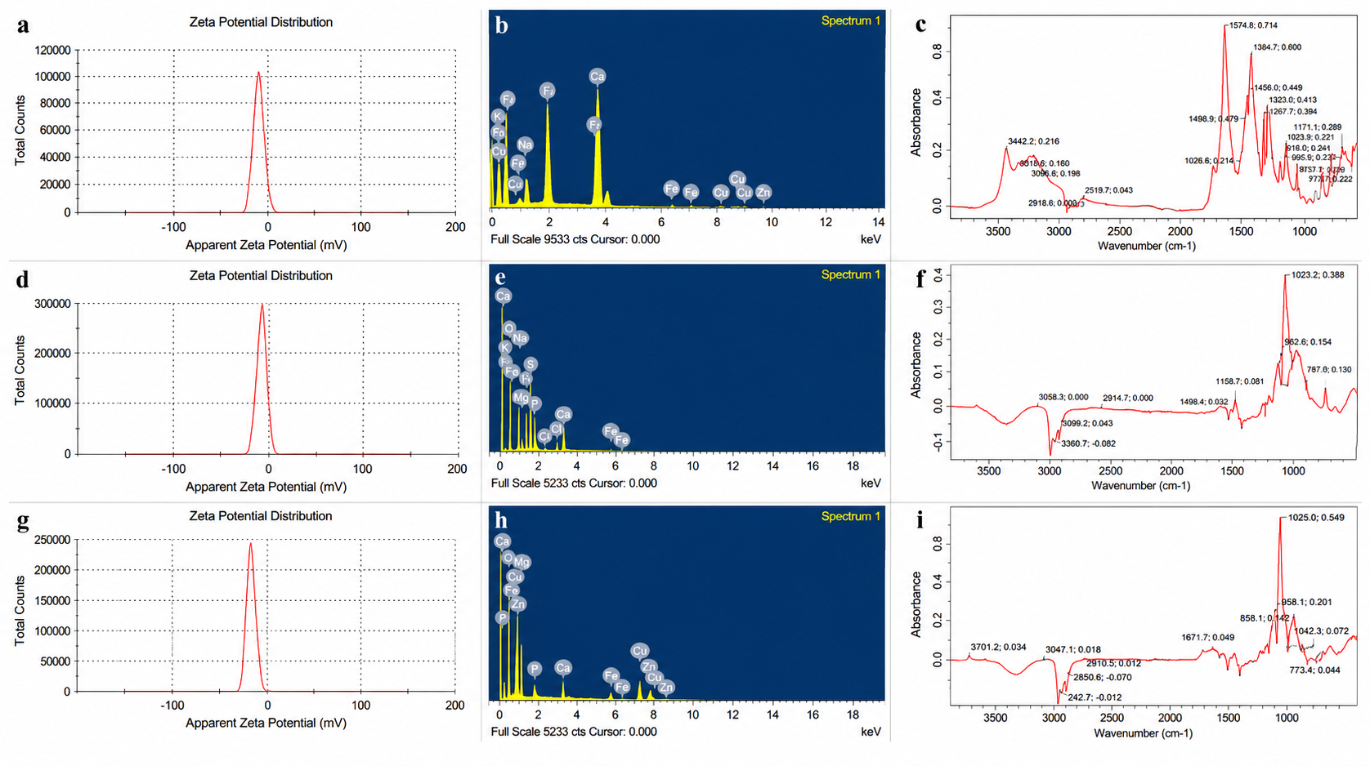
Supplementary Fig. S1: (i) Zeta potential analysis (a), (d), (g), (ii) Energy-dispersive X-ray spectroscopy (b), (e), (h), (iii) FTIR spectra of HNF (c), ZNF (f), and CNF(i).
Supplementary Table. S1: XRD data presenting 2-theta degree and Crystallite Size for HNF.
2-theta degree | Crystallite Size (nm) | Lattice Strain (ε)
25.98 | 30.55 | 0.00527
29.18 | 30.76 | 0.00467
30.72 | 30.87 | 0.00443
31.98 | 30.96 | 0.00424
33.1 | 31.05 | 0.00409
34.26 | 31.15 | 0.00394
35.56 | 31.26 | 0.00379
39.98 | 31.62 | 0.00339
46.86 | 32.44 | 0.00280
49.56 | 32.79 | 0.00263

Supplementary Table. S2: XRD data presenting 2-theta degree and Crystallite Size for ZNF.
2-theta degree | Crystallite Size (nm) | Lattice Strain (ε)
13.96 | 29.99 | 0.00993
24.38 | 30.45 | 0.00563
26.48 | 30.58 | 0.00517
30.22 | 30.83 | 0.00450
32.7 | 31.02 | 0.00414
40.16 | 31.69 | 0.00333

Supplementary Table. S3: XRD data presenting 2-theta degree and Crystallite Size for CNF.
2-theta degree | Crystallite Size (nm) | Lattice Strain (ε)
31.76 | 30.95 | 0.00427
34.42 | 31.16 | 0.00392
35.52 | 31.26 | 0.00380
36.26 | 31.32 | 0.00371
38.74 | 31.55 | 0.00346
42.94 | 31.99 | 0.00309
48.76 | 32.68 | 0.00268
68.02 | 35.91 | 0.00180

Supplementary Table S4: Swelling Ratio, Equilibrium Water Content and Water Absorption Capacity
SRCNFs | Swelling Ratio | Equilibrium Water Content | Water Absorption Capacity
HNF | 2.94% | 71% | 85%
ZNF | 3.2% | 75.2% | 79%
CNF | 2.72% | 66.7% | 74%

Supplementary Table S5: Water Retention Capacity Analysis
Water Retention Capacity Analysis (WRCs)
Days | Control | HNF | ZNF | CNF
5th | 77% | 83% | 95.8% | 81.6%
10th | 69.2% | 70% | 81.5% | 72.9%
15th | 51.3% | 61% | 65.2% | 57.8%

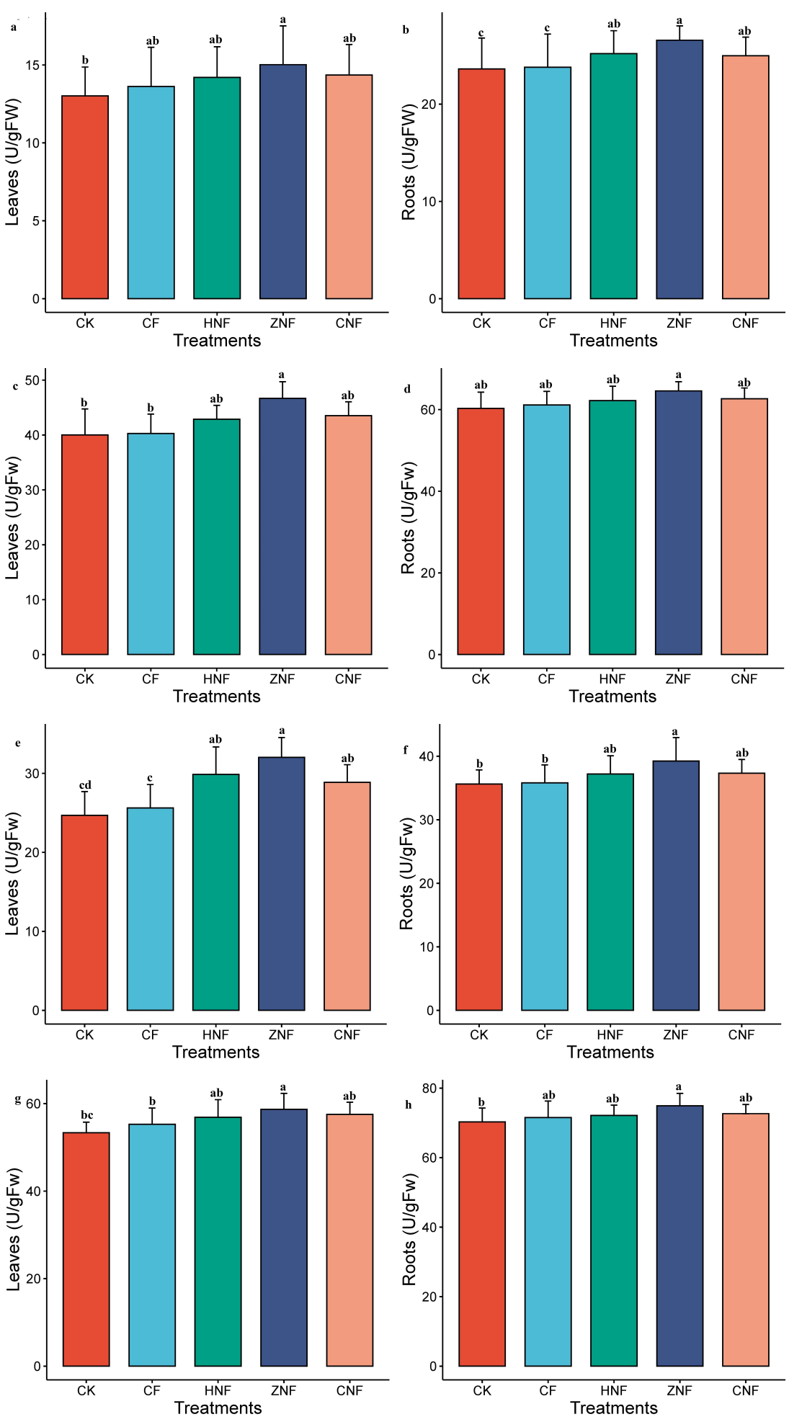
Supplementary Fig. S2: SOD (a,b), CAT (c,d), POD (e,f) and APX (g,h) activities in plants with different treatments. Data are means ± standard error of three replicates. Bars followed by the different letters are different at p < 0.05 according to the DMRT.
Supplementary Fig. S3: IAA (a,b), CA (c,d), MDA (e,f) and H₂O₂ (g,h) activities in plants with different treatments. Data are means ± standard error of three replicates. Data are means ± standard error of three replicates. Bars followed by the different letters are different at p < 0.05 according to the DMRT.
Supplementary Table S6: Plant Biometry
Treatments | Height  (cm) | Tiller No. | Root  (cm) | Leaves | 1000 Grain Weight (gms)
CK | 90±2.14 c | 12±2.63 c | 9±1.87 b | 30±2.61 b | 17±1.73 c
CF | 105±3.21 b | 17±2.29 b | 11±2.76 a | 45±1.51 a | 24±3.68 a
HNF | 105±2.7 b | 15±1.57 b | 11.7±3.71 a | 45±2.52 a | 23.5±1.81 b
ZNF | 109±1.51 a | 20±2.77 a | 11.9±3.01 a | 48±3.29 a | 24.7±2.63 a
CNF | 105.8±3.2 b | 18±3.11 b | 11.5±2.14 a | 43±2.76 a | 23.7±3.93 b
N.B.: Values were expressed as means ± standard error of triplicate samples

Supplementary Table S7: Comparative effects of fertilizer on nutritional compositions and antioxidant properties on rice grains
Treatments | Protein (%) | Carbohydrate (%) | TPC  (mg GAE/100 g) | TF  (mg/100 g)
CK | 8.2±2.02 c | 72±1.68 c | 12.5±1.34 b | 2.89±1.47 b
CF | 11±2.86 b | 75±2.05 b | 17.01±2.56 a | 4.85±2.68 a
HNF | 12±1.35 ab | 76.3±1.55 ab | 16.3±2.45 a | 4.29±2.92a
ZNF | 13±2.49 a | 77.01±1.83 a | 17.4±1.67 a | 4.77±2.02a
CNF | 11±2.45 b | 76.5±2.43 ab | 16.5±1.25 a | 4.09±2.45a
N.B.: Values were expressed as means ± standard error of triplicate samples

Supplementary Table S8: Available NPK in the soil
Treatments | Available Nitrogen  (Kg/ha) | Available Phosphorus  (Kg/ha) | Available Potassium (Kg/ha)
CK | 301.13±7.04d | 41.63±2.18d | 126.35±6.03d
CF | 377.06±6.17b | 59.42±4.21a | 160.49±5.33b
HNF | 366.12±7.21c | 56.99±3.14c | 146.02±6.89c
ZNF | 379.06±6.08a | 62.9±2.86a | 163.06±6.42a
CNF | 366.26±6.48c | 55.51±3.69b | 148.82±4.73c
N.B.: Values were expressed as means ± standard error of triplicate samples

Supplementary Table S9: Soil, Roots, Leaves, Grains Mineral Nutrients Content
 | Treatments | CK | CF | HNF | ZNF | CNF
Soil | Ca | 17.89±1.68e | 20.08±1.66d | 36.02±2.08a | 27.53±1.8c | 34.02±1.29b
Soil | Mg | 77.48±2.08e | 95.62±2.57d | 124.24±4.01b | 138.24±4.14a | 109.34±2.63c
Soil | Mn | 3.09±0.93d | 3.41±0.58c | 4.01±0.95b | 4.43±0.45a | 4.06±0.68b
Soil | Fe | 26.29±2.35e | 29.4±1.57d | 55.65±1.97c | 61.65±3.4a | 59.29±4.63b
Soil | Zn | 3.32±0.35d | 3.79±0.54c | 3.99±0.32a | 3.96±0.52a | 3.86±0.35b
Roots | Ca | 12.89±1.33d | 14.08±2.85c | 17.02±0.56a | 15.53±0.43b | 17.02±0.58a
Roots | Mg | 28.48±2.56d | 32.62±2.84c | 37.24±2.78b | 39.24±3.45a | 37.34±3.61b
Roots | Mn | 2.09±0.34d | 2.41±0.34cd | 3.01±0.75b | 3.43±0.55a | 3.06±0.47b
Roots | Fe | 6.29±1.21e | 7.4±1.34d | 8.65±1.63c | 9.65±1.74a | 9.29±1.32ab
Roots | Zn | 4.32±1.35a | 6.89±1.25c | 7.99±1.45b | 8.96±1.32a | 8.06±1.67b
Leaves | Ca | 11.89±2.46d | 13.08±2.31c | 16.02±2.67a | 14.53±2.48b | 16.02±2.51a
Leaves | Mg | 26.48±3.78c | 30.62±3.08b | 34.24±2.66a | 34.24±2.96a | 34.34±2.09a
Leaves | Mn | 1.01±0.267d | 1.41±0.321bc | 1.81±0.210ab | 1.93±0.245a | 1.96±0.156a
Leaves | Fe | 2±0.32d | 2.14±0.319c | 2.65±0.294a | 2.65±0.185a | 2.29±0.315b
Leaves | Zn | 1.32±0.341d | 1.79±0.567bc | 1.99±0.258a | 1.96±0.293ab | 1.86±0.184b
Grains | Ca | 5.89±1.25d | 6.08±1.57c | 8.02±1.78a | 7.53±1.24b | 8.02±1.82a
Grains | Mg | 30.48±3.62e | 33.62±3.01cd | 34.24±2.32c | 38.24±3.71ab | 39.34±2.74a
Grains | Mn | 0.9±0.139cd | 1.01±0.215bc | 1.41±0.364a | 1.43±0.231a | 1.36±0.155ab
Grains | Fe | 2±0.358d | 2.04±0.313c | 2.85±0.45ab | 3.01±0.41a | 2.99±0.15a
Grains | Zn | 1.06±0.24d | 1.66±0.251c | 1.89±0.29ab | 1.96±0.265a | 1.86±0.315ab
N.B.: Values were expressed as means ± standard error of triplicate samples

