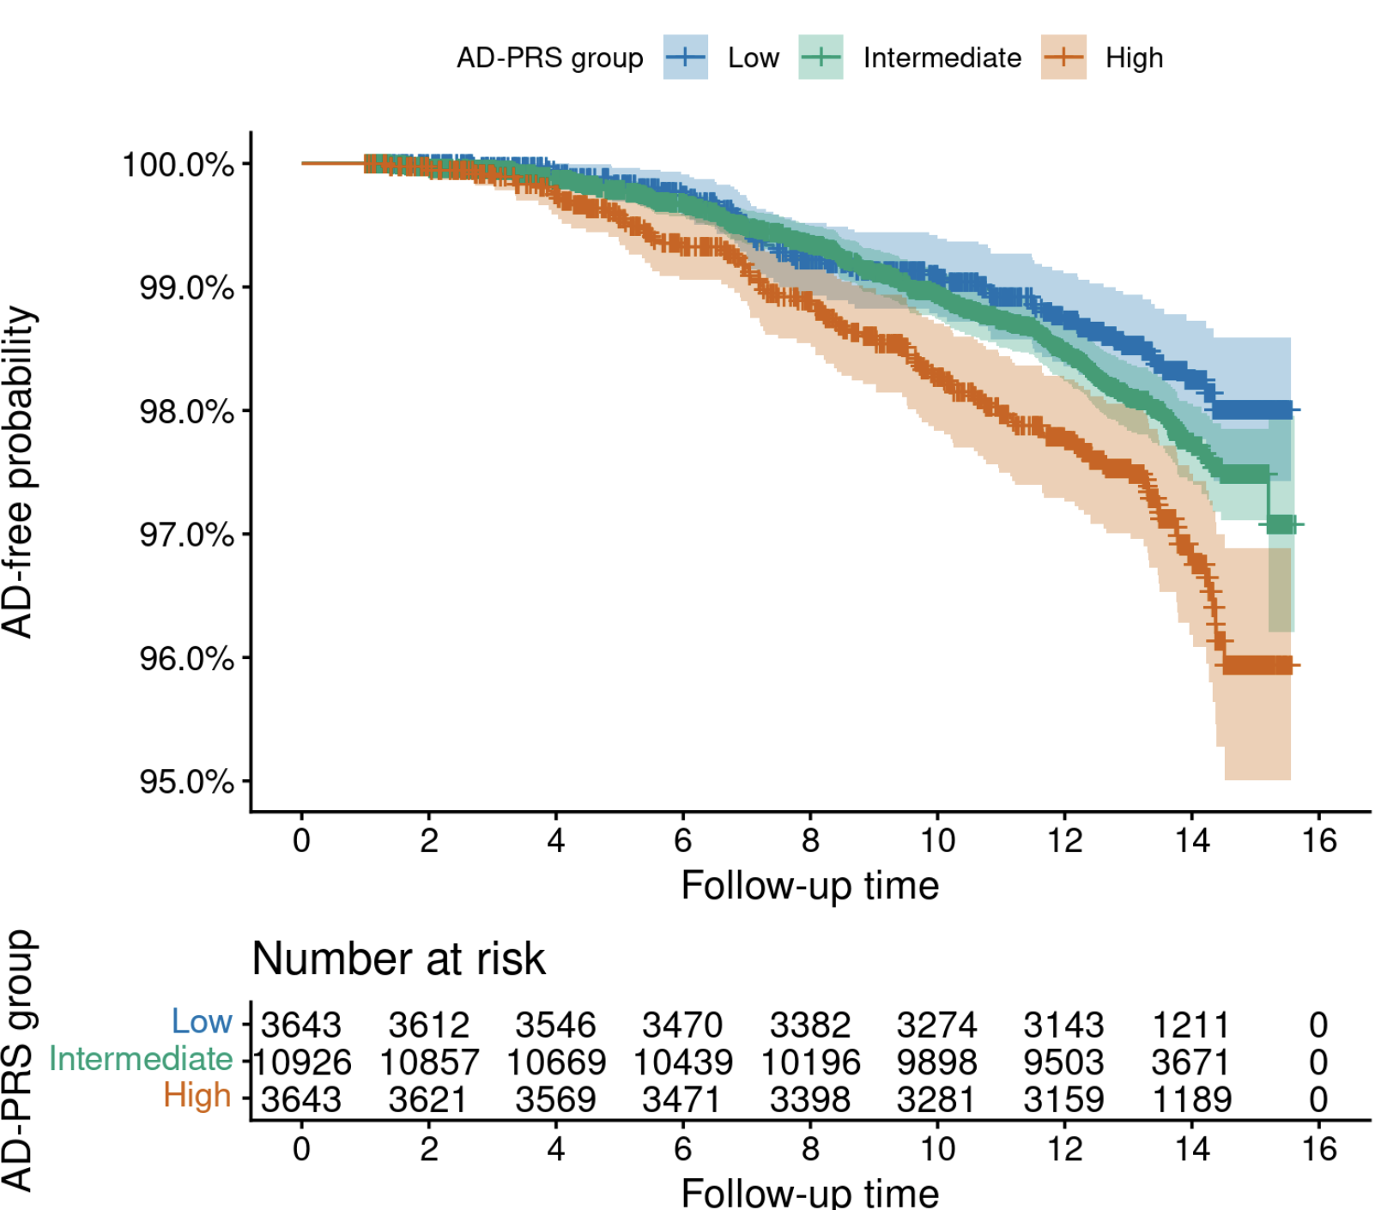
Supplemental Figure 1. Kaplan-Meier curves of AD-free survival stratified by AD-PRS groups.

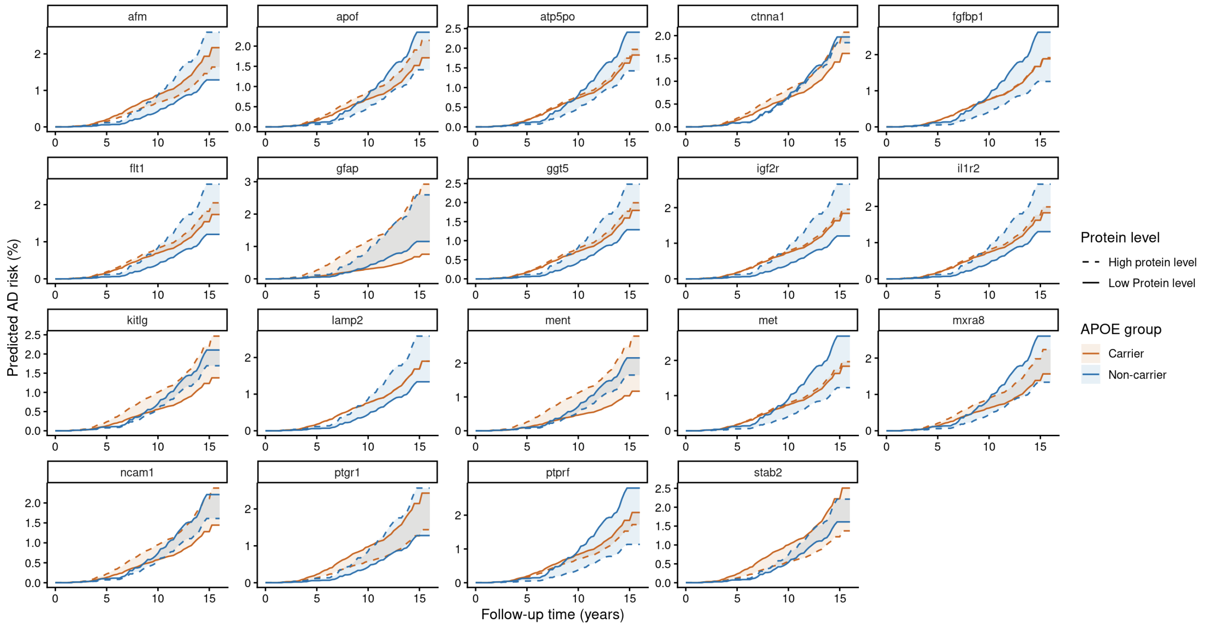
Supplemental Figure 2 Calibrated standardized predicted cumulative AD risk by protein level and APOE ε4 carrier status for selected proteins (the top six newly identified proteins with the strongest positive and negative associations among APOE ε4 non-carriers, along with all five newly identified proteins among APOE ε4 carriers were labeled). Standardized predicted cumulative AD risk curves were generated from Cox proportional hazards models stratified by APOE ε4 carrier status and adjusted for age, sex, education, and the first 20 genetic PCs. For each protein, predicted risks were estimated at prespecified low and high protein levels, defined as Q1 − 1.5 × IQR and Q3 + 1.5 × IQR, respectively. To estimate absolute cumulative risk, the model-based baseline hazard was calibrated to an external population-level AD incidence rate of 11.98 per 10,000 person-years at the calibration horizon, while preserving the relative effects estimated from the Cox model.

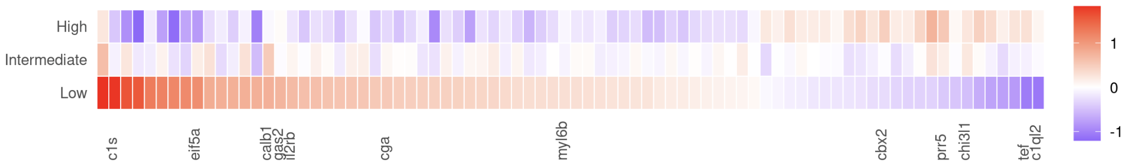
Supplemental Figure 3: Differential protein-AD associations by AD-PRS levels. This plot compares the estimated associations between 80 plasma proteins and incident AD stratified by AD-PRS groups. Each tile represents one protein. Labeled tile columns indicate proteins reaching adjusted significance in at least one AD-PRS group. Unlabeled tile columns indicate proteins that did not reach adjusted significance in any group.

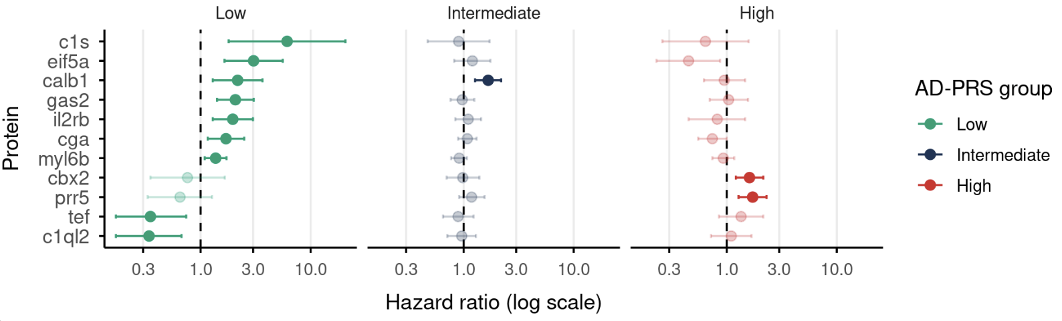
Supplemental Figure 4 Forest plot of Hazard Ratios (HRs) and 95% confidence intervals (Cis) for newly identified proteins across low, intermediate, and high AD-PRS groups.

- b.
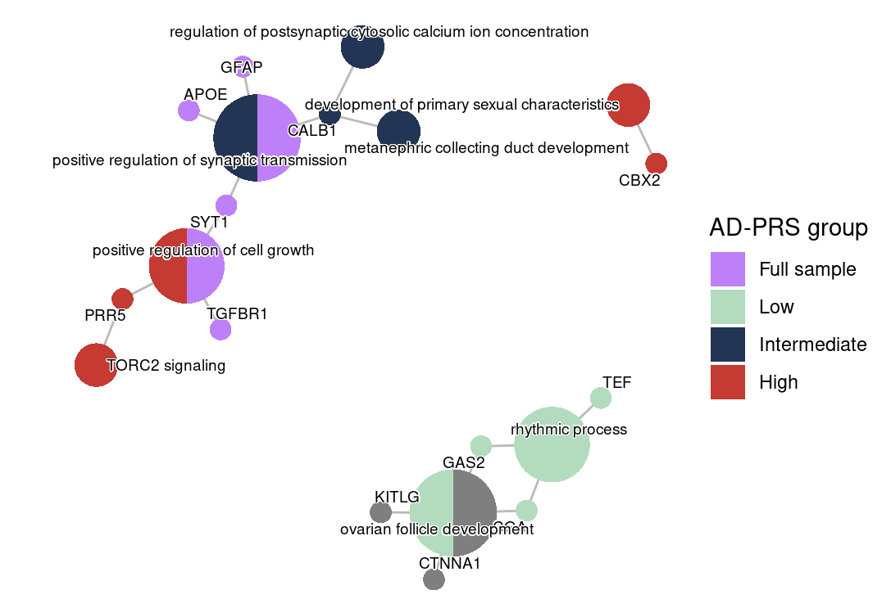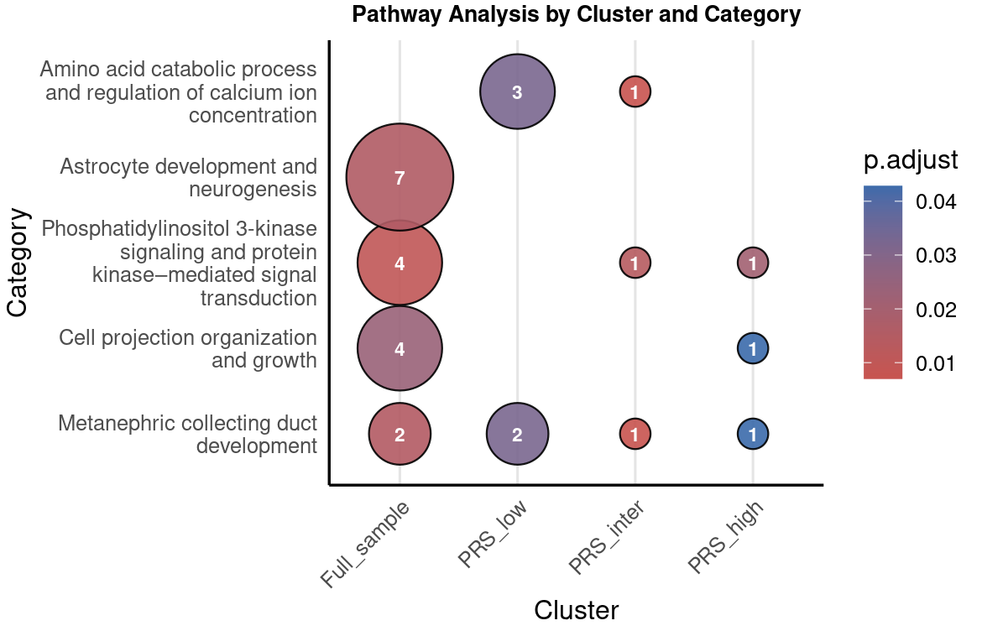
Supplemental Figure 5 Enrichment analysis of AD-associated proteins by AD-PRS groups
- Network of newly identified proteins enriched in GO processes. Node size reflects the number of mapped proteins contributing to each process, and colors indicate the stratum in which the signal was prioritized (full sample, low AD-PRS, intermediate AD-PRS, or high AD-PRS group)
- Pathway enrichment across the full sample and AD-PRS groups. This bubble plot summarizes enriched biological pathways identified in the full sample, low AD-PRS, intermediate AD-PRS, or high AD-PRS group, after grouping similar enriched terms into GO-style functional categories. Bubble size represents the number of enriched proteins within each functional category and subgroup, and bubble color represents the FDR-adjusted P value.

