Appendix

Appendix A

Table A1: Drought Exposure and Coping Strategies

Used Own Savings Sold Livestock Received Assistance

VARIABLES | Food Insecure | Low DDS |  | Food Insecure | Low DDS |  | Food Insecure | Low DDS
Drought exposure | 0.250*** | 0.006 |  | 0.180*** | -0.039 |  | 0.199*** | -0.004
 | (0.035) | (0.033) |  | (0.032) | (0.029) |  | (0.034) | (0.029)
Coping strategy | 0.055** | -0.052** |  | 0.140*** | -0.086* |  | 0.146*** | -0.007
 | (0.026) | (0.022) |  | (0.050) | (0.045) |  | (0.054) | (0.043)
Drought × Coping | -0.186*** | -0.061 |  | 0.034 | 0.177** |  | -0.091 | -0.099
 | (0.050) | (0.042) |  | (0.074) | (0.076) |  | (0.068) | (0.064)
Household size | 0.029 | -0.004 |  | 0.027 | -0.004 |  | 0.026 | -0.005
 | (0.018) | (0.016) |  | (0.018) | (0.016) |  | (0.018) | (0.017)
Household age | 0.002 | 0.001 |  | 0.002 | 0.001 |  | 0.002 | 0.001
 | (0.001) | (0.001) |  | (0.001) | (0.001) |  | (0.001) | (0.001)
Household sex | -0.018 | -0.070** |  | -0.018 | -0.070** |  | -0.018 | -0.070**
 | (0.035) | (0.031) |  | (0.035) | (0.031) |  | (0.035) | (0.031)
Adult equivalent | -0.030 | -0.018 |  | -0.030 | -0.018 |  | -0.030 | -0.018
 | (0.022) | (0.021) |  | (0.022) | (0.021) |  | (0.022) | (0.021)
Distance to market | -0.0003 | -0.0007 |  | -0.0003 | -0.0007 |  | -0.0003 | -0.0007
 | (0.001) | (0.001) |  | (0.001) | (0.001) |  | (0.001) | (0.001)
Distance to road | -0.001 | -0.001 |  | -0.001 | -0.001 |  | -0.001 | -0.001
 | (0.001) | (0.001) |  | (0.001) | (0.001) |  | (0.001) | (0.001)
Housing index | -0.020 | -0.026** |  | -0.020 | -0.026** |  | -0.019 | -0.027**
 | (0.014) | (0.012) |  | (0.014) | (0.012) |  | (0.014) | (0.012)
2021.year | 0.200*** | 0.384*** |  | 0.200*** | 0.384*** |  | 0.199*** | 0.377***
 | (0.022) | (0.019) |  | (0.022) | (0.019) |  | (0.022) | (0.019)
Constant | 0.204*** | 0.239*** |  | 0.204*** | 0.239*** |  | 0.209*** | 0.243***
 | (0.074) | (0.068) |  | (0.074) | (0.068) |  | (0.075) | (0.067)
Observations | 9,587 |  | 9,587 |  |  | 9,587
Households | 4,904 |  | 4,904 |  |  | 4,904
R-squared | 0.190 / 0.309 |  | 0.190 / 0.309 |  |  | 0.189 / 0.307
Robust standard errors in parentheses.
*** p<0.01, ** p<0.05, * p<0.

Table A2: Flood Exposure and Coping Strategies

Used Own Savings Sold Livestock Received Assistance

VARIABLES | Food Insecure | Low DDS |  | Food Insecure | Low DDS |  | Food Insecure | Low DDS
Flood exposure | 0.176*** | -0.023 |  | 0.131*** | -0.068** |  | 0.155*** | -0.015
 | (0.037) | (0.036) |  | (0.035) | (0.030) |  | (0.034) | (0.030)
Coping strategy | 0.042 | -0.059*** |  | 0.202*** | -0.065 |  | 0.181*** | 0.005
 | (0.026) | (0.021) |  | (0.055) | (0.044) |  | (0.049) | (0.041)
Flood × Coping | -0.129** | -0.043 |  | -0.050 | 0.230*** |  | -0.184*** | -0.154**
 | (0.054) | (0.050) |  | (0.076) | (0.079) |  | (0.067) | (0.063)
Household size | 0.027 | -0.005 |  | 0.025 | -0.003 |  | 0.024 | -0.006
 | (0.018) | (0.016) |  | (0.018) | (0.016) |  | (0.018) | (0.017)
Household age | 0.003* | 0.001 |  | 0.002* | 0.001 |  | 0.003* | 0.001
 | (0.001) | (0.001) |  | (0.001) | (0.001) |  | (0.001) | (0.001)
Household sex | -0.029 | -0.073** |  | -0.032 | -0.070** |  | -0.025 | -0.072**
 | (0.036) | (0.031) |  | (0.036) | (0.031) |  | (0.035) | (0.031)
Adult equivalent | -0.031 | -0.015 |  | -0.030 | -0.018 |  | -0.029 | -0.015
 | (0.023) | (0.021) |  | (0.022) | (0.021) |  | (0.023) | (0.021)
Distance market | -0.0004 | -0.0008 |  | -0.0004 | -0.0007 |  | -0.0004 | -0.0007
 | (0.001) | (0.001) |  | (0.001) | (0.001) |  | (0.001) | (0.001)
Distance to road | -0.001 | -0.001 |  | -0.001 | -0.001 |  | -0.001 | -0.001
 | (0.001) | (0.001) |  | (0.001) | (0.001) |  | (0.001) | (0.001)
Housing index | -0.023 | -0.026** |  | -0.021 | -0.028** |  | -0.020 | -0.026**
 | (0.014) | (0.012) |  | (0.014) | (0.012) |  | (0.014) | (0.012)
2021.year | 0.214*** | 0.391*** |  | 0.220*** | 0.383*** |  | 0.213*** | 0.382***
 | (0.022) | (0.019) |  | (0.021) | (0.019) |  | (0.022) | (0.019)
Constant | 0.214*** | 0.238*** |  | 0.229*** | 0.236*** |  | 0.218*** | 0.242***
 | (0.076) | (0.068) |  | (0.076) | (0.068) |  | (0.075) | (0.067)
Observations | 9,587 |  | 9,587 |  |  | 9,587
Households | 4,904 |  | 4,904 |  |  | 4,904
R-squared | 0.175 / 0.310 |  | 0.179 / 0.309 |  |  | 0.179 / 0.309
Robust standard errors in parentheses.
*** p<0.01, ** p<0.05, * p<0.1

Table A3: Rainfall Irregularity and Coping Strategies

Used Own Savings Sold Livestock Received Assistance

VARIABLES | Food Insecure | Low DDS |  | Food Insecure | Low DDS |  | Food Insecure | Low DDS
Rainfall irregularity | 0.167*** | -0.023 |  | 0.110*** | -0.070** |  | 0.139*** | -0.039
 | (0.034) | (0.031) |  | (0.032) | (0.027) |  | (0.031) | (0.027)
Coping strategy | 0.071** | -0.046** |  | 0.180*** | -0.116** |  | 0.208*** | -0.027
 | (0.028) | (0.023) |  | (0.063) | (0.049) |  | (0.054) | (0.043)
Rainfall × Coping | -0.160*** | -0.061 |  | 0.006 | 0.268*** |  | -0.189*** | -0.056
 | (0.049) | (0.042) |  | (0.080) | (0.077) |  | (0.066) | (0.062)
Household size | 0.030* | -0.006 |  | 0.028 | -0.004 |  | 0.027 | -0.007
 | (0.018) | (0.016) |  | (0.018) | (0.016) |  | (0.018) | (0.016)
Household age | 0.003* | 0.001 |  | 0.002* | 0.001 |  | 0.003* | 0.001
 | (0.001) | (0.001) |  | (0.001) | (0.001) |  | (0.001) | (0.001)
Household sex | -0.033 | -0.074** |  | -0.032 | -0.069** |  | -0.025 | -0.072**
 | (0.036) | (0.031) |  | (0.036) | (0.031) |  | (0.035) | (0.031)
Adult equivalent | -0.034 | -0.014 |  | -0.033 | -0.018 |  | -0.031 | -0.014
 | (0.023) | (0.020) |  | (0.022) | (0.020) |  | (0.023) | (0.021)
Distance to market | -0.0004 | -0.0008 |  | -0.0003 | -0.0007 |  | -0.0004 | -0.0007
 | (0.001) | (0.001) |  | (0.001) | (0.001) |  | (0.001) | (0.001)
dDistance to road | -0.001 | -0.001 |  | -0.001 | -0.001 |  | -0.001 | -0.001
 | (0.001) | (0.001) |  | (0.001) | (0.001) |  | (0.001) | (0.001)
Housing index | -0.022 | -0.026** |  | -0.020 | -0.028** |  | -0.018 | -0.027**
 | (0.014) | (0.012) |  | (0.014) | (0.012) |  | (0.014) | (0.012)
2021.year | 0.195*** | 0.399*** |  | 0.205*** | 0.392*** |  | 0.195*** | 0.393***
 | (0.025) | (0.021) |  | (0.024) | (0.020) |  | (0.025) | (0.020)
Constant | 0.210*** | 0.238*** |  | 0.225*** | 0.236*** |  | 0.211*** | 0.241***
 | (0.075) | (0.068) |  | (0.075) | (0.068) |  | (0.075) | (0.067)
Observations | 9,587 |  | 9,587 |  |  | 9,587
Households | 4,904 |  | 4,904 |  |  | 4,904
R-squared | 0.176 / 0.310 |  | 0.178 / 0.310 |  |  | 0.179 / 0.308
Robust standard errors in parentheses.
*** p<0.01, ** p<0.05, * p<0.1

Appendix B

Figure B1: Drought exposure indicator
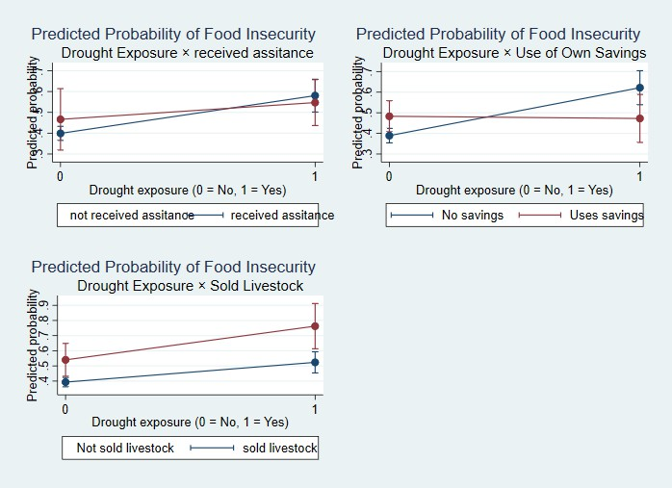

Figure B2: Flood exposure indicator
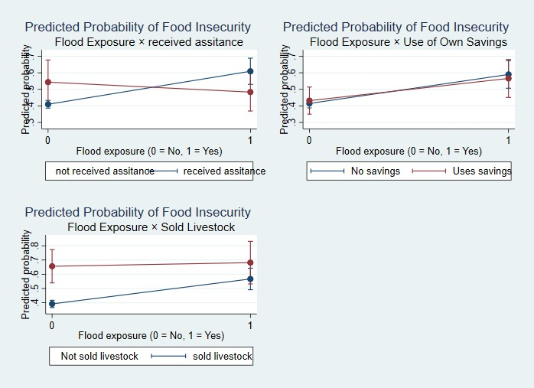

Figure B3: Rainfall variability indicator
