Supplementary Materials
Title: Testing the Effects of Changing Landscape Connectivity on Juvenile Chinook Salmon Densities within the Skagit River Delta in Response to a Natural Experiment
Authors: Matthew L. Nelson¹, Michael T. LeMoine¹, Correigh M. Greene¹, Eric M. Beamer¹*
ORCID IDs: M.L Nelson (0009-0008-0120-0780), C.M. Greene (0000-0001-8568-1092)
Affiliations:
¹Skagit River System Cooperative, La Conner, Washington, USA
*Retired
Corresponding Author: M.L. Nelson; mnelson@skagitcoop.org

Table S1 Variable summary by site. Variables not summarized here did not vary by site. sd = standard deviation
Site |  | Cumulative Annual Density | Landscape Connectivity | Salinity | Depth | Pathways
Browns Sl Barrow Ch | mean | 6.91 | 0.0224 | 7.11 | 3.25 | 1.65
 | sd | 1.12 | 0.0003 | 1.93 | 0.13 | 0.49
Browns Sl Diked Side | mean | 8.30 | 0.0228 | 7.29 | 3.14 | 1.73
 | sd | 1.18 | 0.0009 | 1.83 | 0.19 | 0.46
Cattail Saltmarsh | mean | 8.70 | 0.0395 | 1.15 | 1.16 | 1.73
 | sd | 0.84 | 0.0020 | 0.92 | 0.16 | 0.46
Grain of Sand | mean | 10.19 | 0.0875 | 0.03 | 1.38 | 1.00
 | sd | 0.87 | 0 | 0.03 | 0.28 | 0.00
Ika | mean | 9.66 | 0.0326 | 1.25 | 2.44 | 2.73
 | sd | 0.75 | 0.0036 | 0.77 | 0.37 | 0.46

Table S2 Variable summary by year. Standard deviations not shown indicate values that did not vary between each site within each year. n = 5 sites for all years except 2017-2021 where n = 4. LC = landscape connectivity
Year |  | Cumulative Annual Density | Fry Outmigrants | LC | Salinity | Depth | Air Temperature | River Discharge | Pathways
2000 | mean | 8.68 | 14.03 | 0.0416 | 3.53 | 2.06 | 19.16 | 28900 | 1.20
 | sd | 1.19 | — | 0.0269 | 3.15 | 0.93 | — | — | 0.45
2001 | mean | 9.25 | 15.45 | 0.0416 | 5.30 | 2.17 | 17.58 | 16500 | 1.20
 | sd | 1.09 | — | 0.0269 | 4.73 | 1.02 | — | — | 0.45
2002 | mean | 9.59 | 15.28 | 0.0415 | 3.28 | 2.22 | 19.80 | 66600 | 1.20
 | sd | 0.99 | — | 0.0269 | 2.56 | 0.91 | — | — | 0.45
2003 | mean | 9.95 | 15.36 | 0.0415 | 3.19 | 2.14 | 20.65 | 45200 | 1.20
 | sd | 1.63 | — | 0.0269 | 3.08 | 0.89 | — | — | 0.45
2004 | mean | 7.29 | 13.94 | 0.0415 | 3.80 | 2.14 | 20.85 | 25000 | 1.20
 | sd | 1.26 | — | 0.0269 | 3.70 | 1.02 | — | — | 0.45
2005 | mean | 9.57 | 14.97 | 0.0415 | 4.54 | 2.23 | 17.51 | 20400 | 1.20
 | sd | 1.40 | — | 0.0269 | 4.36 | 1.11 | — | — | 0.45
2006 | mean | 9.26 | 15.45 | 0.0415 | 4.58 | 2.07 | 19.93 | 29200 | 2.00
 | sd | 1.42 | — | 0.0269 | 3.84 | 1.00 | — | — | 0.71
2007 | mean | 9.23 | 14.41 | 0.0415 | 2.54 | 2.24 | 18.08 | 74200 | 2.00
 | sd | 0.84 | — | 0.0269 | 2.43 | 0.97 | — | — | 0.71
2008 | mean | 8.60 | 13.73 | 0.0416 | 3.24 | 2.33 | 22.06 | 19700 | 2.00
 | sd | 1.58 | — | 0.0269 | 3.23 | 0.97 | — | — | 0.71
2009 | mean | 9.07 | 14.27 | 0.0416 | 4.32 | 2.20 | 25.96 | 22200 | 2.00
 | sd | 1.81 | — | 0.0269 | 3.40 | 0.95 | — | — | 0.71
2010 | mean | 8.36 | 13.59 | 0.0416 | 4.41 | 2.30 | 25.60 | 14500 | 2.00
 | sd | 2.06 | — | 0.0269 | 4.36 | 0.92 | — | — | 0.71
2011 | mean | 9.17 | 14.97 | 0.0416 | 2.61 | 2.35 | 24.55 | 33900 | 2.00
 | sd | 1.14 | — | 0.0269 | 2.27 | 0.88 | — | — | 0.71
2012 | mean | 8.60 | 15.18 | 0.0416 | 3.66 | 2.45 | 18.89 | 37400 | 2.00
 | sd | 1.84 | — | 0.0269 | 2.78 | 0.90 | — | — | 0.71
2013 | mean | 9.01 | 15.34 | 0.0416 | 2.97 | 2.26 | 21.98 | 39000 | 2.00
 | sd | 1.87 | — | 0.0269 | 2.32 | 0.99 | — | — | 0.71
2014 | mean | 8.76 | 15.04 | 0.0411 | 2.16 | 2.43 | 21.34 | 48800 | 2.00
 | sd | 1.83 | — | 0.0269 | 1.88 | 0.91 | — | — | 0.71
2015 | mean | 7.47 | 13.83 | 0.0407 | 4.80 | 2.33 | 28.27 | 60200 | 2.00
 | sd | 1.21 | — | 0.0270 | 4.42 | 1.06 | — | — | 0.71
2016 | mean | 8.41 | 14.78 | 0.0407 | 3.24 | 2.28 | 21.06 | 59300 | 2.00
 | sd | 1.67 | — | 0.0270 | 2.74 | 1.06 | — | — | 0.71
2017 | mean | 9.23 | 14.67 | 0.0450 | 1.76 | 2.34 | 20.95 | 47500 | 2.00
 | sd | 1.40 | — | 0.0292 | 1.46 | 1.02 | — | — | 0.82
2018 | mean | 9.27 | 14.26 | 0.0441 | 3.54 | 2.18 | 20.31 | 57400 | 2.00
 | sd | 1.14 | — | 0.0296 | 2.37 | 1.03 | — | — | 0.82
2019 | mean | 8.74 | 14.08 | 0.0431 | 4.92 | 2.27 | 21.21 | 37000 | 2.00
 | sd | 0.88 | — | 0.0300 | 3.16 | 1.31 | — | — | 0.82
2020 | mean | 8.61 | 14.27 | 0.0432 | 3.28 | 1.87 | 19.89 | 67700 | 2.00
 | sd | 1.17 | — | 0.0299 | 1.93 | 0.97 | — | — | 0.82
2021 | mean | 8.31 | 14.17 | 0.0433 | 4.21 | 2.04 | 23.83 | 27800 | 2.00
 | sd | 1.39 | — | 0.0298 | 2.88 | 1.13 | — | — | 0.82

Table S3 Raw landscape connectivity data by site
 | Site
Year | Browns Sl Barrow Ch | Browns Sl Diked Side | Cattail Saltmarsh | Grain of Sand | Ika | Avulsion Formation Status
2000 | 0.0223 | 0.0223 | 0.0405 | 0.0875 | 0.0351 | pre
2001 | 0.0223 | 0.0223 | 0.0405 | 0.0875 | 0.0351 | pre
2002 | 0.0223 | 0.0223 | 0.0405 | 0.0875 | 0.0351 | pre
2003 | 0.0222 | 0.0222 | 0.0404 | 0.0875 | 0.0351 | pre
2004 | 0.0222 | 0.0222 | 0.0404 | 0.0875 | 0.0351 | pre
2005 | 0.0222 | 0.0222 | 0.0404 | 0.0875 | 0.0351 | pre
2006 | 0.0222 | 0.0222 | 0.0404 | 0.0875 | 0.0351 | post
2007 | 0.0222 | 0.0222 | 0.0404 | 0.0875 | 0.0351 | post
2008 | 0.0223 | 0.0223 | 0.0407 | 0.0875 | 0.035 | post
2009 | 0.0223 | 0.0223 | 0.041 | 0.0875 | 0.0349 | post
2010 | 0.0223 | 0.0223 | 0.041 | 0.0875 | 0.0349 | post
2011 | 0.0223 | 0.0223 | 0.041 | 0.0875 | 0.0349 | post
2012 | 0.0223 | 0.0223 | 0.041 | 0.0875 | 0.0349 | post
2013 | 0.0223 | 0.0223 | 0.041 | 0.0875 | 0.0349 | post
2014 | 0.0228 | 0.0228 | 0.04 | 0.0875 | 0.0326 | post
2015 | 0.0232 | 0.0232 | 0.0391 | 0.0875 | 0.0303 | post
2016 | 0.0233 | 0.0233 | 0.0394 | 0.0875 | 0.0298 | post
2017 | - | 0.0235 | 0.0397 | 0.0875 | 0.0292 | post
2018 | - | 0.0235 | 0.0375 | 0.0875 | 0.0277 | post
2019 | - | 0.0235 | 0.0353 | 0.0875 | 0.0262 | post
2020 | - | 0.0247 | 0.0349 | 0.0875 | 0.0259 | post
2021 | - | 0.0258 | 0.0345 | 0.0875 | 0.0252 | post

Table S4 Variable inflation factor (VIF) summary table
Predictor Variable | VIF Value
Fry Outmigrants | 1.316
Landscape connectivity | 1.403
Salinity | 1.191
Depth | 1.528
Air Temperature | 1.447
River Discharge | 1.097
Pathways | 1.376

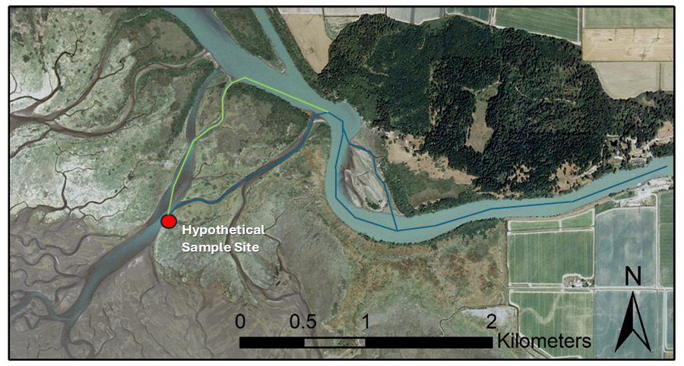
Fig. S1 Fish pathways count diagram. Shown here is a hypothetical sample site (red) and two possible pathways (blue and green) that a juvenile Chinook Salmon may take to access this site. Note that the first blue pathway bifurcates but this split does not count as a second pathway since fish are obligated to rejoin the larger distributary in order to reach the sample site
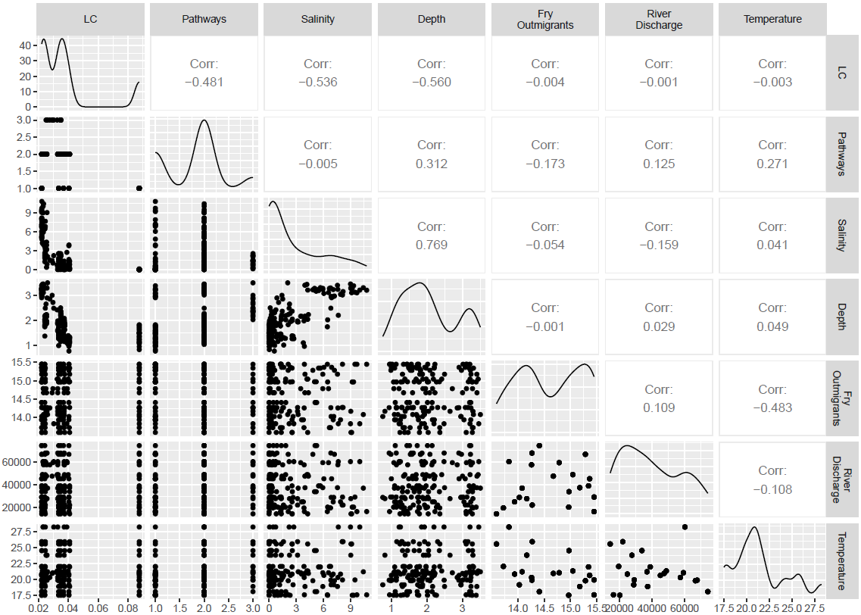
Fig. S2 Correlation Plots. R-values are displayed in results. LC = Landscape Connectivity

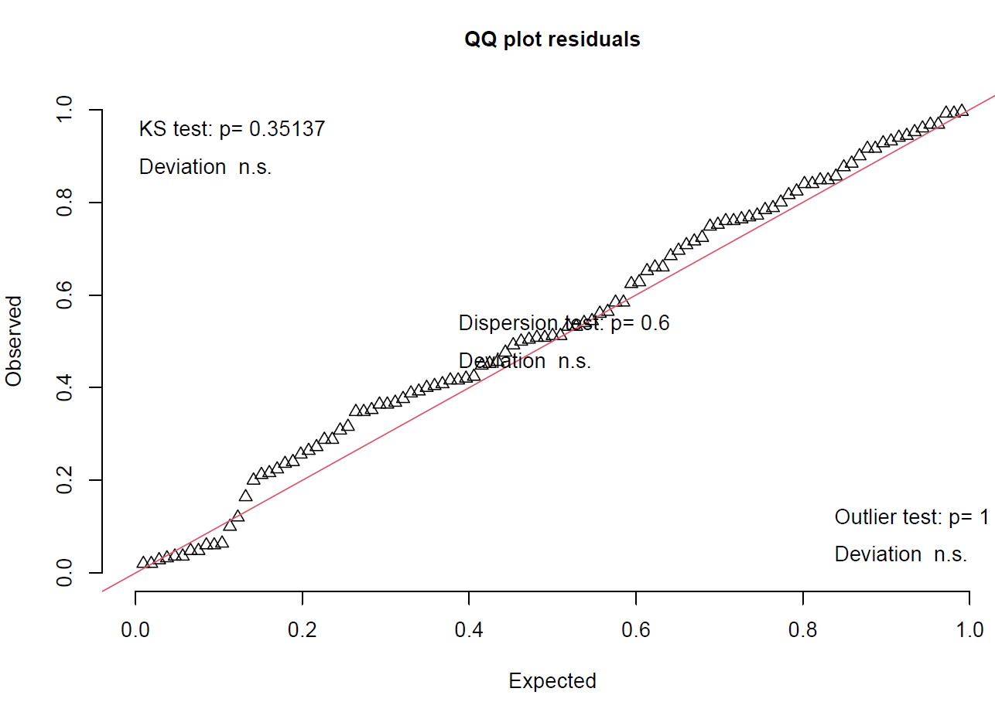
Fig. S3 QQ residuals plot for best fit model

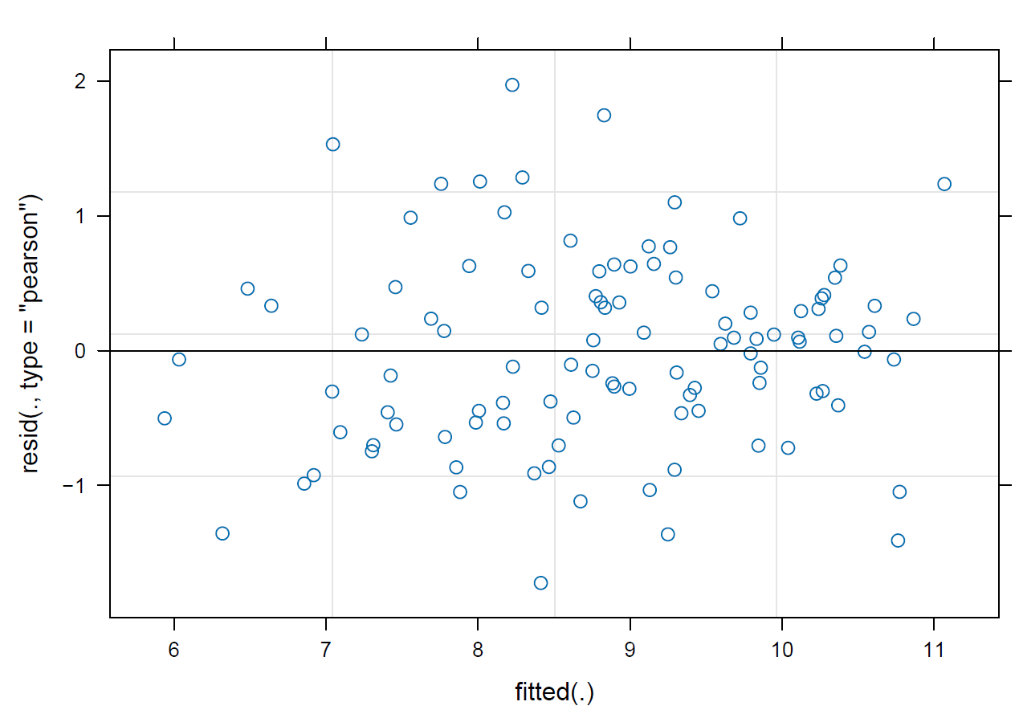
Fig. S4 Residuals plot for best fit model

