A REGIONAL APPROACH FOR HEALTH RISK ASSESSMENT OF TOXICANTS IN PLASTIC FOOD CONTAINERS
Nguyen Thi Lan Binh¹, Nguyen Thi Thanh Truc*¹, Nguyen Thi Ngoc Tran¹, Vu Dinh Khang¹, Byeong-Kyu Lee*²
¹Institute for the Environmental Science, Engineering&Management, Industrial University of Ho Chi Minh City, No. 12 Nguyen Van Bao, Ward 4, Ho Chi Minh City 700000, Vietnam.
²Department of Civil and Environmental Engineering, University of Ulsan, Daehakro 93, Namgu, Ulsan 44610, Republic of Korea.

Supporting information
Table S1. The collected plastic food containers using in the study
1 - PET food containers
2 – PP food containers | 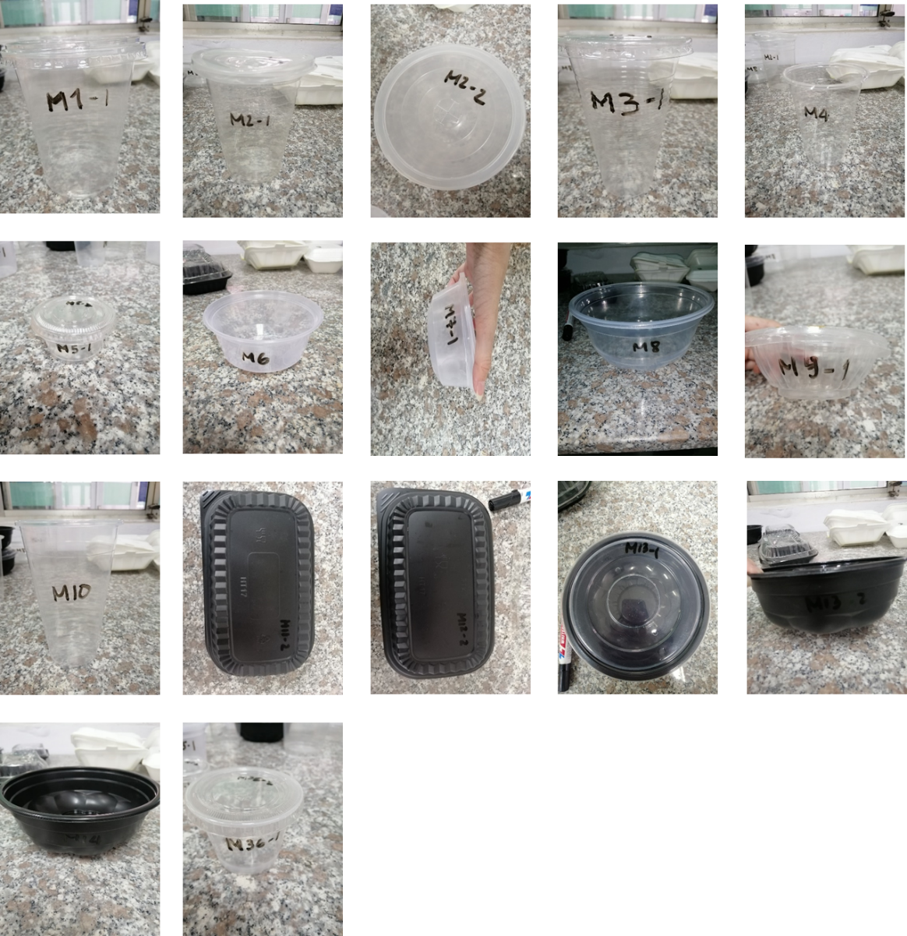
3- PS food containers | 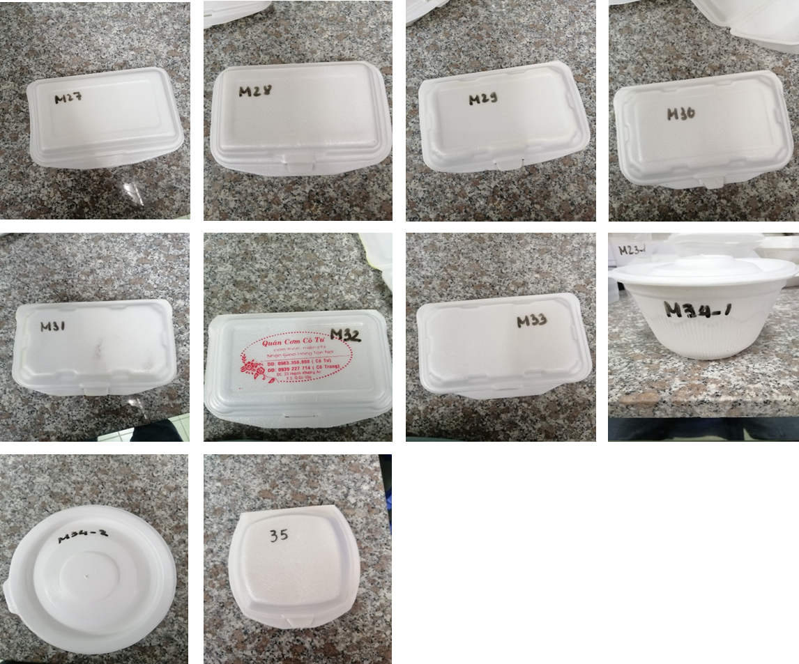
4 – X food containers | 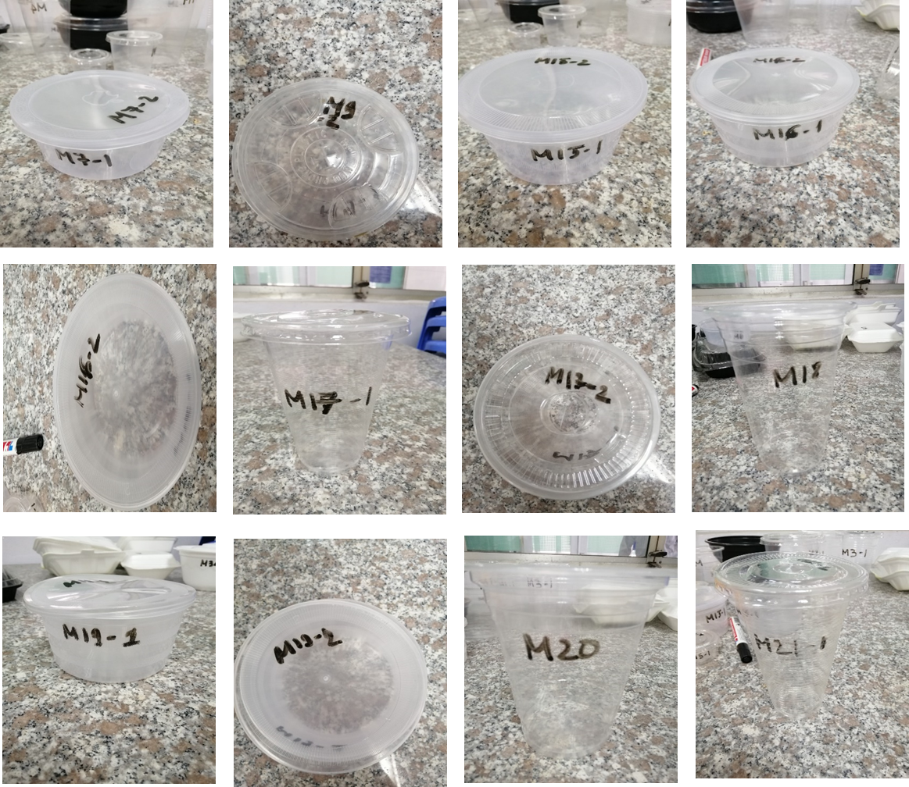  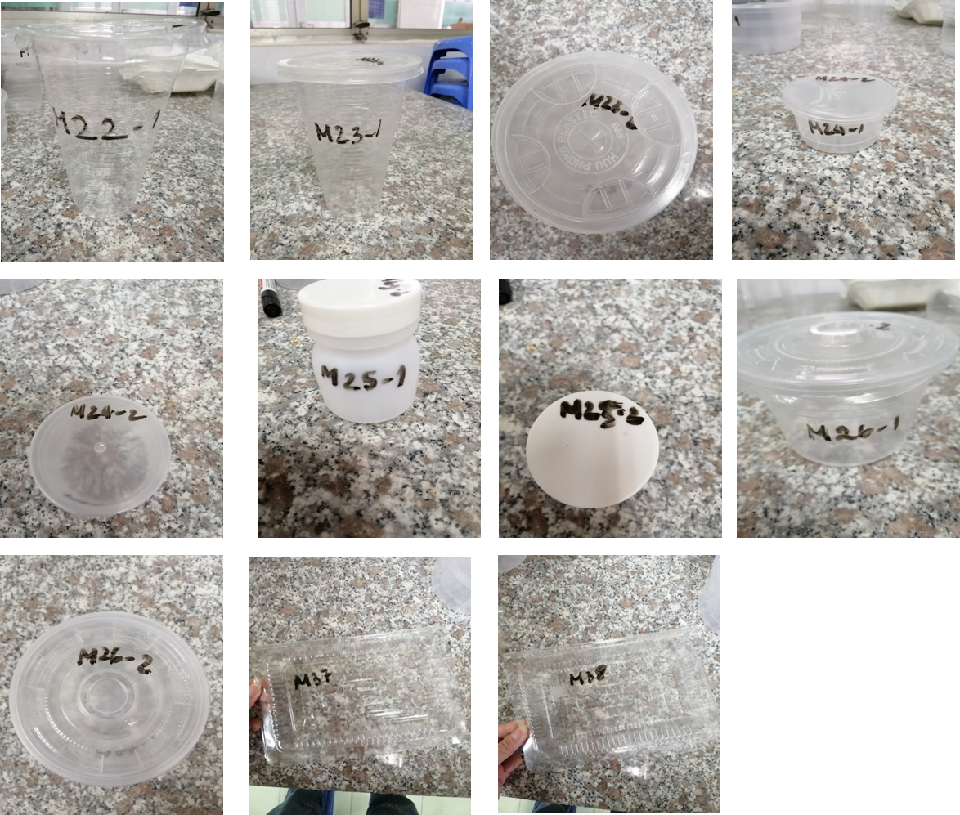

Table S2. The Chi-square test results of the three relationships between plastic recycling habits and occupation, gender, age.
Chi-Square Tests (Occupation)
 | Value | df | Asymp. Sig. (2-sided)
Pearson Chi-Square | 40.543ª | 54 | .912
Likelihood Ratio | 47.168 | 54 | .733
N of Valid Cases | 250
a. 66 cells (86.8%) have expected count less than 5. The minimum expected count is .10.

Chi-Square Tests (Gender)
 | Value | df | Asymp. Sig. (2-sided)
Pearson Chi-Square | 8.026ª | 3 | .045
Likelihood Ratio | 8.268 | 3 | .041
Linear-by-Linear Association | 3.163 | 1 | .075
N of Valid Cases | 250
a. 0 cells (.0%) have expected count less than 5. The minimum expected count is 10.71.

Chi-Square Tests (Age)
 | Value | df | Asymp. Sig. (2-sided)
Pearson Chi-Square | 10.654ª | 9 | 0.300
Likelihood Ratio | 10.774 | 9 | 0.292
Linear-by-Linear Association | 8.523 | 1 | 0.004
N of Valid Cases | 250
a. 1 cells (6.3%) have expected count less than 0.05. The minimum expected count is 4.37.

Table S3. The concentration results of hazardous ellements in plastic food containers (ppm)
No. | Sample | Plastic types | Cd | Pb | Cr | Hg | Br | Cl | Sb | S | Sn
1 | M1-1 | PP | ND | ND | 7,933 | ND | ND | 62,7 | ND | ND | ND
2 | M1-2 | PET | ND | ND | ND | ND | ND | 80,9 | 404,6 | ND | ND
3 | M2-1 | PP | ND | ND | 5,033 | ND | ND | 73,133 | ND | ND | ND
4 | M2-2 | PP | ND | ND | ND | ND | ND | ND | ND | ND | ND
5 | M3-1 | PP | ND | ND | 5,925 | ND | ND | 138,1 | ND | ND | ND
6 | M3-2 | PET | ND | ND | ND | ND | ND | ND | 401.7 | ND | ND
7 | M4 | PP | ND | ND | 7,7 | ND | ND | ND | ND | ND | ND
8 | M5-1 | PP | ND | ND | 5,7 | ND | ND | ND | ND | ND | ND
9 | M5-2 | PET | ND | ND | ND | ND | ND | ND | 379,6 | ND | ND
10 | M6 | PP | ND | ND | ND | ND | ND | 54,033 | ND | ND | ND
11 | M7-1 | PP | ND | ND | 7,65 | ND | ND | 68,367 | ND | ND | ND
12 | M7-2 | X | ND | ND | ND | ND | ND | 99,2 | ND | ND | ND
13 | M8 | PP | ND | ND | ND | ND | ND | 56,45 | ND | ND | ND
14 | M9-1 | PP | ND | ND | 5,75 | ND | ND | ND | ND | ND | ND
15 | M9-2 | X | ND | ND | ND | ND | ND | 58,45 | ND | ND | ND
16 | M10 | PP | ND | ND | ND | ND | ND | 42,65 | ND | ND | ND
17 | M11-1 | PET | ND | ND | ND | ND | ND | ND | 433,3 | ND | ND
18 | M11-2 | PP | ND | ND | ND | ND | ND | 38,425 | ND | ND | ND
19 | M12-1 | PET | ND | ND | ND | 7,37 | ND | ND | 292,3 | ND | ND
20 | M12-2 | PP | ND | ND | ND | ND | ND | 251,7 | ND | 426,25 | ND
21 | M13-1 | PP | ND | ND | 5 | ND | ND | ND | ND | ND | ND
22 | M13-2 | PP | ND | ND | ND | ND | ND | 105,15 | ND | 592,07 | ND
23 | M14 | PP | ND | ND | ND | ND | ND | 181,9 | ND | 583,1 | ND
24 | M15-1 | X | ND | ND | ND | ND | ND | ND | ND | ND | ND
25 | M15-2 | X | ND | ND | ND | ND | ND | ND | ND | ND | ND
26 | M16-1 | X | ND | ND | 5,45 | ND | ND | 42,25 | ND | ND | ND
27 | M16-2 | X | ND | ND | ND | ND | ND | 65,7 | ND | ND | ND
28 | M17-1 | X | ND | ND | 6,875 | ND | ND | ND | ND | ND | ND
29 | M17-2 | X | ND | ND | ND | ND | ND | 61,533 | 372,7 | ND | ND
30 | M18 | X | ND | ND | 6,85 | ND | ND | 97,75 | ND | ND | ND
31 | M19-1 | X | ND | ND | 5,25 | ND | ND | ND | ND | 356,65 | ND
32 | M19-2 | X | ND | ND | ND | ND | ND | ND | ND | ND | ND
33 | M20 | X | ND | ND | 6,5 | ND | ND | 107,9 | ND | ND | ND
34 | M21-1 | X | ND | ND | 6,967 | ND | ND | 119,1 | ND | ND | ND
35 | M21-2 | PET | ND | ND | ND | ND | ND | 99,2 | 372,9 | 434,45 | ND
36 | M22-1 | X | ND | ND | 9,467 | ND | ND | ND | ND | ND | ND
37 | M22-2 | PET | ND | ND | ND | ND | ND | ND | 427 | ND | ND
38 | M23-1 | X | ND | ND | 10,27 | ND | ND | 102,7 | ND | ND | ND
39 | M23-2 | X | ND | ND | ND | ND | ND | 73,233 | ND | ND | ND
40 | M24-1 | X | ND | ND | ND | 0,9 | ND | 196,33 | ND | 523 | ND
41 | M24-2 | X | ND | ND | ND | ND | ND | ND | ND | ND | ND
42 | M25-1 | X | ND | ND | 4,45 | ND | ND | 181,35 | ND | ND | ND
43 | M25-2 | X | ND | ND | ND | ND | 2,4667 | 176,8 | ND | 531,93 | ND
44 | M26-1 | X | ND | ND | 6,167 | ND | ND | ND | ND | ND | ND
45 | M26-2 | X | ND | ND | 5,367 | ND | ND | 62,9 | ND | ND | ND
46 | M27 | PS | ND | ND | 8,525 | ND | 99,975 | 336,03 | ND | 675 | ND
47 | M28 | PS | ND | ND | 6,7 | ND | 101,8 | 1.361,9 | ND | 593 | ND
48 | M29 | PS | ND | ND | 7,7 | ND | 11,767 | 836,63 | ND | 818,43 | ND
49 | M30 | PS | ND | ND | 8,467 | ND | 6,4667 | 399,53 | ND | 532,2 | ND
50 | M31 | PS | ND | ND | 8,15 | ND | 18,2 | 530,43 | ND | 830,83 | ND
51 | M32 | PS | ND | ND | ND | ND | 2,7 | 1.138,9 | ND | 587,75 | ND
52 | M33 | PS | ND | ND | 7,833 | ND | 117,37 | 405.27 | ND | 496,8 | ND
53 | M34-1 | PS | ND | ND | 5,95 | ND | 4,0333 | ND | ND | 506,13 | ND
54 | M34-2 | PS | ND | 4,5 | 4,767 | ND | 1,575 | 103,8 | ND | 484,4 | ND
55 | M35 | PS | ND | ND | ND | ND | 100,1 | 1.351,8 | ND | 715,6 | ND
56 | M36-1 | PP | ND | ND | 7,4 | ND | ND | 116,4 | ND | ND | ND
57 | M36-2 | PET | ND | ND | 4,85 | 6,3 | ND | 55,55 | 294,7 | 334,8 | ND
58 | M37 | X | ND | ND | ND | ND | ND | ND | 389 | ND | ND
59 | M38 | X | ND | ND | ND | ND | ND | ND | 408,5 | ND | ND

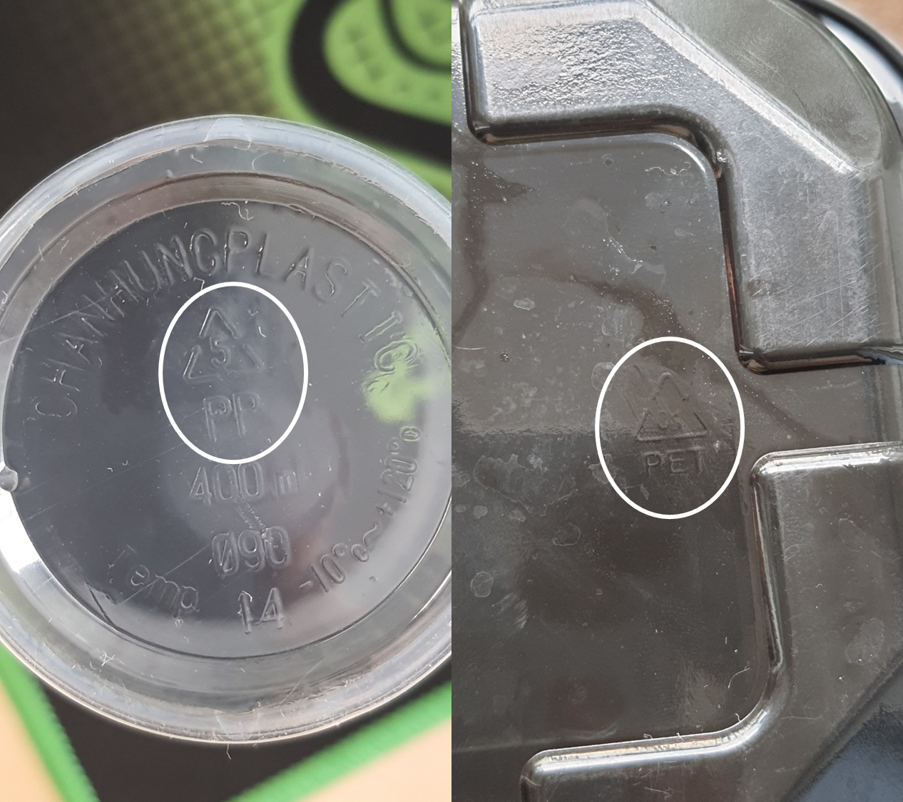
Figure S1. Example of recycling code (Resin identification code) on the collected samples
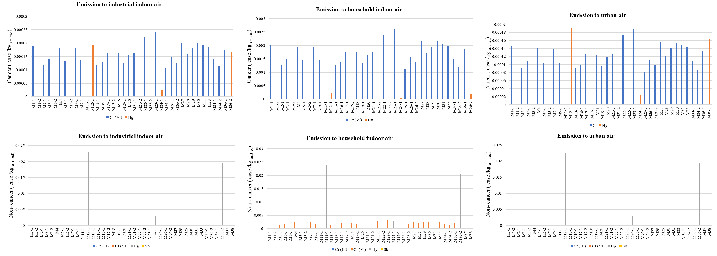
Figure S2. The results of USEtox LCIA modeling impacts of metals exposure assessments in air, water, and soil for human toxicity (cancer and Non- ancer) in the concentration of toxic emissions cases/kg_{emitted}.

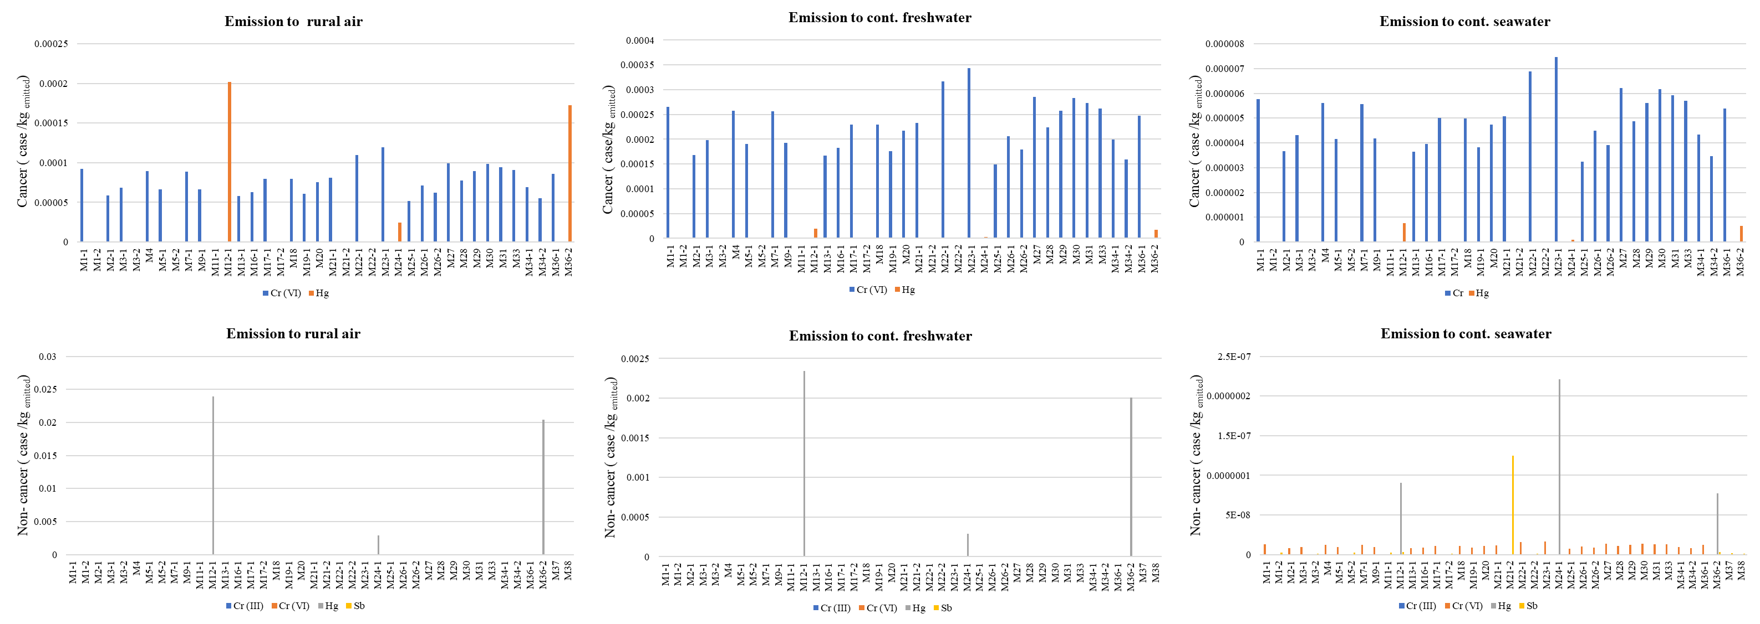
Figure S2. The results of USEtox LCIA modeling impacts of metals exposure assessments in air, water, and soil for human toxicity (cancer and Non- ancer) in the concentration of toxic emissions cases/kg_{emitted}. (Continued)
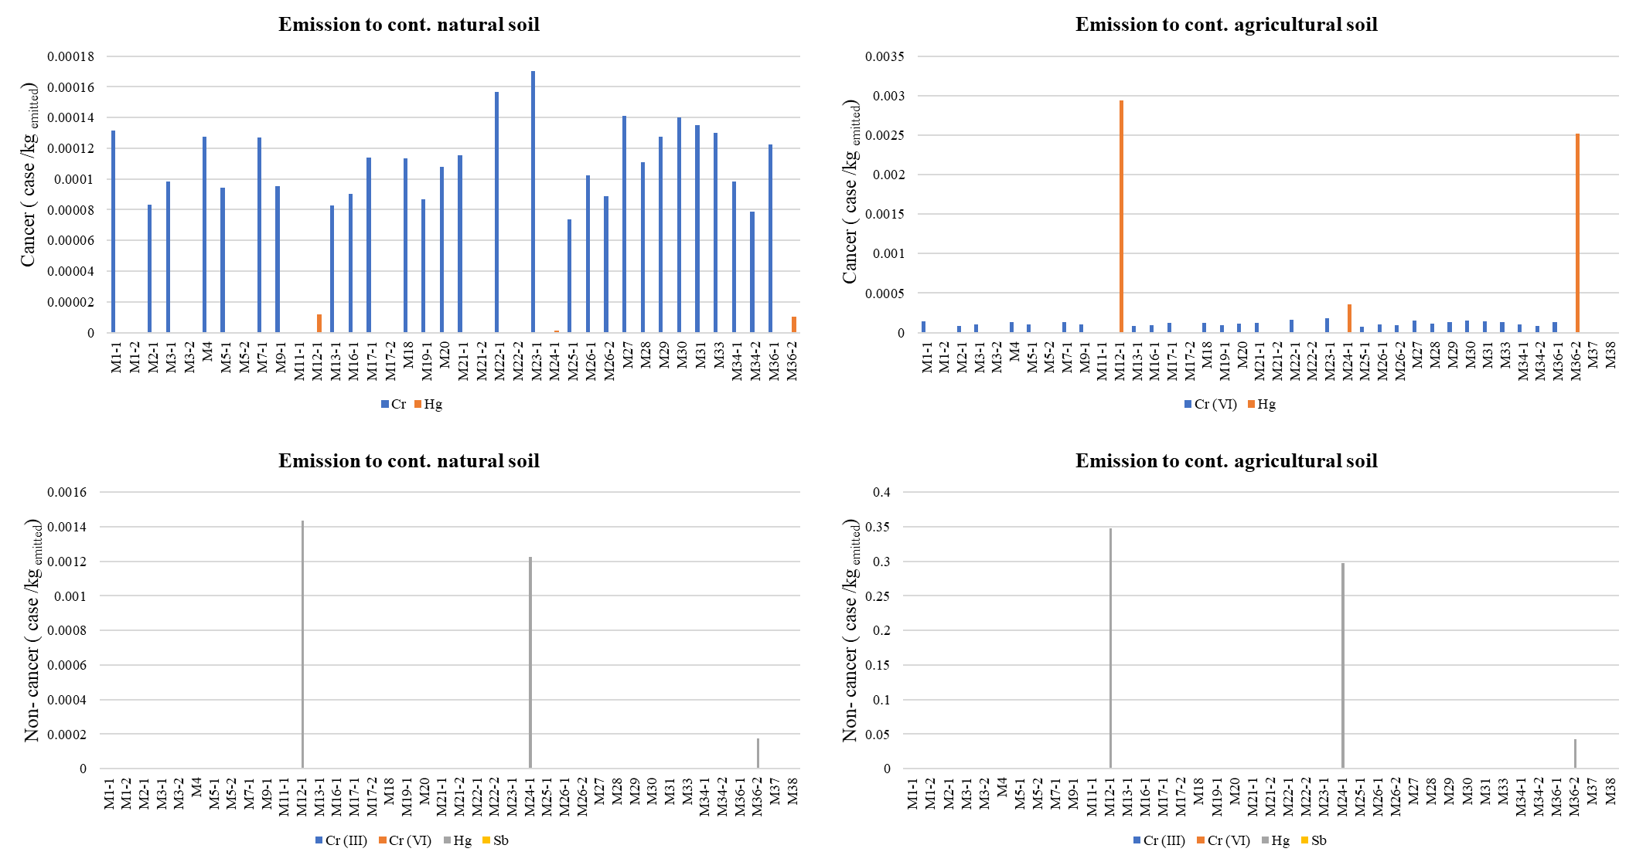

Figure S2. The results of USEtox LCIA modeling impacts of metals exposure assessments in air, water, and soil for human toxicity (cancer and Non- ancer) in the concentration of toxic emissions cases/kg_{emitted}. (Continued)
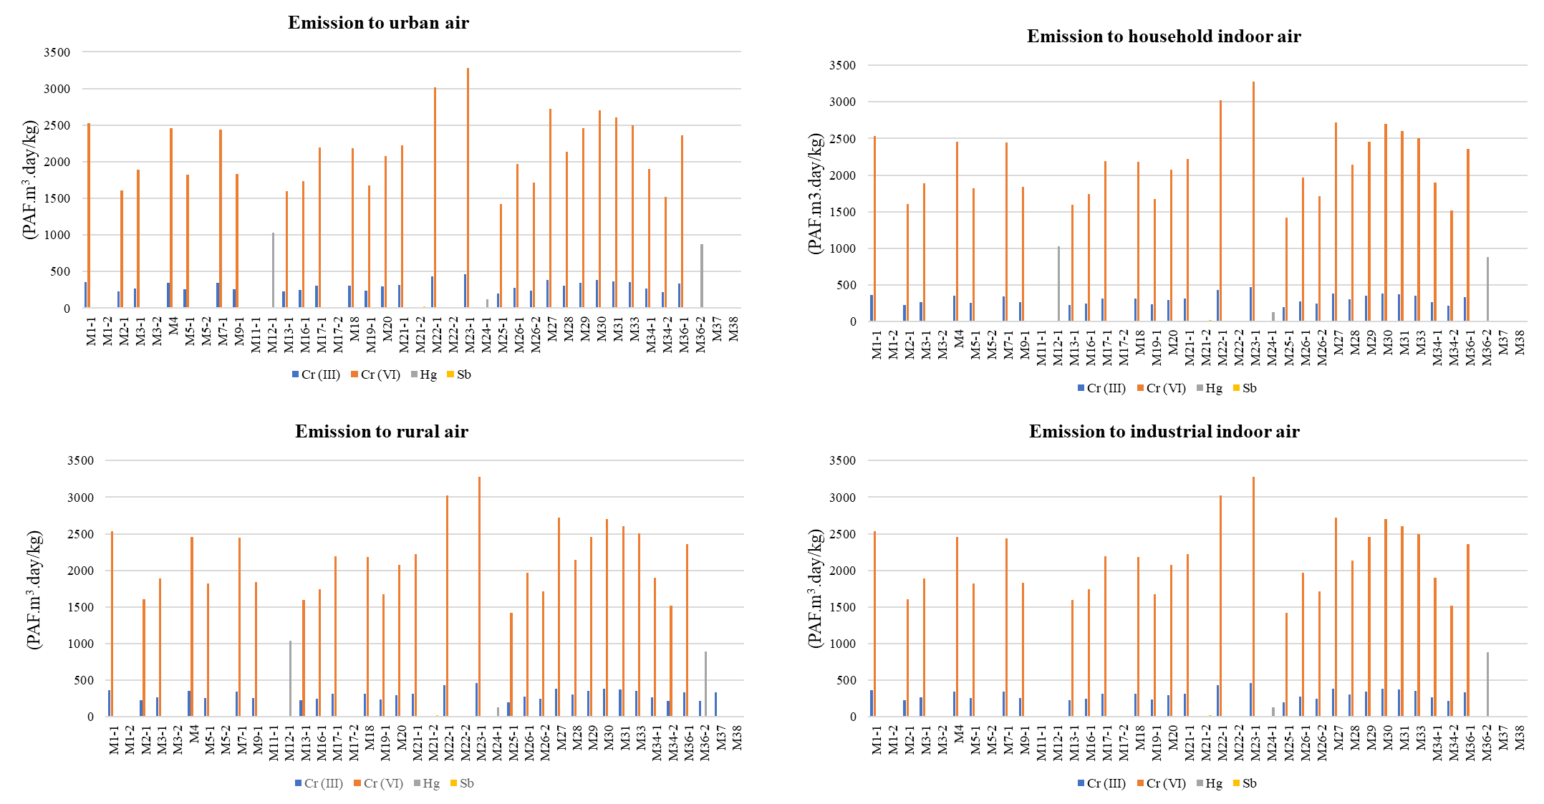
Figure S3. The results of USEtox LCIA modeling impacts of metals exposure assessments in air, water, and soil for eco-toxicity in terms of the potentially affected fraction (PAF) of species due to change in concentration of toxic emissions (PAF m³ day/kg)

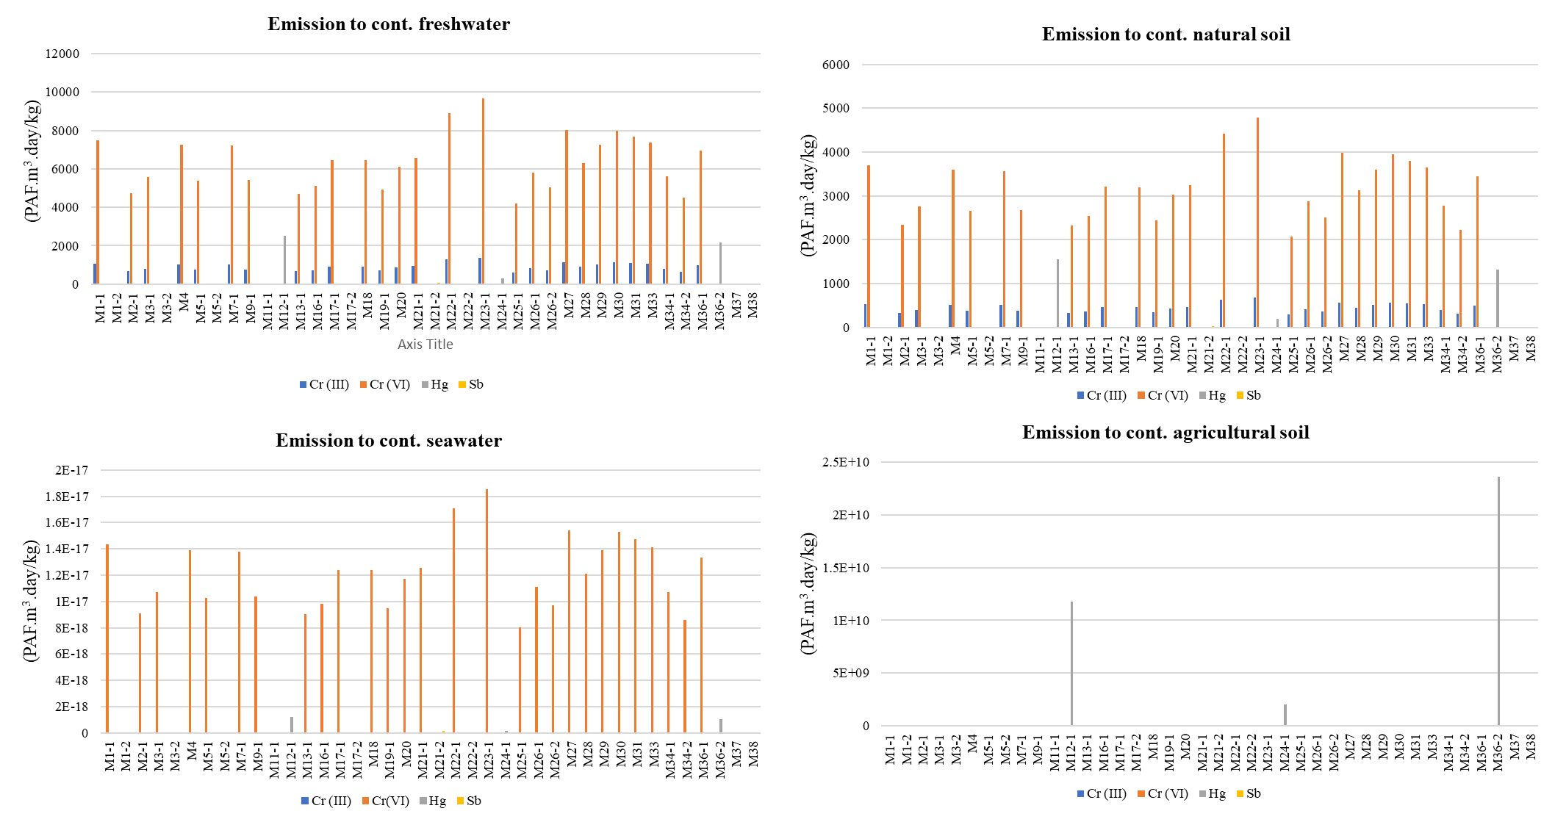
Figure S3. The results of USEtox LCIA modeling impacts of metals exposure assessments in air, water, and soil for eco-toxicity in terms of the potentially affected fraction (PAF) of species due to change in concentration of toxic emissions (PAF m³ day/kg) (Continued)

