Supplementary Material for

Tissue-based methylation testing as a predictor of clinical regression in patients with CIN2/3
F. Runello, M. Schaafsma, S. Dick, W.W. Kremer, D.A.M. Heideman, J. Berkhof, C.J.L.M. Meijer, M.C.G. Bleeker, R.D.M. Steenbergen

Table of contents

Supplementary Figure 1. Directed acyclic graphs of the association between (A) FAM19A4/miR124-2 methylation, (B) p16^{INK4a}/Ki-67 immunoscore and (C) HPV E4 expression, and CIN2/3 clinical regression…...…………………………………………………………………………………...………............2
Supplementary Table 1. Baseline cytology, p16 ^{INK4a} and Ki-67 scores, methylation and HPV genotyping results, and clinical endpoint stratified by baseline histology.…………………………………………........................................................................................3
Supplementary Figure 2. Methylation levels of individual markers FAM19A4 and miR124-2 according to HPV E4 expression.……… ……………….………………………...........................................................5
Supplementary Table 2. Association between FAM19A4/miR124-2 methylation, p16^{ink4a}/Ki-67 immunoscore and HPV E4 expression, and CIN2/3 clinical regression……………………………………6
Supplementary Figure 3. Cumulative regression incidences by Kaplan Meier analysis stratified by methylation results on baseline, paired cervical scrapes…………………………………………..…………7
Supplementary Figure 4. Conditional scatterplots representing the methylation levels of FAM19A4 and mir124-2 in paired cervical biopsies and clinician-collected cervical scrapes, stratified by study outcome………………………………………………………………………………………………...8
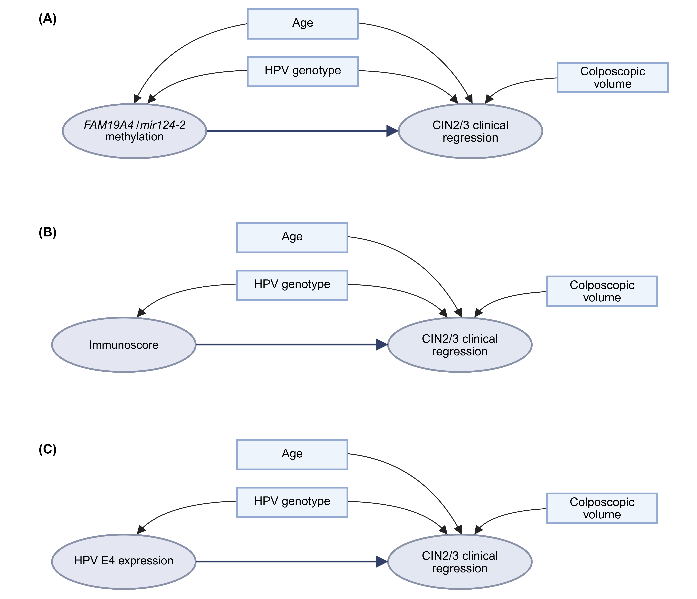

Supplementary Figure 1. Directed acyclic graphs of the association between (A) FAM19A4/miR124-2 methylation, (B) p16^{ink4a}/Ki-67 immunoscore and (C) HPV E4 expression, and CIN2/3 clinical regression.
Abbreviations: CIN, cervical intraepithelial neoplasia; HPV, human papillomavirus.
Supplementary Table 1. Baseline cytology, p16 ^{INK4a} and Ki-67 scores, methylation and HPV genotyping results, and clinical endpoint stratified by baseline histology.
Abbreviations: ASC-US, atypical squamous cells of undetermined significance; CIN, cervical intraepithelial neoplasia; HPV, human papillomavirus; HSIL, high-grade squamous intraepithelial lesion; LSIL, low-grade squamous intraepithelial lesion.
Baseline
 |  |  | CIN2 | CIN3 | Total
Cytology
 | ASC-US/LSIL |  | 38 | 12 | 50
 | HSIL |  | 24 | 15 | 39
p16^{INK4a}
 | Positive (block-type)
 |  | score 1 | 2 | 1 | 3
 |  | score 2 | 35 | 11 | 46
 |  | score 3 | 25 | 15 | 40
 | Negative/patchy |  | 0 | 0 | 0
Ki-67
 | Increased
 |  | score 1 | 16 | 4 | 20
 |  | score 2 | 39 | 18 | 57
 |  | score 3 | 7 | 5 | 12
 | Not increased |  | 0 | 0 | 0
Methylation on biopsies
 | Positive |  | 20 | 13 | 33
 | Negative |  | 32 | 10 | 42
 | Invalid |  | 10 | 4 | 14
HPV genotyping
 | HPV16 positive¹ |  | 27 | 20 | 47
 | HPV18 positive¹ |  | 12 | 3 | 15
 | HPV other positive¹ |  | 44 | 18 | 62
 | HPV negative |  | 1 | 0 | 1
Clinical endpoint
 |  |  | CIN2 | CIN3 | Total
Regression |  |  | 37 | 14 | 51
Persistence |  |  | 6 | 9 | 15
Progression |  |  | 19 | 4 | 23
¹Samples with multiple infections were calculated separately for HPV16, HPV18 and HPV other.
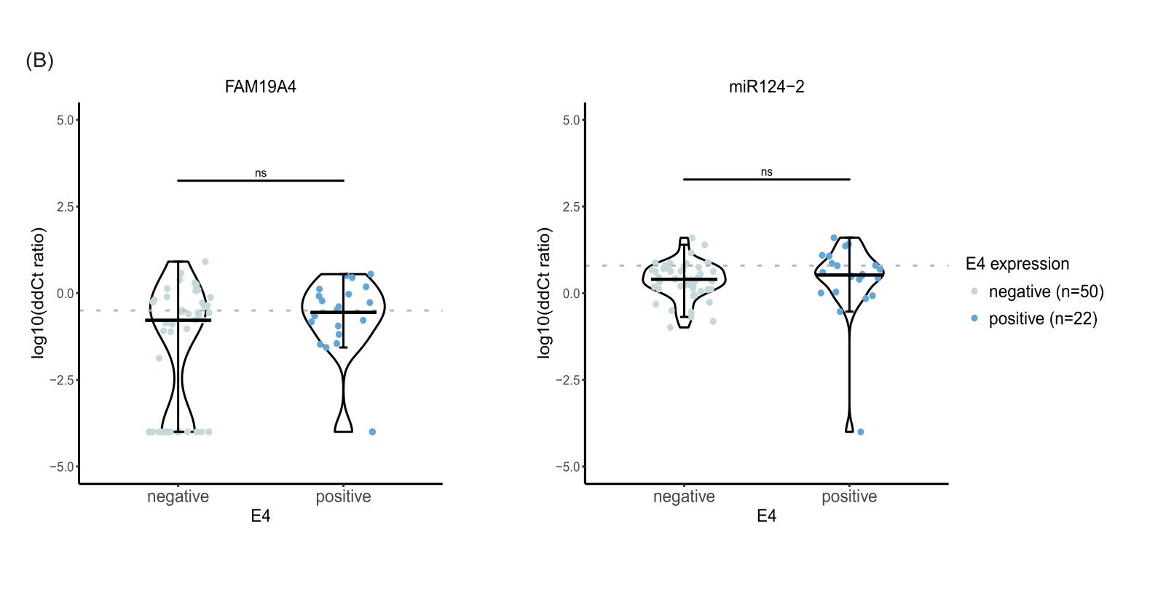
Supplementary Figure 2. Methylation levels of individual markers FAM19A4 and miR124-2 according to HPV E4 expression. Thresholds to categorize samples into methylation-negative or methylation-positive are represented by the grey dotted lines. Hinges correspond to the 1st and 3rd quantiles, whiskers represent maximum and minimum values.
Number of valid cases is reported in the legend.
ns, not significant; *p < .05; **p < .01; ***p < .001; ****p < .0001.
Abbreviations: CIN, cervical intraepithelial neoplasia.

Supplementary Table 1. Association between FAM19A4/miR124-2 methylation, p16^{INK4a}/Ki-67 immunoscore and HPV E4 expression, and CIN2/3 clinical regression. Clinical regression was defined as absence of CIN1+ or a high-risk HPV-negative cervical scrape with normal cytology.
Statistical significance is presented in bold.
Abbreviations: CI, confidence interval; HPV, human papillomavirus; HR, hazard ratio.

 |  |  | Univariable analysis |  |  |  |  | Multivariable analysis
 |  |  |  |  |  |  |  | Adjusted for age |  |  |  | Adjusted for age, HPV genotype
 |  | n | HR |  | (95% CI) | p-value |  | HR | (95% CI) | p-value |  | HR | (95% CI) | p-value
Methylation test
Positive |  | 33 | 1.0
 | Negative | 42 | 2.31 |  | (1.06-5.03) | 0.034 |  | 2.59 | (1.17-5.73) | 0.019 |  | 2.39 | (1.05-5.47) | 0.038
p16^{INK4a}/Ki-67 IS
 | 5-6 | 40 | 1.0
 | 2-4 | 49 | 1.73 |  | (0.84-3.58) | 0.136 |  | 1.67 | (0.80-3.45) | 0.170 |  | 1.54 | (0.74-3.26) | 0.250
HPV E4
 | Negative | 57 | 1.0
 | Positive | 29 | 0.62 |  | (0.28-1.39) | 0.243 |  | 0.67 | (0.3-1.51) | 0.334 |  | 0.64 | (0.28-1.47) | 0.294

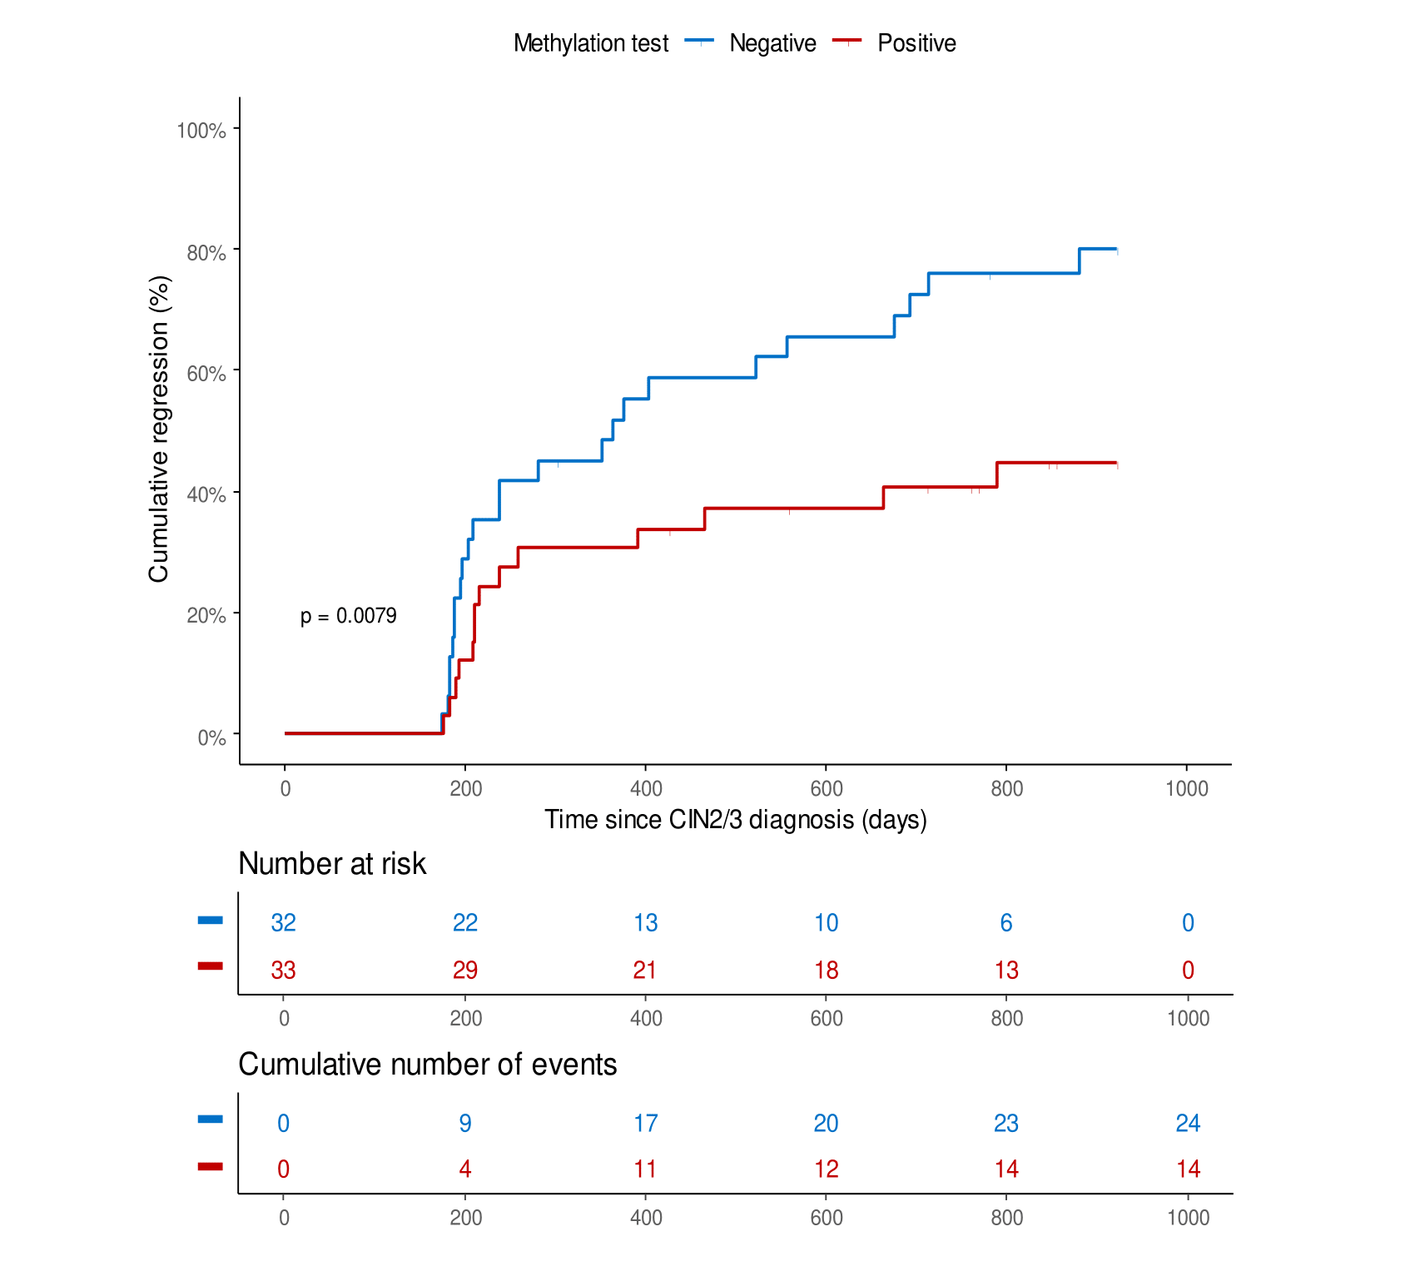
Supplementary Figure 3. Cumulative regression incidences by Kaplan Meier analysis stratified by methylation results on baseline, paired cervical scrapes. Clinical regression was defined as absence of CIN2+ or a high-risk HPV-negative cervical scrape with normal cytology.
Abbreviations: CIN, cervical intraepithelial neoplasia.
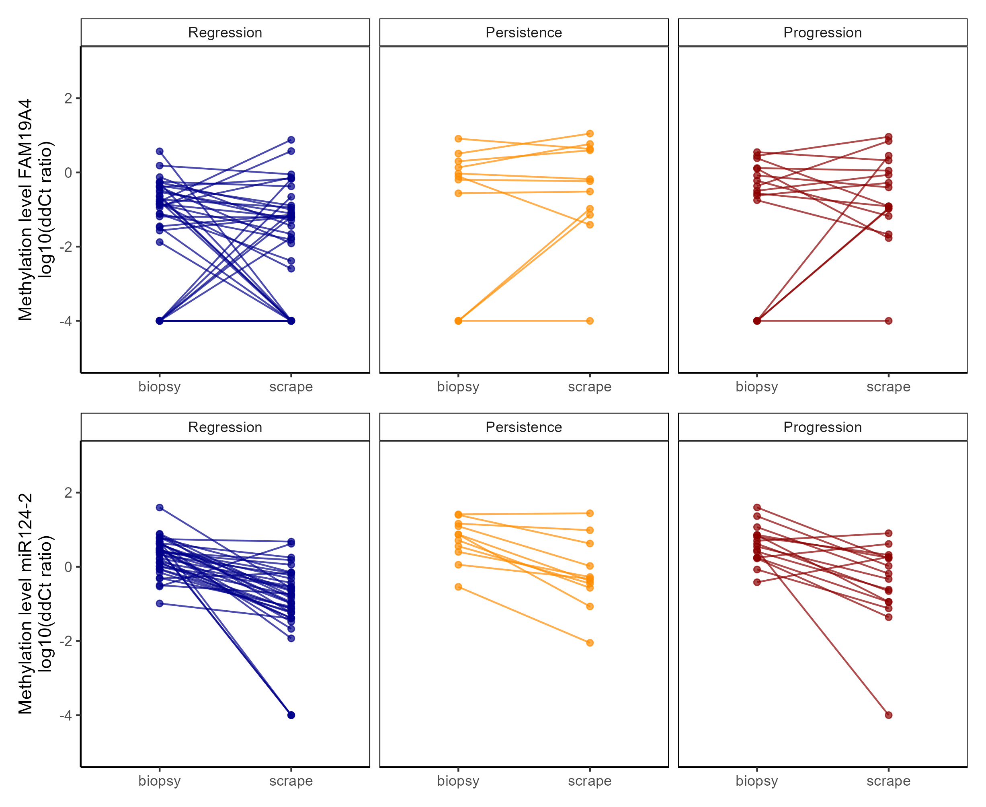

Supplementary Figure 4. Conditional scatterplots representing the methylation levels of FAM19A4 and mir124-2 in paired cervical biopsies and clinician-collected cervical scrapes, stratified by study clinical outcome.

