Supplementary Figures

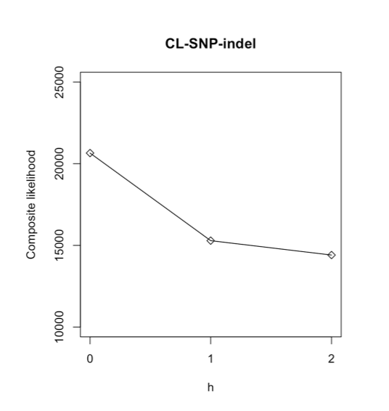
Supplementary Fig. S1. Slope heuristics for the composite likelihood score for SNaQ networks with h = 0, 1, 2.

Supplementary Fig. S2. ADMIXTURE results illustrating the cross-validation error for increasing values of K. Results support 5 ancestral populations within the Sceloporus graciosus complex.

Supplementary Fig. S3. ADMIXTURE clustering results for the Sceloporus graciosus complex based on the best supported model of K = 5. (A) Individual plot ordered by ancestry. The arrow represents a S. arenicolus individual with most of its ancestry originating from a S. graciosus ancestral population. Multiple colors represent mixed ancestry within each individual. (B) Population plot. Multiple colors represent mixed ancestry within each ancestral population. W. GB = Western Great Basin.

Supplementary Fig. S4. ADMIXTURE clustering results for the Sceloporus graciosus complex based on a K = 4 model. (A) Individual plot with individuals ordered according to the best model (K = 5). The arrow represents a S. arenicolus individual with most of its ancestry originating from a S. graciosus ancestral population. Multiple colors represent mixed ancestry within each individual. (B) Spatial distribution of populations. Multiple colors represent mixed ancestry within each individual. W. GB = Western Great Basin.

Supplementary Fig. S5. ADMIXTURE clustering results for the Sceloporus graciosus complex based on a K = 6 model. (A) Individual plot with individuals ordered according to the best model (K = 5). The arrow represents a S. arenicolus individual with most of its ancestry originating from a S. graciosus ancestral population. Multiple colors represent mixed ancestry within each individual. (B) Spatial distribution of populations. Multiple colors represent mixed ancestry within each individual. W. GB = Western Great Basin.

Supplementary Fig. S6. ADMIXTURE results illustrating the cross-validation error for increasing values of K based on the filtered data set limiting missing data to <25% (=17,018 SNPs). Results support 7 ancestral populations within the Sceloporus graciosus complex.

Supplementary Fig. S7. ADMIXTURE clustering results for the Sceloporus graciosus complex based on a K = 7 model inferred from a filtered data set with <25% missing data per SNP ( =17,018 SNPs). (A) Individual plot with individuals ordered according to the best model from the original data (K = 5). The arrow represents a S. arenicolus individual with most of its ancestry originating from a S. graciosus ancestral population. Multiple colors represent mixed ancestry within each individual. (B) Spatial distribution of populations. Multiple colors represent mixed ancestry within each individual.

Supplementary Fig. S8. Expected (He) and observed (Ho) heterozygosity for each population of the Sceloporus graciosus complex. Colored population bars correspond to those presented in Figs. 1 and S3. W. GB = Western Great Basin.

Supplementary Fig. S9. Pairwise population differentiation (Fst) within the Sceloporus graciosus complex based on the genomic data. Warmer colors indicate greater genetic divergence. W. GB = Western Great Basin.

Supplementary Fig. S10. Scatterplot and best fit line showing positive relationship between geographic distance and genetic distance (i.e. isolation by distance; IBD) within the S. graciosus complex. Inference was done at the individual level.

Supplementary Fig. S11. (A). Maximum likelihood (ML) genealogy of the Sceloporus graciosus complex based on the concatenated mtDNA data. Values adjacent to branches represent support values (SH-aLRTS/ultrafast bootstrap). For clarity, only support values for major branches are shown. For ease of comparison, individuals are color coded based on the concatenated genomic genealogy and ADMIXTURE results (Fig. 1). Additional outgroups were pruned for visualization purposes. Small arrow indicates S. arenicolus sample with S. graciosus nuclear background.

Supplementary Fig. S12. Results of coalescent simulations in BPP for different posterior peaks in Model B (Supplementary Table S9). (A) Branch lengths (coalescent times) using gene trees simulated with two sequences from one population involved in gene flow (C_Plateau; t_{AA}). (B) Branch lengths (coalescent times) using gene trees simulated with one sequence from each population involved in gene flow (C_Plateau, E_California; t_{AB}). In both plots, the colors represent coalescent times for each peak. All simulations used parameter estimates from both runs of the empirical data.

Supplementary Fig. S13. Diagnostics from two independent EEMS runs. (A) Comparison of fitted versus observed dissimilarity between demes; (B) Comparison of fitted versus observed dissimilarity within demes. The strong linear relationship depicted in both plots suggests that the EEMS model fits the data well. (C) Distance between demes versus observed dissimilarity between demes. The linear relationship supports the presence of isolation-by-distance (IBD) in the data. (D) Convergence and mixing of two independent MCMC chains. The overlap indicates that both chains were sampling from similar posterior distributions.

