Supplementary Information
Development of an In Vitro Denture Stomatitis Model Simulating Candida albicans Biofilm Formation and Detachment under Daily Antiseptic Immersion
Pornpot Jiangkongkho ¹, Thatawee Khemwong²*

¹Department of Restorative Dentistry, Faculty of Dentistry, Naresuan University, Phitsanulok, Thailand
²Department of Oral Diagnosis, Faculty of Dentistry, Naresuan University, Phitsanulok, Thailand
*Corresponding author: Assistant Professor Dr. Thatawee Khemwong, Thataweek@nu.ac.th

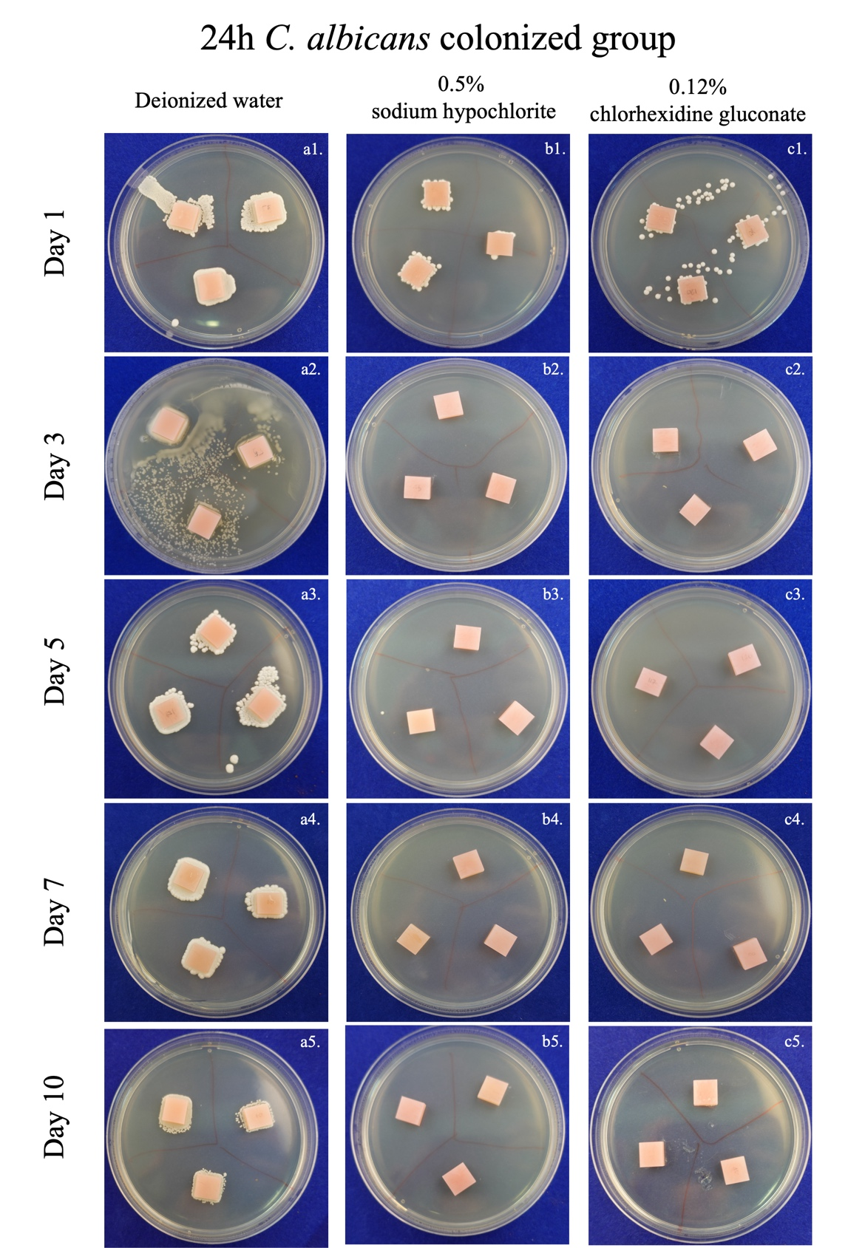
Supplementary Figure S1. Photographic images of the 24 h colonization group (a1–5, b1–5, c1–5), taken after 72 h of incubation. Residual C. albicans was observed across all deionized water timepoints (a1–5), albeit slightly reduced. In the 0.5% sodium hypochlorite group, C. albicans colonies were observed until Day 5 (b3–5). In the 0.12% chlorhexidine gluconate group, no colonies were observed after Day 5 (c3–5).
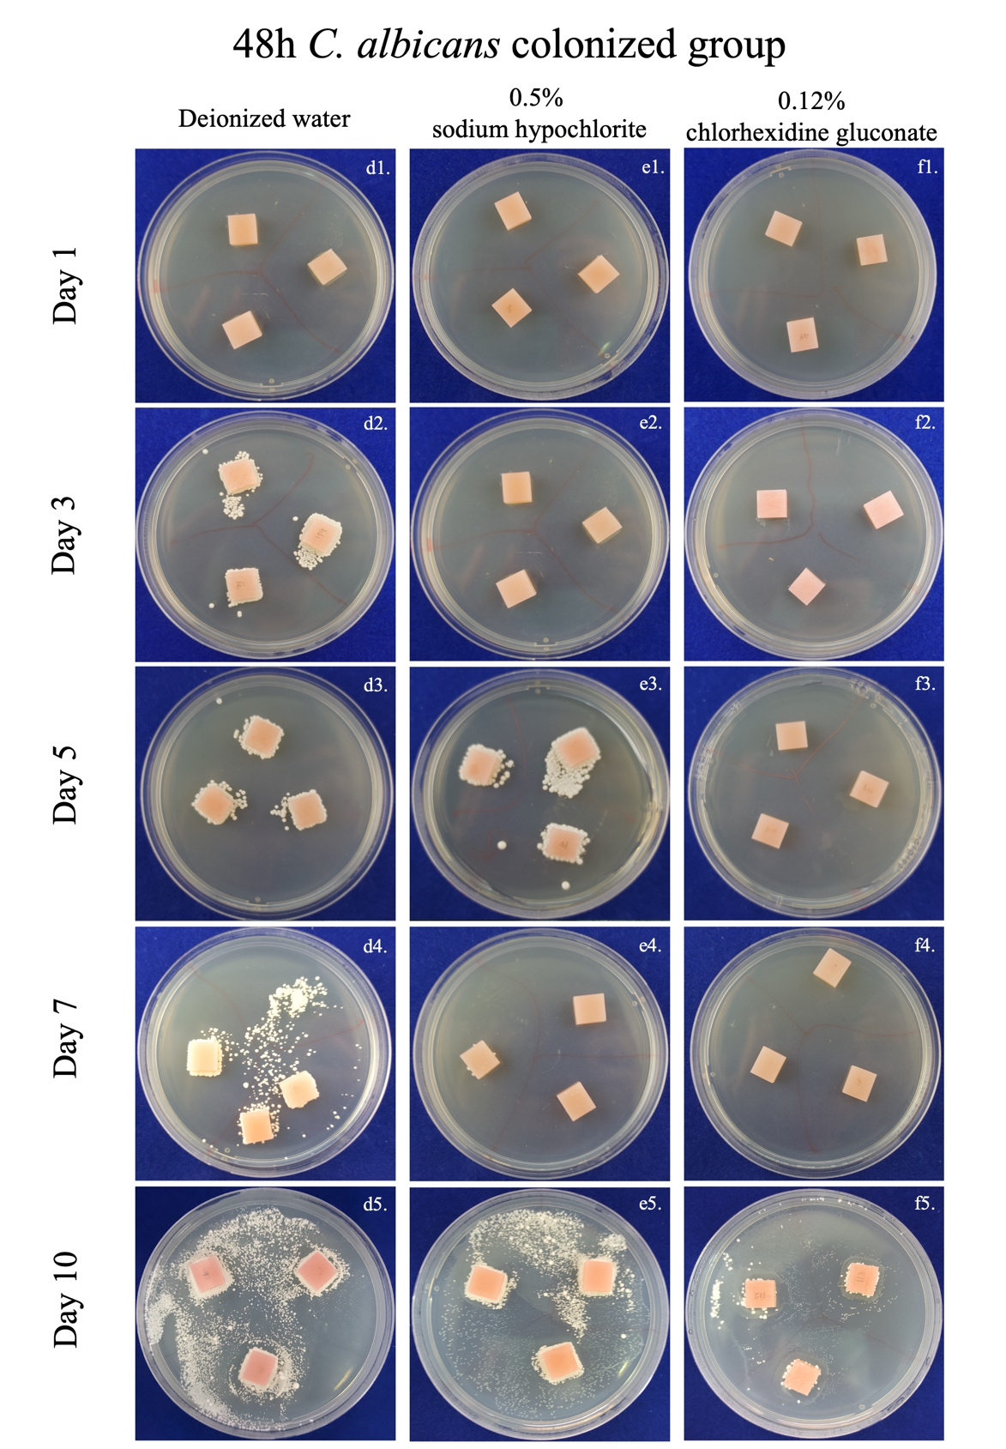
Supplementary Figure S2. Photographic images of the 48 h colonization group (d1–5, e1–5, f1–5), taken after 72 h of incubation. Residual C. albicans was observed in the deionized water group (d1–5) and the 0.5% sodium hypochlorite group (e1–4), though colony numbers gradually decreased. In the 0.12% chlorhexidine gluconate group, colonies disappeared by Day 5 (f3–4). On Day 10, positive results were observed in both treated groups (e5, f5) owing to contamination of the broth.
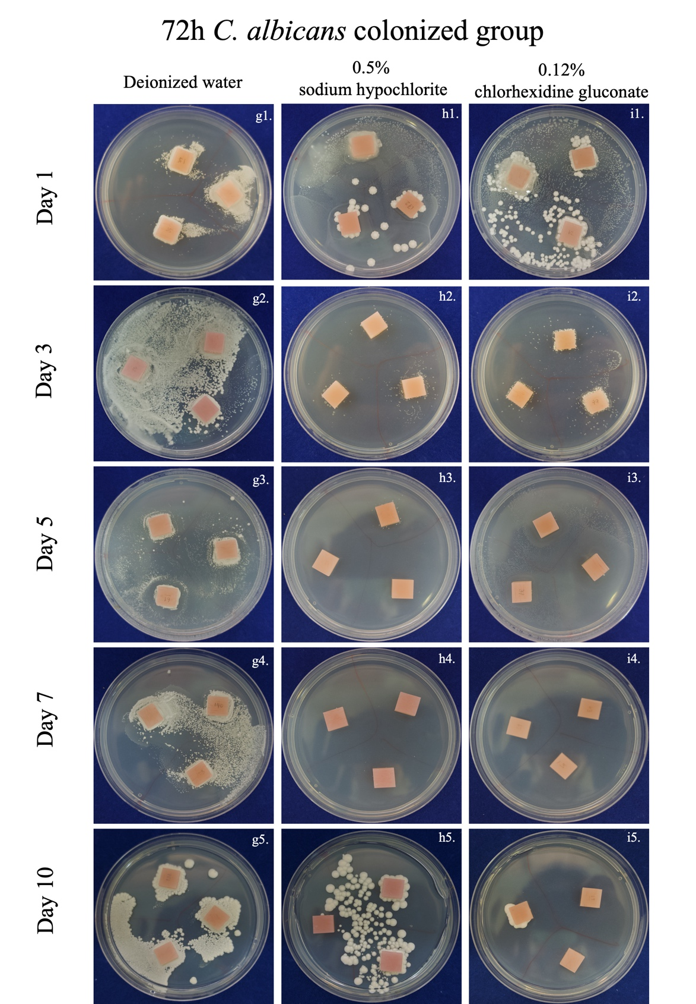
Supplementary Figure S3. Photographic images of the 72 h colonization group (g1–5, h1–5, i1–5), taken after 72 h of incubation. Residual C. albicans was observed in the deionized water group (g1–5), decreasing gradually. In the 0.12% chlorhexidine gluconate group, colonies gradually decreased (i1–3) and disappeared by Day 7 (i4). The 0.5% sodium hypochlorite group showed colonies throughout the timeline, with numbers gradually decreasing until Day 7 (h1–4); however, colonies reappeared at Day 10 in both treated groups (h5, i5).

