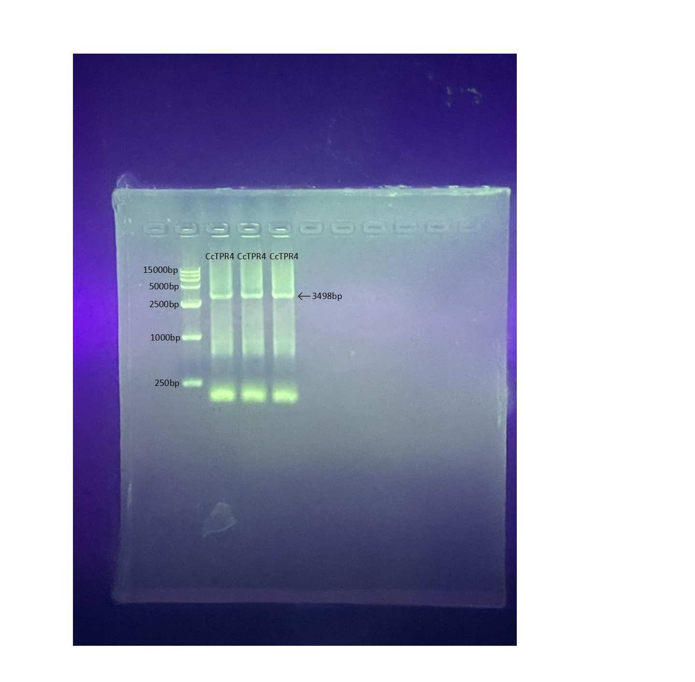

Fig. S5. The complete, uncropped original version of the agarose gel electrophoresis image showing the amplified coding sequence (CDS) of CcTPR4 in Figure 6A.

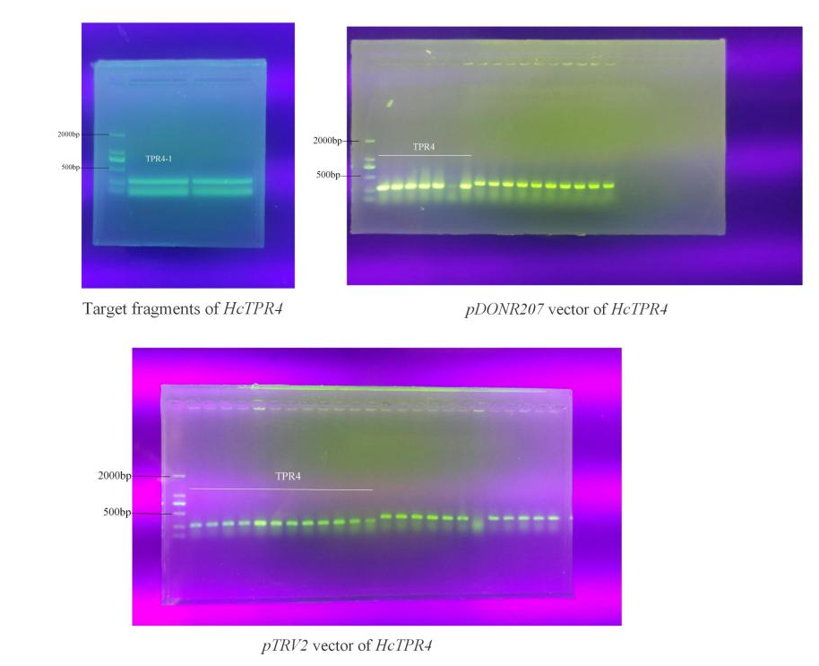

Fig. S6.The complete, uncropped original agarose gel electrophoresis image showing positive clones of pDONR207::HcTPR4 and pTRV2::HcTPR4 vectors in Figure S4D.

