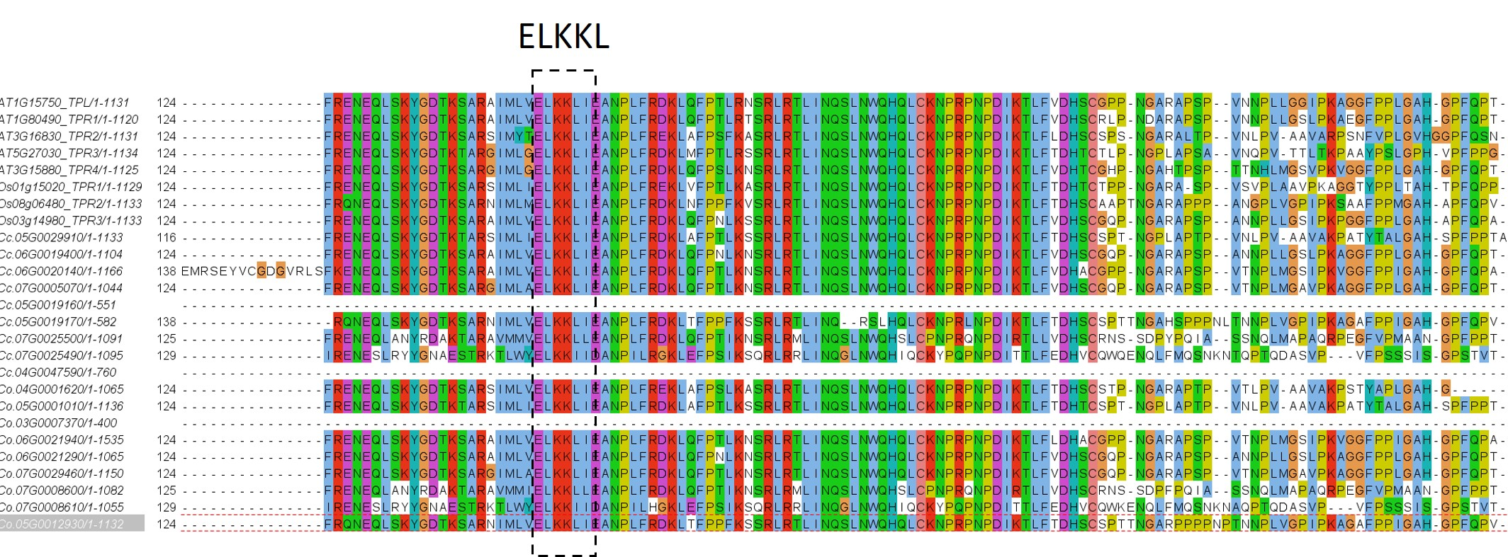
Fig. S1. The ELKKL domain in TOPLESS/TOPLESS-related (TPL/TPR) family proteins.

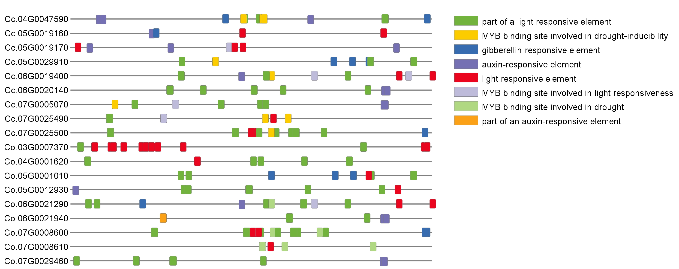
Fig. S2. Distribution of cis-acting elements in the promoters of TOPLESS/TOPLESS-related (TPL/TPR) family genes.

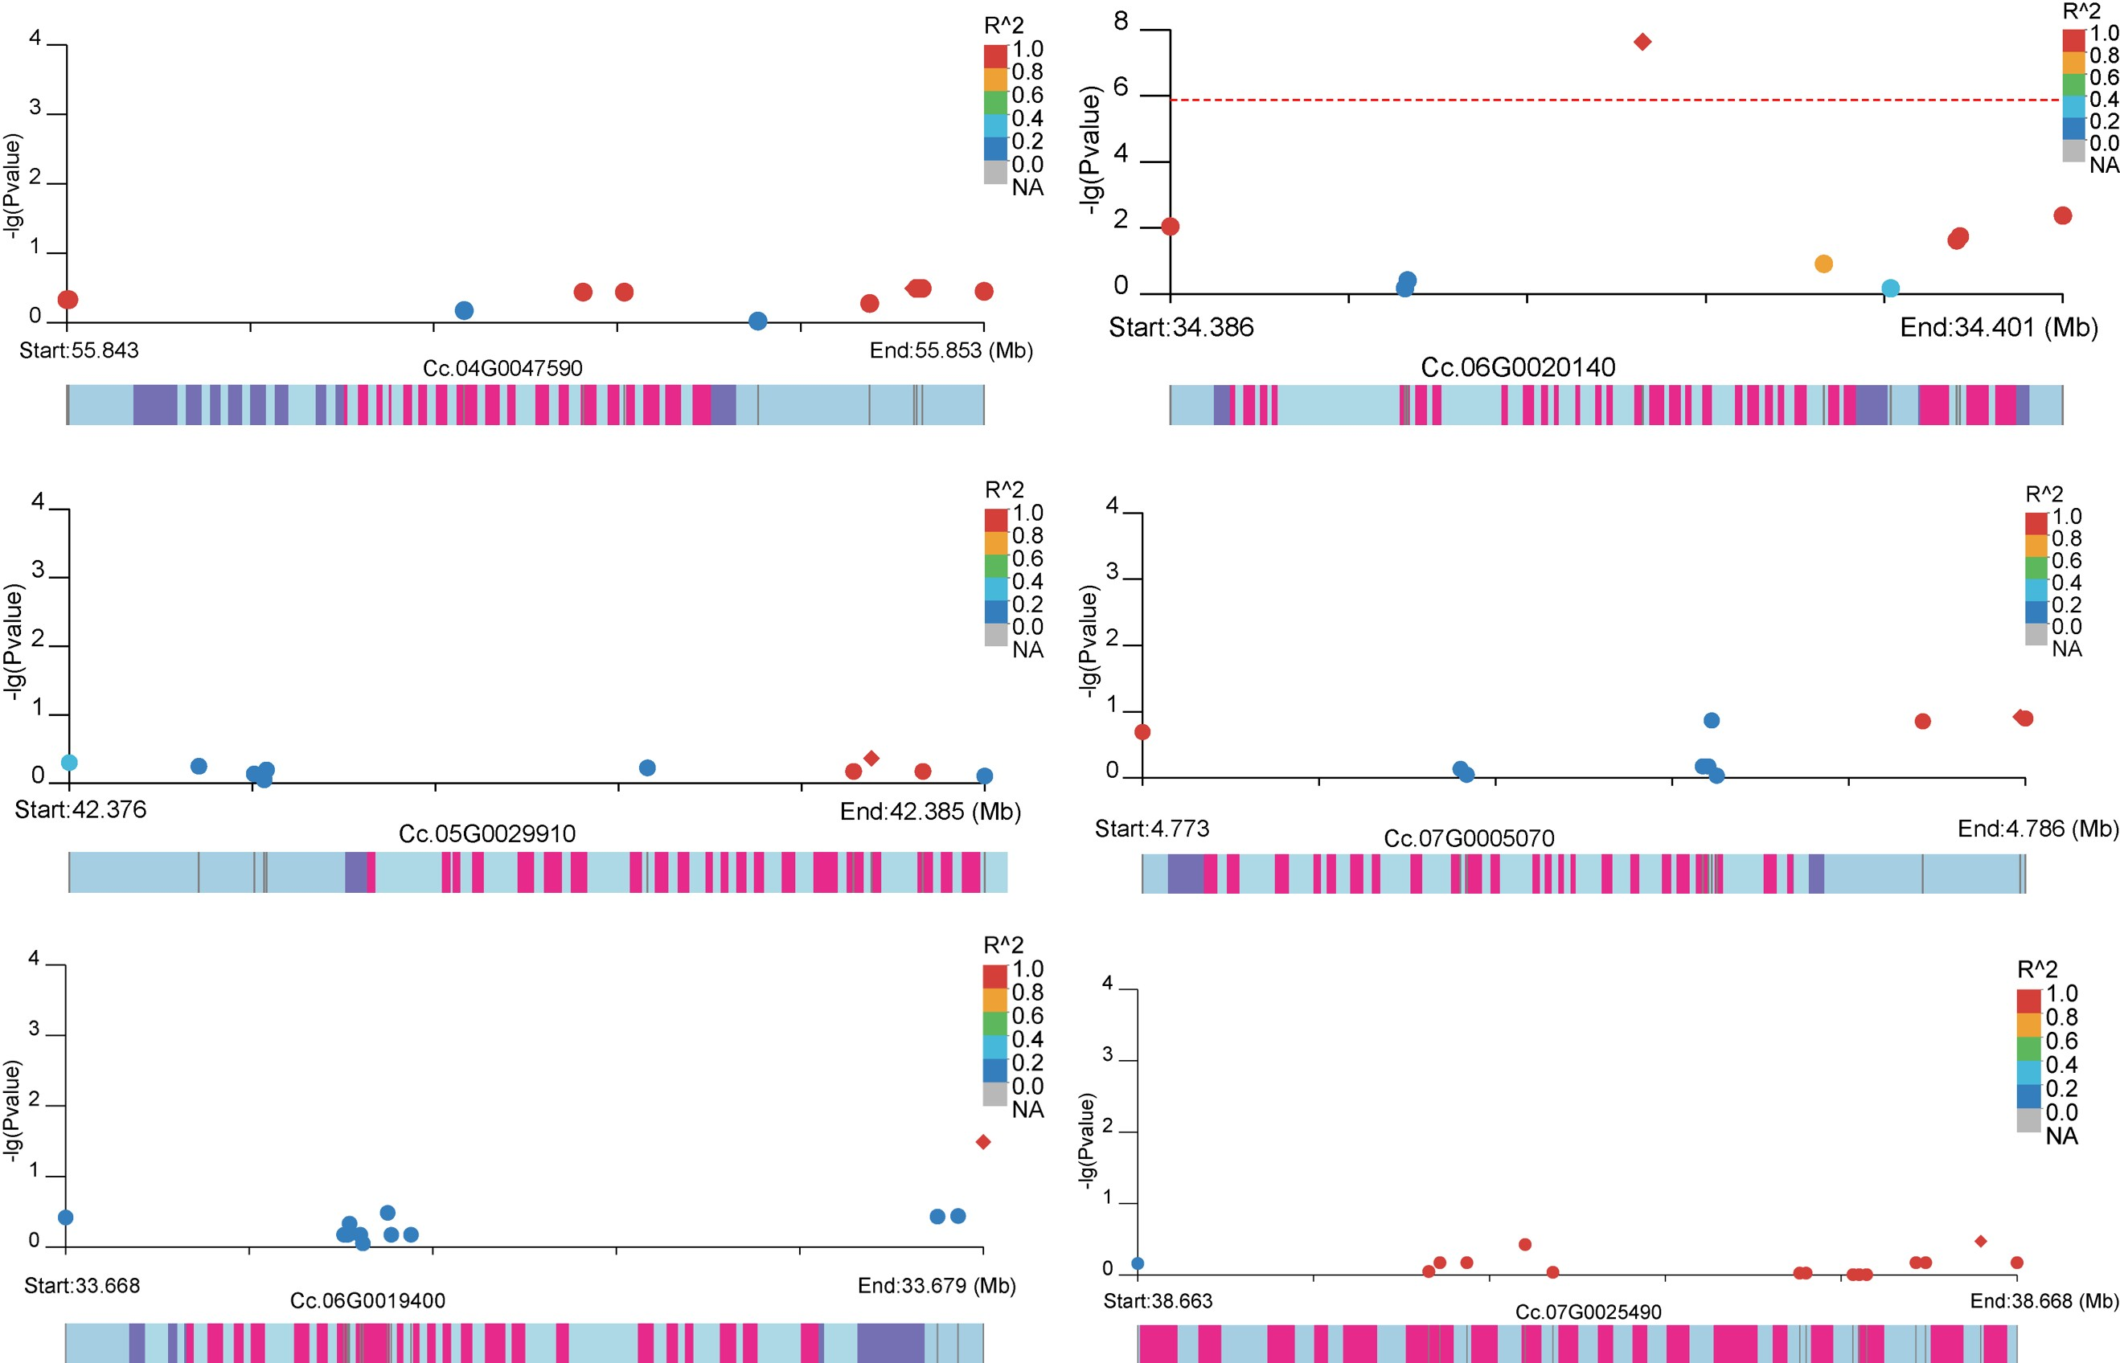
Fig. S3. Association analysis between TPL/TPR genes and fresh bark weight per plant (FBW) in jute.

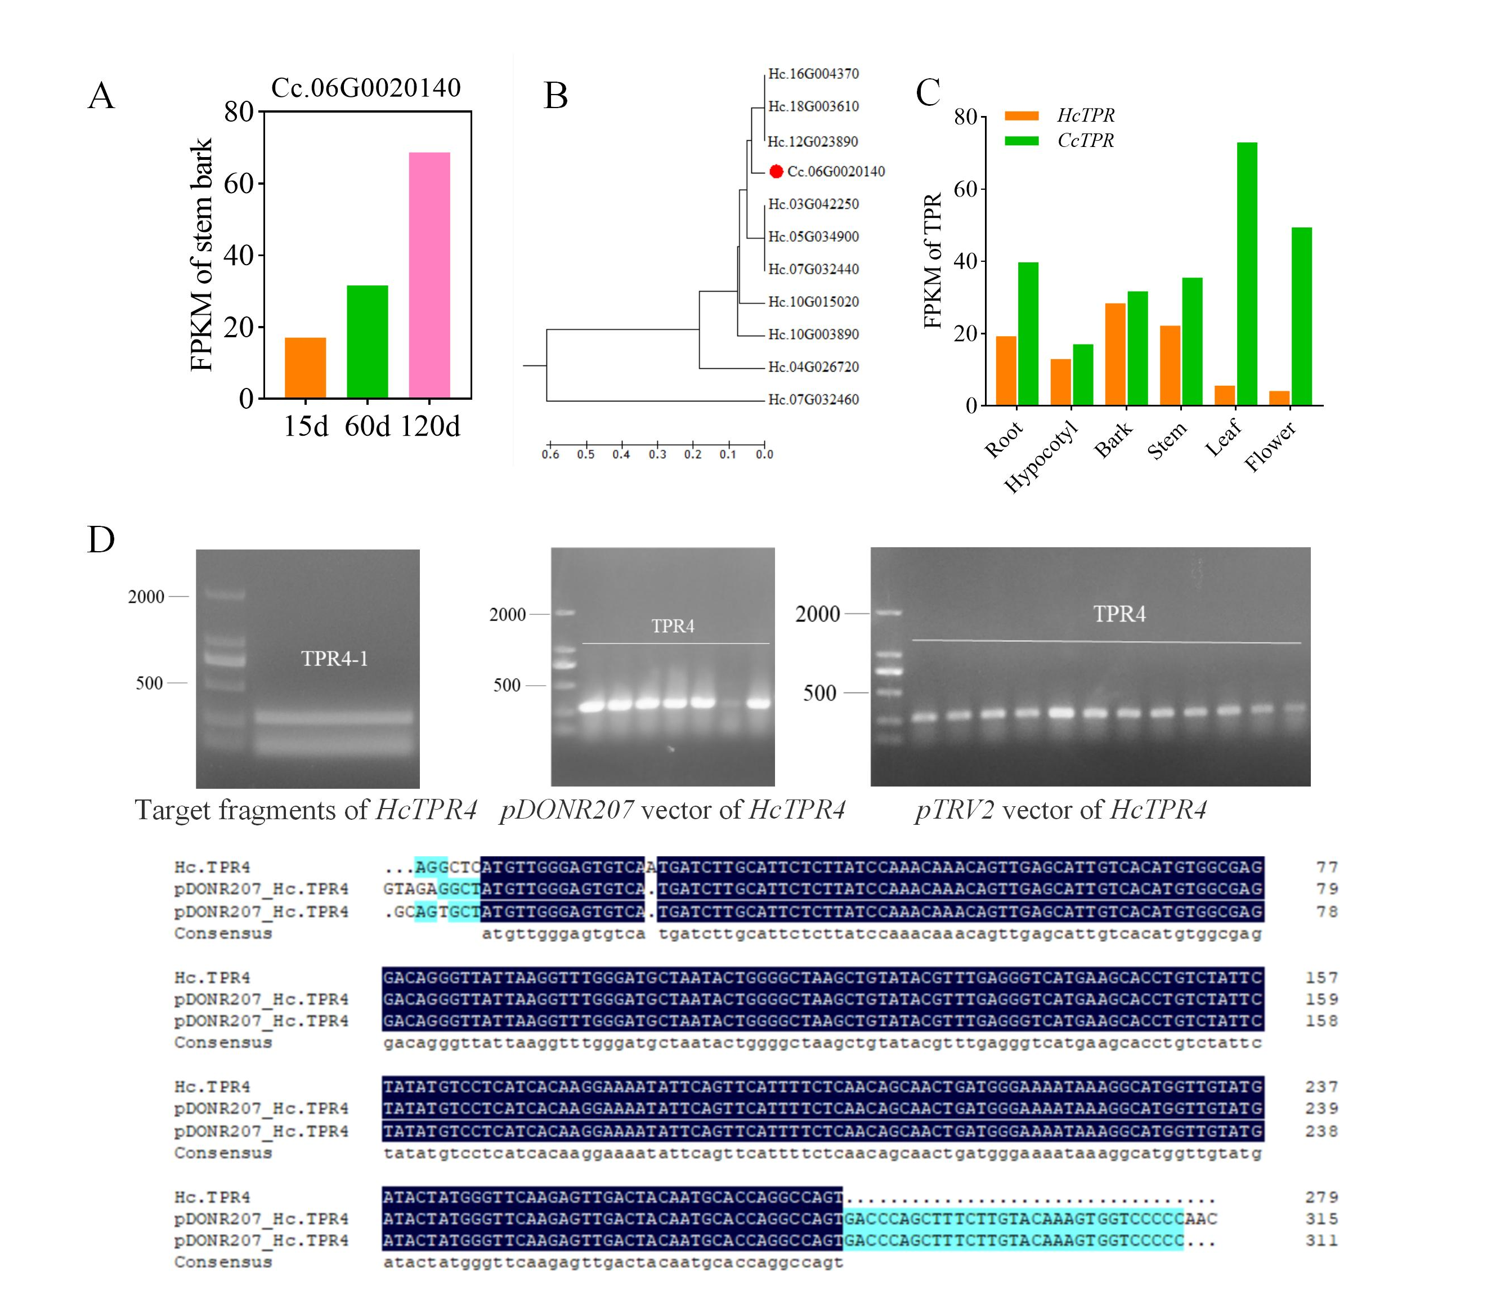
Fig. S4. Construction and sequencing of pTRV2::HcTPR4 vector for virus-induced gene silencing (VIGS).

