Supplementary Material
Supplementary Tables S1–S6 and Figures S1–S5
Prior depressive-symptom burden, current deviation from personal history, and incident heart disease: a three-cohort longitudinal study
Contents
Table S1. Cohort-specific measurement definitions, harmonization, and longitudinal implementation
Table S2. Analytic sample derivation and event counts
Table S3. Decomposition diagnostics and selected robustness analyses
Table S4. Cross-cohort heterogeneity and reweighting diagnostics
Table S5. Supporting life-course adversity, psychological-burden formation, and biomarker analyses
Table S6. Age-related heterogeneity in associations of depressive-symptom history components with incident heart disease
Supplementary Figures S1–S5
Figure S1. Cohort-specific analytic branches and analysis sample roles
Figure S2. Decomposition diagnostics in the three analytic cohorts
Figure S3. Robustness of prior-burden and current-deviation associations
Figure S4. SHARE leave-one-country-out analyses
Figure S5. HRS-to-ELSA reweighting diagnostics

Table S1. Cohort-specific measurement definitions, harmonization, and longitudinal implementation
Panel A. Variable definitions and harmonization
Domain | Item | HRS | SHARE | ELSA | Interpretation
Psychological scale | Instrument and score range | CES-D-8 total score, 0–8 | EURO-D total score, 0–12 | CES-D-8 total score, 0–8 | HRS and ELSA share the CES-D-8 total-score range; SHARE provides an independent EURO-D comparison.
Current snapshot | Definition | CES-D-8 score at the current wave | EURO-D score at the current wave | CES-D-8 score at the current wave | The current snapshot is shown descriptively and in a separately specified model.
Prior burden | Definition | Mean of all eligible CES-D-8 measurements strictly before the current wave | Mean of all eligible EURO-D measurements strictly before the current wave | Mean of all eligible CES-D-8 measurements strictly before the current wave | No future psychological measurement contributes to an earlier prior burden.
Current deviation | Definition | Current CES-D-8 minus the participant-specific prior mean | Current EURO-D minus the participant-specific prior mean | Current CES-D-8 minus the participant-specific prior mean | Positive values indicate worse current symptoms than the participant's own prior history.
Incident heart disease | Definition | First newly reported heart disease at the next selected wave among participants free of heart disease at the start of the current risk interval; follow-up ceased after the first incident event | First newly reported harmonized heart disease at the next selected wave among participants free of heart disease at the start of the current risk interval; follow-up ceased after the first incident event | First newly reported heart disease at the next selected wave among participants free of heart disease at the start of the current risk interval; follow-up ceased after the first incident event | Outcome definitions were harmonized conceptually rather than assumed to be item-identical; the same first-event risk-set rule was applied across cohorts.
Life-course adversity | Definition | Standardized cumulative life-course adversity score | Cohort-specific standardized adversity score | Cohort-specific standardized adversity score | Adversity was standardized within cohort and is not interpreted as an identical absolute scale across cohorts.
Primary covariates | Adjustment set | Interval, life-course adversity, age, sex, education, and BMI | Interval and country fixed effects; age, sex, education, BMI, hypertension, diabetes, and partnered status | Interval, life-course adversity, age, sex, education, and BMI | Adjustment sets were prespecified within each cohort; differences reflect data availability and cohort design.

Panel B. Longitudinal waves and risk intervals
Domain | Item | HRS | SHARE | ELSA | Interpretation
Rolling-window implementation | History, current wave, and next-wave outcome | 2012/2014 history → 2016 current → 2018 outcome; 2012/2014/2016 history → 2018 current → 2020 outcome; 2012/2014/2016/2018 history → 2020 current → 2022 outcome | W1/W2 history → W4 current → W5 outcome; W1/W2/W4 history → W5 current → W6 outcome; W1/W2/W4/W5 history → W6 current → W8 outcome; W1/W2/W4/W5/W6 history → W8 current → W9 outcome | all eligible waves before W4 → W4 current → W5 outcome; all eligible waves before W5 → W5 current → W6 outcome; all eligible waves before W6 → W6 current → W7 outcome; all eligible waves before W7 → W7 current → W8 outcome; all eligible waves before W8 → W8 current → W9 outcome; all eligible waves before W9 → W9 current → W10 outcome | Each person could contribute more than one eligible risk interval until the first incident event.
Minimum prior measurements | Eligibility threshold | At least 2 prior CES-D-8 measurements | At least 2 prior EURO-D measurements | At least 2 prior CES-D-8 measurements | The minimum-history threshold was prespecified before outcome modeling.
Temporal information rule | Future information | Future CES-D-8 values were prohibited from earlier intervals | Future EURO-D values were prohibited from earlier intervals | Future CES-D-8 values were prohibited from earlier intervals | The decomposition is strictly lagged.
Primary estimation | Model family | Complementary log-log discrete-time model with respondent-clustered robust standard errors and interval fixed effects | Complementary log-log discrete-time model with respondent-clustered robust standard errors, interval fixed effects, and country fixed effects | Complementary log-log discrete-time model with respondent-clustered robust standard errors and interval fixed effects | Cohort-specific SD estimates are used for within-cohort process replication; raw CES-D points are used for formal HRS–ELSA heterogeneity.

Panel C. Measurement comparability
Domain | Item | HRS | SHARE | ELSA | Interpretation
Within-HRS longitudinal invariance | CES-D-8 loading and threshold invariance | Practical loading and threshold invariance was supported across HRS 2012, 2014, and 2016. | Not tested because SHARE used EURO-D | No separate longitudinal item-invariance claim promoted | The one-factor CES-D structure showed acceptable practical loading and threshold invariance across 2012, 2014, and 2016. The raw 0-8 score remains the primary measure; invariant-factor scores may be used as a sensitivity analysis.
HRS–ELSA item-level comparability | Repeated-item harmonization | Eight CES-D items available across 2012, 2014, and 2016 | Not item-harmonized to CES-D-8 | Repeated CES-D-8 total-score process analysis was feasible, but full item-level harmonization and longitudinal invariance were not established. | ELSA feasibility supported total-score process analysis but did not justify a full cross-cohort item-level invariance claim.
SHARE EURO-D comparability | Different psychological instrument | Not applicable | EURO-D was used as an independent measure of the same broad depressive-symptom construct rather than as an item-equivalent CES-D measure. | CES-D-8 total-score process analysis retained despite limited item-level harmonization | SHARE strengthens generalizability across a different instrument and social setting.
Cross-cohort claim boundary | Permitted interpretation | Longitudinal comparison supported within HRS | Replicates the prior-burden construct, not an identical CES-D metric | Same total-score family as HRS, but full cross-cohort measurement equivalence was not established | Cross-cohort findings concern a shared psychological-burden construct; exact latent-scale equivalence across all three cohorts is not claimed.

Note. Prior burden was defined from psychological measurements strictly before the current wave, and current deviation was the current score minus the participant-specific prior mean. HRS and ELSA used CES-D-8, whereas SHARE used EURO-D as an independent measure of the same broad depressive-symptom construct. Exact latent-scale equivalence across all three cohorts is not claimed.

Table S2. Analytic sample derivation and event counts
Panel A. HRS analysis branches
Cohort | Analysis branch | Participants | Person-waves | Events | History/eligibility information | Notes
HRS | Life-course adversity and incident heart disease | 7,579 |  | 901 | Baseline adversity analysis among participants free of heart disease at baseline | Primary adversity–heart-disease association
HRS | Endpoint-state psychological-burden formation | 7,292 |  |  | Low at both endpoints, incident high, remitted high, and persistent high states | The three nonreference state estimates share this analysis sample.
HRS | Three-wave cumulative psychological-burden outcomes | 7,193 |  |  | Complete CES-D-8 measurements in 2012, 2014, and 2016 | Shared sample for mean burden and number of high-burden waves.
HRS | Repeated psychological level and adversity × time | 7,292 | 21,777 |  | Repeated CES-D-8 observations from 2012 to 2016 | 7,292 participants contributed 21,777 repeated CES-D-8 observations.
HRS | Strictly lagged dynamic decomposition | 7,094 | 17,611 | 821 | At least 2 prior measurements; all eligible prior values used | Primary HRS prior-burden/current-deviation sample
HRS | Biomarker-selection source population | 6,805 |  | 814 | 2016 psychological history/current deviation available before biomarker restriction | Target population represented by biomarker-selection weights
HRS | Biomarker common sample | 3,217 |  | 366 | IL-6, sTNFR1, and the prespecified two-marker composite jointly available | Secondary selection-weighted biomarker analysis
HRS | HRS source sample for reweighting to ELSA | 7,094 | 17,611 | 821 | Raw CES-D-point history and deviation used for the HRS–ELSA reweighting analysis | Participant-level HRS source population

Panel B. SHARE analysis branches
Cohort | Analysis branch | Participants | Person-waves | Events | History/eligibility information | Notes
SHARE | Feasibility-qualified independent EURO-D analysis | 26,489 | 47,295 | 2,792 | All available eligible prior EURO-D values | Independent EURO-D dynamic-process sample
SHARE | Next-wave outcome-observability audit | 39,658 | 69,366 |  | Rows eligible before requiring observed next-wave heart-disease status; 47,336 outcomes were observed and 22,030 were missing | Of 47,336 rows with observed next-wave outcomes, 41 were excluded because partnered status was missing, leaving 47,295 person-waves in the primary model
SHARE | Observation-probability IPW sensitivity | 26,489 | 47,295 | 2,792 | Observed next-wave outcomes with stabilized, truncated observation weights | Stabilized and truncated observation weights

Panel C. ELSA analysis branches
Cohort | Analysis branch | Participants | Person-waves | Events | History/eligibility information | Notes
ELSA | Same-structure dynamic-process analysis | 2,271 | 9,248 | 419 | At least 2 prior CES-D-8 measurements | Prespecified ELSA process analysis
ELSA | Common-scale heterogeneity and reweighting target | 2,271 | 9,248 | 419 | Raw CES-D-point history and deviation | Raw CES-D-point comparison and measured-composition reweighting target

Panel D. Risk-interval samples
Cohort | Analysis branch | Participants | Person-waves | Events | History/eligibility information | Notes
HRS | 2016–2018 | 6,805 | 6,805 | 280 | Mean prior-measure count=2.00; complete-history=100.0% | Interval-specific descriptive count
HRS | 2018–2020 | 5,899 | 5,899 | 253 | Mean prior-measure count=2.98; complete-history=98.3% | Interval-specific descriptive count
HRS | 2020–2022 | 4,907 | 4,907 | 288 | Mean prior-measure count=3.94; complete-history=94.8% | Interval-specific descriptive count
SHARE | W4–W5 | 7,052 | 7,052 | 302 | Mean prior-measure count=2.00; complete-history=100.0% | Interval-specific descriptive count
SHARE | W5–W6 | 9,772 | 9,772 | 421 | Mean prior-measure count=2.52; complete-history=52.5% | Interval-specific descriptive count
SHARE | W6–W8 | 14,195 | 14,195 | 1,303 | Mean prior-measure count=2.59; complete-history=20.2% | Interval-specific descriptive count
SHARE | W8–W9 | 16,276 | 16,276 | 766 | Mean prior-measure count=3.05; complete-history=13.0% | Interval-specific descriptive count
ELSA | W4–W5 | 1,846 | 1,846 | 65 | Mean prior-measure count=2.95; complete-history=95.0% | Interval-specific descriptive count
ELSA | W5–W6 | 1,957 | 1,957 | 47 | Mean prior-measure count=3.62; complete-history=78.6% | Interval-specific descriptive count
ELSA | W6–W7 | 1,750 | 1,750 | 67 | Mean prior-measure count=4.56; complete-history=75.9% | Interval-specific descriptive count
ELSA | W7–W8 | 1,508 | 1,508 | 73 | Mean prior-measure count=5.49; complete-history=74.0% | Interval-specific descriptive count
ELSA | W8–W9 | 1,273 | 1,273 | 59 | Mean prior-measure count=6.41; complete-history=70.5% | Interval-specific descriptive count
ELSA | W9–W10 | 914 | 914 | 108 | Mean prior-measure count=7.34; complete-history=66.4% | Interval-specific descriptive count

Note. Participants, person-waves, and events are reported for each analysis branch. Blank cells indicate that a quantity was not applicable or was not retained in the supplementary summary; no value was imputed. The repeated psychological-level analysis included 7,292 participants contributing 21,777 observations.

Table S3. Decomposition diagnostics and selected robustness analyses
Panel A. Decomposition diagnostics
Cohort | Analysis | Component | Effect measure | Result | P value | Sample | Interpretation
HRS | Primary identical-sample decomposition | Correlation between prior burden and current deviation | Diagnostic | r=−0.291 |  | N=7,094; person-waves=17,611; events=821 | Pearson correlation on the primary person-wave sample
HRS | Primary identical-sample decomposition | Variance inflation factor for prior burden | Diagnostic | VIF=1.204 |  | N=7,094; person-waves=17,611; events=821 | Auxiliary VIF from the joint-model design matrix
HRS | Primary identical-sample decomposition | Variance inflation factor for current deviation | Diagnostic | VIF=1.101 |  | N=7,094; person-waves=17,611; events=821 | Auxiliary VIF from the joint-model design matrix
HRS | Primary identical-sample decomposition | Maximum condition index | Diagnostic | 1.670 |  | N=7,094; person-waves=17,611; events=821 | Condition index from the centered and scaled nonconstant joint-model design matrix
HRS | Prior-history availability | Distribution of prior psychological measurements | Diagnostic | median=3.0; IQR=2.0–4.0; range=2–4; complete-history=98.0% |  | N=7,094; person-waves=17,611; events=821
HRS | Joint-model completion | Joint prior-burden-plus-deviation model | Diagnostic | Model completed successfully. |  | N=7,094; person-waves=17,611; events=821
SHARE | Primary identical-sample decomposition | Correlation between prior burden and current deviation | Diagnostic | r=−0.317 |  | N=26,489; person-waves=47,295; events=2,792 | Primary identical-sample correlation
SHARE | Primary identical-sample decomposition | Variance inflation factor for prior burden | Diagnostic | VIF=1.303 |  | N=26,489; person-waves=47,295; events=2,792 | Auxiliary R²=0.232
SHARE | Primary identical-sample decomposition | Variance inflation factor for current deviation | Diagnostic | VIF=1.140 |  | N=26,489; person-waves=47,295; events=2,792 | Auxiliary R²=0.123
ELSA | Primary identical-sample decomposition | Correlation and variance inflation diagnostics | Diagnostic | r=−0.254; VIF history=1.139; VIF current deviation=1.084 |  | N=2,271; person-waves=9,248; events=419 | Diagnostic calculation in the exact ELSA primary person-wave sample; no material multicollinearity
ELSA | Prior-history availability | Distribution of prior psychological measurements | Diagnostic | mean=4.72; median=5.0; IQR=3.0–6.0 |  | N=2,271; person-waves=9,248; events=419
ELSA | Joint-model completion | Joint prior-burden-plus-deviation model | Diagnostic | Model completed successfully. |  | N=2,271; person-waves=9,248; events=419
All cohorts | Model specification boundary | Model-specification boundary | Diagnostic | Current snapshot was not entered together with prior burden and current deviation because current snapshot equals their sum by construction.

Panel B. HRS robustness
Cohort | Analysis | Component | Effect measure | Result | P value | Sample | Interpretation
HRS | Complete-history sensitivity | Prior burden | HR per cohort-specific SD | 1.262 (1.164–1.368) | <0.001 | N=6,805; person-waves=17,252; events=799
HRS | Complete-history sensitivity | Current deviation | HR per cohort-specific SD | 1.120 (1.032–1.216) | 0.007 | N=6,805; person-waves=17,252; events=799
HRS | Exclude 2016–2018 interval | Prior burden | HR per cohort-specific SD | 1.297 (1.173–1.434) | <0.001 | N=6,089; person-waves=10,806; events=541
HRS | Exclude 2016–2018 interval | Current deviation | HR per cohort-specific SD | 1.062 (0.960–1.175) | 0.246 | N=6,089; person-waves=10,806; events=541
HRS | Raw CES-D one-point scale | Prior burden | HR per 1 CES-D-8 point | 1.132 (1.085–1.182) | <0.001 | N=7,094; person-waves=17,611; events=821
HRS | Raw CES-D one-point scale | Current deviation | HR per 1 CES-D-8 point | 1.060 (1.014–1.107) | 0.009 | N=7,094; person-waves=17,611; events=821

Panel C. SHARE robustness
Cohort | Analysis | Component | Effect measure | Result | P value | Sample | Interpretation
SHARE | SHARE history-availability robustness | History restricted to the two most recent available prior EURO-D measurements | HR per fixed SHARE Wave-1 EURO-D SD | 1.214 (1.159–1.272) | <0.001 | N=26,489; events=2,792 | The prior-burden association did not depend on unequal numbers of prior measurements.
SHARE | SHARE history-availability robustness | Current deviation from the recent-two prior mean | HR per fixed SHARE Wave-1 EURO-D SD | 1.143 (1.095–1.194) | <0.001 | N=26,489; events=2,792 | The current-deviation association was preserved using the recent-two definition.
SHARE | SHARE history-availability robustness | Recent-two history versus deviation coefficient | Beta difference | 0.060 (0.009–0.111) | 0.021 | N=26,489; events=2,792 | Prior burden remained stronger under an equalized two-measure history definition.
SHARE | SHARE history-count robustness | Prior burden after adjustment for prior-measure count | HR per fixed SHARE Wave-1 EURO-D SD | 1.229 (1.172–1.290) | <0.001 | N=26,489; events=2,792 | Adjustment for measurement density did not materially alter the history estimate.
SHARE | SHARE history-count robustness | Current deviation after adjustment for prior-measure count | HR per fixed SHARE Wave-1 EURO-D SD | 1.136 (1.088–1.186) | <0.001 | N=26,489; events=2,792 | Adjustment for measurement density did not materially alter the deviation estimate.
SHARE | SHARE history-count robustness | Within-interval-centered number of prior EURO-D measurements | HR per additional prior measurement | 0.976 (0.925–1.029) | 0.367 | N=26,489; events=2,792 | History-measure count itself was not associated with the outcome.
SHARE | SHARE history-count robustness | Count-adjusted history versus deviation coefficient | Beta difference | 0.079 (0.026–0.133) | 0.003 | N=26,489; events=2,792 | Prior burden remained stronger after adjustment for measurement count.
SHARE | SHARE outcome-observability audit | Prior burden and next-wave outcome observability | OR per fixed SHARE Wave-1 EURO-D SD | 0.870 (0.850–0.891) | <0.001 | 39,658 participants; 69,366 eligible person-waves; 47,336 observed and 22,030 missing next-wave outcomes | Greater prior burden predicted lower next-wave outcome observability.
SHARE | SHARE outcome-observability audit | Current deviation and next-wave outcome observability | OR per fixed SHARE Wave-1 EURO-D SD | 0.908 (0.891–0.927) | <0.001 | 39,658 participants; 69,366 eligible person-waves; 47,336 observed and 22,030 missing next-wave outcomes | Greater current deviation predicted lower next-wave outcome observability.
SHARE | SHARE observation-IPW robustness | Prior burden after inverse-probability weighting for next-wave outcome observation | Weighted HR per fixed SHARE Wave-1 EURO-D SD | 1.221 (1.164–1.281) | <0.001 | N=26,489; events=2,792 | Selection on measured predictors of outcome observability did not explain the prior-burden association.
SHARE | SHARE observation-IPW robustness | Current deviation after inverse-probability weighting for next-wave outcome observation | Weighted HR per fixed SHARE Wave-1 EURO-D SD | 1.136 (1.088–1.187) | <0.001 | N=26,489; events=2,792 | Selection on measured predictors of outcome observability did not explain the deviation association.
SHARE | SHARE observation-IPW robustness | Observation-IPW history versus deviation coefficient | Beta difference | 0.072 (0.018–0.125) | 0.009 | N=26,489; events=2,792 | Prior burden remained stronger after correction for measured outcome observability.
SHARE | Exclude first risk interval | Prior burden | HR | 1.228 (1.167–1.293) | <0.001 | N=24,838; events=2,490 | Direction and magnitude remained compatible with the primary SHARE model.
SHARE | Exclude first risk interval | Current deviation | HR | 1.132 (1.082–1.186) | <0.001 | N=24,838; events=2,490 | Direction and magnitude remained compatible with the primary SHARE model.
SHARE | Country-clustered robust standard errors | Prior burden | HR | 1.231 (1.166–1.299) | <0.001 | N=26,489; events=2,792 | Direction and magnitude remained compatible with the primary SHARE model.
SHARE | Country-clustered robust standard errors | Current deviation | HR | 1.136 (1.091–1.182) | <0.001 | N=26,489; events=2,792 | Direction and magnitude remained compatible with the primary SHARE model.
SHARE | Leave one country out | Prior burden | HR range | 1.210–1.247 |  |  | 17 country-omission analyses; all point estimates above 1 = TRUE
SHARE | Leave one country out | Current deviation | HR range | 1.127–1.155 |  |  | 17 country-omission analyses; all point estimates above 1 = TRUE

Panel D. ELSA robustness
Cohort | Analysis | Component | Effect measure | Result | P value | Sample | Interpretation
ELSA | Complete prior-history sensitivity | Prior burden | HR per cohort-specific SD | 0.971 (0.832–1.134) | 0.711 | person-waves=7,242; events=345 | The ELSA null pattern was not materially altered.
ELSA | Complete prior-history sensitivity | Current deviation | HR per cohort-specific SD | 0.954 (0.833–1.092) | 0.496 | person-waves=7,242; events=345 | The ELSA null pattern was not materially altered.
ELSA | First three ELSA intervals | Prior burden | HR per cohort-specific SD | 1.008 (0.833–1.219) | 0.937 | person-waves=5,553; events=179 | The ELSA null pattern was not materially altered.
ELSA | First three ELSA intervals | Current deviation | HR per cohort-specific SD | 0.896 (0.753–1.066) | 0.215 | person-waves=5,553; events=179 | The ELSA null pattern was not materially altered.
ELSA | Raw CES-D one-point scale | Prior burden | HR per 1 CES-D-8 point | 1.009 (0.926–1.100) | 0.833 | N=2,271; person-waves=9,248; events=419 | The ELSA null pattern was not materially altered.
ELSA | Raw CES-D one-point scale | Current deviation | HR per 1 CES-D-8 point | 0.944 (0.875–1.018) | 0.137 | N=2,271; person-waves=9,248; events=419 | The ELSA null pattern was not materially altered.
ELSA | Harmonized core without BMI | Prior burden | HR per cohort-specific SD | 1.026 (0.907–1.160) | 0.687 | person-waves=10,713; events=485 | The ELSA null pattern was not materially altered.
ELSA | Harmonized core without BMI | Current deviation | HR per cohort-specific SD | 0.956 (0.857–1.066) | 0.419 | person-waves=10,713; events=485 | The ELSA null pattern was not materially altered.

Note. Current snapshot was not entered together with prior burden and current deviation because current snapshot equals their sum by construction. SHARE leave-one-country-out entries report the range of point estimates. ELSA correlation and VIF diagnostics were reconstructed in the final QC on the exact primary person-wave sample.

Table S4. Cross-cohort heterogeneity and reweighting diagnostics
Panel A. Formal HRS–ELSA heterogeneity
Domain | Comparison or diagnostic | Result | Prespecified criterion | Interpretation
Coefficient interaction on the common raw CES-D scale | Prior burden: ELSA minus HRS log-HR coefficient | β difference −0.115 (−0.211 to −0.019); P=0.019 | Two-sided interaction test on log-HR coefficients | Prior-burden coefficients differed significantly between HRS and ELSA.
Coefficient interaction on the common raw CES-D scale | Current deviation: ELSA minus HRS log-HR coefficient | β difference −0.116 (−0.204 to −0.028); P=0.010 | Two-sided interaction test on log-HR coefficients | Current-deviation coefficients differed significantly between HRS and ELSA.

Panel B. Original, reweighted, and observed effects
Domain | Comparison or diagnostic | Result | Prespecified criterion | Interpretation
Effect estimate per 1 raw CES-D point | Original HRS — prior burden | 1.132 (1.085–1.182); P<0.001 | Cluster-robust model CI and P | Original unweighted HRS effect
Effect estimate per 1 raw CES-D point | Original HRS — current deviation | 1.060 (1.014–1.107); P=0.009 | Cluster-robust model CI and P | Original unweighted HRS effect
Effect estimate per 1 raw CES-D point | HRS reweighted to ELSA — prior burden | 1.133 (1.060–1.202); bootstrap P=0.004; cluster-robust P<0.001 | Participant-bootstrap CI preferred for reweighted effects; robust P retained for transparency | Reweighted HRS effect under the measured ELSA baseline covariate distribution
Effect estimate per 1 raw CES-D point | HRS reweighted to ELSA — current deviation | 1.066 (1.004–1.139); bootstrap P=0.040; cluster-robust P=0.060 | Participant-bootstrap CI preferred for reweighted effects; robust P retained for transparency | Reweighted HRS effect under the measured ELSA baseline covariate distribution
Effect estimate per 1 raw CES-D point | Observed ELSA — prior burden | 1.009 (0.926–1.100); P=0.833 | Cluster-robust model CI and P | Observed ELSA effect
Effect estimate per 1 raw CES-D point | Observed ELSA — current deviation | 0.944 (0.875–1.018); P=0.137 | Cluster-robust model CI and P | Observed ELSA effect

Panel C. Weighting diagnostics
Domain | Comparison or diagnostic | Result | Prespecified criterion | Interpretation
Reweighting diagnostics | Weight truncation | 1.0% and 99.0% quantiles | Fixed 1st/99th percentile truncation | No alternative truncation threshold was searched.
Reweighting diagnostics | Effective sample size | 3,912 | At least 50% of source participants | Efficiency after reweighting.
Reweighting diagnostics | Effective sample size ratio | 55.1% | At least 50% | The prespecified ESS gate was assessed.
Reweighting diagnostics | Target support coverage | 97.1% | At least 90% | The prespecified target-support gate was assessed.
Reweighting diagnostics | Source support coverage | 91.9% | Descriptive | Proportion of HRS source participants inside common central propensity support.
Reweighting diagnostics | Maximum absolute SMD before weighting | 0.481 | Descriptive | Initial measured covariate imbalance.
Reweighting diagnostics | Maximum absolute SMD after weighting | 0.024 | ≤0.10 | Measured covariates were balanced after weighting.
Reweighting diagnostics | Bootstrap completion | 500/500 | At least 450 successful replications | Participant-level bootstrap refitted both the membership and weighted outcome models.

Panel D. Interpretation boundaries
Domain | Comparison or diagnostic | Result | Prespecified criterion | Interpretation
Claim boundary | Measured composition | Measured baseline composition did not materially explain the HRS–ELSA coefficient gap. | Interpretation boundary | Reweighting HRS to the measured baseline composition of the ELSA analytic population did not materially reduce the HRS–ELSA coefficient gaps. The available demographic, educational, BMI, and adversity differences were insufficient to explain the non-replication.
Claim boundary | Causal interpretation | Not a causal transportability analysis | Interpretation boundary | Weights address measured baseline composition only.
Claim boundary | Residual differences | Measurement, contextual, and unmeasured differences may remain | Interpretation boundary | Failure of measured composition to explain the gap does not identify a single alternative cause.
Claim boundary | Negative ELSA result | The core dynamic process was not replicated in ELSA. | Interpretation boundary | ELSA non-replication is retained and is not rescued by alternative definitions or algorithms.

Note. Formal HRS–ELSA heterogeneity was evaluated on the common raw CES-D scale. Weights address measured baseline composition only and do not establish causal transportability. Participant-bootstrap confidence intervals are preferred for reweighted effects; cluster-robust P values are retained for transparency.

Table S5. Supporting life-course adversity, psychological-burden formation, and biomarker analyses
Panel A. Life-course adversity and psychological-burden formation
Association | Effect measure | Estimate (95% CI) | P value | Sample | Interpretation
Life-course adversity and incident heart disease in HRS | HR per 1-SD adversity | 1.121 (1.053–1.194) | <0.001 | HRS adversity analysis, N=7,579; events=901 | Original manuscript foundation; longitudinal association, not a causal effect.
Life-course adversity and incident high burden by 2016 | OR per 1-SD adversity | 1.255 (1.144–1.377) | <0.001 | Endpoint-state sample, N=7,292 | Higher adversity was associated with emergence of high burden by 2016.
Life-course adversity and remitted high burden by 2016 | OR per 1-SD adversity | 1.335 (1.223–1.458) | <0.001 | Endpoint-state sample, N=7,292 | Higher adversity was associated with high psychological burden in 2012 followed by remission by 2016.
Life-course adversity and persistent high burden | OR per 1-SD adversity | 1.497 (1.361–1.645) | <0.001 | Endpoint-state sample, N=7,292 | Higher adversity was most strongly associated with persistent high burden.
Life-course adversity and three-wave mean CES-D burden | Beta per 1-SD adversity | 0.124 (0.105–0.142) | <0.001 | Three-wave complete sample, N=7,193 | Adversity was associated with a higher cumulative psychological level.
Life-course adversity and number of high-burden waves (0–3) | Ordinal OR per 1-SD adversity | 1.321 (1.251–1.395) | <0.001 | Three-wave complete sample, N=7,193 | Adversity was associated with exposure to high burden at more waves.
Life-course adversity and 2012 psychological level | Beta per 1-SD adversity | 0.130 (0.109–0.152) | <0.001 | Repeated-measures HRS sample | Adversity primarily marked a persistently higher psychological level.
Life-course adversity × time (additional change per 2 years) | Interaction beta | −0.006 (−0.017–0.005) | 0.258 | Repeated-measures HRS sample | No evidence that adversity produced faster worsening over 2012–2016.

Panel B. Secondary biomarker analyses
Association | Effect measure | Estimate (95% CI) | P value | Sample | Interpretation
sTNFR1 → incident heart disease after biomarker-selection weighting | HR per SD | 1.171 (1.023–1.342) | 0.022 | HRS biomarker sample, N=3,217; events=366 | Secondary component-specific biological anchor retained.
IL-6 → incident heart disease after biomarker-selection weighting | HR per SD | 0.895 (0.782–1.023) | 0.104 | HRS biomarker sample, N=3,217; events=366 | Not retained after weighting and mutual component adjustment.
Two-marker inflammatory composite → incident heart disease after weighting | HR per SD | 1.042 (0.911–1.192) | 0.549 | HRS biomarker sample, N=3,217; events=366 | The prespecified composite was not retained after weighting.
Biomarker-selection weighting framework | Methodological note |  |  | Source population N=6,805 (814 events); biomarker sample N=3,217 (366 events) | Inverse-probability weighting for biomarker availability was used to represent the biomarker-eligible sample back to the defined psychological-process source population.
Kidney-function independence | Interpretive boundary |  |  |  | A reliable kidney-function-independent biomarker association was not established and is not claimed.

Note. These analyses provide supporting evidence for adversity-related psychological-burden formation and secondary inflammatory biomarkers. Biomarker-selection weighting was used to represent the biomarker sample back to the eligible source population. A reliable kidney-function-independent biomarker association was not established and is not claimed.
Table S6. Age-related heterogeneity in the associations of depressive-symptom history components with incident heart disease
Panel A. Age-group interaction analysis
Cohort | Component | Age 50–64, HR (95% CI) | Age ≥65, HR (95% CI) | Component interaction P | Joint interaction P
HRS | Prior burden | 1.343 (1.162–1.551) | 1.234 (1.125–1.354) | 0.323 | 0.552
HRS | Current deviation | 1.101 (0.931–1.303) | 1.118 (1.020–1.226) | 0.876 | —
ELSA | Prior burden | 1.280 (0.986–1.660) | 0.933 (0.793–1.097) | 0.041 | 0.029
ELSA | Current deviation | 0.869 (0.665–1.135) | 0.937 (0.819–1.073) | 0.618 | —
SHARE | Prior burden | 1.367 (1.246–1.500) | 1.202 (1.140–1.268) | 0.015 | 0.048
SHARE | Current deviation | 1.193 (1.084–1.314) | 1.125 (1.073–1.181) | 0.284 | —
Panel B. Continuous-age interaction analysis
Cohort | Component | HR ratio per 10-year older age (95% CI) | Component interaction P | Joint interaction P
HRS | Prior burden | 0.976 (0.899–1.061) | 0.572 | 0.522
HRS | Current deviation | 0.954 (0.876–1.039) | 0.280 | —
ELSA | Prior burden | 0.940 (0.794–1.114) | 0.478 | 0.093
ELSA | Current deviation | 1.113 (0.968–1.278) | 0.132 | —
SHARE | Prior burden | 0.928 (0.886–0.971) | 0.001 | 0.002
SHARE | Current deviation | 0.954 (0.912–0.997) | 0.038 | —
Note. Age group was defined at the start of each risk interval. Participants could contribute risk intervals to both age groups as they aged during follow-up. Panel A hazard ratios were derived from the same cohort-specific interaction model and are expressed per the scaling used in the primary models (cohort-specific SD in HRS and ELSA and the fixed Wave-1 EURO-D SD in SHARE). The 50–64-year and ≥65-year strata contributed 6,062/171 and 11,549/650 person-waves/events in HRS, 3,702/78 and 5,546/341 in ELSA, and 16,903/571 and 30,392/2,221 in SHARE, respectively. Panel B models age continuously in 10-year units centered at 65 years. The HR ratio per 10-year older age is the multiplicative change in the component-specific HR associated with a 10-year increase in age; values below 1 indicate attenuation of the relative association with older age. All models included prior burden and current deviation simultaneously, retained the cohort-specific covariate adjustment and interval structure of the primary analysis, and used participant-clustered standard errors. Joint interaction P values test the two age-by-component interaction terms simultaneously. CI, confidence interval; HR, hazard ratio.
General abbreviations
BMI, body mass index; CES-D, Center for Epidemiologic Studies Depression scale; ELSA, English Longitudinal Study of Ageing; EURO-D, European Depression scale; HRS, Health and Retirement Study; HR, hazard ratio; IPW, inverse-probability weighting; OR, odds ratio; SHARE, Survey of Health, Ageing and Retirement in Europe; SMD, standardized mean difference; sTNFR1, soluble tumor necrosis factor receptor 1; VIF, variance inflation factor.

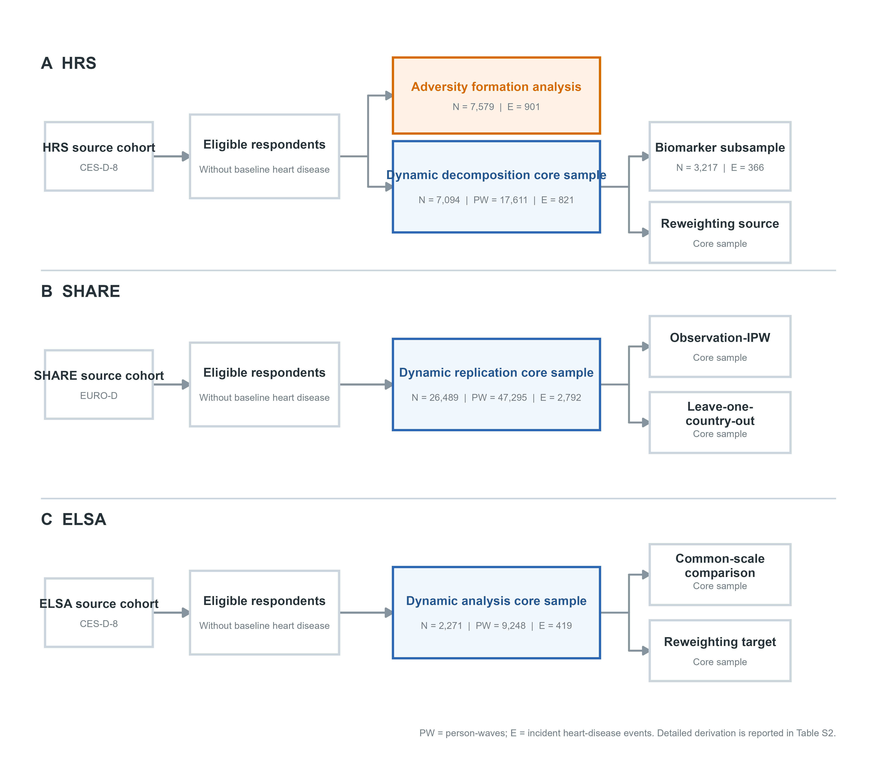
Supplementary Figure S1. Cohort-specific analytic branches and analysis sample roles. The diagram shows the HRS adversity-formation, dynamic-decomposition, biomarker, and reweighting branches; the SHARE independent EURO-D and robustness branches; and the ELSA second CES-D-8 evaluation and reweighting branches. Detailed sample derivation is reported in Table S2. E, incident heart-disease events; PW, person-waves.
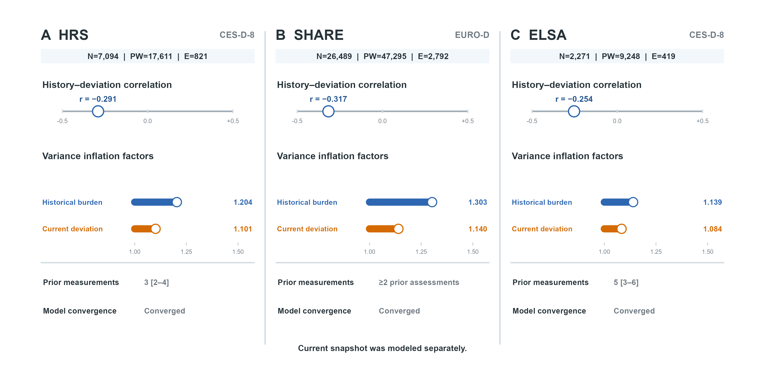
Supplementary Figure S2. Decomposition diagnostics in the three analytic cohorts. Pearson correlations between prior burden and current deviation and variance inflation factors from the joint model are shown on the exact primary person-wave samples. Prior burden used only psychological assessments strictly before the current wave; the current snapshot was modeled separately because it equals prior burden plus current deviation by construction. Correlations were modest and variance inflation factors were low in all cohorts, including ELSA, providing no evidence of problematic multicollinearity. E, incident heart-disease events; PW, person-waves; VIF, variance inflation factor.
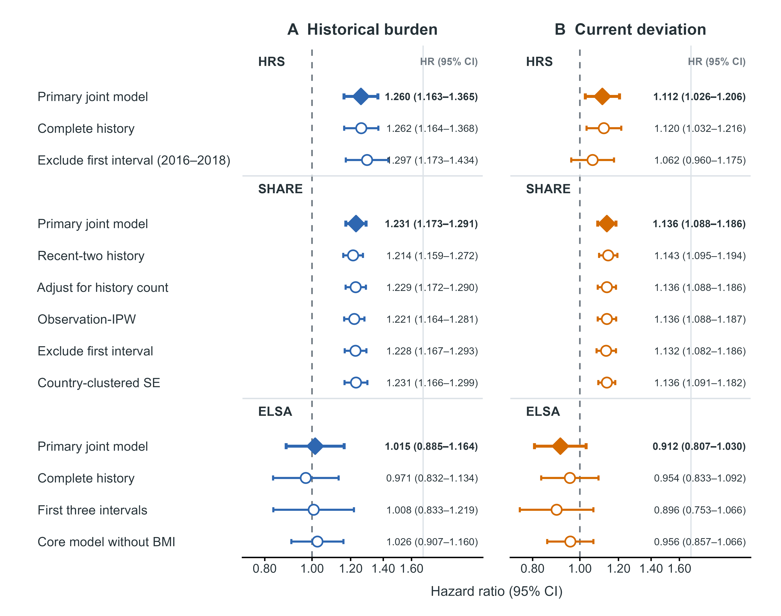
Supplementary Figure S3. Robustness of prior-burden and current-deviation associations with incident heart disease. Filled diamonds denote primary joint-model estimates and open circles denote prespecified sensitivity analyses. HRS and ELSA estimates are per cohort-specific SD; SHARE estimates are per fixed Wave-1 EURO-D SD. The dashed vertical line denotes HR=1. Complete-history, recent-two, history-count, observation-IPW, interval-exclusion, country-clustered, and harmonized-core analyses are shown where applicable. CI, confidence interval; HR, hazard ratio; IPW, inverse-probability weighting; SD, standard deviation.
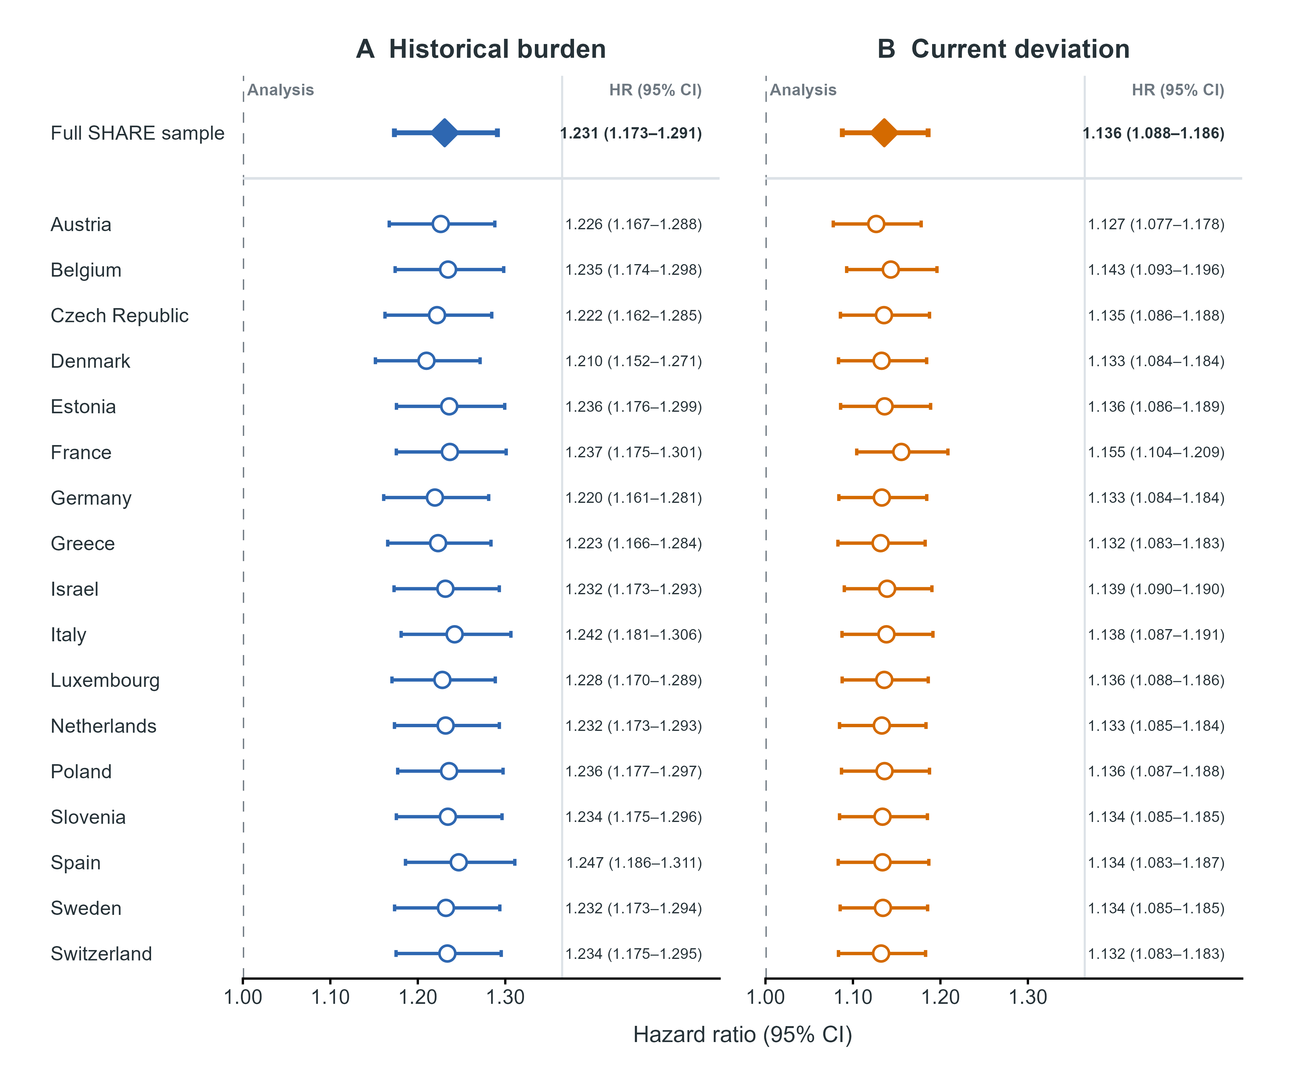
Supplementary Figure S4. SHARE leave-one-country-out analyses. The full SHARE estimate is shown by the filled diamond; open circles show estimates after omitting each country in turn. Prior burden and current deviation were estimated jointly using the primary SHARE specification. All point estimates remained above 1 across the 17 country-omission analyses. CI, confidence interval; HR, hazard ratio.
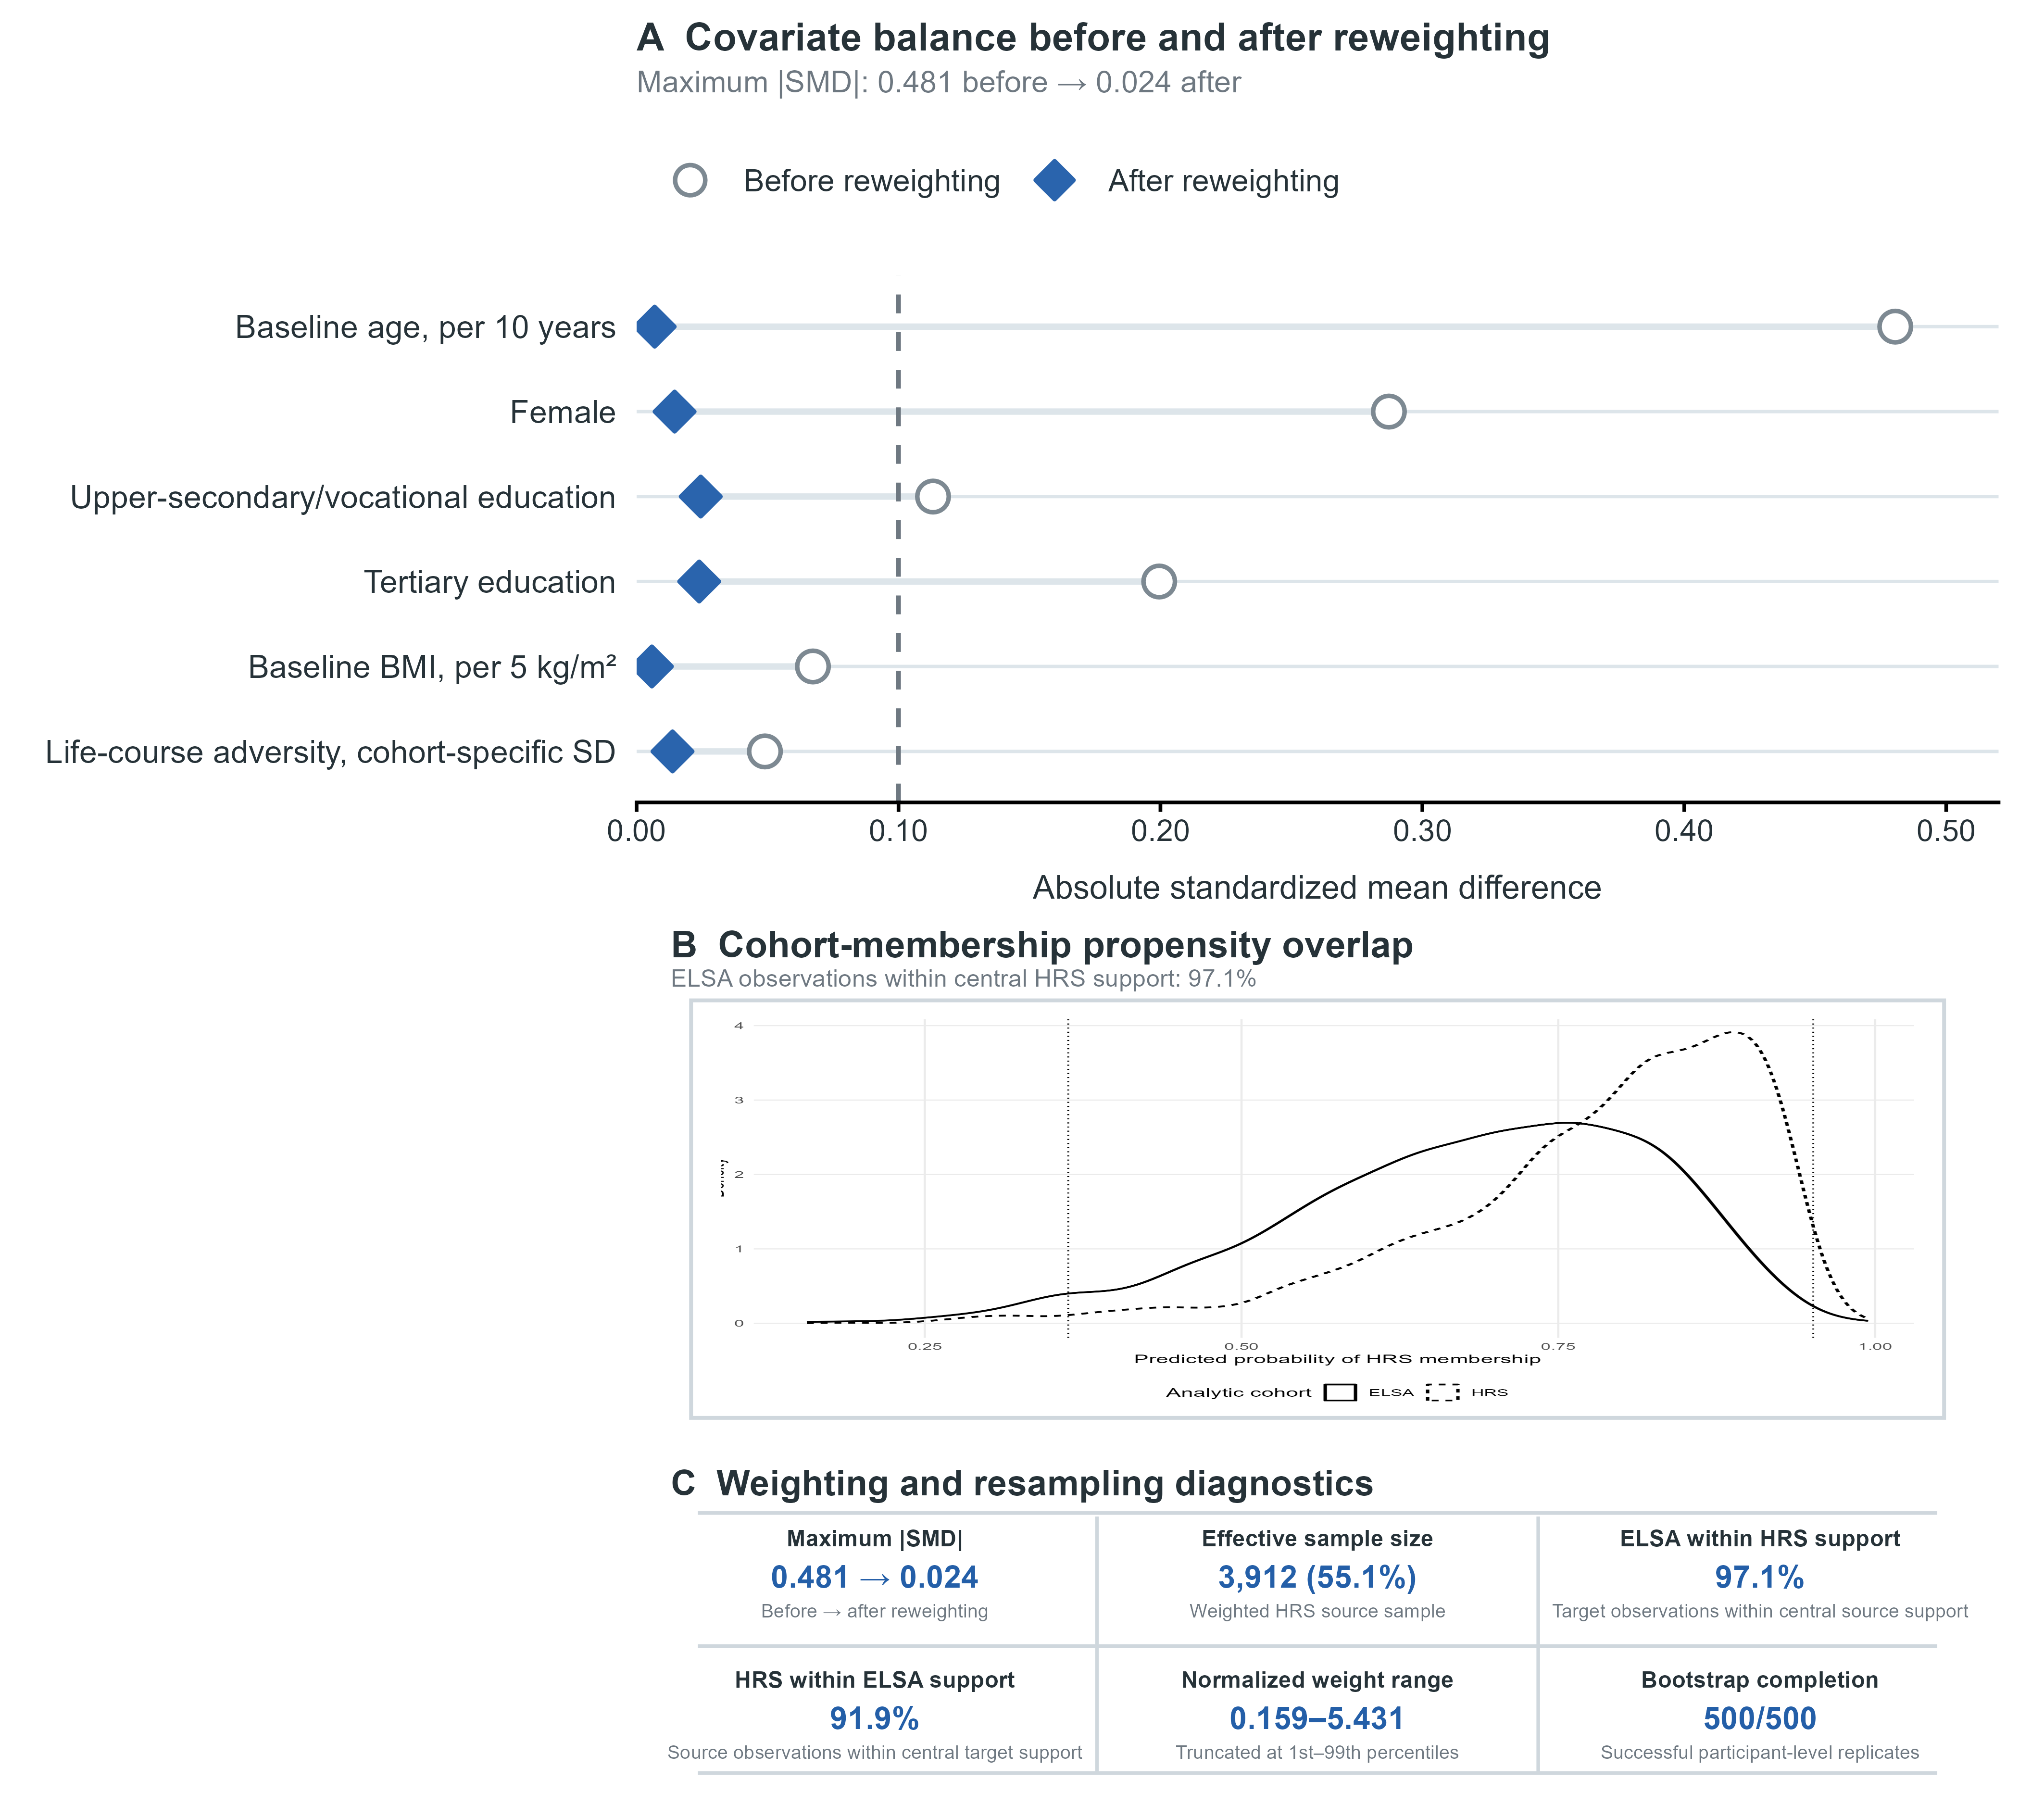
Supplementary Figure S5. HRS-to-ELSA reweighting diagnostics. (A) Absolute standardized mean differences before and after weighting for measured baseline covariates; the dashed line marks 0.10. (B) Overlap of cohort-membership propensity distributions within the common-support region. (C) Weighting and resampling diagnostics, including maximum standardized mean difference, effective sample size, support coverage, reweighted sample size, and successful bootstrap replications. Weights reweighted HRS to the measured baseline composition of ELSA and do not establish causal transportability. ESS, effective sample size; SMD, standardized mean difference.

