Supplementary Materials
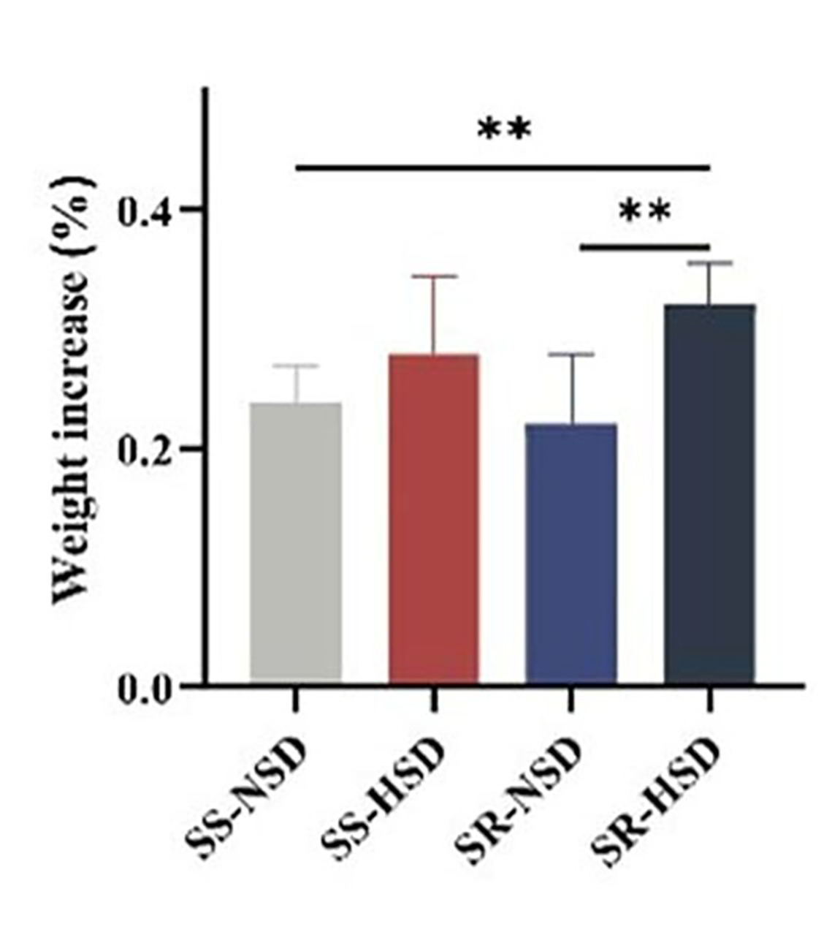
Supplemental Figure S1. The weight gain in SS and SR rats via a 6-week HSD (** p <0.01).

