Supplementary Materials
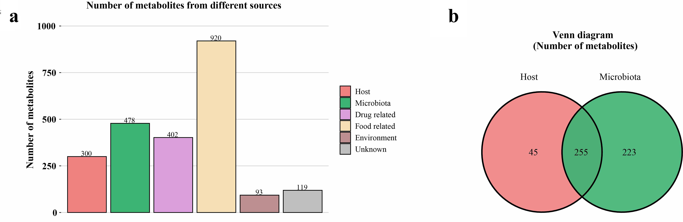

Supplemental Figure S3. The origins of fecal metabolites based on the “MetOrigin” tool. (a) Number of metabolites from different sources; (b) The venn diagram of metabolites from host and microbiota.

