Supplementary Materials
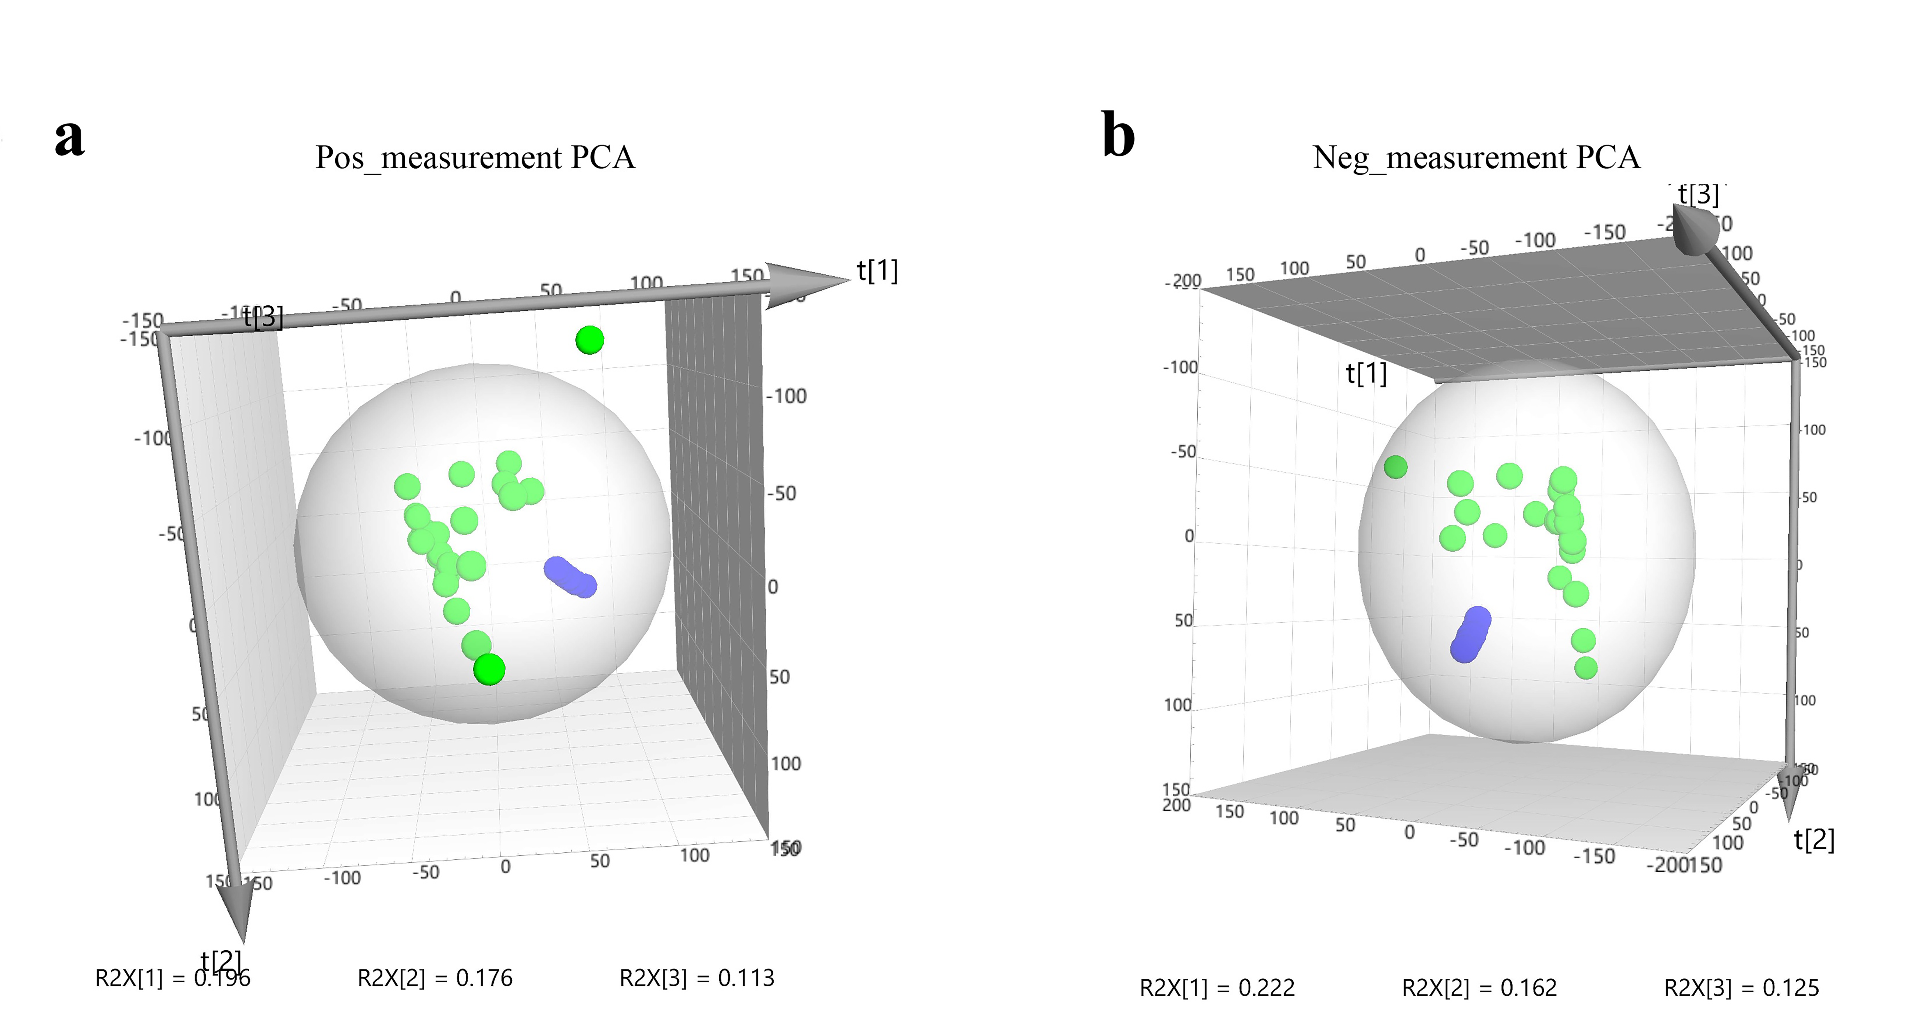
Supplemental Figure S4. PCA model of quality control samples from plasma metabolites. (a) Positive mode; (b) Negative mode.

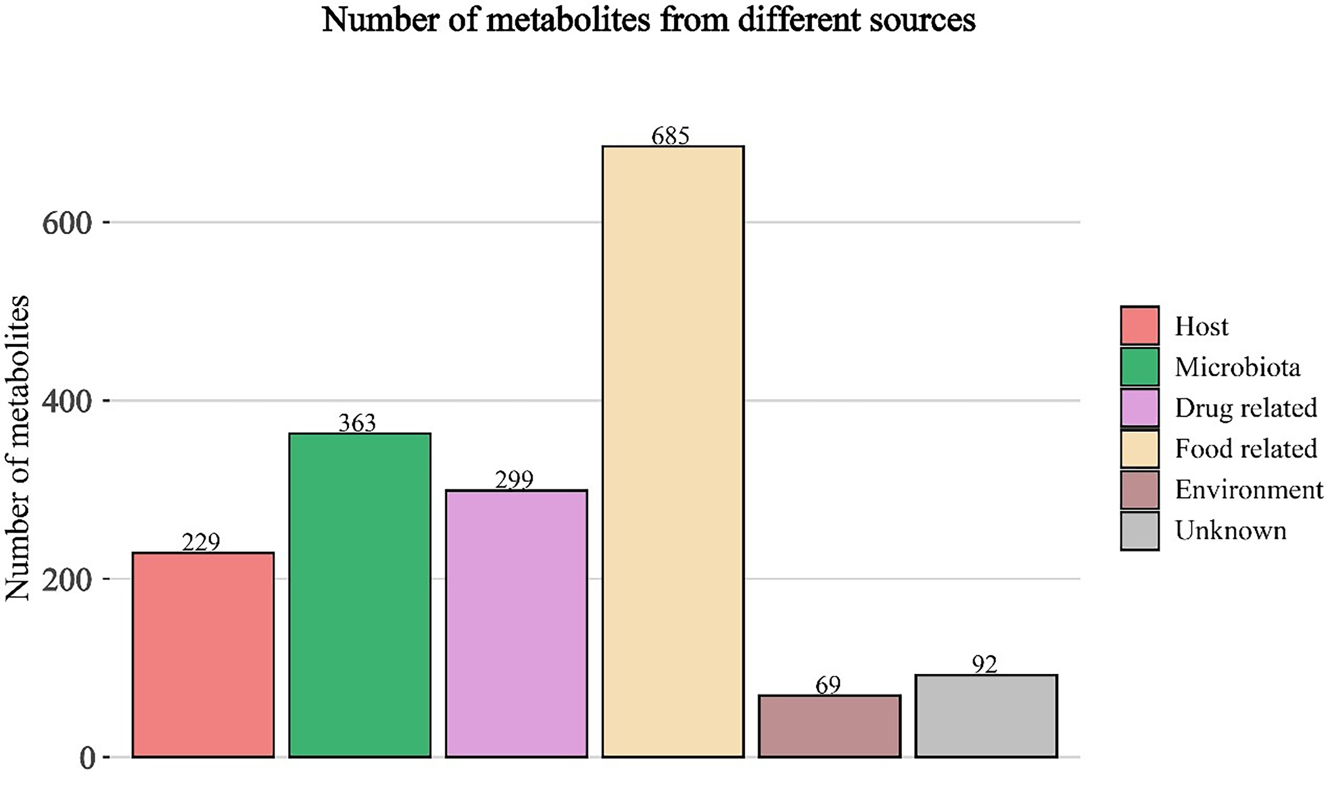
Supplemental Figure S5. The origins of plasma metabolites based on the “MetOrigin” tool.

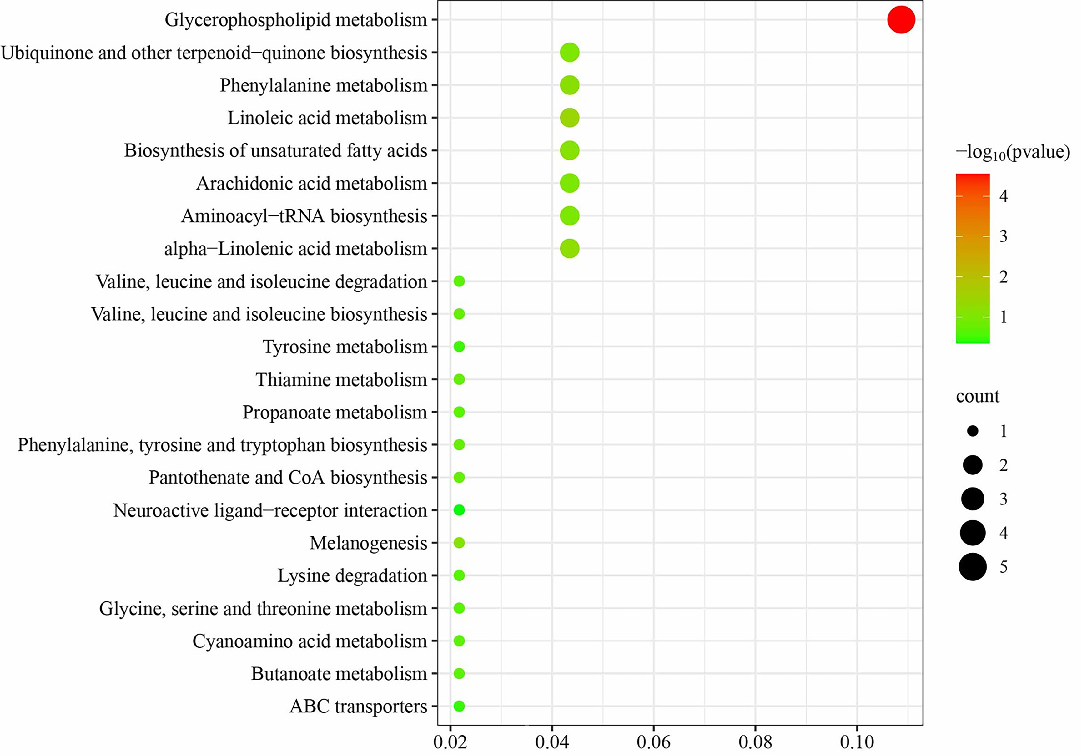
Supplemental Figure S6. The KEGG analysis of the metabolites from the correlation analysis based on the Spearman’s rank correlation analysis.

