Supplementary Materials
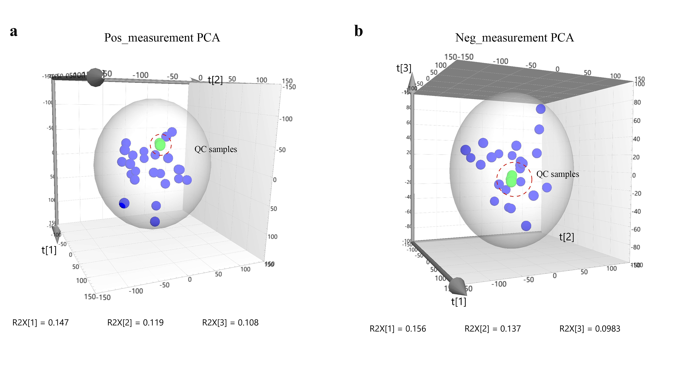
Supplemental Figure S2. PCA model of quality control samples from fecal metabolites. (a) Positive mode; (b) Negative mode.

