Machine learning-enabled discovery of refractory high entropy alloys on curated data
Yonggang Yan^{1*}, Nan Zhou¹, Yalin Liao², Lijuan Cui¹, Dahuan Zhu^{3*} and Xunxiang Hu^{1*}
¹College of Physics, Sichuan University, Chengdu 610065, China
²Department of Electrical and Computer Engineering, University of Delaware, Evans Hall, 139 The Green, Newark, DE 19716, USA
³Institute of Plasma Physics, Hefei Institutes of Physical Science, Chinese Academy of Sciences, Hefei, 230031, China
⁺Corresponding author.
E-mail: huxx@scu.edu.cn, yanyonggang24@scu.edu.cn, dhzhu@ipp.ac.cn

- Dataset construction
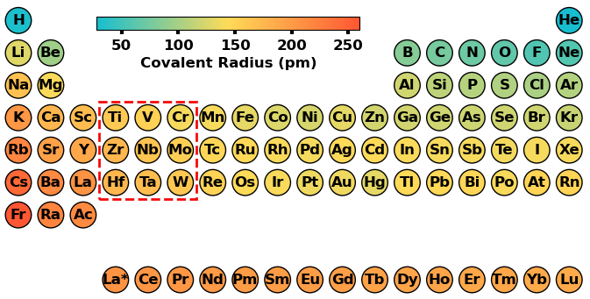
Fig. S1 Elements involved in current work.
To construct a dataset, over 1000 RHEAs were collected from around 500 peer-reviewed papers published by major publishers, including Science, Elsevier, Springer Nature, Wiley, MDPI and others. RHEAs only comprising refractory elements (Ti, V, Cr, Zr, Nb, Mo, Hf, Ta, and W) were collected to construct the dataset, as shown in Fig. S1. These RHEAs were mainly synthesized by vacuum arc melting, spark plasma sintering (SPS), hot isostatic pressing (HIP), additive manufacturing, and magnetron sputtering. Among these techniques, arc melting and SPS are the most widely employed manufacturing methods. Notably, it can be expected that the microstructure of alloys vary to some extent depending on the process routine[1], thus compromising the reliability of phase diagram research. For instance, magnetron sputtered films are far from equilibrium processes. SPS-sintered alloys often contain impurities such as unreacted initial phases, oxides[2], and carbides[3]. Therefore, only alloys fabricated by arc melting, which constitute over 90% of the published RHEAs, were selected for dataset construction. Generally, arc-melted alloys are defined as cast state. XRD pattern of as-cast alloys usually displays broadened peaks and/or their SEM-EDS images exhibit dendrites and interdendrite regions with significantly different compositions, consequently, leading to the unambiguous phase identification. In addition, some published alloys have an undefined thermal history and, as a consequence, an undefined structural state. Due to the aforementioned reasons, phase identification remains challenging. To ensure label quality, only RHEAs subjected to further homogenization and recrystallization treatments were selected for dataset construction. SPSS is expected to exhibit a high degree of chemical homogeneity and a simple crystal structure. It is quite common in literature for RHEAs to be labeled as SPSS, even though they exhibit broadened, unidentified additional peaks in XRD patterns or significant chemical heterogeneity, particularly in as-cast alloys. As Steurer cautions, not all RHEAs described as “single-phase” in the literature may truly be single-phase materials[1]. Consequently, the direct use of phases reported in literature as labels for data-driven phase investigations may compromise the reliability of the models as well as the subsequently extracted knowledge. The phase of RHEAs calls for careful assessment. As such, the phase of the RHEAs in current investigation were carefully re-evaluated by combining their XRD patterns and SEM-EDS elemental mapping. Finally, a total of 675 entries were screened to construct the dataset, including 333 SPSS and 342 multiphases. Among the multiphase alloys, 140 alloys exhibit a multiphase SSs, while the remaining alloys are composed of SS matrix with IMs (SS+IM). IMs were mainly the AB₂-type Laves structure. SSs exhibits predominantly BCC crystal structure, with HCP structured phases occurring frequently. RHEAs were statistically analyzed based on their number of constituent elements, which predominantly range from three to five, as shown in Fig. S3.
The original descriptor pool contains 14 descriptors. Two descriptors (Ec_b and ${\text{T}}_{\text{m}}_\text{b}$) are initially present in the dataset, while they exhibited strong correlations with IP1_b, as shown in Fig. S2. As a result, they were excluded to improve the model’s predictive performance. Finally, a dataset containing 12 descriptors was constructed for model training, as listed in Table S1.
Fig. S2 Heatmap plotted using Pearson correlation coefficient for the descriptors.
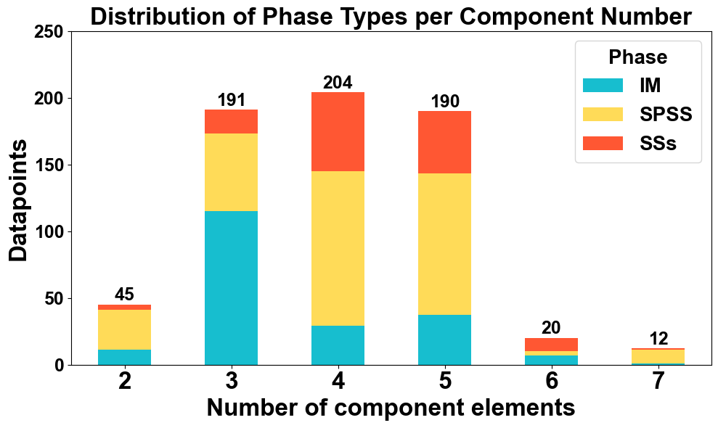
Fig. S3 Distribution of RHEAs by number of principal elements.
Table S1. Details of the descriptors of the curated dataset.
Type | Abbreviation | Description
Thermodynamic  parameters | $${\text{∆}\text{S}}_{\text{m}\text{ix}}$$ | Mixing entropy
Thermodynamic  parameters | $${\text{∆}\text{H}}_{\text{m}\text{ix}}$$ | Mixing enthalpy calculated by Miedema’s model
Thermodynamic  parameters | $$\text{IP1_b}$$ | Mean first ionization energy difference between the two groups of constituent elements
Electronic parameters | $$\text{VEC}\text{_dv}$$ | Standard deviation of valence electron concentration of the constituent elements
Electronic parameters | $$\text{EN_b}$$ | Mean electronegativity difference between the two groups of constituent elements
Electronic parameters | $$\text{MSO_dv}$$ | Standard deviation of the most stable oxidation state of the constituent elements
Electronic parameters | $$\text{e/}\text{a_dv}$$ | Standard deviation of electron concentration of the constituent elements
Electronic parameters | $$\text{EA_dv}$$ | Standard deviation of electron affinity of the constituent elements
Atomic parameter | $${\text{R}}_{\text{c}}\text{_dv}$$ | Standard deviation of the covalent radius of the constituent elements
Annealing condition | $${\text{T}}_{\text{ann}}$$ | Annealing temperature
Annealing condition | t | Annealing time
Others | S | Averaged maximum solid solubility limits of binary systems of elements
Notes: S value of each element was calculated as the average of its maximum solubilities in the other eight constituent elements. Although this simplified averaging scheme effectively captures the overall solubility tendency, it cannot fully describe the complex interactions governing SPSS formation, suggesting that more rigorous solubility descriptors may further improve predictive performance.
  - ML model of SSs and IM training
To investigate the factors governing SPSS phase stability, separate IM and SSs classification models were developed using the GB algorithm. Their corresponding hyperparameters are summarized in Table S2. The model achieved an average cross-validation F1 score of 0.907 ± 0.032, demonstrating excellent predictive performance and robustness. Compared to the SPSS model, IM model exhibits superior performance. The SSs model was trained using the same method, SSs model obtained an averaged F1_CV score of 0.750 ± 0.059 for its CV models. To minimize the influence of IM phases on the classification of SS, all IM phases were excluded for the SSs dataset construction. As a result, the SSs dataset suffered from a severe imbalance problem, thus degrading the model performance. Despite its relatively low predictive performance, the SSs model remains capable of providing meaningful physical insights into the formation of multiphase solid solutions.
Table S2 Hypermeters of the different ML models.
Model | F1_CV | Hyperparameter
SPSS model | 0.894±0.024 | "n_estimators": 800, "learning_rate": 0.008, "max_depth": 7, "subsample": 0.7, "max_features": "sqrt"
IM model | 0.907 ± 0.032 | "n_estimators": 100, "learning_rate": 0.008, "max_depth": 5, "subsample": 0.9, "max_features": "sqrt"
SSs model | 0.750 ± 0.059 | "n_estimators": 500, "learning_rate": 0.009, "max_depth": 12, "subsample": 0.6, "max_features": "log2"

Fig. S4 Performance evaluation of IM and SSs model. (a) Averaged F1 and accuracy scores of IM models (40 repetitions of 5-fold cross-validation); (b) Averaged F1 and accuracy scores of SSs models (40 repetitions of 5-fold cross-validation).
Although the ML model performs well, its development is still constrained by the quality of labels, the effectiveness of descriptors, and the size of the dataset. First, misclassified labels remain inevitable, as few cases may contain nanoscale or submicron IM/SSs phases that are difficult to detect using XRD and SEM-EDS[4]. Second, the descriptors still omit other important information that are strongly related to phase formation. For instance, heat treatment is described only by annealing temperature and time, omitting critical thermal parameters such as heating and cooling rates, which significantly influence microstructure[5]. Third, the dataset includes 675 RHEAs, with an uneven distribution in the elemental compositional space. Future improvements in ML model’s performance can be achieved through the aforementioned aspects.
  - Phase stability mechanisms
Fig. S5 shows the model explanation by permutation descriptor importance and SHAP method. For IM model, the descriptor importance follows the order: $\text{MSO_dv}$, ${\text{R}}_{\text{c}}\text{_dv}$, ${\text{∆}\text{H}}_{\text{mix}}$, S, $\text{VEC}\text{_dv}$, $\text{e/}\text{a_dv}$, $\text{E}\text{A}\text{_}\text{dv}$, $∆{\text{S}}_{\text{mix}}$, $\text{IP1}\text{_b}$, $\text{E}\text{N}\text{_b}$, time and ${\text{T}}_{\text{ann}}$. Among all descriptors, MSO_dv and Rc_dv exhibit the highest relative importance, indicating that electronic number and geometric atomic size play a dominant role in controlling IM formation. ${\text{∆}\text{H}}_{\text{mix}}$ also contribute significantly, highlighting the relevance of thermodynamic stability in phase formation. In contrast, annealing condition-based descriptors (${\text{T}}_{\text{ann}}$ and time), show minimal importance, suggesting a relatively stable of the IM phase. Actually, ${\text{R}}_{\text{c}}\text{_dv}$ has been considered as a key factor in determining IM formation in binary alloys, based on the geometric principle of closest packing in previous studies[6, 7]. However, the electronic characteristics of constituent elements outweigh geometric factors in RHEAs, although both contribute synergistically to IM formation (Fig. S8). For SSs model, the descriptor importance follows the order: $\text{IP1}\text{_}\text{b}$, ${\text{R}}_{\text{c}}\text{_dv}$, ${\text{T}}_{\text{ann}}$, $\text{E}\text{N}\text{_b}$, $\text{MSO_dv}$, ${\text{∆}\text{S}}_{\text{mix}}$, ${\text{∆}\text{H}}_{\text{mix}}$, $\text{E}\text{A}\text{_}\text{dv}$, $\text{VEC}\text{_dv}$, time, S and $\text{e/}\text{a_dv}$. Among all descriptors, IP1_b exhibits the highest importance in the SS prediction. This is followed by ${\text{T}}_{\text{ann}}$ and EN_b suggesting that both thermal history and bonding characteristics significantly influence phase behavior. In contrast, MSO_dv and $∆{\text{H}}_{\text{mix}}$, which served as key factor for IM formation, show less importance in SSs prediction. The distinct physical processes underlying the formation of SSs and IM phases are likely attributed to the differences in their dominant bonding characteristics.
Fig. S5 Model explanation by SHAP analysis. (a-b) Ranking of descriptor importance IM prediction; (c-d) Ranking of descriptor importance SSs prediction.
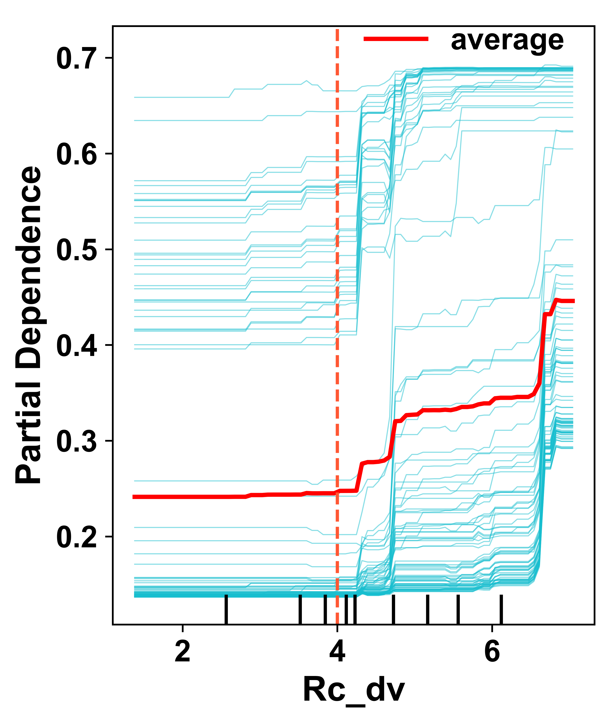
Fig. S6 Effect of Rc_dv on the prediction probabilities of SS+IM
${\text{R}}_{\text{c}}\text{_dv}$, representing atomic size mismatch, is widely used to predict SPSS formation. However, it shows limited relevance in the current SPSS model. This discrepancy is notable in many Ti-based RHEAs, where Ti’s atomic size closely matches W[8], Mo[9], Nb[10] and Ta[11], yet these systems often form multiphase SSs. Like MSO_dv, its effect on SPSS can be better understood through its influence on ordered IM formation. This is supported by IM model, where ${\text{R}}_{\text{c}}\text{_dv}$ ranks as the second important descriptor (Fig. S5a-b). ${\text{R}}_{\text{c}}\text{_dv}$ shows a strong correlation with IM prediction (Fig. S5a and Fig. S6). Furthermore, it exhibits an inverse relationship with the formation of IM (Fig. S5b). Actually, ${\text{R}}_{\text{c}}\text{_dv}$ has been considered as a key factor in determining IM formation in binary alloys, based on the geometric principle of closest packing in previous studies[6, 7]. However, the electronic characteristics of constituent elements outweigh geometric factors in RHEAs, although both contribute synergistically to IM formation.
Though designed to capture thermodynamic mixing tendencies, DFT calculations show only weak correlation between ${\text{∆}\text{H}}_{\text{mix}}$ and ${\text{∆}\text{H}}_{\text{mix}}^{\text{DFT}}$ (Fig. S7), suggesting its limitation in being directly explained by Gibbs free energy. Nevertheless, ${\text{∆}\text{H}}_{\text{mix}}$ still provides useful thermodynamic insights into RHEAs.
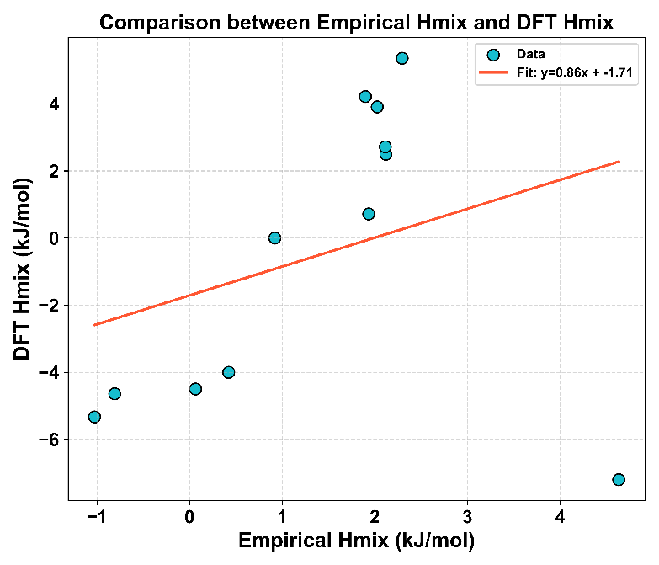
Fig. S7 Comparison between empirically derived ${\text{∆}\text{H}}_{\text{mix}}$ from the Miedema model and ${\text{∆H}}_{\text{mix}}^{\text{DFT}}$. Each point represents a different alloy system. A linear regression fit (blue line) yields the relationship: ${\text{∆H}}_{\text{mix}}^{\text{DFT}}\text{=0.86}{\text{∆}\text{H}}_{\text{mix}}\text{-}\text{1.7}\text{1}$.
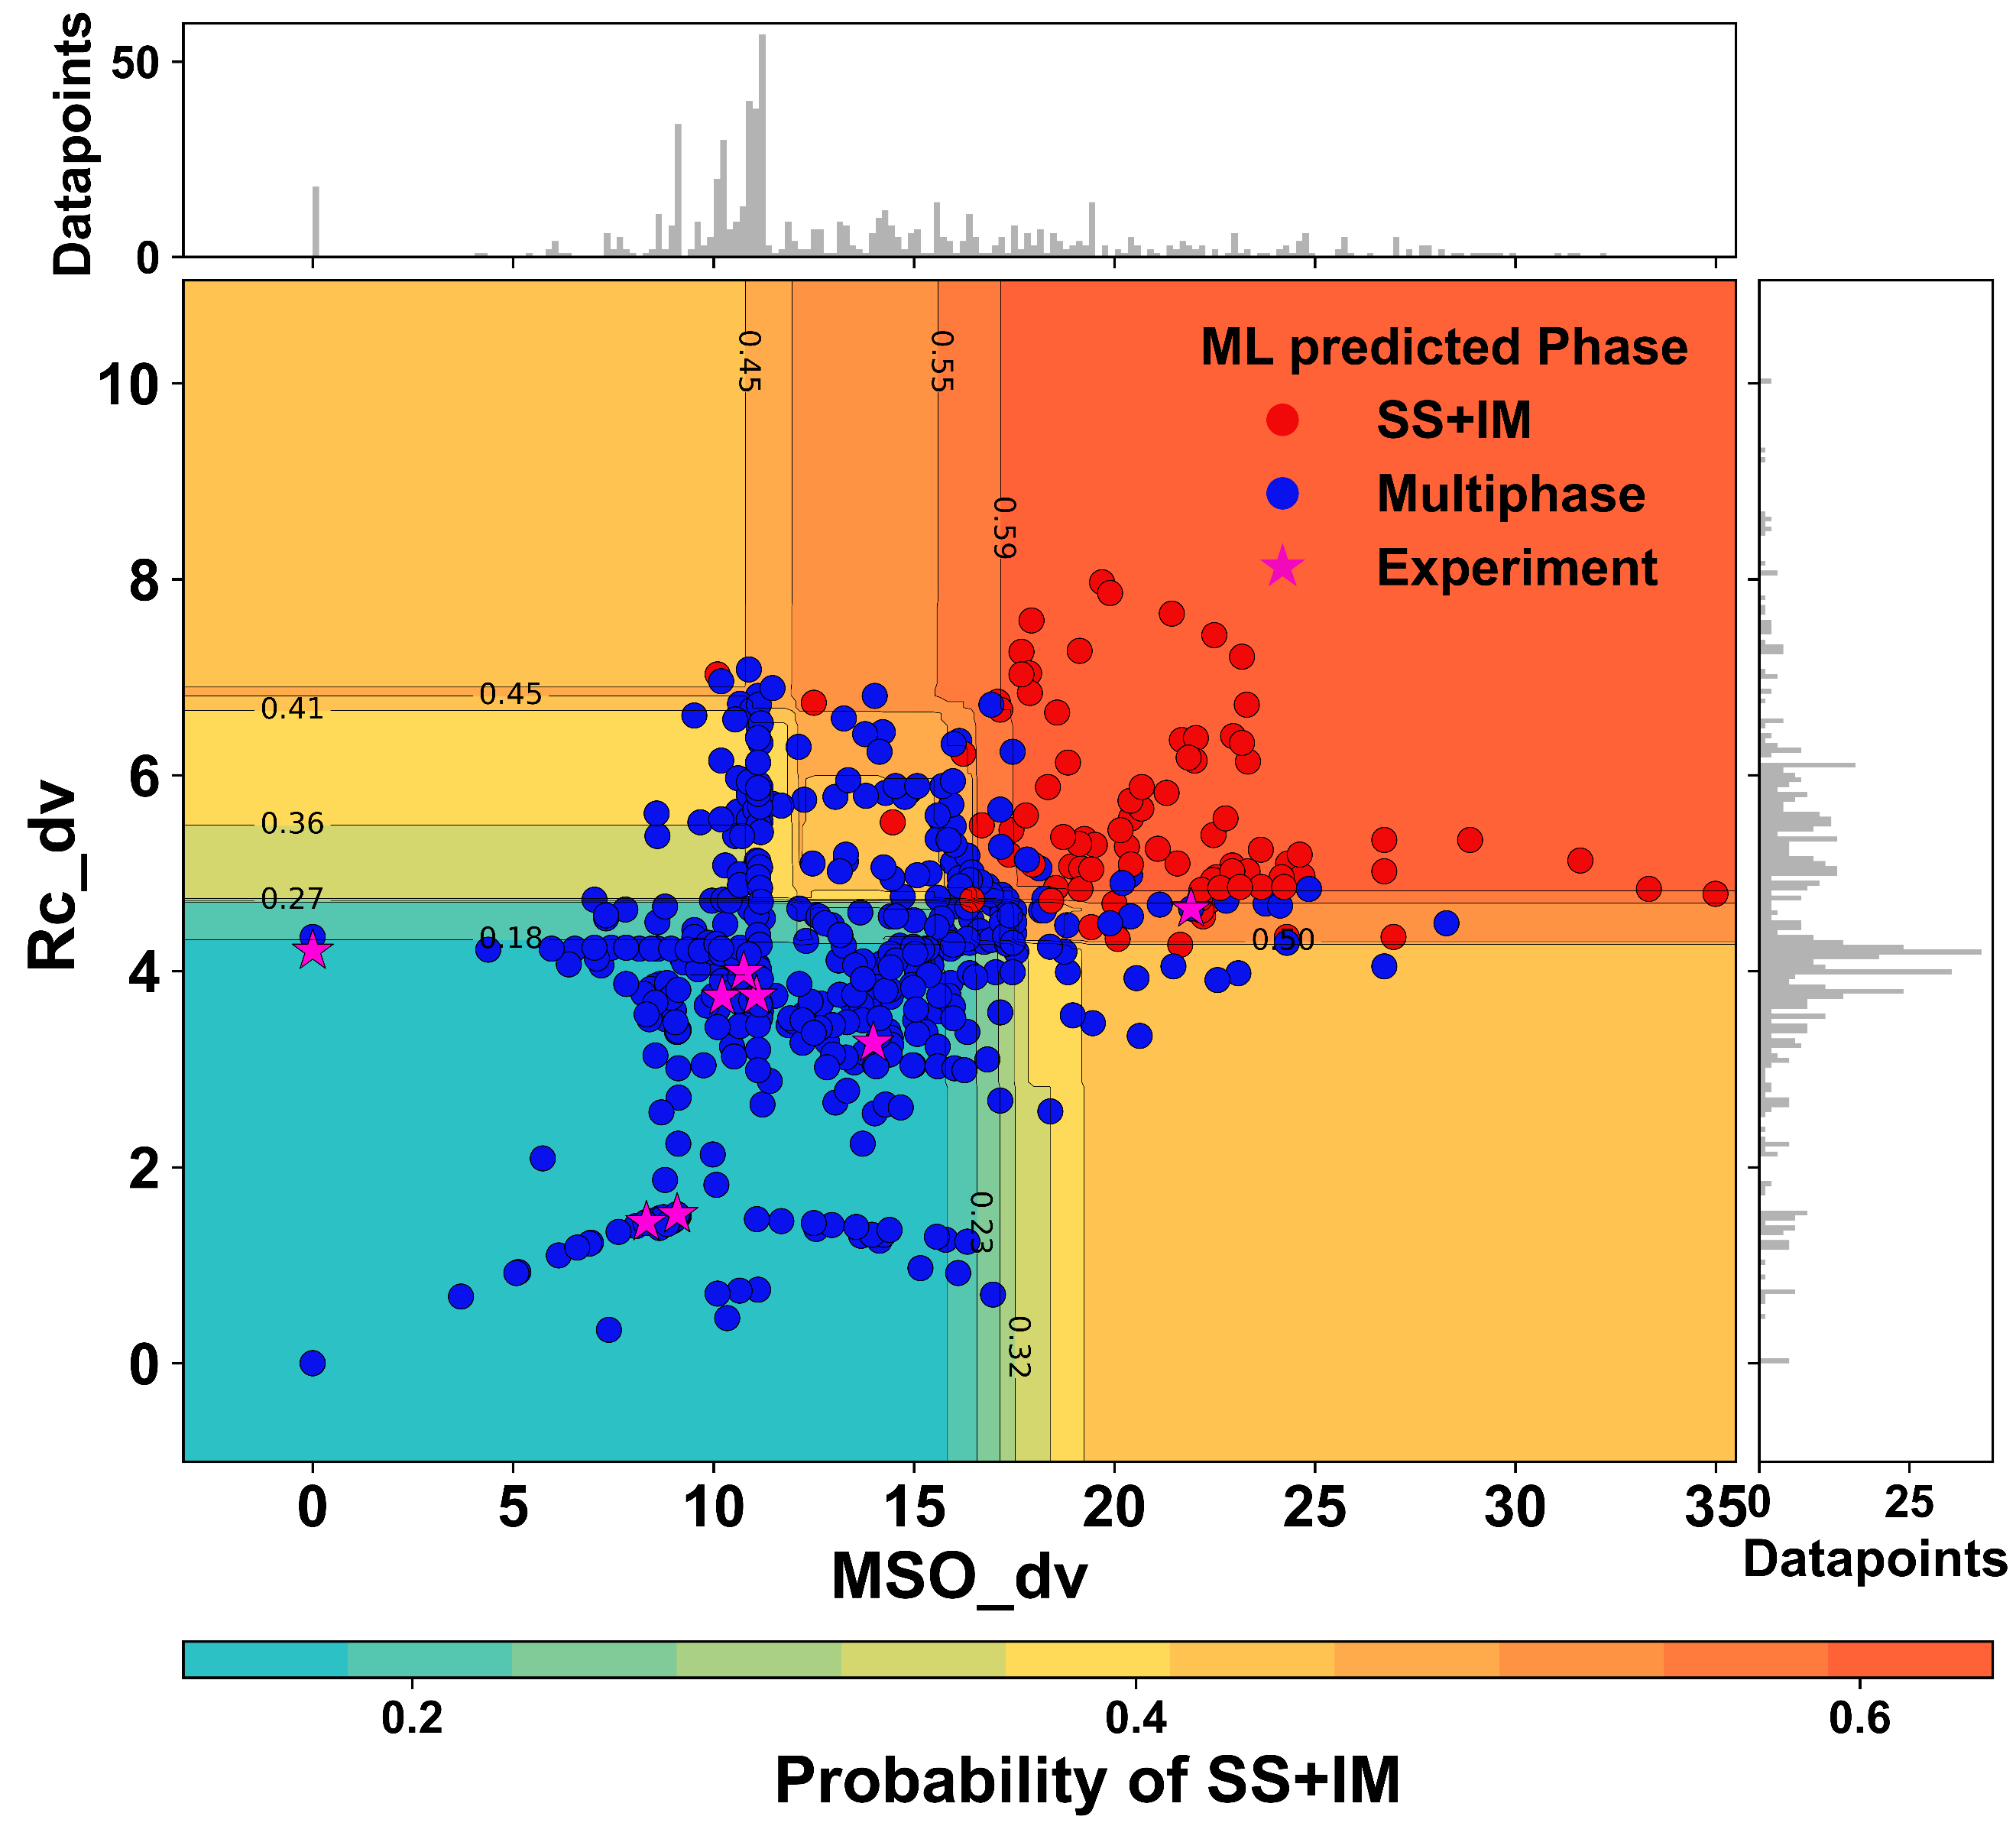
Fig. S8 Two-way PDPs showing the joint influence of MSO_dv and ${\text{R}}_{\text{c}}\text{_dv}$ on phase prediction outcomes. Solid circles represent as-cast RHEAs, while red stars indicate the alloys developed in current study.
Table S3 MSO and VEC of refractory metals.
Refractory elements | MSO | e/a | VEC
Ti | 4 | 2 | 4
V | 5 | 2 | 5
Cr | 3 | 1 | 6
Zr | 4 | 2 | 4
Nb | 5 | 1 | 5
Mo | 6 | 1 | 6
Hf | 4 | 2 | 4
Ta | 5 | 2 | 5
W | 6 | 2 | 6
Of the RHEAs considered in our DFT calculations, three have been experimentally investigated and their phases confirmed in prior studies. The equal molar TaNbV was manufactured by arc melting, followed by vacuum annealing at 1150 °C for 24 h. XRD analysis confirmed the formation of SS phase without IM formation [12, 13]. Similarly, TaNbVW was synthesized by vacuum arc melting of equimolar pure metals, and combined XRD and SEM-EDS analyses revealed the formation of multiphase SSs[14]. TaNbMoV[15] was also fabricated by vacuum arc melting, with XRD and SEM-EDS characterization indicating the formation of SS phases. Since TaNbVCr has not been reported previously, it was synthesized by vacuum arc melting in this work. To ensure the chemical homogeneity, the button ingots were remelted six times, flipped after each melting. A final annealing at a temperature of 1400 °C for 4 h. The combination of XRD pattern and SEM-EDS exhibits the formation of IMs (Fig. S9). The corresponding phases are summarized in Table S4.
Table S4 Bader charge analysis of RHEAs.
RHEAs | Phase | $${∆H}_{\text{mix}}$$  (kJ/mol) | Cr/Mo/W | Ta | Nb | V
CrTaNbV | SS+IM | 1.77 | 0.10-0.33 | -0.09~0.26 | -0.12-0.10 | -0.39~-0.17
WTaNbV | SS | 0.16 | 0.47~0.91 | -0.43~0.19 | -0.41~0 | -0.57~-0.27
MoTaNbV | SS | -0.5 | 0.24~0.71 | -0.33~0.19 | -0.25~0.04 | -0.49~-0.18
TaNbV | SS | 1.14 | - | 0.03~0.27 | -0.06~0.14 | -0.33~-0.12
Fig. S9 SEM-EDS and XRD pattern of TaNbVCr.
1.4 Experimental validation
We randomly selected 10 refractory MPEAs for experimental validation. The alloys, i.e. WTa based systems and HfTi-based systems, were fabricated by vacuum arc melting, followed by an annealing to eliminate the dendrite structures. The alloys contain all the elements involved in current work.
Table S5 The predicted and experimental phase of the new RHEAs.
Compositions | $$\text{MSO_dv}$$ | $${∆H}_{\text{mix}}$$ | Prediction | Experimental | Validity
Hf_{0.33}Zr_{0.33}Ti_{0.34} | 0 | 0 | SPSS | None-SPSS | ×
W₁Mo₁Ta₁V_{0.25}Cr_{0.25} | 13.98 | -5.95 | None-SPSS | None-SPSS | √
Nb_{0.26}Ta_{0.24}Ti_{0.21}V_{0.24}W_{0.05} | 10.00 | -1.29 | SPSS | SPSS | √
Hf₁Ti₁Nb₁Ta_{0.2} | 11.70 | 4.22 | SPSS | SPSS | √
Hf₁Ti₁Nb₁Zr_{0.2} | 10.75 | 3.91 | SPSS | SPSS | √
W_{0.33}Mo_{0.33}Ta_{0.33} | 8.32 | -5.33 | SPSS | SPSS | √
W_{0.5}Ta_{0.5}Mo₁Nb₁ | 9.09 | -6.33 | SPSS | SPSS | √
W_{0.75}Ta_{0.75}Mo₁Nb₁ | 9.09 | -6.42 | SPSS | SPSS | √
W_{0.25}Ta_{0.25}Mo₁Nb₁ | 9.09 | -6.20 | SPSS | SPSS | √
W₁Mo₁Ta₁V₁Cr₁ | 21.91 | -3.52 | None-SPSS | None-SPSS | √
Fig. S10 SEM micrographs and the corresponding EDS of RHEAs. (a) Nb_{0.26}Ta_{0.24}Ti_{0.21}V_{0.24}W_{0.05}, (b) W₁Mo₁Ta₁V_{0.25}Cr_{0.25}, as-cast Hf_{0.33}Zr_{0.33}Ti_{0.34}, (d) annealed Hf_{0.33}Zr_{0.33}Ti_{0.34}, (e) W_{0.33}Mo_{0.33}Ta_{0.33}, (f) Hf₁Ti₁Nb₁Ta_{0.2}, (f), Hf₁Ti₁Nb₁Zr_{0.2}, (h) W_{0.5}Ta_{0.5}Mo₁Nb₁, (i) W_{0.75}Ta_{0.75}Mo₁Nb₁, (j) W_{0.25}Ta_{0.25}Mo₁Nb₁, (k) W₁Mo₁Ta₁V₁Cr₁.

References:
[1] W. Steurer, Mater. Charact. 162 (2020) 110179.
[2] M. Guo, L. Xu, L. Qi, Y. Zhao, Z. Li, S. Wei, J. Alloys Compd. 1002 (2024) 175310.
[3] O.A. Waseem, H.J. Ryu, Sci. Rep. 7(1) (2017) 1926.
[4] S. Wei, S.J. Kim, J. Kang, Y. Zhang, Y. Zhang, T. Furuhara, E.S. Park, C.C. Tasan, Nat. Mater. 19(11) (2020) 1175-1181.
[5] H. Huang, Y. Sun, P. Cao, Y. Wu, X. Liu, S. Jiang, H. Wang, Z. Lu, Scr. Mater. 211 (2022) 114506.
[6] W.Y. Kim, T. Takasugi, Scr. Mater. 48(5) (2003) 559-563.
[7] R. Darvishi Kamachali, L. Wang, Scr. Mater. 206 (2022) 114226.
[8] H.X. Xue, X.C. Cai, B.R. Sun, X. Shen, C.C. Du, X.J. Wang, T.T. Yang, S.W. Xin, T.D. Shen, J. Mater. Sci. Technol 114 (2022) 16-28.
[9] W.-d. Zhang, Y. Liu, H. Wu, M. Song, T.-y. Zhang, X.-d. Lan, T.-h. Yao, Mater. Charact. 106 (2015) 302-307.
[10] D. Kalita, Ł. Rogal, T. Czeppe, A. Wójcik, A. Kolano-Burian, P. Zackiewicz, B. Kania, J. Dutkiewicz, J. Mater. Eng. Perform. 29(3) (2020) 1445-1452.
[11] Y.L. Zhou, M. Niinomi, T. Akahori, Mater. Sci. Eng.A 371(1) (2004) 283-290.
[12] I.A. Ivanov, A. Ryskulov, A. Kurakhmedov, A. Kozlovskiy, D. Shlimas, M.V. Zdorovets, V.V. Uglov, S.V. Zlotski, J. Ke, J. Mater. Sci.: Mater. Electron. 32(23) (2021) 27260-27267.
[13] L. Yang, K. Xiong, H. Dai, H. Wu, S. Zhang, Y. Wang, J. He, Y. Mao, Mater. Sci. Eng.A 889 (2024) 145841.
[14] H.W. Yao, J.W. Qiao, M.C. Gao, J.A. Hawk, S.G. Ma, H.F. Zhou, Y. Zhang, Mater. Sci. Eng.A 674 (2016) 203-211.
[15] W. Zheng, S. Lü, S. Wu, X. Chen, W. Guo, Mater. Sci. Eng.A 850 (2022) 143554.

