Construction and Properties of Ag-I Polymeric clusters attach with Nitrogen Heterocyclic Transition Metal moiety
Min Liuª, Yu Xinª, Yong Heng Xingª*, Feng Ying Baiª*, Zhan Shi^{b}
ªCollege of Chemistry and Chemical Engineering, Liaoning Normal University, Huanghe Road 850#, Dalian 116029, P. R. China
^{b}State Key Laboratory of Inorganic Synthesis and Preparative Chemistry, College of Chemistry, Jilin University, Changchun 130012, P.R. China
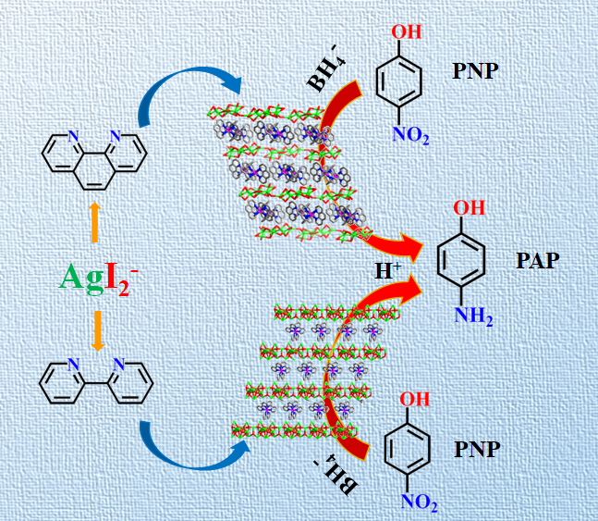
Two silver cluster compounds {[Co(1,10′-phen)₃]₂‧[Ag₈I₁₂]} (1) and {[Co(2, 2′-bipy)₃]‧[Ag₁₀I₁₁]‧(OH)‧3DMF‧2H₂O} (2) (1,10′-phen=1,10′-phenanthroline, 2, 2′-bipy=2,2′-bipyridine) were designed and synthesized by solvent evaporation method. Compounds 1 and 2 through the electrostatic interaction between the metallic Ag cluster moiety and the metallic Co cluster moiety, formed stable interlaced layered super molecular structures. Compounds 1 and 2 can efficiently catalyze the reduction of p-nitrophenol in the aqueous solution, and the reduction and removal rate can reach more than 90%. The results shows that the catalytic reduction of PNP solution by 1 and 2 conforms to the quasi-first order kinetic model.

