Supporting information
Construction and Properties of Ag-I Polymeric clusters attach with Nitrogen Heterocyclic Transition Metal moiety
Min Liuª, Yu Xinª, Yong Heng Xingª*, Feng Ying Baiª*, Zhan Shi^{b}
ªCollege of Chemistry and Chemical Engineering, Liaoning Normal University, Huanghe Road 850#, Dalian 116029, P. R. China
^{b}State Key Laboratory of Inorganic Synthesis and Preparative Chemistry, College of Chemistry, Jilin University, Changchun 130012, P.R. China

Supplementary Index
Materials and methods 2
X-ray crystallographic determination 2
Preparations of 1 and 2 3
Standard curves of PNP solution 7
IR spectra 8
UV-vis spectra 9
PXRD pattern 10
TG curves 11

Materials and methods
All starting materials were of reagent grade quality and were obtained from commercial sources without further purification. The powder X-ray diffraction patterns (PXRD) of 1 and 2 were obtained on Advance-D8 equipped with Cu-Kα radiation, and the range was 5° <2θ <60°, with a step size of 0.02° (2θ) and a count time of 2 s per step at room temperature. All IR measurements were obtained using a Bruker AXS TENSOR-27 FT-IR spectrometer with pressed KBr pellets in the range of 400–4000 cm⁻¹ at room temperature. UV-vis-NIR spectra were recorded on a JASCO V-570 UV/vis/NIR microspectrophotometer (200-2500 nm). Liquid UV-visible absorption spectroscopy was performed on SPECORD 250/PLUS. The maximum absorption wavelength of the PNP solution was measured on spectrophotometer UV-1000. Thermogravimetric analysis (TG) was performed on a PerkinElmer Diamond TG/DTA under N₂ atmosphere from 30 °C to 800 °C with a heating rate of 10 °C/min.

X-ray crystallographic determination
Single crystals of 1 and 2 were mounted on glass fibers for X-ray measurement. Reflection data was collected at room temperature on a Bruker AXS SMART APEX II CCD diffractometer with graphite monochromatized Mo-Kα radiation (λ = 0.71073 Å). All the measured independent reflections (I > 2σ (I)) were used in the structural analyses, and semi-empirical absorption corrections were applied using the SADABS program^{[1]}. All calculations were performed in OLEX2 platform^{[2,3]}. The crystal was kept at 296 K during data collection. SQUEEZE the diffraction peaks of the disordered guest molecules of 1 and 2 using PLATON software. The results show that there are 138 electrons in each structural unit of 2. According to the calculation result of SQUEEZE, three DMF molecules and two H₂O molecules was directly added to the final molecular formula of the compound 2, and it was verified by elemental analysis and thermogravimetric analysis. The crystal was measured using a single axis diffractometer, we made various attempt to grow crystals of better quality without success. The crystal showed poor diffraction data with reflections of moderate intensity as showed the R_{int}. So, the compound 2 has an A level alert that is diffrn measured fraction theta full value low 0.761. The crystallographic data for compounds 1 and 2 were listed in Table S1. The major bond lengths of the compounds were listed in Table S2.1 and Table S2.2.

Preparations of 1 and 2
Preparation of AgI₂⁻ solution: Weigh AgNO₃ (0.339 g, 0.002 mol) and KI (0.664 g, 0.004 mol) in 50mL beaker, respectively put 10 mL DMF to dissolve them completely, and add the AgNO₃ solution dropwise to the KI solution, and the resulting precipitate just completely dissolved.
The synthesis methods of 1 and 2 are similar, and 1 was mainly introduced. Dissolve Co(NO₃)₂·6H₂O (0.0146 g, 0.05 mmol) in 2 mL DMF solution, add 5 mL AgI₂⁻ solution to it, stir for 10 min, and then add 1,10′-phenanthroline ( 0.0198 g, 0.1 mmol) of 2 mL DMF solution, adjusted to pH=6 with HI and DMF solution, stirred for about 30 min, an orange transparent solution was obtained, which was volatilized at room temperature for ten days to obtain orange massive crystals.
{[Co(1,10′-phen)₃]₂‧[Ag₈I₁₂]} (1) Yield: 0.1218g; 68% (calculated based on Co (II)). Elemental analysis C₇₂H₄₈N₁₂I₁₂Ag₈Co measured value (%): C, 24.36; H, 1.31; N, 4, 70; theoretical value (%): C, 24.12; H, 1.35; N, 4.69. Infrared spectrum (KBr, cm⁻¹): 3446, 3137, 1673, 1520, 1421, 1149, 1095, 726.
{[Co(2,2′-bipy)₃]‧[Ag₁₀I₁₁]‧(OH)‧3DMF‧2H₂O} (2) Yield: 0.089g; 59% (calculated based on Co (II)). Elemental analysis C₃₀H₂₅N₆OI₁₁Ag₁₀Co measured value (%): C, 14.35; H, 1.08; N, 3.81; theoretical value (%): C, 14.31; H, 1.11; N, 3.85. Infrared spectrum (KBr, cm-1): 3426, 3129, 1663, 1601, 1412, 1167, 1089, 760.

Table S1 Crystallographic data for 1 and 2*
Compounds | 1 | 2
Formula | C₇₂H₄₈N₁₂I₁₂Ag₈Co | C₃₀H₂₅N₆OI₁₁Ag₁₀Co
M (g·mol⁻¹) | 3584.84 | 3019.09
Crystal system | Monoclinic | Monoclinic
Space group | P2₁/c | C2/c
a (Å) | 29.2509(11) | 12.402(8)
b (Å) | 17.6371(6) | 32.754(19)
c (Å) | 24.6865(9) | 14.532(9)
α (°) | 90 | 90
β (°) | 111.9820(10) | 106.895(11)
γ (°) | 90 | 90
V (Å³) | 11809.9(7) | 5648(6)
Z | 4 | 4
Dc (g·cm⁻³) | 2.016 | 3.550
F(000) | 6520.0 | 5340.0
Μ(Mo Kα) (mm⁻¹) | 4.740 | 9.713
2θ (°) | 1.502-56.558 | 3.65-49.986
Reflections collected | 75291 | 10537
Independent reflections(I>2σ(I)) | 28864 | 3794
Parameters | 955 | 242
∆(ρ)(e Å⁻³) | 1.96 and -1.70 | 0.77 and -0.90
Goodness of fit | 0.867 | 0.936
Rª | 0.0446(0.0847)^{b} | 0.0758(0.1621)^{b}
wR₂ª | 0.1100(0.1208)^{b} | 0.1666(0.2180)^{b}
*ªR=∑│F_{O}-F_{C}│/∑│F_{O}, wR₂={∑[w(F_{O}²-F_{C}²)²]/∑[w(F_{O}²)²]}^{1/2}; [F_{O}>4σ(F_{O})]. ^{b}Based on all data.

Table S2.1 Major bond lengths for 1 (Å)*
1
Co(1)-N(1) | 2.138(4) | Co(1)-N(4) | 2.146(4)
Co(1)-N(2) | 2.129(4) | Co(1)-N(5) | 2.122(4)
Co(1)-N(3) | 2.123(4) | Co(1)-N(6) | 2.155(4)
Co(2)-N(7) | 2.153(4) | Co(2)-N(10) | 2.114(4)
Co(2)-N(8) | 2.124(4) | Co(2)-N(11) | 2.125(4)
Co(2)-N(9) | 2.148(4) | Co(2)-N(12) | 2.125(4)
I(3)-Ag(4) | 2.8954(8) | I(3)-Ag(2) | 3.2524(7)
I(3)-Ag(1) | 2.9046(8) | I(9)-Ag(8) | 2.8490(7)
I(3)-Ag(3) | 2.9860(8) | I(9)-Ag(7) | 2.292(7)
I(11)-Ag(6) | 2.8368(7) | I(11)-Ag(7) | 2.8802(7)
I(11)-Ag(8) | 3.0781(8) | I(5)-Ag(6) | 2.8990(7)
I(5)-Ag(4) | 2.8277(7) | I(5)-Ag(3) | 2.9920(7)
I(4)-Ag(4) | 2.8597(7) | I(4)-Ag(5) | 2.9243(7)
I(4)-Ag(2) | 2.9418(9) | I(6)-Ag(6) | 2.9991(8)
I(6)-Ag(4) | 2.8912(7) | I(6)-Ag(7) | 3.0389(8)
I(6)-Ag(5) | 2.9181(7) | I(8)-Ag(5) | 2.8122(7)
I(8)-Ag(1) | 2.7099(7) | I(2)-Ag(1) | 2.8446(8)
I(2)-Ag(2) | 2.8048(8) | I(10)-Ag(6) | 2.8007(7)
I(10)-Ag(8) | 2.8643(8) | I(7)-Ag(7) | 2.8237(8)
I(7)-Ag(5) | 2.7883(8) | I(1)-Ag(3) | 2.8389(8)
I(12)-Ag(8) | 2.8598(8) | I(12)-Ag(3)^{#1} | 2.7922(8)
*Symmetry codes: 1: #1 x, 1.5-y, 0.5+z

Table S2.2 Major bond lengths for 2 (Å)*
2
Co(1)-N(1) | 1.914(9) | I(4)- Ag(6) | 2.981(4)
Co(1)-N(2) | 1.976(11) | I(5)-Ag(6) | 2.783(5)
Co(1)-N(3) | 1.912(8) | I(1)-Ag(2) | 2.736(3)
I(4)-Ag(5) | 3.057(4) | I(4)-Ag(2) | 2.784(4)
I(5)-Ag(5) | 3.024(5) | I(3)-Ag(3) | 2.740(5)
I(5)-Ag(5)^{#1} | 2.886(5) | I(2)-Ag(3) | 2.996(6)
I(6)-Ag(5)^{#1} | 2.794(5) | I(1)-Ag(1) | 2.783(5)
I(6)-Ag(5) | 2.907(5) | I(6)-Ag(4) | 2.922(6)
I(3)-Ag(5) | 2.934(5) | I(2)-Ag(4) | 2.838(6)
I(2)-Ag(5) | 3.212(6)
I(3)-Ag(2) | 2.776(5)
I(4)-Ag(3) | 2.847(5)
I(5)-Ag(3) | 2.911(5)
I(6)-Ag(3) | 2.927(5)
I(2)-Ag(1)^{#2} | 2.761(6)
I(2)-Ag(1) | 2.461(6)
*Symmetry codes: 2: #1 1-x, y, 0.5-z; #2 2-x, y, 0.5-z

Standard curves of PNP solution
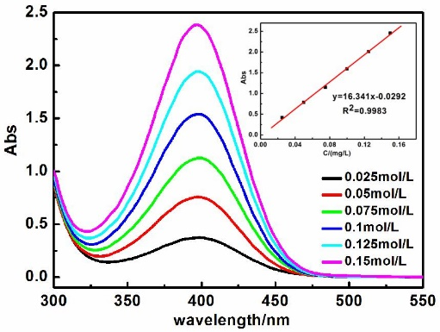
Figure S1 Standard curves of PNP solution

IR spectra:
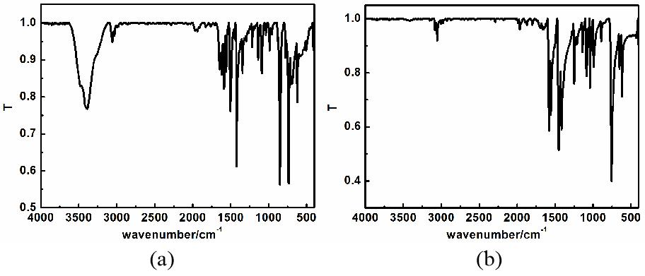
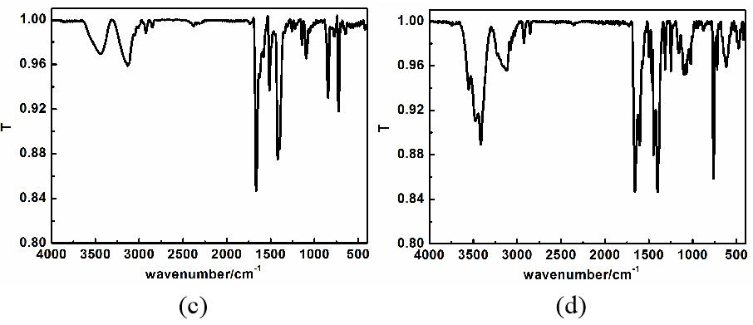
Figure S 2 IR spectrum: (a) 1, 10′-phen; (b) 2, 2ʹ-bipy; (c) 1; (d) 2
Table S3 IR spectra (cm⁻¹) of 1, 10′-phen, 2, 2ʹ-bipy, 1 and 2
 | 1, 10′-phen | 2, 2ʹ-bipy | 1 | 2
ν_{Ar-H} | 3064 | 3057 | 3137 | 3129
ν_{C=N} | 1654 | 1665 | 1673 | 1663
ν_{C=C} | 1510, 1432 | 1593, 1456 | 1520, 1421 | 1601, 1412
ν_{C-C} | 1149 | 1087 | 1149 | 1167
ν_{C-N} | 1087 | 1050 | 1095 | 1089
δ_{Ar-H} | 761 | 761 | 726 | 760

UV-vis spectra
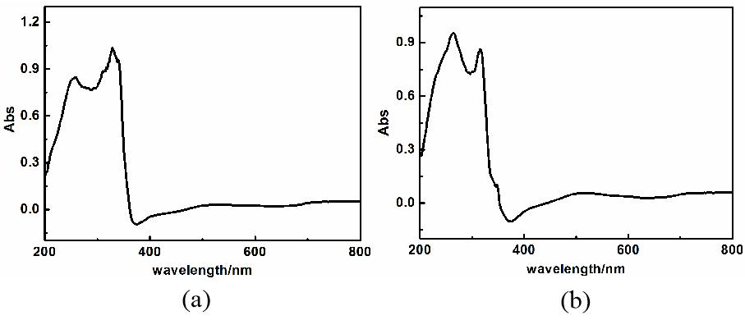
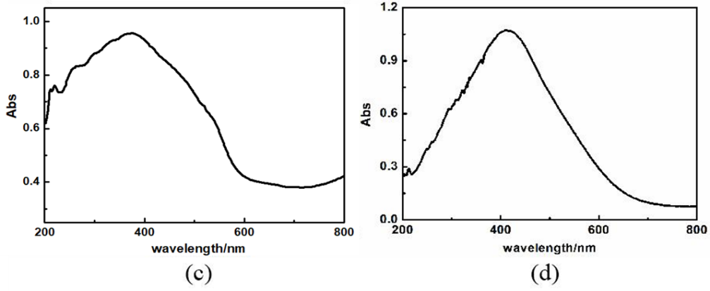
Fig. S3. UV spectrum: (a) 1, 10′-phen; (b) 2, 2ʹ-bipy; (c) 1; (d) 2

Table S4 UV spectrum (nm) of 1, 10′-phen, 2, 2ʹ-bipy, 1 and 2
 | LLCT |  | LMCT | MMCT
 | π-π* | n-π* | LMCT | MMCT
1, 10′-phen | 256 | 325
2, 2ʹ-bipy | 264 | 316
1 | 220 | 261 | 376
2 | 218 | 321 | 411

PXRD pattern
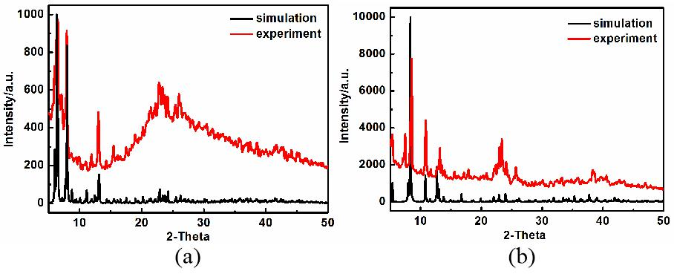
Figure S4 The PXRD spectrum: (a) 1 ;(b) 2
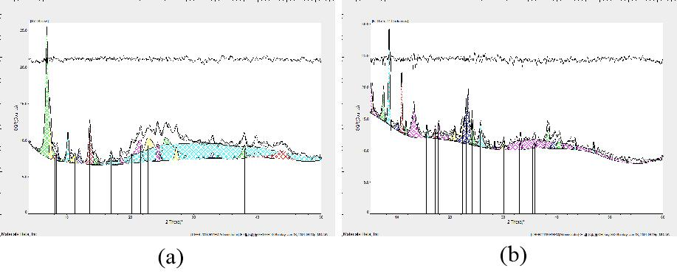
Figure S5 The crystallinity rate: (a) 1; (b) 2

TG curves
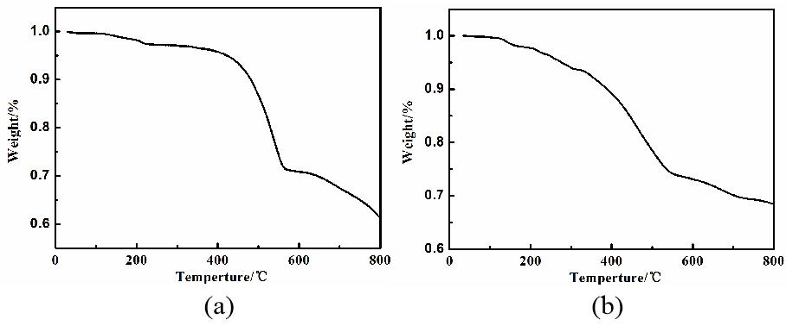
Figure S6 Thermal analysis: (a) 1（b） 2

Table S5 TG analysis of 1 and 2
Compound |  | The first stage of weightlessness | The second stage of weightlessness | The third stage of weightlessness | Residue
1 | Temperature (°C) | 30-560 | 560-800 |  | Ag₂O  CoO
1 | Weightlessness designation | Six 1, 10′-phen | Skeleton collapse |  | Ag₂O  CoO
1 | Actual weightlessness (%) | 29.6 | 8.6 |  | Ag₂O  CoO
1 | Theoretical weight loss rate (%) | 30.1 |  |  | Ag₂O  CoO
2 | Temperature (°C) | 30-150 | 150-530 | 530-800 | Ag₂O  CoO
2 | Weightlessness designation | Two H₂O, and one OH⁻ | Three DMF, and three 2, 2ʹ-bipy | Skeleton collapse | Ag₂O  CoO
2 | Actual weightlessness (%) | 1.7 | 16.9 | 6.0 | Ag₂O  CoO
2 | Theoretical weight loss rate (%) | 1.6 | 16.0 |  | Ag₂O  CoO

Table S6 the coordination environment of metal Ag of 1 and 2*
1
Center metal | Coordination environment | Ligand | Center metal | Coordination environment | Ligand
Ag1 | Three coordination | I2 I3 I8 | Ag5 | Four  coordination | I4 I6 I7 I8
Ag2 | Three coordination | I1 I2 I4 | Ag6 | Four  coordination | I5 I6 I10 I11
Ag3 | Four  coordination | I1 I3 I5 I12 | Ag7 | Four  coordination | I6 I7 I9 I11
Ag4 | Four  coordination | I3 I4 I5 I6 | Ag8 | Four  coordination | I9 I10 I11 I12
2
Center metal | Coordination environment | Ligand | Center metal | Coordination environment | Ligand
Ag1 | Four  coordination | I1 I1^{#1} I2 I2^{#1} | Ag4 | Two  coordination | I4 I6
Ag2 | Three coordination | I2 I3 I4 | Ag5 | Seven  coordination | I1 I1^{#1} I2 I3 I5 I6 I6^{#1}
Ag3 | Three coordination | I4 I5 I5^{#1} | Ag6 | Five  coordination | I1 I2 I3 I5 I6
*Symmetry codes: 2: #1 1-x, y, 0.5-z

References
[1]. SMART and SAINT (software packages); Siemens Analytical X-ray Instruments, Inc.: Madison, WI, 1996.
[2]. O.V. Dolomanov，L.J. Bourhis，R.J. Gildea，J. Howard，H. Puschmann, Journal of Applied Crystallography, 2009, 42, 339-341.
[3]. G.M. Sheldrick, Acta Crystallographica, 2015, 71, 3-8.

