Supplementary Material

Supplementary Figures and Tables

Supplementary Figures
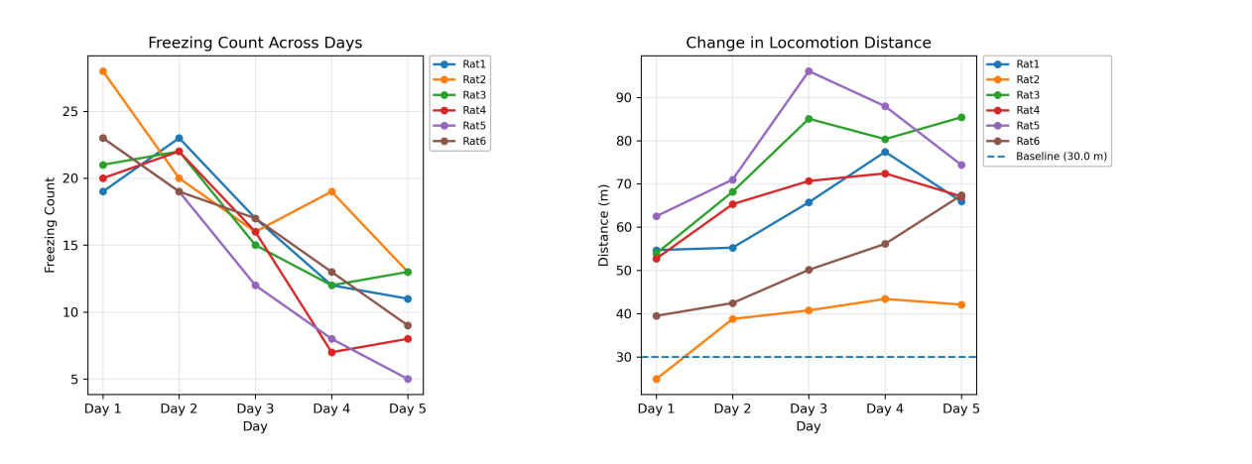
Supplementary Fig 1. Changes in the number of freezes and the distance traveled over training days during the infinite corridor adaptation training of control animals.
The left panel the changes in the number of freezes for each animal, and the right panel shows the changes in the distance traveled by each animal within 10 min, with the dashed line representing 30 m baseline.
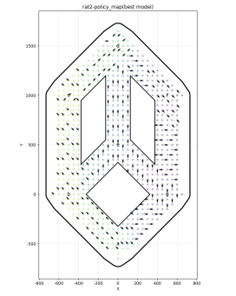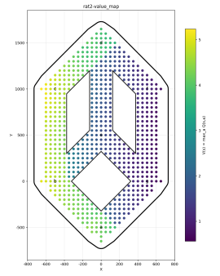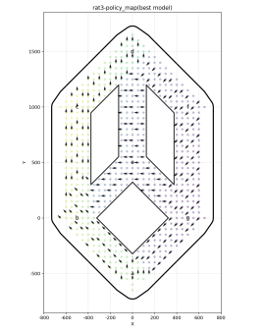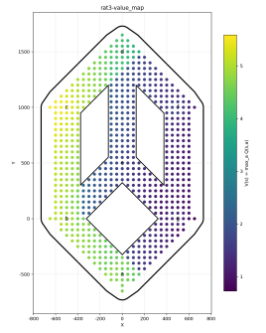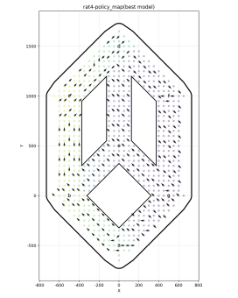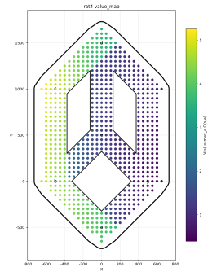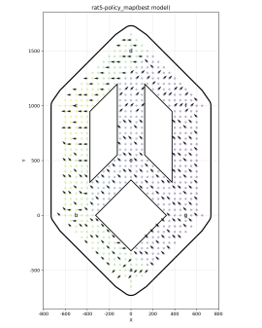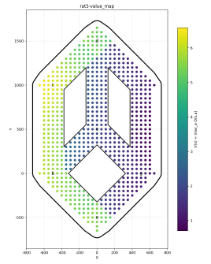

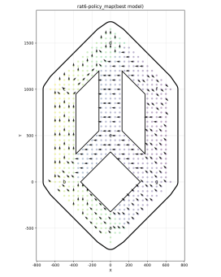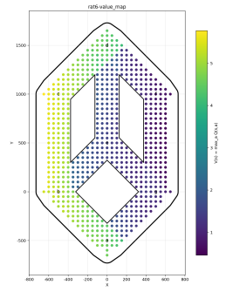
Supplementary Fig 2.State-value distribution and policy-field analysis obtained from offline DQN value learning.
State-value distribution map of a representative animal in the maze space. Colors indicate the value magnitude of each discrete state, with high-value regions mainly concentrated along the left-side path and its adjacent areas.Corresponding optimal action-direction map. Arrows indicate the action direction with the highest Q-value at each discrete state. The overall policy field shows a tendency to advance toward the goal and exhibits more consistent goal-directed directions near the left-side corridor.
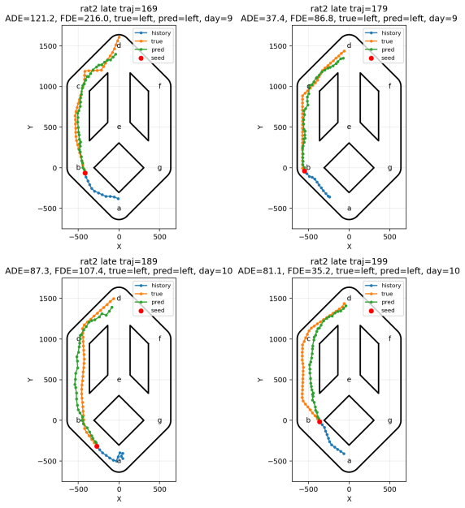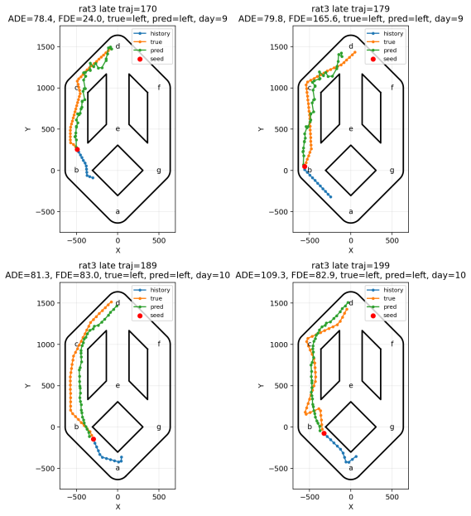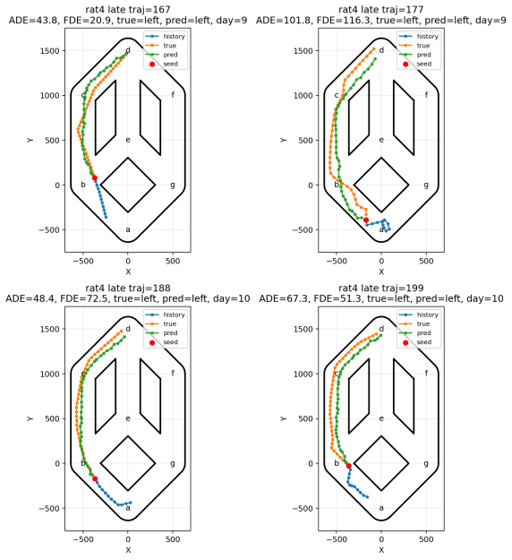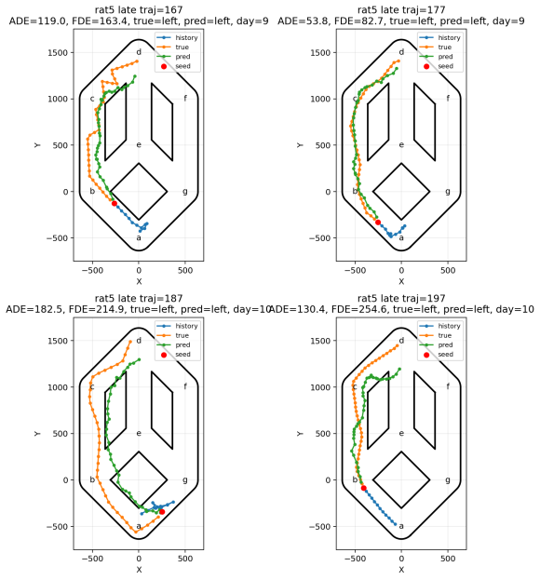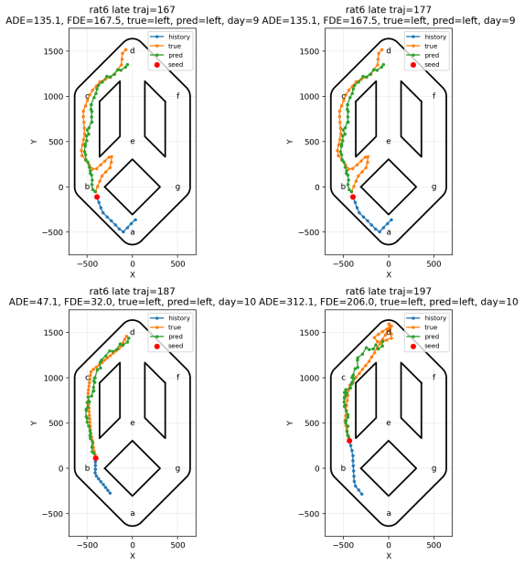
Supplementary Fig 3.Visualization of trajectory prediction results for representative late-stage trials.
The blue trajectory indicates the historical segment, the green trajectory indicates the actual future trajectory, the orange trajectory indicates the model-predicted future trajectory, and the red dot indicates the endpoint of the historical segment/prediction starting point. The results show that the model was able to predict the subsequent path category and the overall movement trend of the future trajectory reasonably well, with prediction errors mainly occurring in local turning details and positional deviations near the endpoint.

