SUPPLEMENTARY FIGURES
SUPPLEMENTARY FIGURE S1: Word cloud of participants’ narratives during the radiotherapy process.
The size of each word reflects its frequency in the dataset.
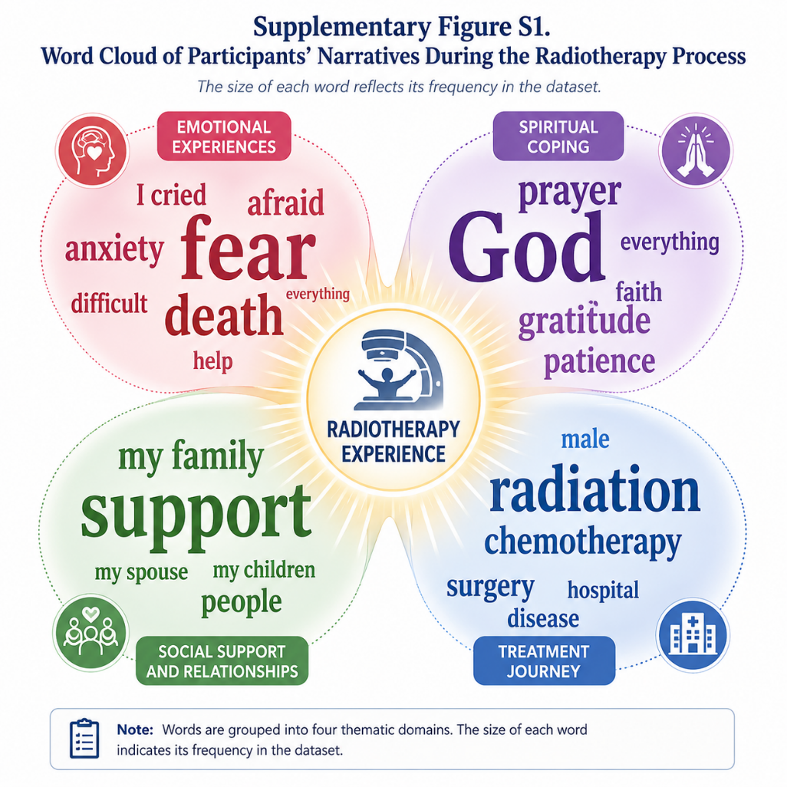

SUPPLEMENTARY FIGURE S2: Word network map illustrating co-occurrence patterns of key concepts.
Nodes represent frequently used words and edges indicate relationships between them.
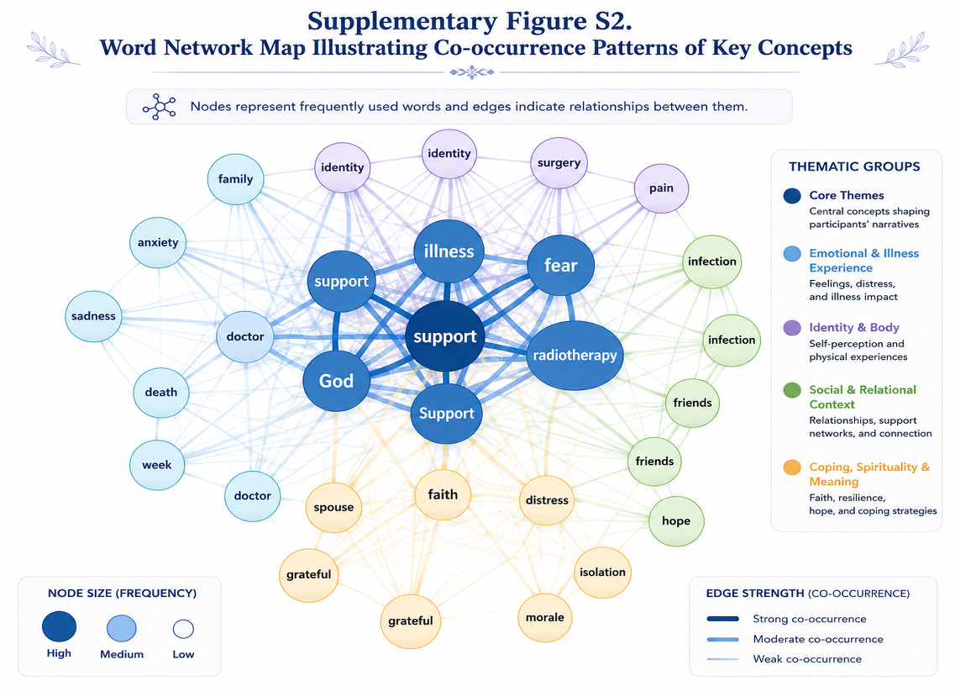

SUPPLEMENTARY FIGURE S3: Hierarchical Code Map Illustrating the Diagnosis Process and Illness Perceptions
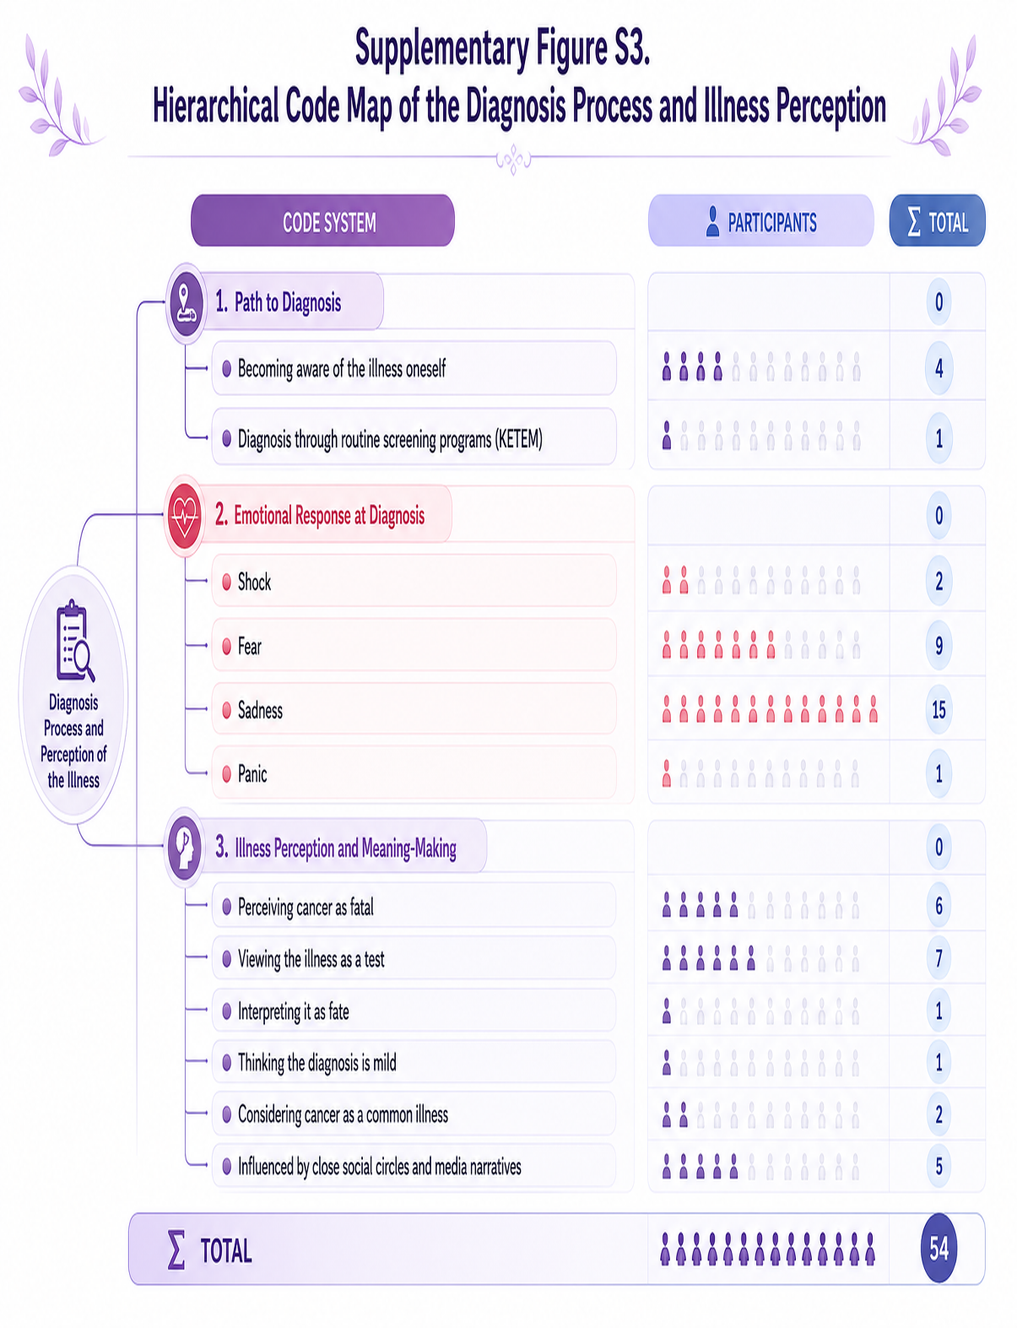

SUPPLEMENTARY FIGURE S4: Hierarchical code map of psychosocial changes during radiotherapy
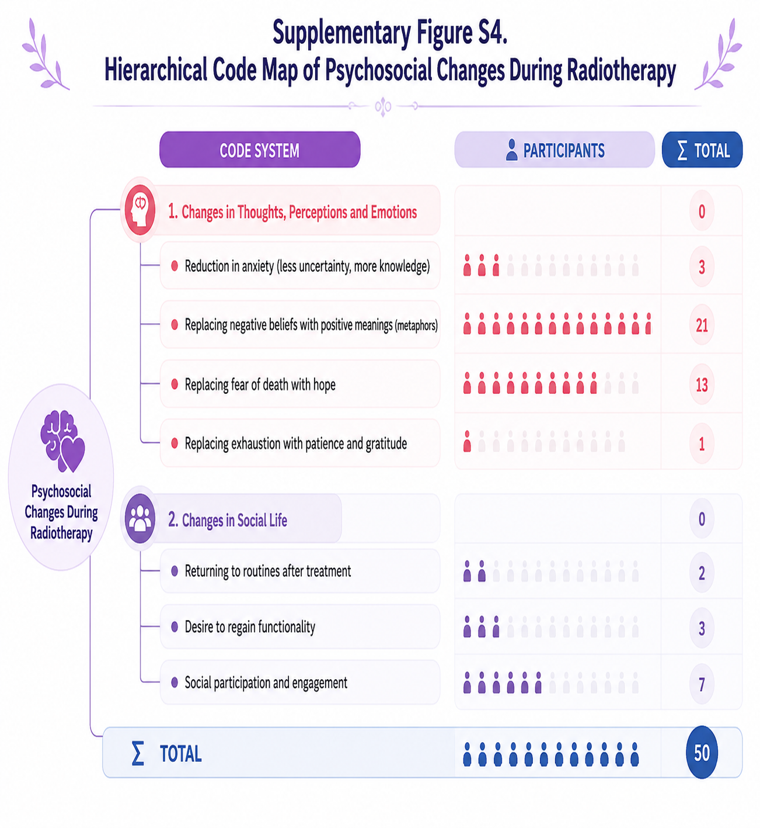

SUPPLEMENTARY FIGURE S5: Hierarchical code map of coping mechanisms and social support systems
