Supporting information for

Rapid and Accurate Quantification of Microplastics in Surface Water using Improved YOLO Model

Hanbin Yang^{1,2}, Haoyu Wang^{1,2}, Fang Tao^{1,2}*, Hailu Fu^{1,2}, Jie Yu^{1,2}, Jie Ouyang^{1,2}, Baofeng Zhang³, Hao Chen³, Mohamed Abou-Elwafa Abdallah⁴, Stuart Harrad⁴

¹College of Energy Environment and Safety Engineering, China Jiliang University, Hangzhou 310018, People’s Republic of China
²Zhejiang Provincial Key Laboratory for Research on Industrial Carbon Metrology Technology, Hangzhou 310018, China
³Zheiang Province of Environmental Monitoring Center, Hangzhou, 310012, China
⁴School of Geography, Earth and Environmental Sciences, University of Birmingham, Birmingham B15 2TT, UK

Text S1 Quality assurance and quality control
Text S2 YOLOv11 model
Table S1 Performance Comparison of Three Commonly Used Object Detection Models
Table S2 Model training strategy used in YOLO-MPs algorithm
Table S3 The quantity of five morphologies of microplastics at six sampling points in the Qiantang River water supply area
Table S4 The average dimensions of five morphologies of microplastics at six sampling points in the Qiantang River
Equation S1 SCConv modifies the feature extraction module C3K2
Equation S2 Improving the C2PSA Module with Deformable Attention Mechanism
Equation S3 Pixel-to-Physical Size Conversion and Calibration Procedure
Fig.S1 The YOLOV11 backbone network
Fig.S2 Six Representative Sampling Sites in the Core Water Supply Zone of the Qiantang River
Fig.S3 (A) Spatial distribution of MPs annotation bounding boxes; (B) Dimensions of MPs annotation bounding boxes
Fig.S4. Dataset sample counts per type: (A) Before sample balancing (B) After sample balancing; Normalized confusion matrices.
Fig.S5 The normalized confusion matrix: A) Before data cleaning B) After data cleaning
Fig.S6. SCConv spatial and channel reconstruction convolution used in YOLO-MPs model
Fig.S7. SCConv spatial and channel reconstruction convolution used in YOLO-MPs model
Fig.S8 SCConv spatial and channel reconstruction convolution used in YOLO-MPs
Fig.S9. Model training process loss and performance index evaluation: (A) Training set bounding box loss curve; (B) Training set classification loss curve; (C) Training set distribution focal loss curve; (D) Precision change trend; (E) Recall change; (F) Validation set bounding box loss curve; (G) Validation set classification loss curve; (H) Validation set distribution focal loss curve; (I) mAP@0.5 index curve; (J) mAP@0.5:0.95 index curve.
Fig.S10. Comparative results of YOLO vs. human-based evaluation: (A) Detection time; (B) Detection quantity.
Fig. S11. Validation of the micro-ruler under the microscope: (A) Length measurement of the micro-ruler; (B) Validation using the microscope stage micrometer.
Fig. S12. Detection and size measurement results of the YOLO-MPs model: (A) Linear; (B) Fragment; (C) Fiber; (D) Pellet; (E) Film.
Text S1: Quality assurance and quality control
To ensure the reliability and accuracy of microplastics (MPs) analysis data, this study established a rigorous Quality Assurance and Quality Control (QA/QC) system:
- Background contamination control: All experimental operations were conducted within a laminar flow hood equipped with an independent ventilation system. Workbench surfaces were covered with clean aluminum foil, which was replaced immediately after each use. Personnel wore unified pure cotton lab coats and powder-free nitrile gloves to eliminate contamination from synthetic fibers.
- Equipment and consumable pretreatment: All laboratory utensils (filtration devices, glassware, etc.) were thoroughly cleaned before use with soap solution, ultrapure water, and ethanol, followed by drying in a plastic-free oven to completely remove residual particles.
- Sample batch management: Water samples (tap water and bottled water) were analyzed in batches of five samples each. Each batch included one blank control (10 L of ultrapure water, processed identically to the actual samples) to monitor potential contamination throughout the entire procedure.
A rigorous QA/QC system can minimize background contamination, validate method performance, and ensure the reproducibility of results.
Text S2: YOLOv11 model
YOLOv11 is a real-time object detection model released by the Ultralytics team in September 2024. Compared to previous YOLO models, it achieves significant improvements in speed, accuracy, and adaptability. Key enhancements include: introduction of the C3k2 mechanism optimizing the feature extraction module, enhancing flexibility and efficiency; addition of the C2PSA module integrating an attention mechanism, enabling the model to focus more precisely on key image regions; and replacing the detection head with Depthwise Separable Convolution (DWConv), reducing parameter count and computational load while maintaining detection accuracy. These optimizations not only improve processing speed and accuracy but also accelerate training and inference through GPU-specific optimizations, making it more competitive in practical applications.
Text S3 SCConv modifies the feature extraction module C3K2
The SCConv module is composed of a Spatial Reconstruction Unit (SRU) and a Channel Reconstruction Unit (CRU) connected in sequence.
Given an input feature map X∈R^(N×C×H×W) , the processing pipeline can be summarized as:
$$X^{w}=SRU(X)$$
$$Y=CRU(X^{w})$$
Where $Y∈R^{N×C×H×W}$ denotes the final output.
Part I: SRU (Spatial Reconstruction Unit)
The SRU reduces spatial redundancy by evaluating channel-wise importance, separating and reconstructing features accordingly.
1) Computation of Spatial Importance Mask
The scaling parameters $γ$from a Group Normalization (GroupNorm) layer are used to generate normalized weights $W_{γ}$.These are multiplied with the output of GroupNorm and activated via a sigmoid function $σ$, producing a spatial importance map M:
$$M=σ(GroupNorm(X)∙W_{γ})$$
2) Separation via Thresholding
A threshold (e.g., 0.5) is applied to binarize the importance map M, resulting in two masks that separate the input features into important and redundant regions:
$M_{1}=Gate(M≥0.5)$ （mask for important regions）
$M_{2}=Gate(M<0.5)$ （mask for redundant regions）
$X_{1}=M_{1}⨀X$（important features）
$X_{2}=M_{2}⨀X$（redundant features）
Here, $⨀$ denotes element-wise multiplication, and$Gate()$is a gating function.
3) Cross Reconstruction
The features $X_{1}$ and $X_{2}$e$,X_{1b}$ and $X_{2a},X_{2b}$ , respectively. These are then combined through cross-addition and concatenation to enhance feature representation and suppress redundancy:
$$X^{w}=Concat(X_{1a}+X_{2b},X_{1b}+X_{2a})$$
The output $X^{w}$ is the spatially refined feature.
Part II: CRU (Channel Reconstruction Unit)
The CRU reduces channel redundancy through a strategy of split-transform–fuse.
- Split:
The input feature $X^{w}$is partitioned along the channel dimension into two parts with a ratio α :
$$X_{up}∈R^{αC×H×W}$$
$$X_{low}∈R^{(1-α)C×H×W}$$
- Transform:
The upper part $X_{up}$ undergoes deep feature extraction using grouped convolution (GWC) and pointwise convolution (PWC), with the results summed:
$$Y_{1}=GWC\left(X_{up}\right)+PWC\left(X_{up}\right)$$
The lower part $X_{low}$ is processed via a lightweight pointwise convolution (PWC) and concatenated with the original input to retain and supplement features at low computational cost:
$$Y_{2}=Concat(PWC\left(X_{low}\right),X_{low})$$
- Fuse:
Global Average Pooling (GAP) is applied to compress spatial dimensions and generate channel-wise statistics. A Softmax function then produces fusion weights $β_{1},β_{2}$, which are used to combine the two parts:
$$s_{1}=GAP\left(Y_{1}\right),s_{2}=GAP\left(Y_{2}\right)$$
$$\left(β_{1},β_{2}\right)=Softmax(s_{1},s_{2})$$
$$Y=β_{1}∙Y_{1}+β_{2}∙Y_{2}$$
The final output Y is the refined feature.

Text S4 Improving the C2PSA Module with Deformable Attention Mechanism
This mechanism employs content-adaptive dynamic offsets to perform sparse sampling on features, subsequently computing attention weights to achieve efficient aggregation.
1) Reference Point Generation
$$pϵR^{H_{G}×W_{G}×2}$$
Where H_G=H/r，W_G=W/r，meaning the height H and width W of the original feature map are divided by a down sampling factor r, resulting in a sparser grid. This step generates a set of fixed initial anchor points or reference points uniformly distributed over the input feature map x.
2) Offset Generation
$$∆_{p}=s∙\tanh\left(θ_{offset}\left(x\right)\right)$$
Where $θ_{offset}$ is a lightweight neural network, $\tanh\left(∙\right)$ is the activation function, and sis a scaling factor. This step is the core of the "deformable" mechanism. It dynamically predicts how much each reference point should shift (i.e., the offset) based on the content of the input feature x.
3) Feature Sampling
$$\hat{x}=ϕ_{bilinear}(x,p+∆_{p})$$
Where $p+∆_{p}$_prepresents the deformed coordinates. Feature values are sampled from the original input feature map x based on the computed new coordinates ($p+∆_{p}$).
4) Key/Value/Query Projection
$$\tilde{K}={Linear}_{K}^{\left(m\right)}\left(\hat{x}\right);\tilde{V}={Linear}_{V}^{\left(m\right)}\left(\hat{x}\right);Q^{\left(m\right)}={Linear}_{Q}^{\left(m\right)}\left(x\right)$$
Where $\hat{x}$ is the feature sampled from the previous step, x is the original input feature，${Linear}^{(m)}$ denotes a linear projection layer. This step prepares the Query, Key, and Value vectors for the standard multi-head attention mechanism.
5) Attention Calculation and Aggregation
$$Z^{(m)}=Softmax(\frac{Q^{\left(m\right)}{({\check{K}}^{\left(m\right)})}^{T}}{\sqrt{d}}+B^{\left(m\right)}){\check{V}}^{\left(m\right)}$$
Where $B^{\left(m\right)}$ is the relative position bias, and $Softmax\left(∙\right)$ normalizes the similarity scores into a probability distribution summing to 1. This step computes the similarity between each Query and its corresponding Key from dynamically sampled locations, then uses these similarity weights to perform a weighted sum over the Values.
6) Output Projection
$$Z=Concat(Z^{\left(1\right)},…,Z^{\left(M\right)})∙W_{o}$$
The outputs from all attention heads are concatenated and projected into the final output space.

Text S5 Pixel-to-Physical Size Conversion and Calibration Procedure
To enable accurate physical dimension measurement, a four-tiered progressive framework was established to map image pixel coordinates to real physical space.
1) Microscope imaging parameter calibration. The critical optical parameters of the microscope system were precisely calibrated, including: Eyepiece magnification ($M_{oc}$): 10× (affects observation only, not measurement); Objective magnification ($M_{obj}$): 5×; C-mount adapter magnification ($M_{int}$): 0.5×; Camera parameters: 20-megapixel (1-inch CMOS sensor), physical pixel size ($d_{pixel}$): 2.4μm × 2.4μm.
2) System effective magnification calculation. The effective magnification ($M_{eff}$) of the imaging system was calculated based on the physical model:
$$M_{eff}=M_{obj}×M_{int}=5×0.5=2.5$$
3) Pixel-to-physical size conversion model establishment. The real physical size corresponding to a single pixel was calculated as:
$$M_{real}=\frac{d_{pixel}}{M_{eff}}=\frac{2.4}{2.5}=0.96 μm/pixel$$
The conversion coefficient $M_{real}=0.96 μm/pixel$ was obtained, serving as the core basis for size measurement.
4) Automated size measurement implementation. The pixel width and height of each detected bounding box output by the YOLO-MPs model were converted into physical dimensions using the established conversion coefficient. The conversion coefficient and confidence parameters were encoded into the detection pipeline, enabling seamless integration of target detection and size measurement.

Table S1：Performance Comparison of Three Commonly Used Object Detection Models
Object Detection Model | Detection Speed | Detection Accuracy | Training Difficulty | Resource Consumption | Reference
MASK R-CNN Series | Slow (5-7 FPS) | Medium (CNN Architecture) | Complex | High Memory + High Compute | [1]
YOLO Series (v5+) | Very Fast (55+ FPS) | High (Transformer Architecture) | Simple | Low to Medium | [1,2]
DETR Series | Medium (15-30 FPS) | High (Transformer Architecture) | Medium | Very High | [2]
Compared to Mask R-CNN and RT-DETR models, YOLO models demonstrate significant advantages in detection speed, accuracy, and resource consumption.
[1] THAMMASANYA T, PATIAM S, RODCHAROEN E, et al. A new approach to classifying polymer type of microplastics based on Faster-RCNN-FPN and spectroscopic imagery under ultraviolet light [J]. Scientific reports, 2024, 14(1): 3529.
[2] XU J J, WANG Z L. Efficient and accurate microplastics identification and segmentation in urban waters using convolutional neural networks [J]. Science of The Total Environment, 2024, 911.
Table S2. Model training strategy used in YOLO-MPs algorithm
Name | Parameters
CPU | Intel i7-14700HX
GPU | NVIDIA RTX 4070
Torch | 2.2.2
Python | 3.10.14
CUDA | 12.4
Optimizer | SGD
Learning rate | 0.01
Epochs | 450
Workers | 4
Batch | 32
Imgsz | 640$×$640

Table S3. The quantity of five morphologies of microplastics at six sampling points in the Qiantang River water supply area
Sample.id | Location | Fiber | Film | Fragment | Linear | Pellet | Total
Site1 | Qibao | 17 | 34 | 40 | 9 | 26 | 126
Site2 | Jiuxi Water Plant | 19 | 10 | 31 | 14 | 15 | 89
Site3 | Nanxingqiao | 32 | 40 | 45 | 27 | 30 | 174
Site4 | Binjiang Water Plant | 10 | 29 | 29 | 7 | 20 | 95
Site5 | Zhutoujiao | 75 | 214 | 350 | 47 | 194 | 880
Site6 | Chifengbu Water Plant | 3 | 11 | 30 | 4 | 15 | 63

Table S4. The average dimensions of five morphologies of microplastics at six sampling points in the Qiantang River.
Sample.id | Location | Fiber* | Film | Fragment | Linear | Pellet
Site1 | Qibao | 430 | 14.5 | 14.0 | 37.9 | 7.38
Site2 | Jiuxi Water Plant | 568 | 10.5 | 11.9 | 58.3 | 4.72
Site3 | Nanxingqiao | 547 | 9.04 | 13.7 | 75.6 | 5.78
Site4 | Binjiang Water Plant | 765 | 15.9 | 18.9 | 13.9 | 5.51
Site5 | Zhutoujiao | 377 | 9.68 | 11.8 | 43.0 | 7.74
Site6 | Chifengbu Water Plant | 604 | 11.5 | 13.3 | 28.7 | 6.24
*The fiber category represents the diagonal length in micrometers ($μm$), while the other four categories denote the area of bounding boxes (length multiplied by width) in square micrometers $(×{10}^{3}{μm}^{2}$)

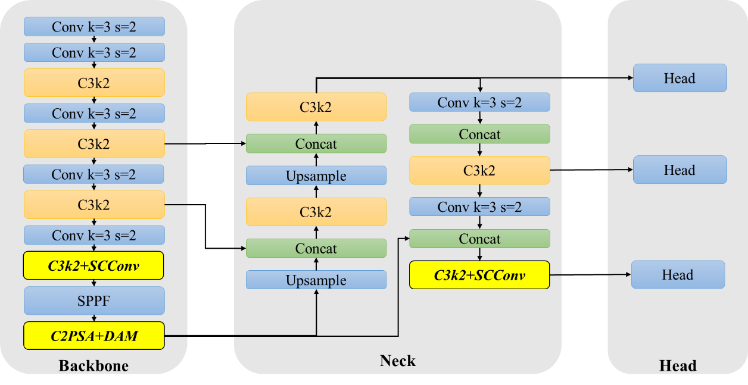
Fig.S1 Schematic diagram of the YOLO-MPs model framework optimization

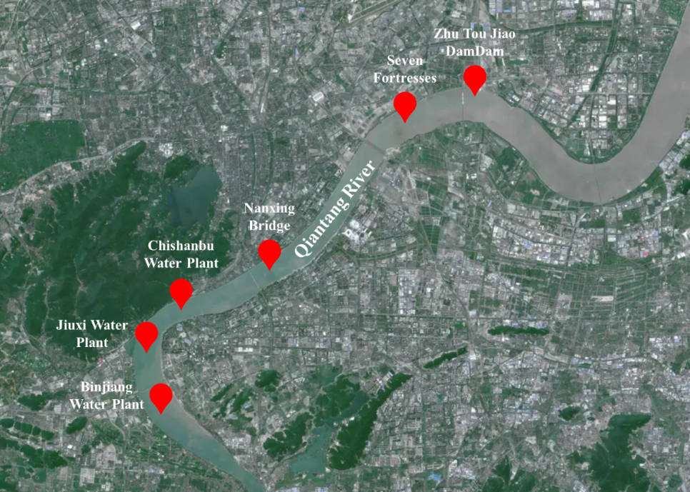
Fig.S2. Six Representative Sampling Sites in the Core Water Supply Zone of the Qiantang River
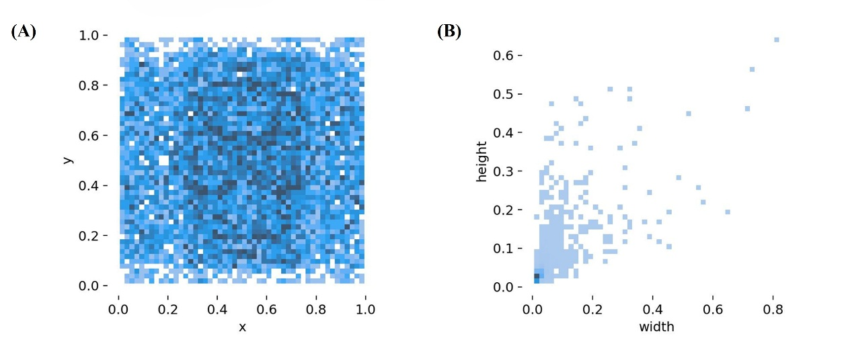
Fig.S3. (A) Spatial distribution of MPs annotation bounding boxes; (B) Dimensions of MPs annotation bounding boxes
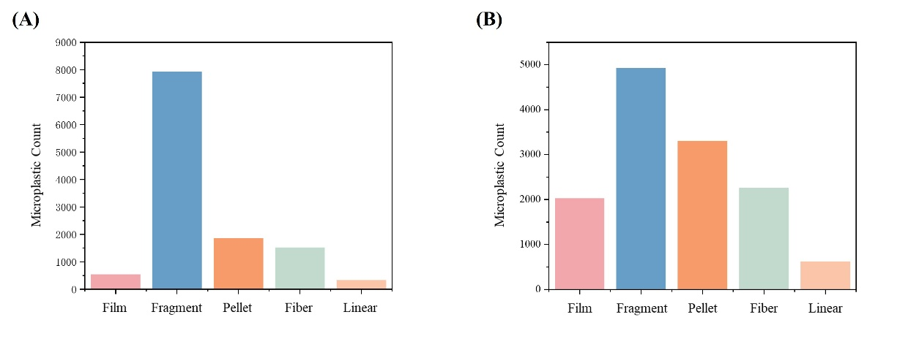
Fig.S4. Dataset sample counts per type: (A) Before sample balancing (B) After sample balancing; Normalized confusion matrices.

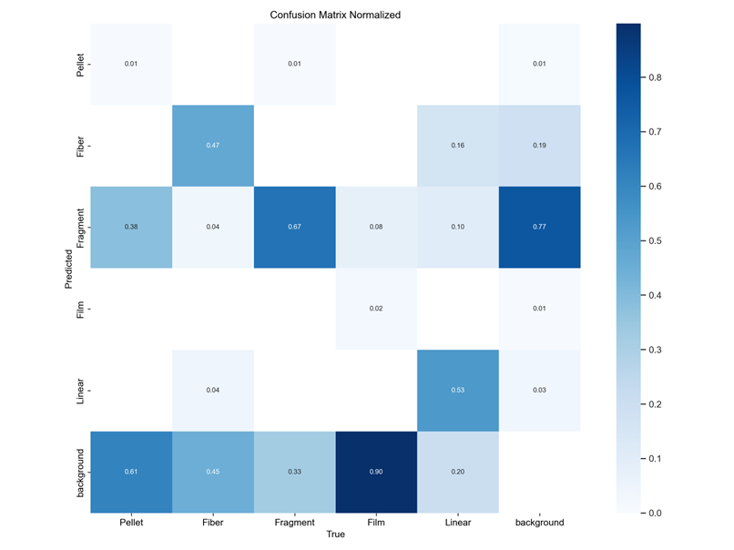
- Before data clean
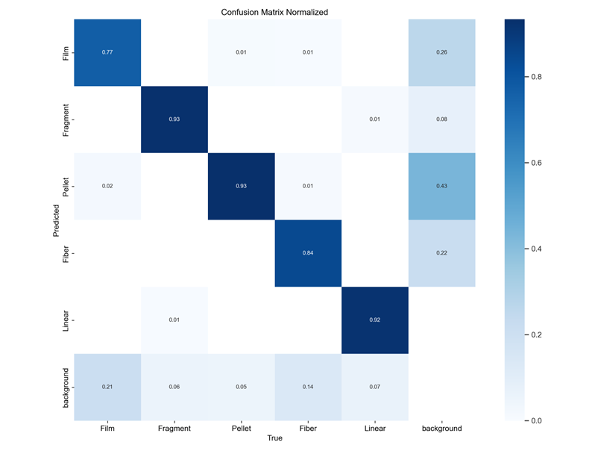
B) After data cleaning
Fig.S5 The normalized confusion matrix: A) Before data cleaning B) After data cleaning

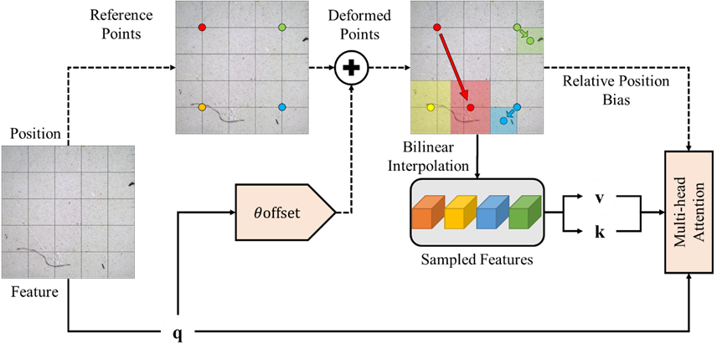
Fig.S6 Deformable attention mechanism used in YOLO-MPs algorithm
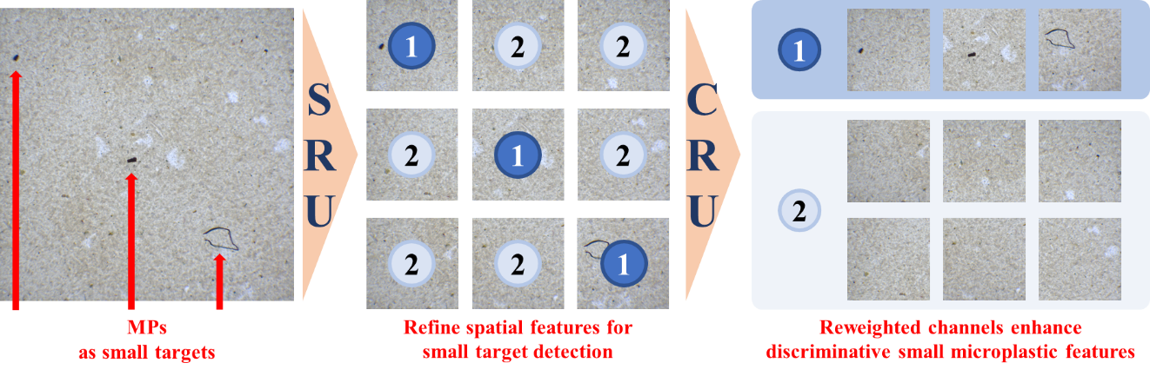
Fig.S7. SCConv spatial and channel reconstruction convolution used in YOLO-MPs model
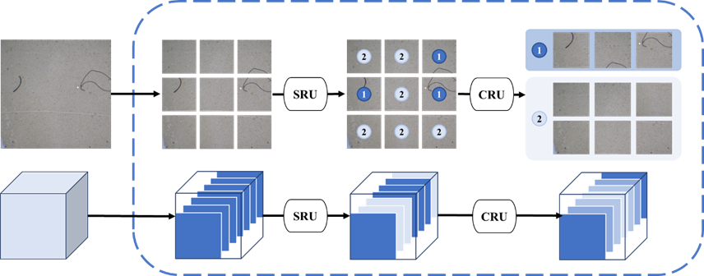
Fig.S8 SCConv spatial and channel reconstruction convolution used in YOLO-MPs algorithm
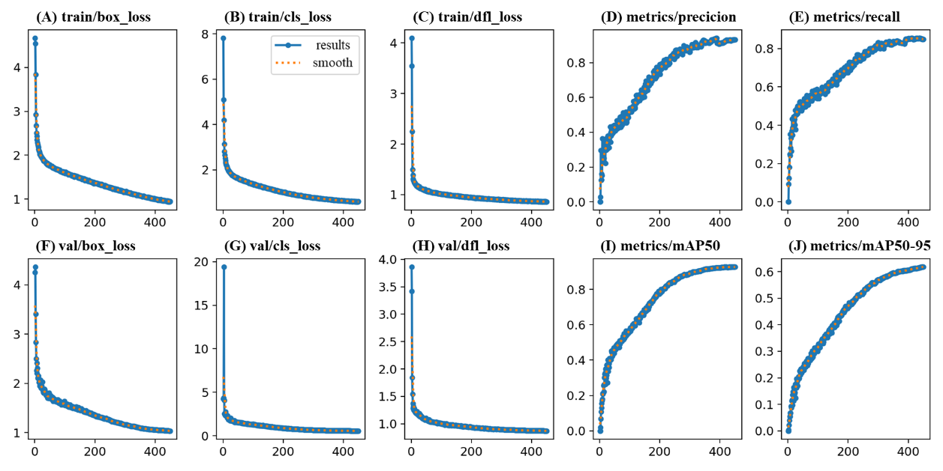
Fig.S9. Model training process loss and performance index evaluation: (A) Training set bounding box loss curve; (B) Training set classification loss curve; (C) Training set distribution focal loss curve; (D) Precision change trend; (E) Recall change; (F) Validation set bounding box loss curve; (G) Validation set classification loss curve; (H) Validation set distribution focal loss curve; (I) mAP@0.5 index curve; (J) mAP@0.5:0.95 index curve.

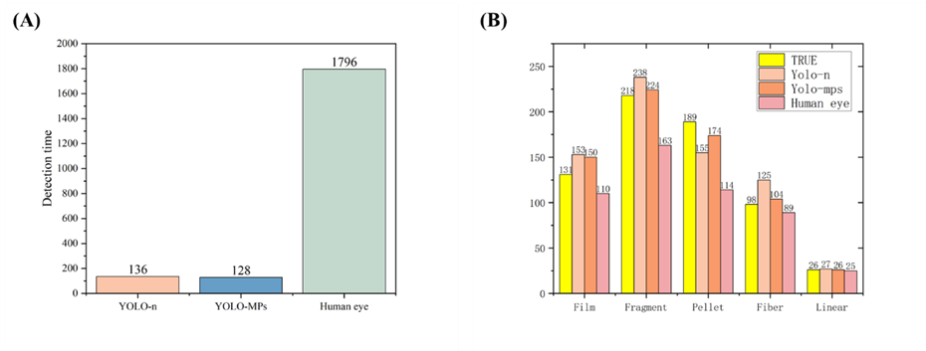
Fig.S10. Comparative results of YOLO vs. human-based evaluation: (A) Detection time; (B) Detection quantity.

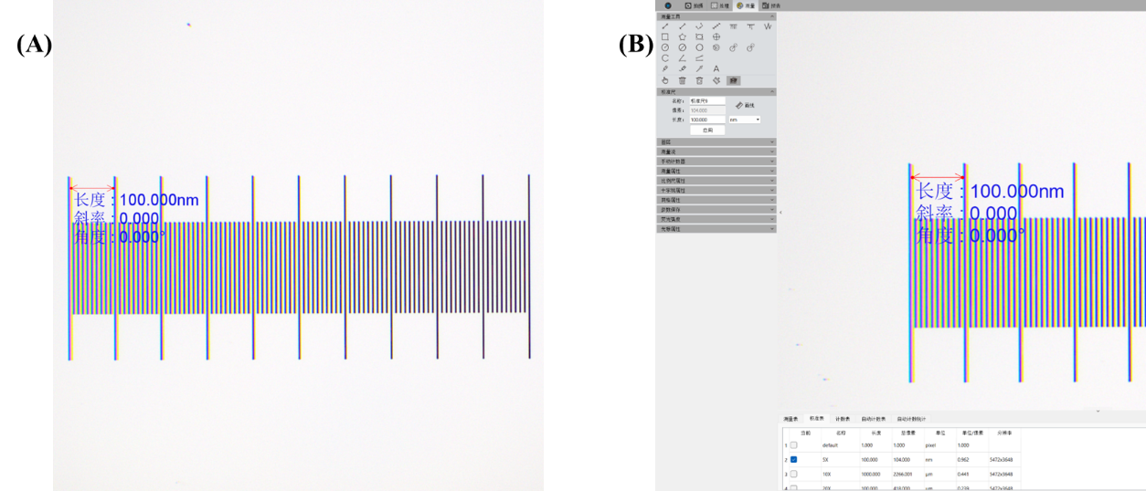
Fig. S11. Validation of the micro-ruler under the microscope: (A) Length measurement of the micro-ruler; (B) Validation using the microscope stage micrometer.

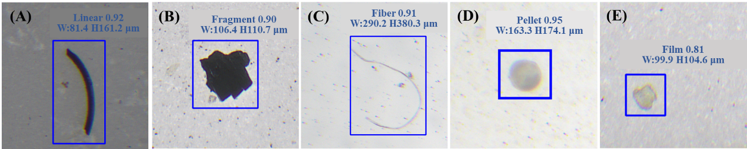
Fig. S12. Detection and size measurement results of the YOLO-MPs model: (A) Linear; (B) Fragment; (C) Fiber; (D) Pellet; (E) Film.

