Supporting Information on
Facile preparation of novel DOPO functionalized cellulose microshphere as adsorbent for uranium adsorption with ultrahigh selectivity

Di Wen^{1, 2}†, Cong Xie³†, Manman Zhang^{1, 2}, Zhen Dong¹, Maolin Zhai⁴, Long Zhao¹*
1 State Key Laboratory of Advanced Electromagnetic Engineering and Technology, School of Electrical and Electronic Engineering, Huazhong University of Science and
Technology, Wuhan 430074, China
2 School of Chemistry and Chemical Engineering, Huazhong University of Science and Technology, Wuhan 430074, China
3 Non-power Nuclear Technology Research and Development Center, Hubei University of Science and Technology, Xianning 437100, China
4 Beijing National Laboratory for Molecular Sciences, Radiochemistry and Radiation Chemistry Key Laboratory of Fundamental Science, Key Laboratory of Polymer Chemistry and Physics of the Ministry of Education, College of Chemistry and Molecular Engineering, Peking University, Beijing 100871, China

† refer to equal contribution
Corresponding author.
E-mail addresses: ryuuchou@hotmail.com (Long Zhao), zhaolong@hust.edu.cn (Long Zhao)

Fig. S1 pHpzc of the t-DOPOR

Fig. S2 Relative proportion of U(VI) as a function of solution pH.(C_{0(U(VI))} = 20 mg/L)

Fig. S3 high-resolution XPS spectra of U 4f for the t-DOPOR-U

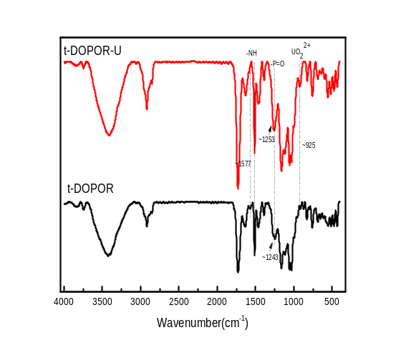

Fig. S4 FTIR image for DOPO-R before and after adsorption with adsorption U(VI)

Table S1 Kinetic parameter of U (VI) individual adsorption onto t-DOPOR
Resin | Experimental data  q_{e}(mg g⁻¹) |  | Pseudo first-order equation  q_{e}(mg g⁻¹) k₁(h⁻¹) R² |  |  | Pseudo-Second-order equation  q_{e}(mg g⁻¹) k₂(g mg⁻¹min⁻¹) R²
t-DOPOR |  | 20.85 | 20.20 | 0.6565 | 0.9615 | 21.21 | 0.05621 | 0.9997

Table S2 Isotherm parameter of U (VI) individual adsorption onto t-DOPOR
Resin | Experimental data  q_{e}(mg g⁻¹) |  | Langmuir model  q_{e}(mg g⁻¹) k₁(h⁻¹) R² |  |  | Freundlich model  q_{e}(mg g⁻¹) k₂(g mg⁻¹min⁻¹) R²
t-DOPOR |  | 67.08 | 69.49 | 0.12 | 0.9921 | 20.07 | 3.891 | 0.9850

Table S3 Thermodynamic parameters for the adsorption of U(VI) on t-DOPOR
 | △H(KJ/mol) | △S(J/mol K) |  | △G(KJ/monl)
 | △H(KJ/mol) | △S(J/mol K) | T=293 K | T=298 K | T=303 K | T=313 K T=323 K
t-DOPOR | 2.87 | 85.22 | -1.15 | -1.57 | -2.00 | -2.85 -3.70

Table S4 t-DOPOR for removing trace amount of U(VI) in practical application
 |  | pH | C₀ | C_{e} | E(%)
contaminated pure water |  | 3 | 6.37 | 0.096 | 98.49
simulated groundwater |  | 7.6 | 24.3 | <0.04 | >99.8

