The role for GABAergic interneurons subtypes in the antidepressant efficacy of
traditional Chinese medicine formula lily bulb and Rehmannia decoction
Xiaoyan Xue ^{1 #}, Hongxiu Zhang ^{1,2 #}, Yanting Lu ^{1 #}, Jin Pan ^{1 #}, Qiancheng Mao ¹, Xing Chang ³, Shijun Wang ^{1 *}, Xiaobin Song ^{1 *}, and Ke Ma ^{1 *}
1 Shandong Co-Innovation Center of Classic TCM Formula, Shandong University of Traditional Chinese Medicine, Jinan 250355, PR China
2 Institute of Virology, Jinan Municipal Center for Disease Control and Prevention, Jinan 250021, PR China
3 Department of Cardiology, Guang'anmen Hospital, Chinese Academy of Traditional Chinese Medicine, Beijing 100053, PR China

Running title: LBRD maintains homeostasis of GABA interneurons

# These authors contributed equally to this work

Address Correspondence to: Dr. Shijun Wang, Shandong Co-Innovation Center of Classic TCM formula, Shandong University of Traditional Chinese Medicine, No. 4655, University Road, Changqing District, Jinan, Shandong 250355, P.R. China, Tel/Fax: 86-531-89628750, E-mail: pathology@163.com;
Dr. Xiaobin Song, Shandong University of Traditional Chinese Medicine, No 4655, University Road, Changqing District, Jinan, Shandong 250355, People’s Republic of China, Tel/Fax +86-531-89628077, Email: xiaobin_song.com@163.com;
Dr. Ke Ma, Shandong Co-Innovation Center of Classic TCM Formula, Shandong University of Traditional Chinese Medicine, No 4655, University Road, Changqing District, Jinan, Shandong 250355, People’s Republic of China, Tel/Fax +86-531-89628077, Email: make@sdutcm.edu.cn.

Figure S1: Total ion chromatogram of LBRD standard decoction in positive and negative ion mode using UHPLC-Q-TOF/MS.
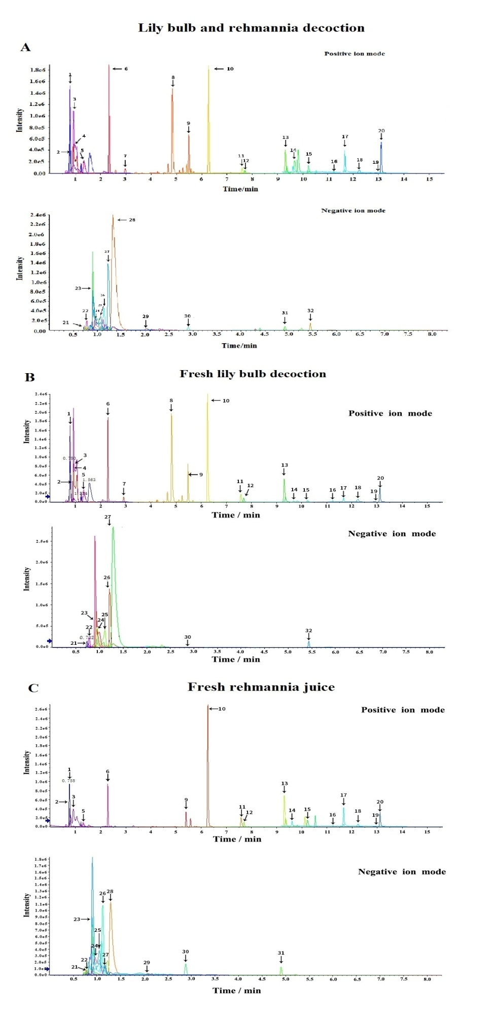
Figure S2: HPLC chromatograms of verbascoside in the fresh lily bulb decoction, fresh Rehmannia juice and LBRD standard decoction

Figure S3. Effects of LBRD standard decoction administration the PV and VIP interneuron subtype.
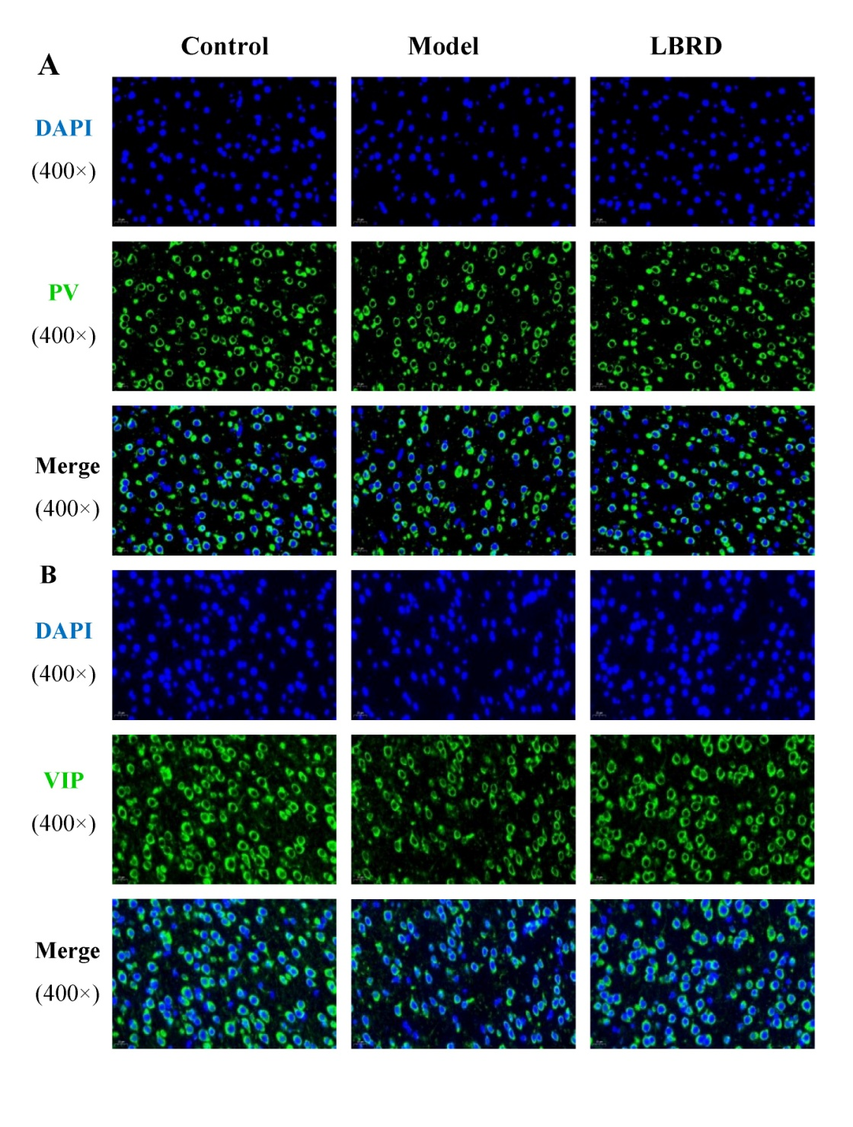

Table S1：Characterization of the chemical constituents in Lily Bulb and Rehmannia Decoction (LBRD) standard decoction by UPLC-QTOF-MS/MS.
Number | Component | Model(+/-) | Retention time (min) | Formula | M/Z | Resource
1 | L-4-Hydroxyglutamate semialdehyde | + | 0.7774 | C5H9NO4 | 148.06 | Both
2 | Verbascoside | + | 0.8489 | C29H36O15 | 624.59 | Both
3 | L-2-Aminoadipic acid | + | 0.9214 | C6H11NO4 | 162.08 | Both
4 | 6-Oxopiperidine-2-carboxylic acid | + | 0.9214 | C6H9NO3 | 144.07 | Fresh lily bulb decoction
5 | 2,5-Furandicarboxylic acid | + | 1.315 | C6H4O5 | 139 | Both
6 | Vidarabine | + | 2.2965 | C10H13N5O4 | 268.1 | Both
7 | Aminoadipic acid | + | 2.9324 | C6H11NO4 | 144.07 | Fresh lily bulb decoction
8 | Coumarin | + | 4.8195 | C9H6O2 | 147.04 | Fresh lily bulb decoction
9 | 8-tridecynoic acid | + | 5.3891 | C13H22O2 | 193.16 | Both
10 | Triethyl phosphate | + | 6.2625 | C6H15O4P | 183.08 | Both
11 | Myristic acid | + | 7.5879 | C14H28O2 | 246.24 | Both
12 | (+)-15S-hydroxy-hexadecanoic acid | + | 7.6919 | C16H32O3 | 290.27 | Both
13 | 17-hydroxy stearic acid | + | 9.3046 | C18H36O3 | 318.3 | Both
14 | 14:0(5Me[R],9Me[R],13Me) | + | 9.6715 | C17H34O2 | 288.29 | Both
15 | Stearic acid | + | 10.2174 | C18H36O2 | 302.31 | Both
16 | 2E,6Z,8Z,12E-hexadecatetraenoc acid | + | 11.2287 | C16H24O2 | 249.18 | Both
17 | Monoethylhexyl phthalic acid | + | 11.6635 | C16H22O4 | 301.14 | Both
18 | Polidocanol | + | 12.2376 | C30H62O10 | 600.47 | Both
19 | 1-O-(2R-hydroxy-hexadecyl)-sn-glycerol | + | 12.9221 | C19H40O4 | 333.3 | Both
20 | Oleamide | + | 13.1112 | C18H35NO | 304.26 | Both
21 | 2-Anthramine | - | 0.7189 | C14H11N | 385.17 | Both
22 | N-Methyl-D-aspartic acid | - | 0.766 | C5H9NO4 | 146.05 | Both
23 | Kojibiose | - | 0.8957 | C5H9NO4 | 341.11 | Both
24 | Maltotriose | - | 0.9073 | C18H32O16 | 549.17 | Both
25 | Maltotetraose | - | 1.0472 | C24H42O21 | 711.22 | Both
26 | Osmundalactone | - | 1.1405 | C6H8O3 | 173.05 | Both
27 | Ikarisoside D | - | 1.2228 | C28H30O11 | 587.18 | Both
28 | 5-methoxy-4-methylbenzene-1,3-diol | - | 1.3967 | C8H10O3 | 199.06 | Fresh raw Rehmannia juice
29 | Catalpol | - | 1.9963 | C15H22O10 | 407.12 | Fresh raw Rehmannia juice
30 | Estradiol-17beta 3-sulfate | - | 2.89 | C18H24O5S | 397.13 | Both
31 | Dihydroartemisinin | - | 4.9027 | C15H24O5 | 283.15 | Fresh raw Rehmannia juice
32 | Diosbulbinoside F | - | 5.41 | C26H34O12 | 519.19 | Fresh lily bulb decoction

Table S2：The quality control of LBRD standard decoction.
Component | Retention time | Area | Height | Concentration mg/L | Percentage  (W/W)
Catalpol | 3.702 | 2923334 | 592979 | 1 | 1±0.202
Fresh rehmannia juice | 3.736 | 578621 | 60586 | 0.20 | 1.0±0.15%
LBRD standard decoction | 3.601 | 477378 | 60810 | 0.16 | 1.6±0.08%
Verbascoside | 16.412 | 92393 | 6331 | 99.6
Fresh lily bulbs | 16.757 | 368593 | 26691 | 158 | 0.01264%
Fresh raw Rehmannia root | 16.762 | 64621 | 5401 | 27.67 | 0.002767%
LBRD standard decoction | 16.762 | 317728 | 23330 | 135.7 | 0.009046%

