Supplementary Materials
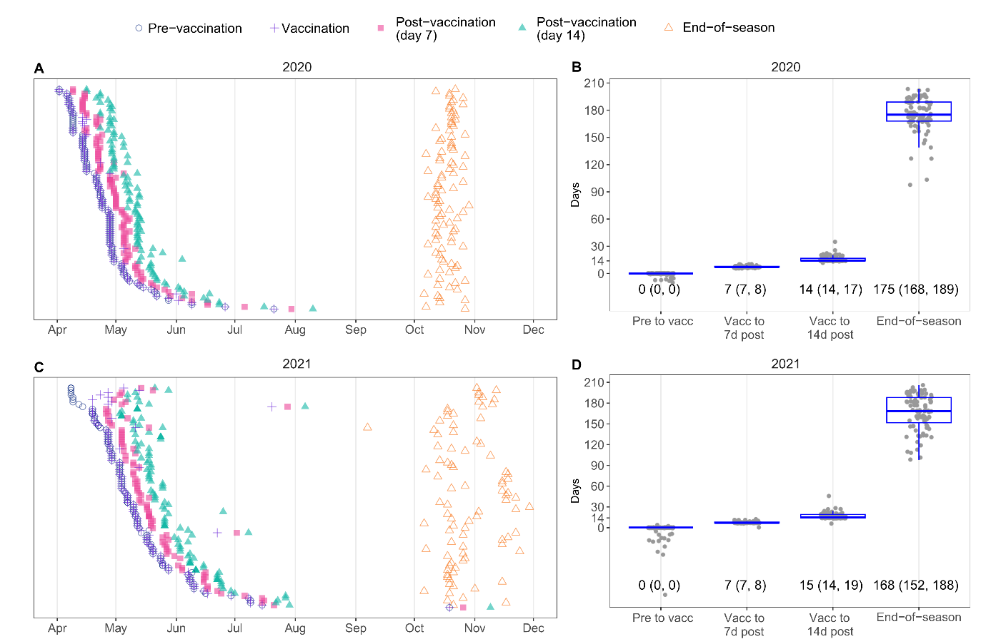
Figure S1. Timing of blood sampling relative to seasonal influenza vaccination. (A,C) Scatter plots show the timing of bleeds ordered by recruitment date for 2020 (A) and 2021 (C). Each point represents a single sample, coloured by sampling timepoint. (B, D) Numbers of the days between visits in 2020 (B) and 2021 (D). Dots show results for each participant. Boxes indicate medians and interquartile ranges (25th and 75th percentile), with whiskers extending to 1.5 * interquartile range. Medians and interquartile ranges are displayed below each box.

Table S1. A(H3N2) viruses assessed by hemagglutination inhibition assay.
Virus Designation ª | Abbreviation | Passage ^{b} | Accession ^{c} | Years in Vaccine ^{d}
A/Bilthoven/16190/68¹ | Bi68 | X, M3 | EPI1868399
A/Bilthoven/21793/72¹ | Bi72 | M3 | EPI1868401
A/Bilthoven/1761/76¹ | Bi76 | M3 | EPI1868402
A/Bilthoven/2271/76¹ | Bil76 | X, M3 | EPI1868403
A/Philippines/2/82¹ | Ph82 | MX, M2 | EPI1868405
A/Netherlands/620/1989¹ | Ne89 | X, M3 | EPI1868433
A/ Netherlands/179/93¹ | Ne93 | X, M3 | EPI1868435
A/ Netherlands /178/95¹ | Ne95 | 293T, M4 | EPI1868436
A/Tasmania/1/97¹ | Ta97 | M7 | EPI1868440
A/Townsville/2/1999¹ | TV99 | S plaque, S4 | EPI1886295
A/ Philippines /472/2002¹ | Ph02 | S plaque, S4 | EPI1868438
A/Victoria/511/2004¹ | Vi04 | S plaque, S3 | EPI1868443
A/Brisbane/10/2007 ² | Br07 | S plaque, S4 | EPI1868482
A/Uruguay/716/2007¹ | Ur07 | E5 | EPI1868481 | 2008, 2009
A/Perth/16/2009 ² | Pe09 | S plaque, S2 | EPI1868486
A/Perth/16/2009 ² | Pe09e | E8 | EPI1868485 | 2010-2012
A/Victoria/361/2011² | Vi11 | S plaque, S3 | EPI1868575
A/Victoria/361/2011² | Vi11e | E6 | EPI1868550 | 2013
A/Texas/50/2012² | Tx12 | S plaque, S4 | EPI1868581
A/Texas/50/12² | Tx12e | E5, E2 | EPI1868551 | 2014
A/Switzerland/9715293/2013² | Sw13 | S9 | EPI1868576
A/ Switzerland /9715293/2013² | Sw13e | E8 | EPI1868552 | 2015
A/New Caledonia/104/2014¹ | Nc14 | S plaque, S7 | EPI1868582
A/Hong Kong/4801/2014³ | HK14 | S2 | EPI5397348
A/Hong Kong/4801/2014² | HK14e | E8 | EPI1868553 | 2016, 2017
A/Newcastle/30/2016^{1,2} | NC16 | S7 | EPI1868578
A/SINGAPORE/16-0019/2016² | Si16e | E10 | EPI1381189 | 2018
A/Kansas/14/2017² | Ka17 | S3 | EPI1868579
A/Kansas/14/2017³ | Ka17e | E9 | EPI1318832
A/Switzerland/8060/2017² | Sw17e | E10 | EPI1322581 | 2019
A/Brisbane/60/2018² | Brs18 | S4 | EPI1868580
A/Brisbane/117/2018² | Br18 | S4 | EPI1281499
A/South Australia/34/2019² | SA19 | S4 | EPI1607117
A/South Australia/34/2019² | SA19e | E7 | EPI1703041 | 2020
A/Darwin/726/2019² | Da19e | S1, S2 | EPI1658695
A/Hong Kong/2671/2019² | HK19e | E8 | EPI1735141 | 2021
A/Cambodia/e0826360/2020² | Ca20 | S3 | EPI1846770
A/Darwin/6/2021² | Da21 | S2 | EPI2604119 | 2022, 2023
A/Darwin/9/2021² | Da21e | E5 | EPI1925255
A/Massachusetts/18/2022² | Ma22 | S2 | EPI3654415 | 2024
a: superscript number indicate whether viruses were included in the initial exploratory antigenic landscape panel but not the final panel (1); in the initial exploratory panel and the final panel (2); or in the final panel but not in the initial exploratory panel (3).
b: Passaged (+/- plaque selected) in embryonated hen’s eggs (E); Madin-Darby canine kidney (M) cell or MDCK cells stably transfected with α-2,6 sialyltransferase (S).
b: Accession codes for HA gene sequences in GISAID, https://gisaid.org/.
d: Strains in Southern Hemisphere influenza vaccines. Vaccine strains corresponding to study years (2020 and 2021) are in bold.
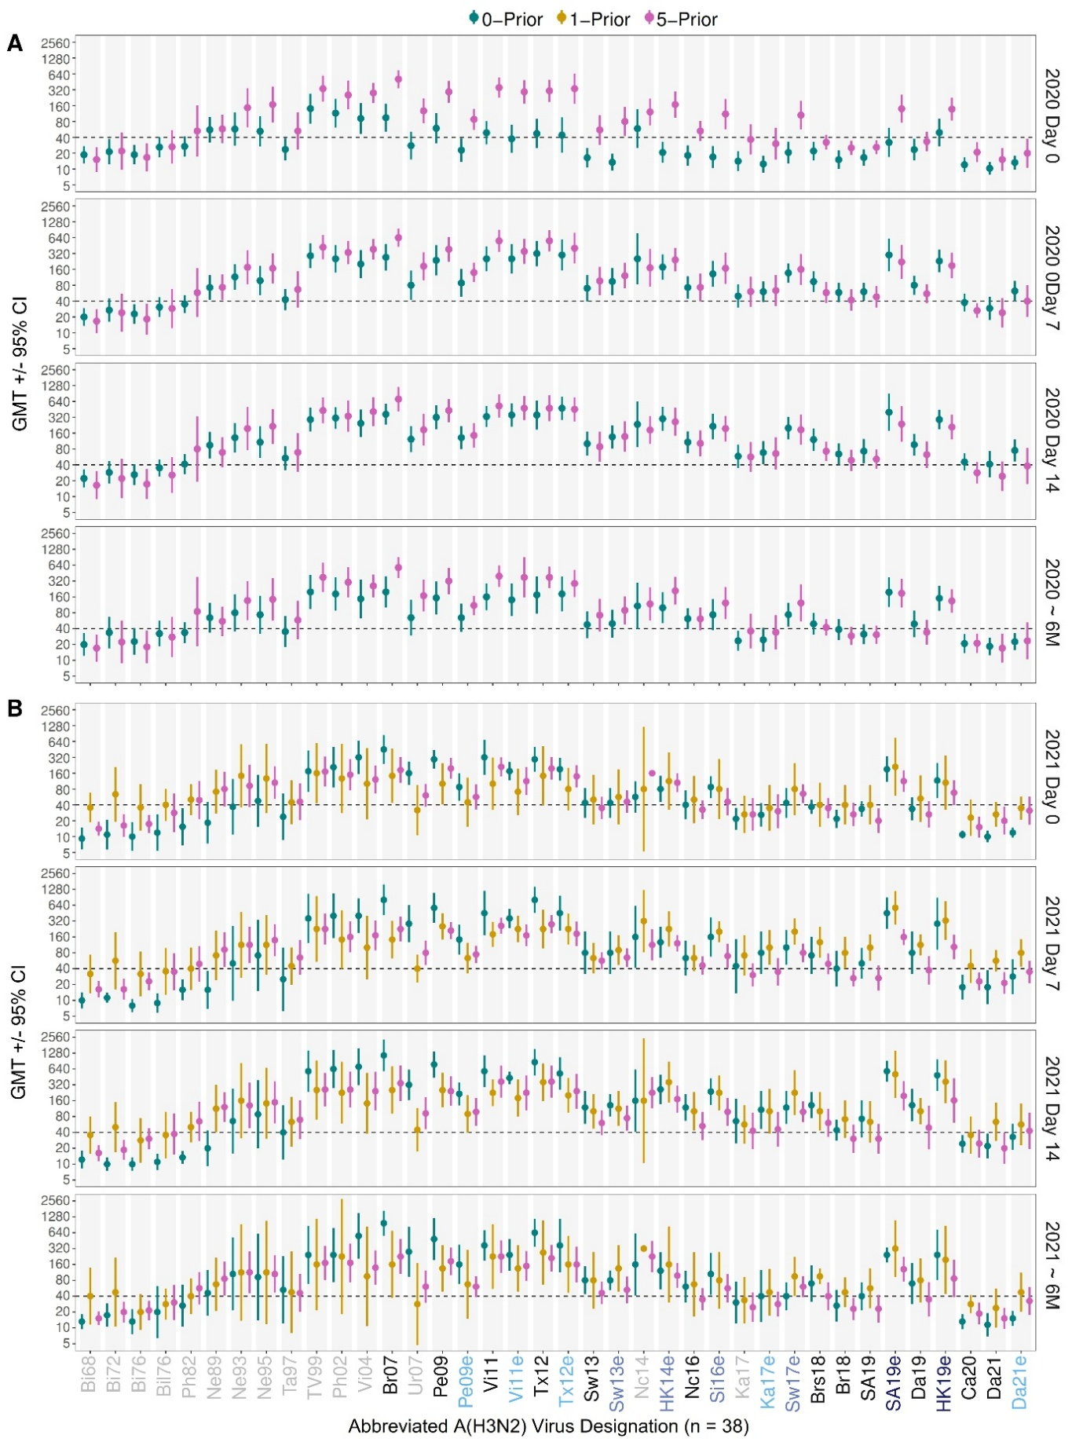
Figure S2. HI antibody titres against the original panel of 38 A(H3N2) viruses spanning 1968 to 2022. Results are shown for 36 participants enrolled in 2020 and 24 enrolled in 2021. Points represent GMTs and vertical bars represent 95% confidence intervals. Results are stratified by study year (panels A and B), time-point (day 0, 7, 14, and 6 months) and prior vaccination (see legend). The dashed line marks the seroprotective threshold (HI = 40). Viruses excluded from the final panel are indicated in light grey. Virus names are abbreviated as Supplementary Table S1. Viruses included in the final panel are colour-coded as in Figure 1A.
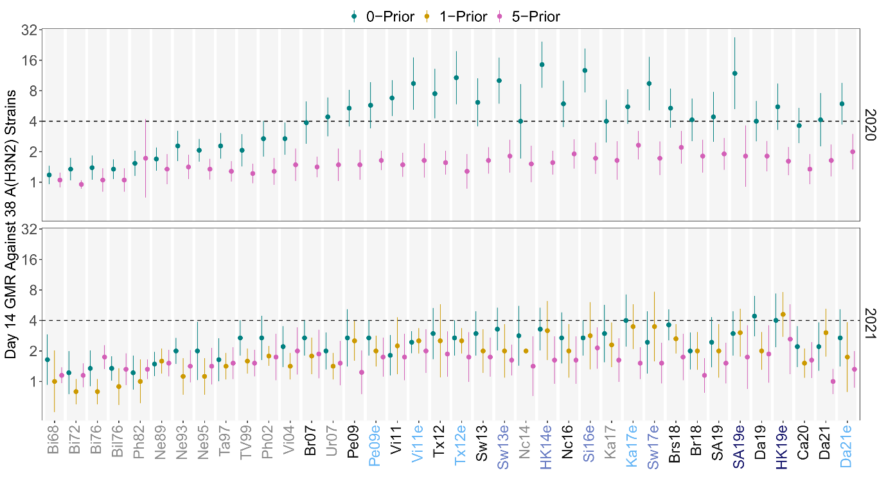
Figure S3. HI antibody titre rises against the original panel of 38 A(H3N2) viruses spanning 1968 to 2022. Geometric mean ratios (GMR) (points), calculated as day 14 post-vaccination divided by pre-vaccination HI antibody titre, are shown for 36 participants enrolled in 2020 and 24 enrolled in 2021, stratified by prior vaccination history (see legend). Vertical bars represent 95% confidence intervals, and the dashed line at GMR = 4 marks the seroconversion threshold. Viruses excluded from the final panela are indicated in light grey. Virus names are abbreviated as Supplementary Table S1. Viruses included in the final panel are colour-coded as in Figure 1A.
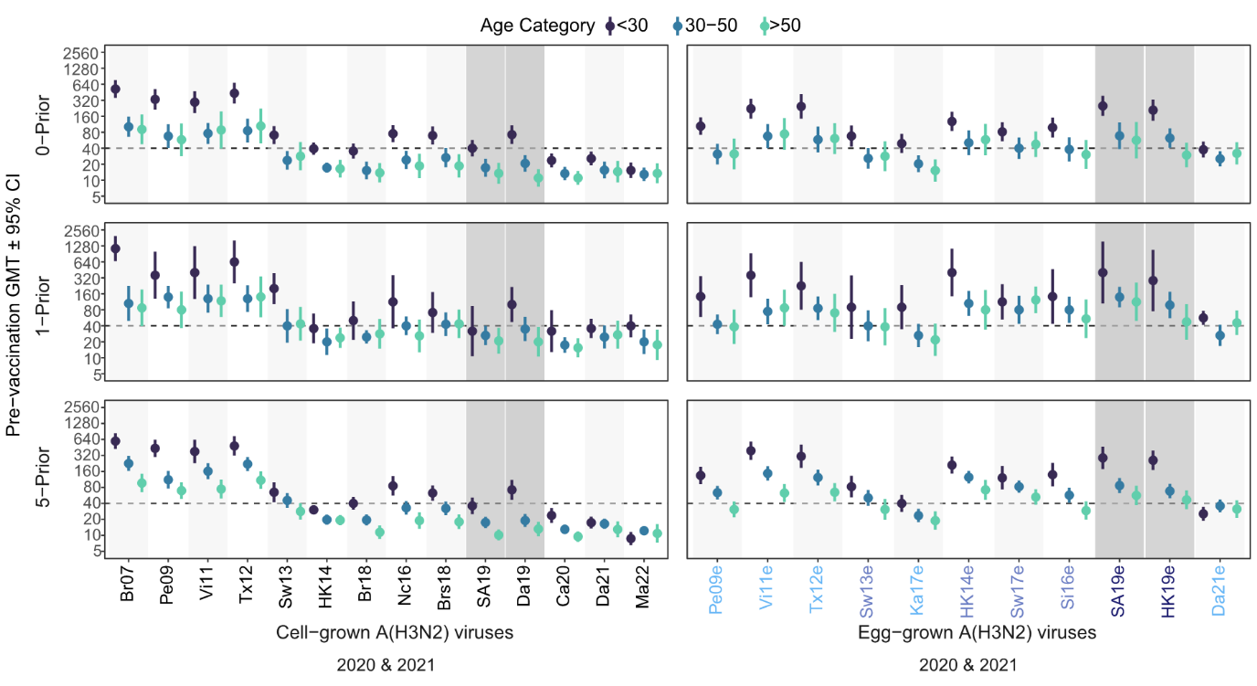
Figure S4. Pre-vaccination HI antibody titres by age group and prior vaccination group. Panels are divided by prior vaccination group (0-Prior = top; 1-Prior = middle; 5-Prior = bottom) and show pre-vaccination GMTs against 14 cell-grown viruses (left panels) or 11 egg-grown viruses (right panels) for each age group (see legend). Points represent GMTs and vertical bars represent 95% confidence intervals. Virus names are abbreviated and coloured according to the scheme defined in Figure 1A.
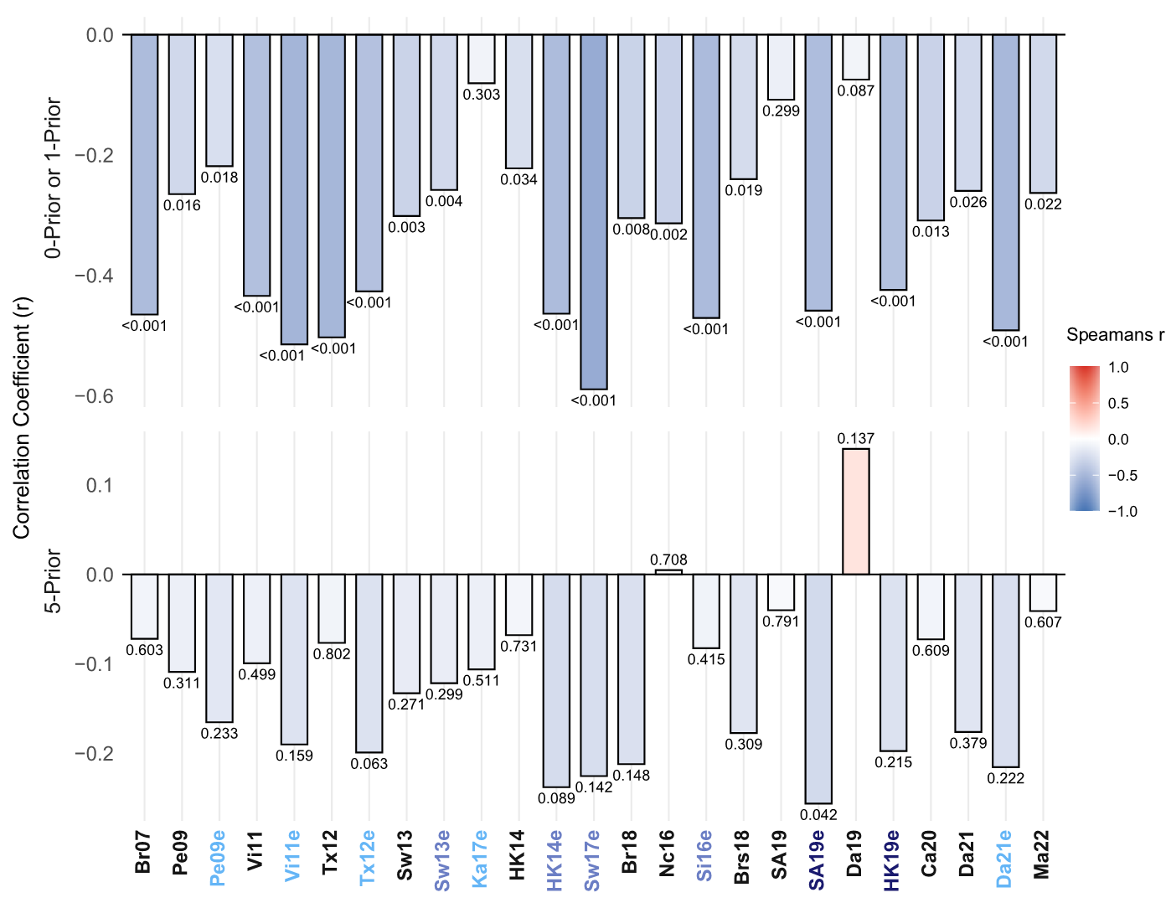
Figure S5. Correlation between pre-vaccination HI antibody titre and post-vaccination (Day 14) antibody fold-rise. Data from the 2020 and 2021 cohort are combined. Spearman’s rank correlation coefficient (r) between log₂ transformed pre-vaccination HI titres and day 14 post-vaccination fold-rise for HCWs vaccinated ≤1 or 5/5 prior years and associated p-values are shown. Negative r values (blue) indicate an inverse relationship where pre-vaccination titres are associated with a lower magnitude of antibody rise. Virus names are abbreviated and coloured according to the scheme defined in Figure 1A.
Table S2. Average breath of seropositivity across A(H3N2) viruses stratified by study year, virus propagation and vaccination history.
Year | Day | Vaccination history | Cell-grown  % (95% CI) ª | p-value ^{b} | Egg-grown  % (95% CI) ª | p-value ^{b}
2020 | 0 | 0-Prior | 25 (16–34) | 0.003 | 29 (20–39) | <0.001
 |  | 5-Prior | 44 (36–52) | Reference | 62 (52–72) | Ref
 | 14 | 0-Prior | 66 (55–76) | 0.156 | 83 (75–91) | 0.422
 |  | 5-Prior | 56 (46–65) | Ref | 78 (68–88) | Ref
2021 | 0 | 0-Prior | 45 (28–61) | 1 | 61 (44–79) | 0.795
 |  | 1-Prior | 45 (25–64) | 1 | 57 (38–77) | 0.795
 |  | 5-Prior | 43 (33–54) | Ref | 64 (51–77) | Ref
 | 14 | 0-Prior | 75 (64–87) | 0.021 | 95 (90–100) | 0.021
 |  | 1-Prior | 72 (55–89) | 0.102 | 87 (72–101) | 0.448
 |  | 5-Prior | 54 (44–65) | Ref | 81 (71–90) | Ref
a: mean percentage of 14 egg-grown viruses or 11 egg-grown viruses against which participants in each prior vaccination group were seropositive, presented with 95% confidence intervals (CI)
b: p-values were obtained from unpaired t-tests and adjusted for multiple testing using Benjamini-Hochberg false discovery rate methods.

Table S3. Breadth of model-predicted seroconversion across A(H3N2) viruses by day 14, stratified by study year, virus propagation and vaccination history.
Year | Vaccination history | Cell-grown % (95%CI) ª | Egg-grown % (95%CI) ª
2020 | 0-Prior | 51 (39–63) | 73 (62–84)
 | 5-Prior | 3 (0–5) | 6 (0–13)
2021 | 0-Prior | 37 (11–63) | 56 (29–83)
 | 1-Prior | 17 (5–29) | 23 (8–37)
 | 5-Prior | 7 (0–16) | 12 (0–24)
a: mean percentage of 14 egg-grown viruses or 11 egg-grown viruses against which participants in each prior vaccination group were predicted to seroconvert, presented with 95% confidence intervals (CI)

Table S4. Model-predicted day 14 titre-rises averaged across A(H3N2) viruses, with 95% confidence intervals (CI), grouped by year of inclusion as a vaccine strain.
Year | Propagation system | Prior vaccination | Virus category ª | GMR (95% CI)
2020 | Cell | 0-Prior | Distant past | 6.87 (6.69–7.04)
 |  |  | Recent past | 2.98 (2.86–3.10)
 |  |  | Prevailing | 2.31 (2.23–2.39)
 |  |  | Future | 2.13 (2.07–2.20)
 |  | 5-Prior | Distant past | 2.67 (2.60–2.74)
 |  |  | Recent past | 1.16 (1.11–1.21)
 |  |  | Prevailing | 0.90 (0.87–0.93)
 |  |  | Future | 0.83 (0.80–0.86)
2021 | Cell | 0-Prior | Distant past | 9.63 (9.20–10.09)
 |  |  | Recent past | 4.01 (3.74–4.29)
 |  |  | Prevailing | 3.82 (3.61–4.05)
 |  |  | Future | 2.76 (2.64–2.88)
 |  | 1-Prior | Distant past | 5.26 (5.04–5.48)
 |  |  | Recent past | 2.19 (2.06–2.32)
 |  |  | Prevailing | 2.09 (1.96–2.22)
 |  |  | Future | 1.50 (1.44–1.57)
 |  | 5-Prior | Distant past | 3.44 (3.33–3.55)
 |  |  | Recent past | 1.43 (1.36–1.50)
 |  |  | Prevailing | 1.36 (1.31–1.42)
 |  |  | Future | 0.98 (0.95–1.01)
2020 | Egg | 0-Prior | Distant past | 5.73 (5.50–5.98)
 |  |  | Recent past | 4.95 (4.75–5.15)
 |  |  | Prevailing | 7.85 (7.59–8.13)
 |  |  | Future | 4.00 (3.70–4.32)
 |  | 5-Prior | Distant past | 2.23 (2.13–2.33)
 |  |  | Recent past | 1.92 (1.84–2.01)
 |  |  | Prevailing | 3.05 (2.95–3.16)
 |  |  | Future | 1.55 (1.43–1.69)
2021 | Egg | 0-Prior | Distant past | 8.04 (7.43–8.70)
 |  |  | Recent past | 7.50 (6.95–8.09)
 |  |  | Prevailing | 7.80 (7.37–8.27)
 |  |  | Future | 4.03 (3.80–4.27)
 |  | 1-Prior | Distant past | 4.39 (4.10–4.70)
 |  |  | Recent past | 4.09 (3.83–4.36)
 |  |  | Prevailing | 4.26 (4.01–4.53)
 |  |  | Future | 2.20 (2.07–2.34)
 |  | 5-Prior | Distant past | 2.87 (2.72–3.03)
 |  |  | Recent past | 2.67 (2.54–2.81)
 |  |  | Prevailing | 2.78 (2.67–2.90)
 |  |  | Future | 1.44 (1.38–1.50)
a: categorized by year(s) that viruses were components of vaccines: Distant Past: 2008-14; Recent Past: 2015-19 (enrolled 2020) or 2016-20 (enrolled 2021); Future 2021-22 (enrolled 2020) or 2022 (enrolled 2021)
Table S5. HA binding IgG titre-rises and seroconversion by day 14: comparison between prior vaccination groups.
Year | HA constructs ª | Prior vaccination | GMR (95% CI) ^{b} | Seroconversion %
2020 | HK14 rHA1 | 0-Prior | 5.67 (3.66–8.78) | 50%
 |  | 5-Prior | 1.93 (1.66–2.25) | 10%
 | HK14 rHA0 | 0-Prior | 6.04 (4.33–8.42) | 50%
 |  | 5-Prior | 2.14 (1.77–2.58) | 16%
 | HK19 rHA0 | 0-Prior | 3.89 (2.69–5.63) | 48%
 |  | 5-Prior | 1.49 (1.26–1.76) | 10%
 | A(H3N2) HA2 | 0-Prior | 2.92 (1.97–4.33) | 33%
 |  | 5-Prior | 1.29 (1.15–1.45) | 0%
 | Swine A(H3N2) HA0 | 0-Prior | 1.89 (1.57–2.28) | 12%
 |  | 5-Prior | 1.47 (1.27–1.69) | 5%
2021 | HK14 rHA1 | 0-Prior | 4.34 (1.78–10.53) | 42%
 |  | 1-Prior | 3.71 (1.82–7.56) | 44%
 |  | 5-Prior | 1.33 (1.07–1.66) | 10%
 | HK14 rHA0 | 0-Prior | 4.25 (1.64–11.06) | 42%
 |  | 1-Prior | 3.34 (1.73–6.47) | 31%
 |  | 5-Prior | 1.35 (1.08–1.67) | 7%
 | HK19 rHA0 | 0-Prior | 5.66 (2.60–12.35) | 58%
 |  | 1-Prior | 3.83 (2.63–5.57) | 44%
 |  | 5-Prior | 2.01 (1.66–2.45) | 21%
 | A(H3N2) HA2 | 0-Prior | 2.75 (1.58–4.79) | 36%
 |  | 1-Prior | 1.38 (0.99–1.91) | 0%
 |  | 5-Prior | 1.23 (1.09–1.39) | 0%
 | Swine A(H3N2) HA0 | 0-Prior | 2.48 (1.65–3.72) | 17%
 |  | 1-Prior | 1.87 (1.45–2.41) | 6%
 |  | 5-Prior | 1.45 (1.22–1.72) | 6%
a: recombinant proteins representing the HA1 domain of A/Hong Kong/4801/2014 (HK14 rHA1); full length A/Hong Kong/4801/2014 (HK14 rHA0); full length A/Hong Kong/2671/2019 (HK19 rHA0); generic HA2 domain (A(H3N2) HA2; and full length A/swine/Colorado/A01203748/2012 (Swine A(H3N2) HA0)
b: geometric mean ratio (GMR) with 95% confidence intervals (CI)
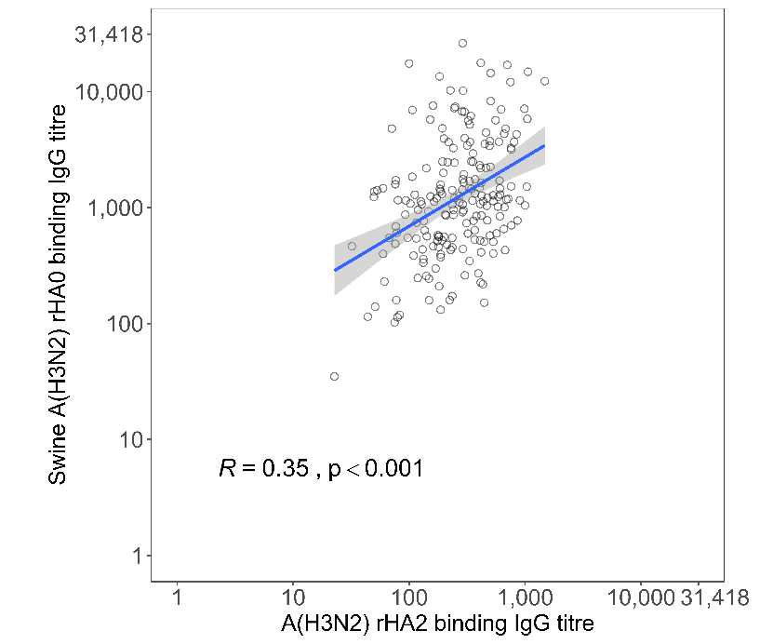
Figure S6. Correlation between A(H3N2) hemagglutinin (HA) stem-binding antibodies and binding to full length swine A(H3N2). Scatter plot showing the relationship between A(H3N2) rHA2 (stem) binding IgG titre and rHA0 (full-length) swine 2012 binding IgG titre. Each point represents an individual sample. The solid line indicates the fitted linear regression with shaded area showing the 95% confidence interval. Spearman’s rank correlation coefficient (r) and correspond p-value are shown.

