Supporting Information

Meta-analysis of biochar-driven changes in soil antibiotic resistance genes: toward mitigation strategies
Congying Wang ^{a,*}, Wenwen Zhang ª, Zhongyu Zhaoª, Yonghua Zhao^{b,}*
ª School of Environmental & Resource Sciences, Shanxi University, Taiyuan 030006, China
^{b} Shaanxi Key Laboratory of Land Consolidation, School of Land Engineering,
Chang’an University, Xi’an, 710064, PR China
*Corresponding author: Congying Wang, Yonghua Zhao
E-mail: wangcongying@sxu.edu.cn (Congying Wang); yonghuaz@chd.edu.cn (Yonghua Zhao)
Tel: +86 351 7010393; Fax: +86 351 7010393

Contents of this file
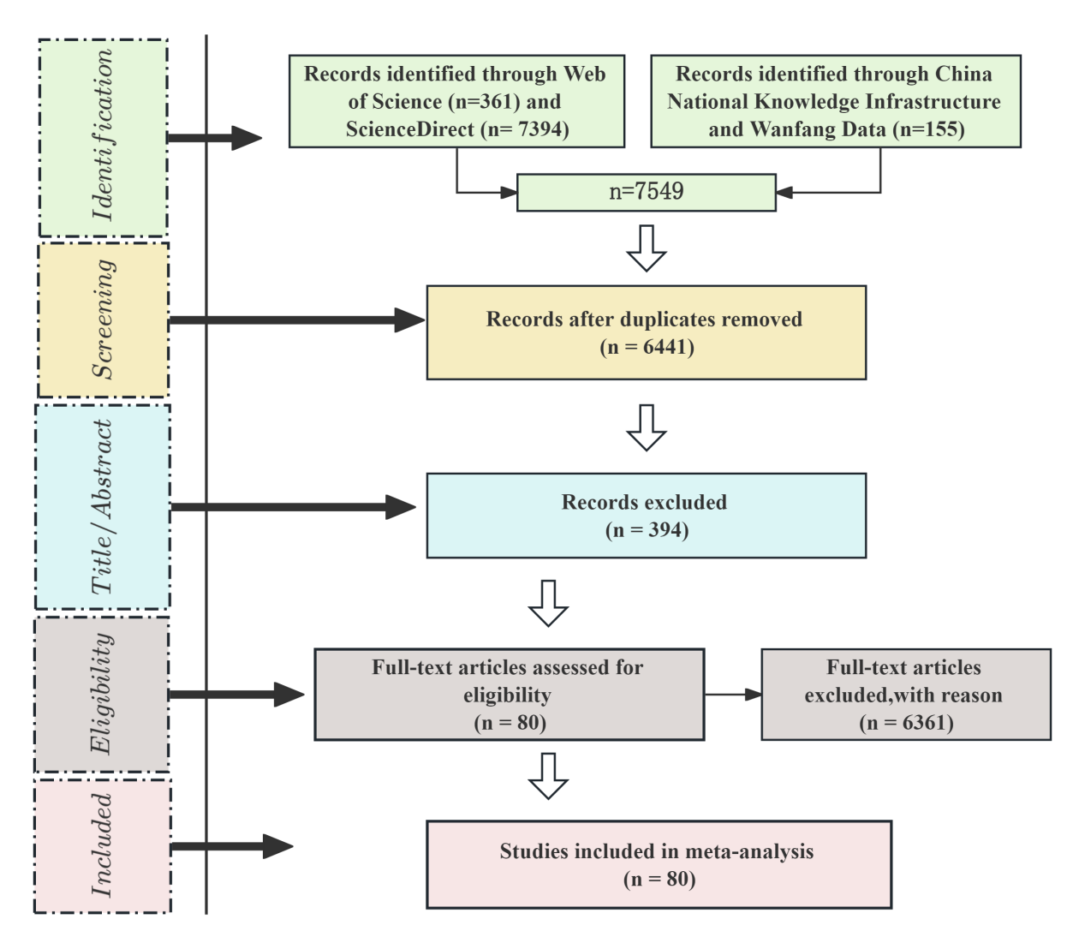
Fig. S1 The PRISMA flow diagram for the current meta-analysis.
The list of 80 studies used in this paper

The 80 studies used in this paper
Ajibade, F.O., Yin, W.-X., Guadie, A., Ajibade, T.F., Liu, Y., Kumwimba, M.N., Liu, W.-Z., Han, J.-L., Wang, H.-C., Wang, A.-J., 2023. Impact of biochar amendment on antibiotic removal and ARGs accumulation in constructed wetlands for low C/N wastewater treatment. Chem. Eng. J. 459, 141541.
An, X.-L., Chen, Q.-L., Zhu, D., Su, J.-Q., 2018. Distinct effects of struvite and biochar amendment on the class 1 integron antibiotic resistance gene cassettes in phyllosphere and rhizosphere. Sci. Total Environ. 631-632, 668-676.
Chen, Q.-L., Fan, X.-T., Zhu, D., An, X.-L., Su, J.-Q., Cui, L., 2018. Effect of biochar amendment on the alleviation of antibiotic resistance in soil and phyllosphere of Brassica chinensis L. Soil Biol. Biochem. 119, 74-82.
Cheng, D., Xiong, J., Chen, J., Chang, H., Wong, J.W.C., 2025. Effect of biochar addition on antibiotic and heavy metal resistance genes during sewage sludge composting. J. Environ. Chem. Eng. 13, 115732.
Cheng, J.-H., Tang, X.-Y., Su, J.-Q., Liu, C., 2021. Field aging alters biochar's effect on antibiotic resistome in manured soil. Environ. Pollut. 288, 117719.
Cheng, P., Chen, J., Tariq, M., Tang, L., Hong, Z., Iqbal, B., Khan, I., Li, G., Du, D., Liu, T., 2025. Role of biochar in reducing polyethylene and polylactic acid microplastic co-contamination with antibiotics in soil-vegetable systems. Process Saf. Environ. Prot. 201, 107541.
Cheng, Y., Wang, X., Zhao, L., Zhang, X., Kong, Q., Li, H., You, X., Li, Y., 2023. Wheat straw pyrochar more efficiently decreased enantioselective uptake of dinotefuran by lettuce and dissemination of antibiotic resistance genes than pyrochar in an agricultural soil. Journal Pre-proof.
Choi, G., Brady, J.A., Obayomi, O., Green, E., Leija, C., Sefcik, K., Gonzalez, D.A., Taggart, C.B., Muir, J.P., Kan, E., 2024. Wood- and manure-derived biochars reduce antibiotic residues and shift antibiotic resistance genes and microbial communities in manure applied forage-soil systems. Agronomy 14, 2100.
Cui, E., Wu, Y., Zuo, Y., Chen, H., 2016. Effect of different biochars on antibiotic resistance genes and bacterial community during chicken manure composting. Bioresour. Technol. 203, 11-17.
Cui, E., Wu, Y., Jiao, Y., Zuo, Y., Rensing, C., Chen, H., 2017. The behavior of antibiotic resistance genes and arsenic influenced by biochar during different manure composting. Environ Sci Pollut Res 24, 14484-14490.
Cui, E.-P., Gao, F., Liu, Y., Fan, X.-Y., Li, Z.-Y., Du, Z.-J., Hu, C., Neal, A.L., 2018. Amendment soil with biochar to control antibiotic resistance genes under unconventional water resources irrigation: proceed with caution. Environ. Pollut. 240, 475-484.
Ding, J., Yin, Y., Sun, A.-Q., Lassen, S.B., Li, G., Zhu, D., Ke, X., 2019. Effects of biochar amendments on antibiotic resistome of the soil and collembolan gut. J. Hazard. Mater. 377, 186-194.
Dong, Z.K., 2022. Migration and control of antibiotic resistance genes in the soil-plant system under chicken manure application. Master’s Thesis, Shandong Agricultural University. (in Chinese)
Duan, M., Li, H., Gu, J., Tuo, X., Sun, W., Qian, X., Wang, X., 2017. Effects of biochar on reducing the abundance of oxytetracycline, antibiotic resistance genes, and human pathogenic bacteria in soil and lettuce. Environ. Pollut. 224, 787-795.
Duan, M., Li, Z., Yan, R., Zhou, B., Su, L., Li, M., Xu, H., Zhang, Z., 2023. Mechanism for combined application of biochar and Bacillus cereus to reduce antibiotic resistance genes in copper contaminated soil and lettuce. Sci. Total Environ. 884, 163422.
Fu, Y., Zhang, A., Guo, T., Zhu, Y., Shao, Y., 2021. Biochar and hyperthermophiles as additives accelerate the removal of antibiotic resistance genes and mobile genetic elements during composting. Materials 14, 5428.
Gong, X., Shi, W., Zhang, Z., Luo, M., Zhang, B., Wan, S., Huang, J., 2024. Exploring the effects of zeolite, biochar, and diatomite as additives for enhancing heavy metals passivation and eliminating antibiotic resistance genes in composts during vermicomposting of dewatered sludge and green waste. J. Environ. Chem. Eng. 12, 112201.
Guo, H., Gu, J., Wang, X., Yu, J., Nasir, M., Peng, H., Zhang, R., Hu, T., Wang, Q., Ma, J., 2019. Responses of antibiotic and heavy metal resistance genes to bamboo charcoal and bamboo vinegar during aerobic composting. Environ. Pollut. 252, 1097-1105.
He, L.-Y., He, L.-K., Gao, F.-Z., Wu, D.-L., Zou, H.-Y., Bai, H., Zhang, M., Ying, G.-G., 2021. Dissipation of antibiotic resistance genes in manure-amended agricultural soil. Sci. Total Environ. 787, 147582.
He, Y., Yin, X., Li, F., Wu, B., Zhu, L., Ge, D., Wang, N., Chen, A., Zhang, L., Yan, B., Huang, H., Luo, L., Wu, G., Zhang, J., 2023. Response characteristics of antibiotic resistance genes and bacterial communities during agricultural waste composting: focusing on biogas residue combined with biochar amendments. Bioresour. Technol. 372, 128636.
He, Y., Zhao, X., Zhu, S., Yuan, L., Li, X., Feng, Z., Yang, X., Luo, L., Xiao, Y., Liu, Y., Wang, L., Deng, O., 2023. Conversion of swine manure into biochar for soil amendment: efficacy and underlying mechanism of dissipating antibiotic resistance genes. Sci. Total Environ. 871, 162046.
Huang, K., Chen, J., Guan, M., Xia, H., Lin, L., 2020. Effects of biochars on the fate of antibiotics and their resistance genes during vermicomposting of dewatered sludge. J. Hazard. Mater. 397, 122767.
Jang, H.M., Kan, E., 2022. Enhanced removal of antibiotic resistance genes and human bacterial pathogens during anaerobic digestion of dairy manure via addition of manure biochar. Chemosphere 304, 135178.
Jauregi, L., González, A., Garbisu, C., Epelde, L., 2023. Organic amendment treatments for antimicrobial resistance and mobile element genes risk reduction in soil-crop systems. Sci. Rep. 13, 863.
Jiao, W., Du, R., Ye, M., Sun, M., Feng, Y., Wan, J., Zhao, Y., Zhang, Z., Huang, D., Du, D., Jiang, X., 2018. 'Agricultural waste to treasure' - biochar and eggshell to impede soil antibiotics/antibiotic resistant bacteria (genes) from accumulating in Solanum tuberosum L. Environ. Pollut. 242, 2088-2095.
Karamova, K., Danilova, N., Selivanovskaya, S., Galitskaya, P., 2022. The impact of chicken manure biochar on antibiotic resistance genes in chicken manure composting. Agriculture 12, 1158.
Li, H., Duan, M., Gu, J., Zhang, Y., Qian, X., Ma, J., Zhang, R., Wang, X., 2017. Effects of bamboo charcoal on antibiotic resistance genes during chicken manure composting. Ecotoxicol. Environ. Saf. 140, 1-6.
Li, Y., Wang, X., Li, J., Wang, Y., Song, J., Xia, S., Jing, H., Zhao, J., 2019. Effects of struvite-humic acid loaded biochar/bentonite composite amendment on Zn(II) and antibiotic resistance genes in manure-soil. Chem. Eng. J. 375, 122012.
Li, Y., Wang, X., Wang, Y., Wang, F., Xia, S., Zhao, J., 2020. Struvite-supported biochar composite effectively lowers Cu bio-availability and the abundance of antibiotic-resistance genes in soil. Sci. Total Environ. 724, 138294.
Li, Y., Zhong, W., Ning, Z., Feng, J., Niu, J., Li, Z., 2022. Effect of biochar on antibiotic resistance genes in the anaerobic digestion system of antibiotic mycelial dreg. Bioresour. Technol. 364, 128052.
Li, Z., Shen, J., Wang, F., Wang, M., Shen, J., Li, Y., Zhu, Q., Wu, J., 2023. Impacts of organic materials amendment on the soil antibiotic resistome in subtropical paddy fields. Front. Microbiol. 13, 1075234.
Liang, Y., Pei, M., Wang, D., Cao, S., Xiao, X., Sun, B., 2017. Improvement of soil ecosystem multifunctionality by dissipating manure-induced antibiotics and resistance genes. Environ. Sci. Technol. 51, 4988-4998.
Lin, Z., Rui, Z., Liu, M., Bian, R., Liu, X., Lu, H., Cheng, K., Zhang, X., Zheng, J., Li, L., Drosos, M., Joseph, S., Ishwaran, N., Pan, G., 2020. Pyrolyzed biowastes deactivated potentially toxic metals and eliminated antibiotic resistant genes for healthy vegetable production. J. Clean. Prod. 276, 124208.
Netthisinghe, A.M.P., Cook, K.L., Gilfillen, R.A., Woosley, P.B., Kingery, T., Sistani, K.R., 2018. Managing beef backgrounding residual soil contaminants by alum and biochar amendments. J. Environ. Qual. 47, 1275-1283.
Ngigi, A.N., Ok, Y.S., Thiele-Bruhn, S., 2020. Biochar affects the dissipation of antibiotics and abundance of antibiotic resistance genes in pig manure. Bioresour. Technol. 315, 123782.
Pan, Q., Zhang, Y., Zhang, X., Yang, Y., Huang, K., Liu, C., 2025. Co-exposure of pyraclostrobin and biochar promoted antibiotic resistance genes transfer from soil to lettuce. J. Hazard. Mater. 489, 137756.
Qian, X., Gu, J., Sun, W., Wang, X., Li, H., 2019. Effects of passivators on antibiotic resistance genes and related mechanisms during composting of copper-enriched pig manure. Sci. Total Environ. 674, 383-391.
Qin, J., Li, J., Pei, H., Li, Q., Cheng, D., Zhou, J., Pei, G., Wang, Y., Liu, F., 2024. Effective remediation and phytotoxicity assessment of oxytetracycline and Cd co-contaminated soil using biochar. Environ. Technol. Innov. 35, 103649.
Qiu, L., Wu, J., Qian, Y., Nafees, M., Zhang, J., Du, W., Yin, Y., Guo, H., 2021. Impact of biochar-induced vertical mobilization of dissolved organic matter, sulfamethazine and antibiotic resistance genes variation in a soil-plant system. J. Hazard. Mater. 417, 126022.
Qiu, L., Niu, L., Nafees, M., Zhou, S., Wu, W., Du, J., Zhou, Q., Jin, M., Guo, H., 2025. Mechanisms for sulfadiazine effective mitigation in biochar-amended soil: from antibiotic resistance to soil microbial community composition and function. J. Environ. Manage. 386, 125702.
Qiu, X., Zhou, G., Wang, H., Wu, X., 2021. The behavior of antibiotic- resistance genes and their relationships with the bacterial community and heavy metals during sewage sludge composting. Ecotoxicol. Environ. Saf. 216, 112190.
Shan, G., Liu, J., Zhu, B., Tan, W., Li, W., Tang, Z., Hu, X., Zhu, L., Xi, B., 2023. Effect of hydrochar on antibiotic-resistance genes and relevant mechanisms during chicken manure composting. J. Hazard. Mater. 454, 131459.
Shan, M., Zheng, C., Song, J., Qiu, M., Huang, C., Cui, M., Wang, J., Chen, W., Zhang, L., Yu, Y., Fang, H., 2024. Biochar and theaflavins mitigate the antibiotic resistome and antibiotic-resistant pathogens in a soil-lettuce continuum. J. Hazard. Mater. 480, 135821.
Shi, S., Tong, Z., Sun, B., Wei, Y., Tian, Y., Zuo, Q., Qiao, X., Duan, J., Bi, W., Qin, J., Zhou, J., Liu, F., 2025. Application of compost amended with biochar on the distribution of antibiotic resistance genes in a soil-cucumber system-from the perspective of high-dose fertilization. Front. Microbiol. 16, 1530296.
Shi, Z., Zhang, P., Liu, Y., Zhao, Y., Wang, C., 2022. Accumulation of antibiotic resistance genes in pakchoi (Brassica chinensis L.) grown in chicken manure-fertilized soil amended with fresh and aged biochars. Environ. Sci. Pollut. Res. 29, 39410-39420.
Sun, L., Tang, D., Tai, X., Wang, J., Long, M., Xian, T., Jia, H., 2023. Effect of composted pig manure, biochar, and their combination on antibiotic resistome dissipation in swine wastewater-treated soil. Environ. Pollut. 323, 121323.
Sun, W., Gu, J., Wang, X., Qian, X., Tuo, X., 2018. Impacts of biochar on the environmental risk of antibiotic resistance genes and mobile genetic elements during anaerobic digestion of cattle farm wastewater. Bioresour. Technol. 256, 342-349.
Tian, S., Sun, X., Xiao, H., Zhou, Y., Huang, X., An, X.-L., Liu, C., Su, J.-Q., 2023. Evaluation of rice straw and its transformation products on norfloxacin degradation and antibiotic resistome attenuation during soil incorporation. Chemosphere 313, 137451.
Tong, Z., Liu, F., Tian, Y., Zhang, J., Liu, H., Duan, J., Bi, W., Qin, J., Xu, S., 2022. Effect of biochar on antibiotics and antibiotic resistance genes variations during co-composting of pig manure and corn straw. Front. Bioeng. Biotechnol. 10, 1024384.
Tong, Z., Liu, F., Sun, B., Tian, Y., Zhang, J., Duan, J., Bi, W., Qin, J., Xu, S., 2023. Effect of biochars with different particle sizes on fates of antibiotics and antibiotic resistance genes during composting of swine manure. Bioresour. Technol. 370, 128542.
Wang, A., Zou, D., O’Connor, P., Chen, B., Zou, J., Zhou, Y., Wang, H., Zhang, M., 2023. Assistant effects of spent mushroom substrate and its derived biochar on soil phytoremediation. J. Soils Sediments 23, 1641-1653.
Wang, G., Chu, Y., Zhu, J., Sheng, L., Liu, G., Xing, Y., Fu, P., Li, Q., Chen, R., 2022. Multi-faceted influences of biochar addition on swine manure digestion under tetracycline antibiotic pressure. Bioresour. Technol. 346, 126352.
Wang, J., Sui, B., Shen, Y., Meng, H., Zhao, L., Zhou, H., Li, R., Ding, J., Cheng, H., Zhang, X., 2018. Effects of different biochars on antibiotic resistance genes during swine manure thermophilic composting. Int. J. Agric. Biol. Eng. 11(6), 166-171.
Wang, Y.-Z., Zhou, S.-Y.-D., Zhou, X.-Y., An, X.-L., Su, J.-Q., 2022. Manure and biochar have limited effect on lettuce leaf endophyte resistome. Sci. Total Environ. 860, 160515.
Wang, Z., Sun, Y., Wang, X., Xia, S., Zhao, J., 2025. Biochar reversed antibiotic resistance genes spread in biodegradable microplastics and Cu co-contaminated soil by lowering Cu bio-availability and regulating denitrification process. J. Environ. Chem. Eng. 13, 115761.
Werner, K.A., Schneider, D., Poehlein, A., Diederich, N., Feyen, L., Axtmann, K., Hübner, T., Brüggemann, N., Prost, K., Daniel, R., Grohmann, E., 2022. Metagenomic insights into the changes of antibiotic resistance and pathogenicity factor pools upon thermophilic composting of human excreta. Front. Microbiol. 13, 826071.
Wu, R., Ma, Y., Jiang, Y., 2023. Effect of composted pig manure, biochar, and their combination on antibiotic resistome dissipation in swine wastewater-treated soil. Environ. Pollut. 323, 121323.
Wu, Z., Zhang, L., Lin, H., Zhou, S., 2024. Enhanced removal of antibiotic resistance genes during chicken manure composting after combined inoculation of Bacillus subtilis with biochar. J. Environ. Sci. 135, 274- 284.
Xie, J., Gu, J., Wang, X., Hu, T., Sun, W., Lei, L., Zhang, R., Guo, H., 2021. Insights into the beneficial effects of woody peat for reducing abundances of antibiotic resistance genes during composting. Bioresour. Technol. 342, 125903.
Xu, S., Duan, Y., Zou, S., Liu, H., Luo, L., Wong, J.W.C., 2022. Evaluations of biochar amendment on anaerobic co-digestion of pig manure and sewage sludge: waste-to-methane conversion, microbial community, and antibiotic resistance genes. Bioresour. Technol. 346, 126400.
Yang, S., Chen, Z., Wen, Q., 2021. Impacts of biochar on anaerobic digestion of swine manure: methanogenesis and antibiotic resistance genes dissemination. Bioresour. Technol. 324, 124679.
Yang, S., Wen, Q., Chen, Z., 2022. Biochar induced inhibitory effects on intracellular and extracellular antibiotic resistance genes in anaerobic digestion of swine manure. Environ. Res. 212, 113530.
Yao, Y., Yang, P., Wang, B., Xu, Q., Song, F., Wang, Y., Zhao, Y., Guo, L., Wang, X., Xu, M., 2025. Divergent mitigation mechanisms of soil antibiotic resistance genes by biochar from different agricultural wastes. Environ. Pollut. 374, 126247.
Ye, M., Sun, M., Feng, Y., Li, X., Schwab, A.P., Wan, J., Liu, M., Tian, D., Liu, K., Wu, J., Jiang, X., 2016. Calcined eggshell waste for mitigating soil antibiotic-resistant bacteria/antibiotic resistance gene dissemination and accumulation in bell pepper. J. Agric. Food Chem. 64, 5446-5453.
Ye, M., Sun, M., Feng, Y., Wan, J., Xie, S., Tian, D., Zhao, Y., Wu, J., Hu, F., Li, H., Jiang, X., 2016. Effect of biochar amendment on the control of soil sulfonamides, antibiotic-resistant bacteria, and gene enrichment in lettuce tissues. J. Hazard. Mater. 309, 219-227.
Ye, M., Sun, M., Zhao, Y., Jiao, W., Xia, B., Liu, M., Feng, Y., Zhang, Z., Huang, D., Huang, R., Wan, J., Du, R., Jiang, X., Hu, F., 2018. Targeted inactivation of antibiotic-resistant Escherichia coli and Pseudomonas aeruginosa in a soil-lettuce system by combined polyvalent bacteriophage and biochar treatment. Environ. Pollut. 241, 978-987.
Zhang, G., Ren, R., Li, L., Zhu, Y., Miao, J., Li, Y., Meng, S., 2022. Positive and negative effects of nanoscale zero-valent iron-enriched biochar on sulfamethoxazole remediation in contaminated soil. Ecotoxicol. Environ. Saf. 246, 114133.
Zhang, G., Ren, R., Yan, X., Zhu, Y., Zhang, H., Yan, G., 2025. The key role of magnetic iron-to-biochar mass ratios in the dissipation of oxytetracycline and its resistance genes in soils with and without biodegradable microplastics. J. Environ. Manage. 377, 124658.
Zhang, M., Xu, Y., Wang, J., Hu, J., Qi, S., Jiang, Z., Yang, S., 2024. Impact of biochar on the antibiotic resistome and associated microbial functions in rhizosphere and bulk soil in water-saving and flooding irrigated paddy fields. Environ. Pollut. 342, 123026.
Zhang, R., Gong, C., Zhao, Y., Gao, Y., Zhang, Y., Zhuang, H., Shan, S., 2025. Biochar based fertilizer reduce the abundance of antibiotic resistance genes in rice soil. J. Soil Sci. Plant Nutr. 25, 1375-1385.
Zhang, X., Gong, Z., Allinson, G., Li, X., Jia, C., 2022. Joint effects of bacterium and biochar in remediation of antibiotic-heavy metal contaminated soil and responses of resistance gene and microbial community. Chemosphere 299, 134333.
Zhang, Y., Chen, M., Bao, C., Wu, J., Zhou, J., He, W., Shi, X., Li, G., 2022. Application of pig manure compost with different biochar modifies the antibiotic resistome and bacterial community in agriculture soil. Water Air Soil Pollut. 233, 108.
Zhao, Y.C., Ye, M., Sun, M.M., Zhang, Z.Y., Huang, D., Zhu, G.F., Zheng, X.X., Chao, H.Z., Feng, Y.F., Wu, J., Hu, F., Jiang, X., 2019. Combined biochar and bacteriophage to control and inactivate antibiotic-resistant pathogenic bacteria in a soil-lettuce system. Soils 51, 942-948. (in Chinese)
Zheng, H., Wang, R., Zhang, Q., Zhao, J., Li, F., Luo, X., Xing, B., 2020. Pyroligneous acid mitigated dissemination of antibiotic resistance genes in soil. Environ. Int. 145, 106158.
Zheng, H., Feng, N., Yang, T., Shi, M., Wang, X., Zhang, Q., Zhao, J., Li, F., Sun, K., Xing, B., 2021. Individual and combined applications of biochar and pyroligneous acid mitigate dissemination of antibiotic resistance genes in agricultural soil. Sci. Total Environ. 796, 148962.
Zhou, G., Qiu, X., Wu, X., Lu, S., 2021. Horizontal gene transfer is a key determinant of antibiotic resistance genes profiles during chicken manure composting with the addition of biochar and zeolite. J. Hazard. Mater. 408, 124883.
Zhou, X., Qiao, M., Su, J.-Q., Wang, Y., Cao, Z.-H., Cheng, W.-D., Zhu, Y.-G., 2019. Turning pig manure into biochar can effectively mitigate antibiotic resistance genes as organic fertilizer. Sci. Total Environ. 649, 902-908.
Zhou, Z., Song, Z., Gu, J., Wang, X., Hu, T., Guo, H., Xie, J., Lei, L., Ding, Q., Jiang, H., Xu, L., 2022. Dynamics and key drivers of antibiotic resistance genes during aerobic composting amended with plant-derived and animal manure-derived biochars. Bioresour. Technol. 355, 127236.
Zhou, Z., Cui, E., Abid, A.A., Zhu, L., Xu, J., Chen, H., 2024. Evaluating the impact of biochar amendment on antibiotic resistance genes and microbiome dynamics in soil, rhizosphere, and endosphere at field scale. J. Hazard. Mater. 477, 135440.
Zhu, P., Wu, Y., Ru, Y., Hou, Y., San, K.W., Yu, X., Guo, W., 2022. Industrial-scale aerobic composting of livestock manures with the addition of biochar: variation of bacterial community and antibiotic resistance genes caused by various composting stages. Environ. Pollut. 314, 120270.

