Supplementary Fig. 1 Minimum strength of unmeasured confounding required to fully explain away the observed hazard ratios (HRs) between cholecystectomy and targeted outcomes. Values in parentheses denote the E-values for the point estimate (blue curve) and the lower limit of the 95% confidence interval (red curve), respectively. Abbreviations: CI, confidence interval; CLD, chronic liver disease; COPD, chronic obstructive pulmonary disease; HR, hazard ratio.

Supplementary Fig. 2 Pooled associations between cholecystectomy with risk of the major diseases stratified by age
Abbreviations: CLD, chronic liver disease; COPD, chronic obstructive pulmonary disease; GERD, gastroesophageal reflux disease; HR, hazard ratio；CI, confidence interval. The estimates were assessed based on the fully adjusted models(see the footnote in Supplementary Tables 1-2).
Supplementary Fig. 3 Pooled associations between cholecystectomy with risk of the major diseases stratified by sex
Abbreviations: CLD, chronic liver disease; COPD, chronic obstructive pulmonary disease; GERD, gastroesophageal reflux disease; HR, hazard ratio；CI, confidence interval. The estimates were assessed based on the fully adjusted models(see the footnote in Supplementary Tables 1-2).
Supplementary Fig. 4 Pooled associations between cholecystectomy with risk of the major diseases stratified by BMI
Body mass index (BMI) was stratified into three categories: normal weight (<25.0 kg/m²), overweight (25.0–29.9 kg/m²), and obesity (≥30.0 kg/m²). Individuals with underweight (BMI <18.5 kg/m²) were merged into the normal weight category due to the extremely limited sample size. Abbreviations: CLD, chronic liver disease; COPD, chronic obstructive pulmonary disease; GERD, gastroesophageal reflux disease; HR, hazard ratio；CI, confidence interval. The estimates were assessed based on the fully adjusted models(see the footnote in Supplementary Tables 1-2).

Supplementary Fig. 5 Pooled associations between cholecystectomy with risk of the major diseases stratified by smoking status
Abbreviations: CLD, chronic liver disease; COPD, chronic obstructive pulmonary disease; GERD, gastroesophageal reflux disease; HR, hazard ratio；CI, confidence interval. The estimates were assessed based on the fully adjusted models(see the footnote in Supplementary Tables 1-2)

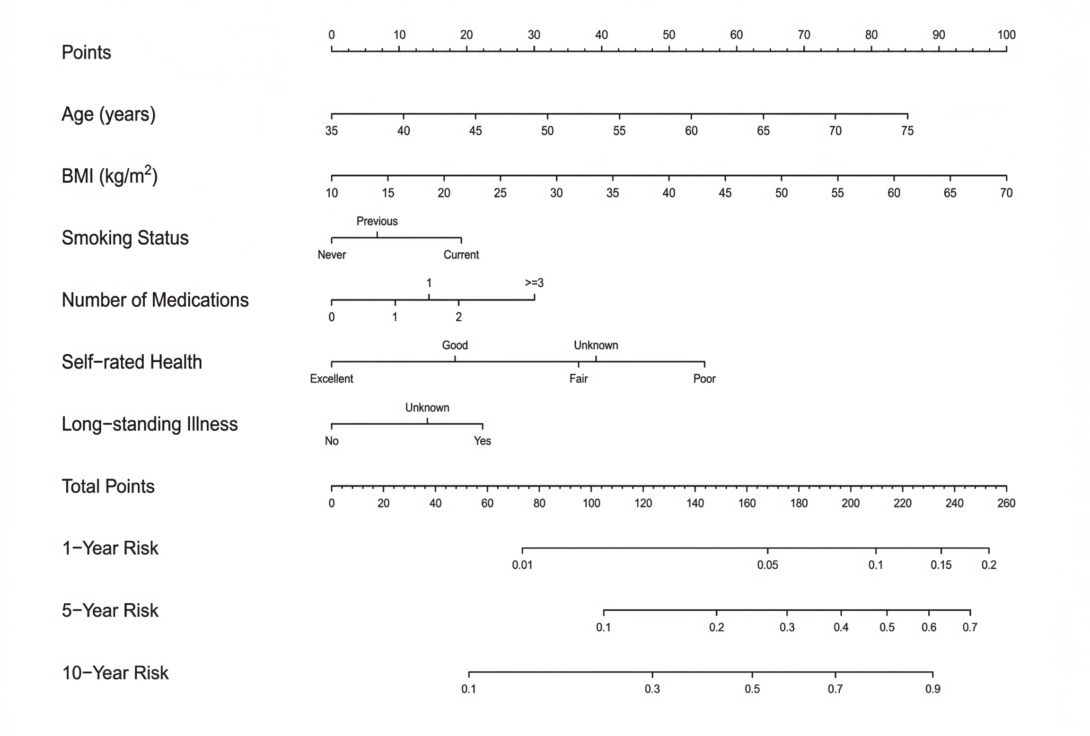
Supplementary Fig. 6 Nomogram for predicting the 1-, 5-, and 10-year probability of any of the 15 major diseases associated with cholecystectomy. By drawing an upward vertical line from the corresponding value of each of the six predictors (age, BMI, smoking, drug_count, Health_R, and illness_L) to the top “Points” scale, a specific score for each variable is obtained. The sum of these individual scores is then located on the “Total Points” scale. Drawing a downward vertical line from this total point value reveals the estimated 1-, 5-, and 10-year risk of developing any of the 15 targeted outcomes on the respective bottom axes. Source data are provided as a Source Data file.
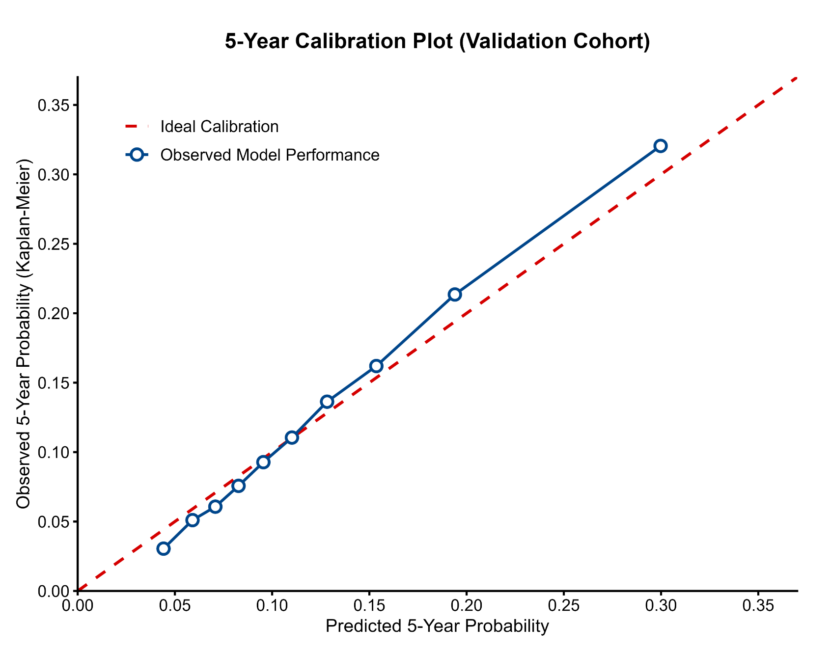
Supplementary Fig. 7 Calibration plot of the prediction model for 5-year outcomes in the validation cohort. The x-axis represents the model-predicted 5-year probability for any of the 15 major diseases associated with cholecystectomy, and the y-axis represents the actual observed 5-year probability estimated using the Kaplan-Meier method. The red dashed line represents ideal calibration, where predicted probabilities perfectly match observed probabilities. The blue line with circles indicates the observed model performance. The close alignment between the observed performance and the ideal reference line suggests that the model's predictions are well-calibrated and highly reliable.

Supplementary Table 1 | Supplementary Table 1. Definitions of the 36 targeted study outcomes and their corresponding ICD-10 codes.

Disease | ICD-10
Chronic obstructive pulmonary disease | J44
Crohn's disease | K50
Ulcerative colitis | K51
Stroke | I64
Breast cancer | C50
Knee osteoarthritis | M17
Prostate cancer | C61
Low back pain | M54
Asthma | J45
Blindness and vision loss | H54
Parkinson's disease | G20
Atrial fibrillation and flutter | I48
Depressive disorders | F32-F33
Peptic ulcer disease | K25-K27
Anxiety disorders | F41
Rheumatoid arthritis | M05
Type 2 diabetes mellitus | E11
Colorectal cancer | C18-C20
Ischemic heart disease | I20,I21,I25
Liver cancer | C22
Cirrhosis and other chronic liver diseases | K74,K76
Irritable bowel syndrome | K58
Lung cancer | C34
Kidney cancer | C64
Gastroduodenitis | K29
Stomach cancer | C16
Gastroesophageal reflux disease | K21
Bile duct cancer | C24
Pancreatic cancer | C25
Bladder cancer | C67
Road injuries | V01-V89
Alzheimer's disease | G30
Esophageal cancer | C15
Osteoporosis | M81
Hypertensive heart disease | I11
Migraine | G43
The table details the 35 specific clinical conditions selected for the primary and subgroup analyses, alongside road injuries, which served as a negative control outcome to detect potential unmeasured confounding. Diagnoses were ascertained within the UK Biobank cohort using the International Classification of Diseases, Tenth Revision (ICD-10).

Supplementary Table 2 | Detailed definitions and data sources for lifestyle covariates (healthy diet and quality sleep) in the UK Biobank.

Covariate | Source and definition
A healthy diet | UK Biobank Food Frequency Questionnaire at baseline;  At least 3 of the following 6 food groups:  1. Vegetables: ≥ 4.5 servings/day  2. Fruits: ≥ 4.5 servings/day  3. Fish: ≥2 servings/week  4. Poultry: ≥2 servings/week  5. Processed meats: ≤ 2 serving/week  6. Unprocessed red meats: ≤ 5 servings/week
Quality sleep | UK Biobank touchscreen questionnaire at baseline;  Without any one of the following 4 tips:  1. Total sleep time: >9 or <7 hours/day  2. Insomnia or sleeplessness usually  3. Snoring  4. Nap during day all the time or often

Note: A healthy diet was defined as meeting at least three of the six specified dietary criteria based on the baseline Food Frequency Questionnaire. Quality sleep was defined as the absence of all four specified adverse sleep characteristics based on the baseline touchscreen questionnaire.

Supplementary Table 5 | Sensitivity analyses of the associations between cholecystectomy and risk of target clinical outcome
 | PSM Cohort |  | 1-Year Lag |  | 2-Year Lag |  | 4-Year Lag
Disease | HR (95% CI) | P-value | HR (95% CI) | P-value | HR (95% CI) | P-value | HR (95% CI) | P-value
Breast cancer | 1.04 (0.96-1.14) | 0.321 | 1.04 (0.96-1.13) | 0.373 | 1.05 (0.96-1.14) | 0.286 | 1.09 (0.99-1.19) | 0.076
Prostate cancer | 1.12 (0.98-1.27) | 0.084 | 1.10 (0.98-1.24) | 0.102 | 1.13 (1.00-1.27) | 0.045 | 1.16 (1.02-1.31) | 0.025
Colorectal cancer | 0.91 (0.80-1.03) | 0.148 | 0.92 (0.81-1.04) | 0.161 | 0.91 (0.80-1.03) | 0.145 | 0.89 (0.78-1.02) | 0.101
Liver cancer | 1.15 (0.86-1.54) | 0.359 | 1.19 (0.91-1.57) | 0.201 | 1.24 (0.95-1.63) | 0.116 | 1.32 (0.99-1.75) | 0.057
Lung cancer | 0.97 (0.85-1.11) | 0.636 | 0.99 (0.87-1.12) | 0.819 | 1.01 (0.88-1.14) | 0.929 | 0.99 (0.87-1.14) | 0.941
Kidney cancer | 1.15 (0.92-1.44) | 0.219 | 1.23 (0.99-1.52) | 0.057 | 1.25 (1.01-1.55) | 0.044 | 1.16 (0.91-1.48) | 0.226
Stomach cancer | 1.25 (0.92-1.68) | 0.148 | 1.18 (0.89-1.55) | 0.247 | 1.16 (0.87-1.54) | 0.308 | 1.22 (0.90-1.64) | 0.201
Bile duct cancer | 0.72 (0.39-1.34) | 0.305 | 0.76 (0.41-1.39) | 0.365 | 0.72 (0.38-1.36) | 0.309 | 0.67 (0.33-1.35) | 0.261
Pancreatic cancer | 1.22 (0.97-1.54) | 0.090 | 1.12 (0.91-1.39) | 0.289 | 1.15 (0.93-1.43) | 0.192 | 1.10 (0.87-1.39) | 0.440
Bladder cancer | 1.17 (0.97-1.41) | 0.095 | 1.15 (0.96-1.36) | 0.122 | 1.13 (0.95-1.35) | 0.178 | 1.12 (0.92-1.36) | 0.273
Esophageal cancer | 1.32 (1.02-1.71) | 0.037 | 1.16 (0.91-1.49) | 0.219 | 1.19 (0.93-1.53) | 0.164 | 1.26 (0.97-1.64) | 0.077
Stroke | 1.13 (0.86-1.49) | 0.369 | 1.09 (0.84-1.43) | 0.516 | 1.04 (0.78-1.39) | 0.777 | 0.95 (0.68-1.31) | 0.752
Atrial fibrillation and flutter | 1.05 (0.99-1.11) | 0.089 | 1.05 (0.99-1.10) | 0.079 | 1.03 (0.98-1.09) | 0.210 | 1.03 (0.97-1.09) | 0.320
Type 2 diabetes mellitus | 1.40 (1.33-1.47) | <0.001 | 1.34 (1.28-1.40) | <0.001 | 1.35 (1.28-1.41) | <0.001 | 1.31 (1.25-1.38) | <0.001
Ischemic heart disease | 1.20 (1.14-1.26) | <0.001 | 1.19 (1.14-1.25) | <0.001 | 1.20 (1.14-1.26) | <0.001 | 1.19 (1.13-1.26) | <0.001
Hypertensive heart disease | 1.02 (0.58-1.80) | 0.944 | 0.97 (0.57-1.65) | 0.917 | 1.05 (0.62-1.79) | 0.848 | 1.07 (0.61-1.89) | 0.816
Crohn's disease | 1.49 (1.19-1.88) | 0.001 | 1.43 (1.15-1.77) | 0.001 | 1.40 (1.11-1.75) | 0.004 | 1.35 (1.05-1.73) | 0.018
Ulcerative colitis | 1.13 (0.94-1.36) | 0.193 | 1.24 (1.04-1.47) | 0.015 | 1.23 (1.03-1.47) | 0.026 | 1.24 (1.02-1.51) | 0.031
Supplementary Table 6 | Sensitivity analyses of the associations between cholecystectomy and risk of target clinical outcome
 | PSM Cohort |  | 1-Year Lag |  | 2-Year Lag |  | 4-Year Lag
Disease | HR (95% CI) | P-value | HR (95% CI) | P-value | HR (95% CI) | P-value | HR (95% CI) | P-value
Cirrhosis and other chronic liver diseases | 1.39 (1.29-1.51) | <0.001 | 1.37 (1.28-1.47) | <0.001 | 1.37 (1.27-1.48) | <0.001 | 1.36 (1.26-1.47) | <0.001
Peptic ulcer disease | 1.12 (1.02-1.24) | 0.023 | 1.16 (1.05-1.28) | 0.002 | 1.16 (1.05-1.28) | 0.003 | 1.16 (1.05-1.30) | 0.005
Irritable bowel syndrome | 1.78 (1.65-1.93) | <0.001 | 1.74 (1.62-1.87) | <0.001 | 1.75 (1.63-1.89) | <0.001 | 1.72 (1.59-1.86) | <0.001
Gastroesophageal reflux disease | 1.39 (1.33-1.45) | <0.001 | 1.38 (1.33-1.44) | <0.001 | 1.38 (1.32-1.44) | <0.001 | 1.36 (1.30-1.42) | <0.001
Gastroduodenitis | 1.53 (1.46-1.61) | <0.001 | 1.52 (1.46-1.59) | <0.001 | 1.53 (1.46-1.60) | <0.001 | 1.51 (1.44-1.58) | <0.001
Alzheimer's disease | 1.15 (0.99-1.33) | 0.060 | 1.13 (0.99-1.29) | 0.072 | 1.13 (0.99-1.29) | 0.071 | 1.14 (0.99-1.30) | 0.060
Parkinson's disease | 1.00 (0.85-1.18) | 0.998 | 1.07 (0.92-1.25) | 0.367 | 1.09 (0.93-1.28) | 0.270 | 1.11 (0.94-1.30) | 0.211
Depressive disorders | 1.23 (1.17-1.30) | <0.001 | 1.24 (1.17-1.30) | <0.001 | 1.23 (1.17-1.30) | <0.001 | 1.22 (1.15-1.29) | <0.001
Anxiety disorders | 1.20 (1.13-1.27) | <0.001 | 1.21 (1.14-1.28) | <0.001 | 1.21 (1.15-1.29) | <0.001 | 1.22 (1.15-1.30) | <0.001
Migraine | 1.26 (1.12-1.41) | <0.001 | 1.25 (1.12-1.39) | <0.001 | 1.25 (1.11-1.39) | <0.001 | 1.22 (1.08-1.37) | 0.001
Low back pain | 1.27 (1.20-1.35) | <0.001 | 1.27 (1.20-1.34) | <0.001 | 1.27 (1.20-1.34) | <0.001 | 1.25 (1.18-1.33) | <0.001
Knee osteoarthritis | 1.15 (1.10-1.21) | <0.001 | 1.16 (1.11-1.22) | <0.001 | 1.16 (1.10-1.22) | <0.001 | 1.12 (1.06-1.18) | <0.001
Rheumatoid arthritis | 1.28 (0.99-1.66) | 0.058 | 1.34 (1.06-1.70) | 0.015 | 1.32 (1.03-1.68) | 0.027 | 1.39 (1.07-1.79) | 0.013
Osteoporosis | 1.12 (1.05-1.20) | 0.001 | 1.10 (1.03-1.17) | 0.003 | 1.09 (1.03-1.17) | 0.006 | 1.10 (1.03-1.18) | 0.006
Chronic obstructive pulmonary disease | 1.19 (1.12-1.28) | <0.001 | 1.22 (1.14-1.29) | <0.001 | 1.21 (1.13-1.29) | <0.001 | 1.18 (1.10-1.27) | <0.001
Asthma | 1.05 (0.99-1.11) | 0.084 | 1.09 (1.03-1.15) | 0.002 | 1.08 (1.02-1.15) | 0.005 | 1.08 (1.01-1.15) | 0.021
Blindness and vision loss | 0.98 (0.81-1.17) | 0.803 | 1.01 (0.85-1.20) | 0.944 | 1.03 (0.87-1.23) | 0.707 | 1.01 (0.84-1.22) | 0.892
Road injuries | 1.05 (0.89-1.23) | 0.599 | 1.10 (0.94-1.28) | 0.248 | 1.05 (0.89-1.24) | 0.541 | 1.03 (0.87-1.24) | 0.706
Note: All adjusted HRs were adjusted for the following covariates: age (continuous variable), gender (female or male), race (White or non-White), education level (college/university or non-college/university), Index of Multiple Deprivation (continuous variable), physical activity (high or low or moderate), smoking (Current or Never or Previous), alcohol drinking (yes or no), healthy diet (yes or no), quality sleep (yes or no), BMI (continuous variable), type 2 diabetes (yes or no), hypertension (yes or no), hyperlipidemia (yes or no) , NASID intake (yes or no), hypoglycemic drug intake (yes or no), hypolipidemic drug intake (yes or no), antihypertensive drug intake (yes or no), vitamin supplement intake (yes or no), and mineral supplement intake (yes or no). Abbreviations: HR, hazard ratio. CI, confidence interval.

